- How to update master table with new and updated records present in another table using hive queries?

Table MASTER Table NEW
ID Value ID VALUE
1 AAA 3 DDD
2 BBB 4 EEE
3 CCC 5 FFF

After update master table should look like
1 AAA
2 BBB
3 DDD
4 EEE
5 FFF

Apply full outer join , It returns all the records from both tables and fills in NULL Values for the columns missing values matched on either side.
SELECT c.Id, c.Name, o.Amount, o.Date1 FROM sample_joins c FULL OUTER JOIN sample_joins1 o ON(c.Id=o.Id)
And then use switch case statement

- Finding 3rd maximum salaried employees in each department from a table in hive.

SELECT * FROM (SELECT DENSE_RANK() OVER (PARTITION BY DEPT ORDER BY SALARY DESC) AS Rank, * FROM EMPLOYEES) A where rank = 3;

SELECT * FROM (SELECT ROW_NUMBER() OVER (PARTITION BY DEPT ORDER BY SALARY DESC) AS Rank, * FROM EMPLOYEES) A where rank = 3;

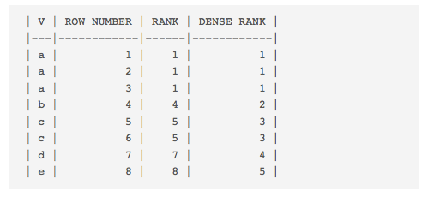

Row_number : assigns unique numbers to each row within the PARTITION given the ORDER BY clause
Rank() : behaves like ROW_NUMBER(), except that “equal” rows are ranked the same.
Dense_rank : Trivially, DENSE_RANK() is a rank with no gaps, i.e. it is “dense”.

- Map Reduce Program to for below scenario:

We have txt file with data UserId, Time Stamp, Status(Login/Logout). Find the user who spent maximum number of time on the application during a day.

sample data should be like
1 5:00am Login
2 5:05am Login
1 5:15am Logout
3 5:23am Login
1 6:00am Login
2 6:00am Logout
3 6:15am Logout
1 7:00am Logout

So the output should be user 1 who spent 75 mins.
- Combiner, partitioner in MR. For custom partitioner which method is implemented? how combiner improves performance.

- Can we implement Similarity Score using MapReduce?

6) we have a cluster with following details
Nodes: 100 Secondary Storage: 4TB Replication Factor: 3 Block Size: 64 MB
How much memory should I allocate to my each node?
If I have to input file size 300TB, how will the cluster handle it?

- Bucketing & Partition
Let's say you have a table
CREATE TABLE mytable (
name string,
city string,
employee_id int )
PARTITIONED BY (year STRING, month STRING, day STRING)
CLUSTERED BY (employee_id) INTO 256 BUCKETS
then hive will store data in a directory hierarchy like
/user/hive/warehouse/mytable/y=2015/m=12/d=02

Also set params like :
set hive.exec.dynamic.partition=true;
set hive.exec.dynamic.partition.mode=nonstrict;
set hive.exec.max.dynamic.partitions=1000;
set hive.exec.max.dynamic.partitions.pernode=1000

The term 'cardinality' refers to the number of possible value a field can have. In general, when choosing a field for partitioning, it should not have a high cardinality, because you'll end up with way too many directories in your file system.
Clustering, aka bucketing, on the other hand, will result in a fixed number of files, since you specify the number of buckets. What hive will do is to take the field, calculate a hash and assign a record to that bucket.
To populate the bucketed table, we have to set hive.enforce.bucketing property to ‘true’
What happens if you use e.g. 256 buckets and the field you're bucketing on has a low cardinality (for instance, it's a US state, so can be only 50 different values?
You'll have 50 buckets with data, and 206 buckets with no data.

Can bucketing can speed up joins with other tables that have exactly the same bucketing?
In the above example, if you're joining two tables on the same employee_id, hive can do the join bucket by bucket (even better if they're already sorted by employee_id since it's going to do a mergesort which works in linear time).
So, bucketing works well when the field has high cardinality and data is evenly distributed among buckets. Partitioning works best when the cardinality of the partitioning field is not too high.
Also, you can partition on multiple fields, with an order (year/month/day is a good example), while you can bucket on only one field.

Another important point to take care is that the columns on which partitioning is done are not part of table definition but the column on which bucketing is done is part of table definition.

Unlike partitioned tables , we cannot directly load data in bucketed table using LOAD DATA (LOCAL) INPATH .

It will automatically sets the number of reduce tasks to be equal to the number of buckets mentioned in the table definition and automatically selects the clustered by column from table definition.

Basically, a bucket is a file in Hive whereas partition is a directory.

http://hadooptutorial.info/bucketing-in-hive/
http://hadooptutorial.info/partitioning-in-hive/

8) Order by, Group by,sort by , distribute by , cluster by
- SORT BY will sort the data within each reducer. You can use any number of reducers for SORT BY operation.
- ORDER BY will sort all of the data together, which has to pass through one reducer. Thus, ORDER BY in hive uses a single
SORT BY – Data is ordered at each of ‘N’ reducers where the reducers can have overlapping range of data.

ORDER BY- This is similar to the ORDER BY in SQL where total ordering of data takes place by passing it to a single reducer.

DISTRUBUTE BY – It is used to distribute the rows among the reducers. Rows that have the same distribute by columns will go to the same reducer.

CLUSTER BY- It is a combination of DISTRIBUTE BY and SORT BY where each of the N reducers gets non overlapping range of data which is then sorted by those ranges at the respective reducers.

9) ChainMapper and ChainReducer concepts

10) Gave a scenario where the hascode for a map was generated using XOR operation on user's home address and shipping address. Gud and Bad things about this approach.

11) If an external table already has data and a new record is to be inserted into it, where will the record go and will old data get overwrite or deleted?
I answered that we can't insert a new record without overwrite. If we use insert overwrite, the old data will remain in the warehouse but now the external table will point to the new data.
- Can we do select from internal table and insert into external table?

- Where will be the data reside. Will it be in hive warehouse or at the location of external table?

- Will dropping external table delete the data or not?

- Will data with internal table remain intact or any impact?

12) How workflow was handled in your project?
13)How to configure sqoop with hdfs. (configurations)?

14 ) - What are you doing to get the notification or how you come to know of task failure in last project?
15 ) How to set number of reducer?

mapred.reduce.tasks
- Default Value: -1
- Added In: Hive 0.1.0
The default number of reduce tasks per job. Typically set to a prime close to the number of available hosts. Ignored when mapred.job.tracker is "local". Hadoop set this to 1 by default, whereas Hive uses -1 as its default value. By setting this property to -1, Hive will automatically figure out what should be the number of reducers.

hive.exec.reducers.bytes.per.reducer
- Default Value: 1,000,000,000 prior to Hive 0.14.0; 256 MB (256,000,000) in Hive 0.14.0 and later
- Added In: Hive 0.2.0; default changed in 0.14.0 with HIVE-7158 (and HIVE-7917)
Size per reducer. The default in Hive 0.14.0 and earlier is 1 GB, that is, if the input size is 10 GB then 10 reducers will be used. In Hive 0.14.0 and later the default is 256 MB, that is, if the input size is 1 GB then 4 reducers will be used.

hive.exec.reducers.max
- Default Value: 999 prior to Hive 0.14.0; 1009 in Hive 0.14.0 and later
- Added In: Hive 0.2.0; default changed in 0.14.0 with HIVE-7158 (and HIVE-7917)
Maximum number of reducers that will be used. If the one specified in the configuration property mapred.reduce.tasks is negative, Hive will use this as the maximum number of reducers when automatically determining the number of reducers.

In short :
In order to change the average load for a reducer (in bytes):
set hive.exec.reducers.bytes.per.reducer=<number>
In order to limit the maximum number of reducers:
set hive.exec.reducers.max=<number>
In order to set a constant number of reducers:
set mapreduce.job.reduces=<number>

16) What is scratch directory?
17) . Read/Write anatomy of HDFS
18) MapReduce program to calculate average of all fields in table.

19) Different phases of mapreduce. (https://dzone.com/articles/word-count-hello-word-program-in-mapreduce )

Workflow of MapReduce consists of 5 steps
- Splitting – The splitting parameter can be anything, e.g. splitting by space, comma, semicolon, or even by a new line (‘\n’).
- Mapping – as explained above
- Intermediate splitting – the entire process in parallel on different clusters. In order to group them in “Reduce Phase” the similar KEY data should be on same cluster.
- Reduce – it is nothing but mostly group by phase
- Combining – The last phase where all the data (individual result set from each cluster) is combine together to form a Result

20) What will you do to improve map-reduce performance(He was more interested in knowing the configuration parameter which we can set for it
like io.sort.mb, size of HDFS block, number of mapper, number of reducer, combiner)

21) You have 3 files each with 100MB, how many splits and mapper will be there.
If there are 3 files of 10 MB each, how many mappers will be there?
. If there are 100 blocks, those are needed to process a job, how many mappers will run.

How can we control the number of splits?

22) Join in Hadoop. On which steps of mapredurec programming we can implement join. Use case where you use reduce side join.

23) How to do map side join in Hive. Is there any particular syntax for it?

Here are two ways to enable it. First is by using a hint, which looks like /*+ MAPJOIN(aliasname), MAPJOIN(anothertable) */. This C-style comment should be placed immediately following the SELECT. It directs Hive to load aliasname (which is a table or alias of the query) into memory.
SELECT /*+ MAPJOIN(c) */ * FROM orders o JOIN cities c ON (o.city_id = c.id);
Another (better, in my opinion) way to turn on mapjoins is to let Hive do it automatically. Simply set hive.auto.convert.join to true in your config, and Hive will automatically use mapjoins for any tables smaller than hive.mapjoin.smalltable.filesize (default is 25MB).

24) How Hive query works(more interested in knowing query ‘s conversion to map-reduce).

25) How can you process two datasets (1 large , and 1 small)?

26) what are the steps to write a mapreduce program to sort the data on any value field.

27). In any database if a query is running slow, what all could be the reasons. Advantage and disadvantages of indexing. Where all we should and should not use indexing?

I do not need the index created in the first question anymore. How can I delete the above index named index_bonuspay?

DROP INDEX index_bonuspay ON employee;

28) What is the difference between Hadoop and yarn.

29) In Yarn, If a reducer fails while running a job, how it will be handled?

30) What is skewness problem and how handle that?

31) What are the different types of Joins available in Hive?

32) How to implement joins in MapReduce.

33) What are the different type of storage or file format available in Hive and explain selection criteria of file format?

– Text
– Sequence
– Avro
– Parquet
– ORC
In my mind the two biggest considerations for ORC over Parquet are:
1. Many of the performance improvements provided in the Stinger initiative are dependent on features of the ORC format including block level index for each column. This leads to potentially more efficient I/O allowing Hive to skip reading entire blocks of data if it determines predicate values are not present there. Also the Cost Based Optimizer has the ability to consider column level metadata present in ORC files in order to generate the most efficient graph.
2. ACID transactions are only possible when using ORC as the file format.

https://www.mapr.com/blog/what-kind-hive-table-best-your-data#.VefqGWxSukq

34) What are different parameters to select a file format like ORC and Parquet for storage in Hive?

34) How to optimize Hive queries?

35) How to handle if new line character (\n) is present as the value of a field in your record when records are itself separated by new line?

- Regex serde

36) How to handle if comma (,) is present as the value of field when fields are itself separated by comma (,) ?

- Regex serde

37) Difference between block size and split size. (http://stackoverflow.com/questions/30549261/split-size-vs-block-size-in-hadoop )

- Split is a logical division of the input data while block is a physical division of data.
- HDFS default block size is default split size if input split is not specified.
- Split is user defined and user can control split size in his Map/Reduce program.
- One split can be mapping to multiple blocks and there can be multiple split of one block.
- The number of map tasks (Mapper) are equal to the number of splits.

37) Mappers Reducers count ( https://wiki.apache.org/hadoop/HowManyMapsAndReduces )

hadoop jar Test_Parallel_for.jar Test_Parallel_for Matrix/test4.txt Result 3 \ -D mapred.map.tasks = 20 \ -D mapred.reduce.tasks =0

Mappers depends on a number of factors:
- Input format and particular configuration properties for the format
- for file based input formats (TextInputFormat, SequenceFileInputFormat etc):
  - Number of input files / paths
  - are the files splittable (typically compressed files are not, SequenceFiles are an exception to this)
  - split size/block size of the files

The mapred.map.tasks parameter is just a hint to the InputFormat for the number of maps. The default InputFormat behavior is to split the total number of bytes into the right number of fragments. However, in the default case the DFS block size of the input files is treated as an upper bound for input splits. A lower bound on the split size can be set via mapred.min.split.size. Thus, if you expect 10TB of input data and have 128MB DFS blocks, you'll end up with 82k maps, unless your mapred.map.tasks is even larger.
map tasks can also be increased manually using the JobConf's conf.setNumMapTasks(int num)
The number of reducers is controlled by mapred.reduce.tasks specified in the way you have it: -D mapred.reduce.tasks=10 would specify 10 reducers. Note that the space after -D is required; if you omit the space, the configuration property is passed along to the relevant JVM, not to Hadoop.
The number of reduce tasks can also be increased in the same way as the map tasks, via JobConf's conf.setNumReduceTasks(int num).

mapred.reduce.tasks=1
mapred.tasktracker.reduce.tasks.maximum=2

39) collectmap,collectlist,collectlist
Collects grouped elements into a collection

SELECT
hash_id, COLLECT_LIST(num_of_cats) AS aggr_set
FROM
tablename
WHERE
blablabla
GROUP BY
hash_id
;

40) What are the different types of tables available in HIve?
There are two types. Managed table and external table. In managed table both the data an schema in under control of hive but in external table only the schema is under control of Hive.

41) Can a table be renamed in Hive?
Alter Table table_name RENAME TO new_name
42) Can Schema be renamed in Hive ?
NO (To check)
43) Can we change the data type of a column in a hive table?
Using REPLACE column option
ALTER TABLE table_name REPLACE COLUMNS ……
44) Is there a date data type in Hive?
Yes. The TIMESTAMP data types stores date in java.sql.timestamp format
45) Can we run unix shell commands from hive? Give example.
Yes, using the ! mark just before the command.
For example !pwd at hive prompt will list the current directory.
46) Can hive queries be executed from script files? How?
Using the source command.
Example −
Hive> source /path/to/file/file_with_query.hql
Using –f option
Example –
$ hive –f file_with_query.hql

47) What is the importance of .hiverc file?
It is a file containing list of commands needs to run when the hive CLI starts. For example setting the strict mode to be true etc.

48) What are the default record and field delimiter used for hive text files?
The default record delimiter is − \n
And the filed delimiters are − \001,\002,\003

49) What do you mean by schema on read?
The schema is validated with the data when reading the data and not enforced when writing data.

50) How do you list all databases whose name starts with p?
SHOW DATABASES LIKE ‘p.*’

51) What is the significance of the line
set hive.mapred.mode = strict;
It sets the mapreduce jobs to strict mode.By which the queries on partitioned tables can not run without a WHERE clause. This prevents very large job running for long time.
And group by without limit (To check)

52) How do you check if a particular partition exists?
This can be done with following query
SHOW PARTITIONS table_name PARTITION(partitioned_column=’partition_value’)

53) Mention what is ObjectInspector functionality in Hive?
ObjectInspector functionality in Hive is used to analyze the internal structure of the columns, rows, and complex objects. It allows to access the internal fields inside the objects.
54) Mention what is (HS2) HiveServer2?
It is a server interface that performs following functions.
- It allows remote clients to execute queries against Hive
- Retrieve the results of mentioned queries
Some advanced features Based on Thrift RPC in its latest version include
- Multi-client concurrency
- Authentication

55) Mention what are views in Hive?
In Hive, Views are Similar to tables. They are generated based on the requirements.
- We can save any result set data as a view in Hive
- Usage is similar to as views used in SQL
- All type of DML operations can be performed on a view
- Only the data don’t get copied with the view (To check)
- Data is not deleted from parent table once we drop the view. (To check)

56) Mention how can you stop a partition form being queried?
You can stop a partition form being queried by using the ENABLE OFFLINE clause with ALTER TABLE statement.
57) Suppose that I want to monitor all the open and aborted transactions in the system along with the transaction id and the transaction state. Can this be achieved using Apache Hive?

Hive 0.13.0 and above version support SHOW TRANSACTIONS command that helps administrators monitor various hive transactions.
58) What is the use of Hcatalog?
Hcatalog provides access to hive metastore to users of other tools on Hadoop so that they can read and write data to hive’s data warehouse.

59) When executing Hive queries in different directories, why is metastore_db created in all places from where Hive is launched?

When running Hive in embedded mode, it creates a local metastore. When you run the query, it first checks whether a metastore already exists or not. The property javax.jdo.option.ConnectionURL defined in the hive-site.xml has a default value jdbc: derby: databaseName=metastore_db; create=true.

The value implies that embedded derby will be used as the Hive metastore and the location of the metastore is metastore_db which will be created only if it does not exist already. The location metastore_db is a relative location so when you run queries from different directories it gets created at all places from wherever you launch hive. This property can be altered in the hive-site.xml file to an absolute path so that it can be used from that particular location instead of creating multiple metastore_db subdirectory multiple times.

60) Explain about the different types of join in Hive.

HiveQL has 4 different types of joins –

JOIN- Similar to Outer Join in SQL

FULL OUTER JOIN – Combines the records of both the left and right outer tables that fulfil the join condition.

LEFT OUTER JOIN- All the rows from the left table are returned even if there are no matches in the right table.

RIGHT OUTER JOIN-All the rows from the right table are returned even if there are no matches in the left table.

61) Is it possible to change the default location of Managed Tables in Hive, if so how?

Yes, we can change the default location of Managed tables using the LOCATION keyword while creating the managed table. The user has to specify the storage path of the managed table as the value to the LOCATION keyword.

62) What will be the output of cast (‘XYZ’ as INT)?

It will return a NULL value.

63) Will the reducer work or not if you use “Limit 1” in any HiveQL query?

64) Why mapreduce will not run if you run select * from table in hive?

65) Implement word count program in Apache Hive.

66) When you point a partition of a hive table to a new directory, what happens to the data?

The data stays in the old location. It has to be moved manually.

67) Write a query to insert a new column(new_col INT) into a hive table (htab) at a position before an existing column (x_col)

ALTER TABLE table_name
CHANGE COLUMN new_col INT
BEFORE x_col
68) Does the archiving of Hive tables give any space saving in HDFS?
No. It only reduces the number of files which becomes easier for namenode to manage.
69) While loading data into a hive table using the LOAD DATA clause, how do you specify it is a hdfs file and not a local file ?
By Omitting the LOCAL CLAUSE in the LOAD DATA statement.
70) If you omit the OVERWRITE clause while creating a hive table,what happens to file which are new and files which already exist?
The new incoming files are just added to the target directory and the existing files are simply overwritten. Other files whose name does not match any of the incoming files will continue to exist.
If you add the OVERWRITE clause then all the existing data in the directory will be deleted before new data is written.
71) What is a Table generating Function on hive?
A table generating function is a function which takes a single column as argument and expands it to multiple column or rows. Example exploe()
72) What is the difference between LIKE and RLIKE operators in Hive?
The LIKE operator behaves the same way as the regular SQL operators used in select queries. Example −
street_name like ‘%Chi’
But the RLIKE operator uses more advance regular expressions which are available in java
Example − street_name RLIKE ‘.*(Chi|Oho).*’ which will select any word which has either chi or oho in it.
73) As part of Optimizing the queries in HIve, what should be the order of table size in a join query?
In a join query the smallest table to be taken in the first position and largest table should be taken in the last position.
74) How will you convert the string ’51.2’ to a float value in the price column?
Select cast(price as FLOAT)
75) Can we LOAD data into a view?
No. A view can not be the target of a INSERT or LOAD statement.
76) What types of costs are associated in creating index on hive tables?
Indexes occupies space and there is a processing cost in arranging the values of the column on which index is cerated.
ORC,Parquet files have inbuilt indexing facility

77) Give the command to see the indexes on a table.
SHOW INDEX ON table_name
This will list all the indexes created on any of the columns in the table table_name.
78) What is bucketing ?
The values in a column are hashed into a number of buckets which is defined by user. It is a way to avoid too many partitions or nested partitions while ensuring optimizes query output.
79) The following statement failed to execute. What can be the cause?

LOAD DATA LOCAL INPATH ‘${env:HOME}/country/state/’
OVERWRITE INTO TABLE address;
The local inpath should contain a file and not a directory. The $env:HOME is a valid variable available in the hive environment.
80) The performance of an aggregate query is improved by setting which of the following property as true?
SET hive.map.aggr = true;
81) Enabling strict mode in Hive restricts
A - Scanning all the partitions
B - Running a order by clause without a LIMIT clause
C - Cartesian product
As it creates long running job.

82) To add a new user defined Function permanently to Hive, we need to

83) The results of a hive query can be stored as
Using the command INSERT OVERWRITE DITECTORY ….. data can be exported to both local and hdfs file system.
84) How to access XML data
LanguageManual XPathUDF :
https://cwiki.apache.org/confluence/display/Hive/LanguageManual+XPathUDF

85) How to access JSON data
get_json_object UDF is a limited version of JSONPath is supported:
$ : Root object
. : Child operator
[] : Subscript operator for array
* : Wildcard for []

json_tuple
A new json_tuple() UDTF is introduced in Hive 0.7. It takes a set of names (keys) and a JSON string, and returns a tuple of values using one function. This is much more efficient than calling GET_JSON_OBJECT UDF to retrieve more than one key from a single JSON string. In any case where a single JSON string would be parsed more than once, your query will be more efficient if you parse it once, which is what JSON_TUPLE is for. As JSON_TUPLE is a UDTF, you will need to use the LATERAL VIEW syntax in order to achieve the same goal.
For example,
Select a.timestamp, get_json_object(a.appevents, '$.eventid'), get_json_object(a.appenvets, '$.eventname') from log a;
should be changed to:
select a.timestamp, b.* from log a lateral view json_tuple(a.appevent, 'eventid', 'eventname') b as f1, f2;
One can also use JSON serde
- CREATE EXTERNAL TABLE json_serde_table (
- id string,
- person struct<email:string, first_name:string, last_name:string, location:struct<address:string, city:string, state:string, zipcode:string>, text:string, url:string>)
- ROW FORMAT SERDE 'org.apache.hive.hcatalog.data.JsonSerDe'
- LOCATION '/tmp/json/';
- SELECT id, person.first_name, person.last_name, person.email,
- person.location.address, person.location.city, person.location.state,
- person.location.zipcode, person.text, person.url
- FROM json_serde_table LIMIT 5;
https://community.hortonworks.com/articles/37937/importing-and-querying-json-data-in-hive.html

86) What is CDC

https://hortonworks.com/blog/four-step-strategy-incremental-updates-hive/

https://docs.hortonworks.com/HDPDocuments/HDP2/HDP-2.4.0/bk_dataintegration/content/incrementally-updating-hive-table-with-sqoop-and-ext-table.html

https://community.hortonworks.com/articles/35709/basic-cdc-in-hadoop-using-spark-with-data-frames.html

87) Compaction in Hive

Compacting ORC files

ALTER TABLE table_name [PARTITION (partition_key = 'partition_value')] CONCATENATE;

https://developer.ibm.com/hadoop/2018/01/19/optimizing-orc-and-parquet-files-for-big-sql-queries-performance/

compaction in Parquet can be done using parquet tools but will be helpful only if the files are really very small as compared to block size.

https://www.cloudera.com/documentation/enterprise/latest/topics/cdh_ig_parquet.html#parquet_files

87) Sqoop

sqoop \
--options-file $conf_param_file \
--query "select xxx , \
yy \
from SCHEMA_NAME.TABLE_NAME \
where \$CONDITIONS" \
--hive-import \
--hive-overwrite \
--hive-table HIVE_TABLE -verbose -m 6 \
--split-by COLUMN_NAME \
--null-string "<NULL>" \
--null-non-string 0 \
--target-dir /path

#################
$conf_param_file
#################

import
--connect
jdbc:oracle:thin:@server:1521/dbname
--username
READ_ONLY_USER
--password
READ_ONLY_USER

88) What is split by and boundary query in Sqoop
The degree of parallelism is controlled by -m <n> or --num-mappers <n>. By default value of --num-mappers is 4.
Second, --split-by <column-name>, will split your task on the basis of column-name.
Third, $CONDITIONS, it is used internally by sqoop to achieve this splitting task.

--split-by : It is used to specify the column of the table used to generate splits for imports. This means that it specifies which column will be used to create the split while importing the data into your cluster. It can be used to enhance the import performance by achieving greater parallelism. Sqoop creates splits based on values in a particular column of the table which is specified by --split-by by the user through the import command. If it is not available, the primary key of the input table is used to create the splits.
Reason to use : Sometimes the primary key doesn't have an even distribution of values between the min and max values(which is used to create the splits if --split-by is not available). In such a situation you can specify some other column which has proper distribution of data to create splits for efficient imports.
--boundary-query : By default sqoop will use query select min(), max() from to find out boundaries for creating splits. In some cases this query is not the most optimal so you can specify any arbitrary query returning two numeric columns using --boundary-query argument.
Reason to use : If --split-by is not giving you the optimal performance you can use this to improve the performance further.

--call <stored-proc-name> | Stored Procedure to call

If the source data gets updated every now and then, how will you synchronise the data in HDFS that is imported by Sqoop?
Data can be synchronised using incremental parameter with data import –
--Incremental parameter can be used with one of the two options-
i) append-If the table is getting updated continuously with new rows and increasing row id values then incremental import with append option should be used where values of some of the columns are checked (columns to be checked are specified using –check-column) and if it discovers any modified value for those columns then only a new row will be inserted.
ii) lastmodified – In this kind of incremental import, the source has a date column which is checked for. Any records that have been updated after the last import based on the lastmodifed column in the source, the values would be updated.

88)

---------------------------------------- MR ------------------------------------

- What is speculative execution in Hadoop?
Hadoop ecosystem works on dividing tasks into smaller sub tasks, which are then spread over the nodes for processing. While processing a task, there is a possibility that some of the systems could be slow, which may slow down the overall process thus requiring lot of time to complete a particular task.Multiple copies of MapReduce tasks are run on other DataNodes. As most of the tasks finish, Hadoop creates redundant copies of the remaining tasks, and assigns it to the nodes that are not executing any other task. This process is referred to as Speculative Execution. This way if the same task is finished by some other node then Hadoop will stop all the other nodes which are processing that task.
- What is the advantage of having a Distributed Cache in Hadoop?
- What is InputSplit in Hadoop?
- How many JVMs run on a DataNode and what is their use?
- Which object will you use to track the progress of a job?
- Why cannot you use Java primitive data types in Hadoop MapReduce?
- How do reducers communicate with each other?
- What is secondary sort ?
Secondary sort is a technique that allows the MapReduce programmer to control the order that the values show up within a reduce function call.
Lets assume that our secondary sorting is on a composite key made out of Last Name and First Name.
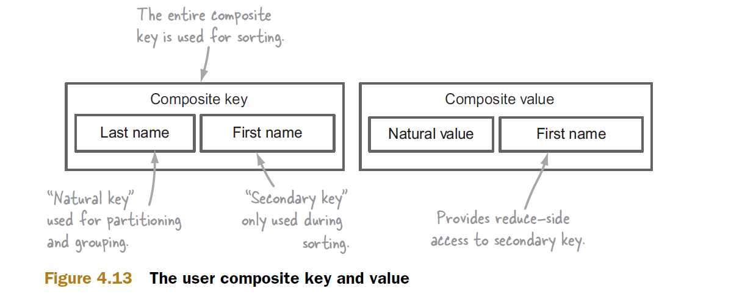
Now lets look at the steps involved in secondary sorting
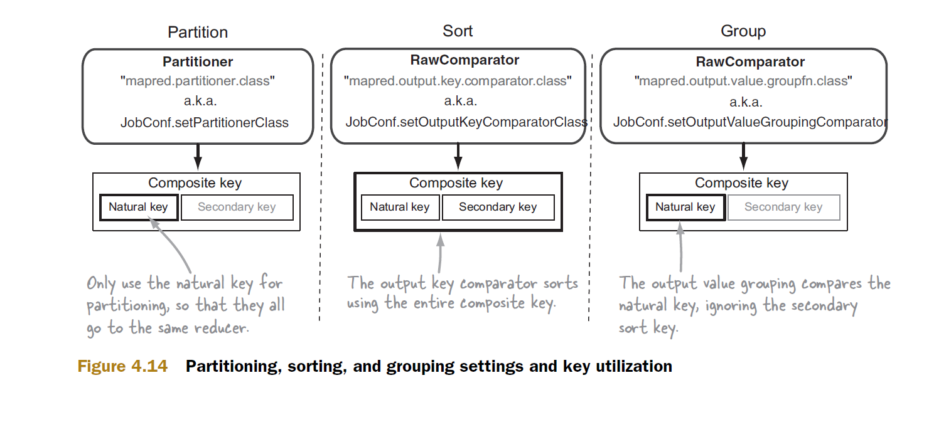
The partitioner and the group comparator use only natural key, the partitioner uses it to channel all records with the same natural key to a single reducer. This partitioning happens in the Map Phase, data from various Map tasks are received by reducers where they are grouped and then sent to the reduce method. This grouping is where the group comparator comes into picture, if we would not have specified a custom group comparator then Hadoop would have used the default implementation which would have considered the entire composite key, which would have lead to incorrect results.
Finally just reviewing the steps involved in a MR Job and relating it to secondary sorting should help us clear out the lingering doubts
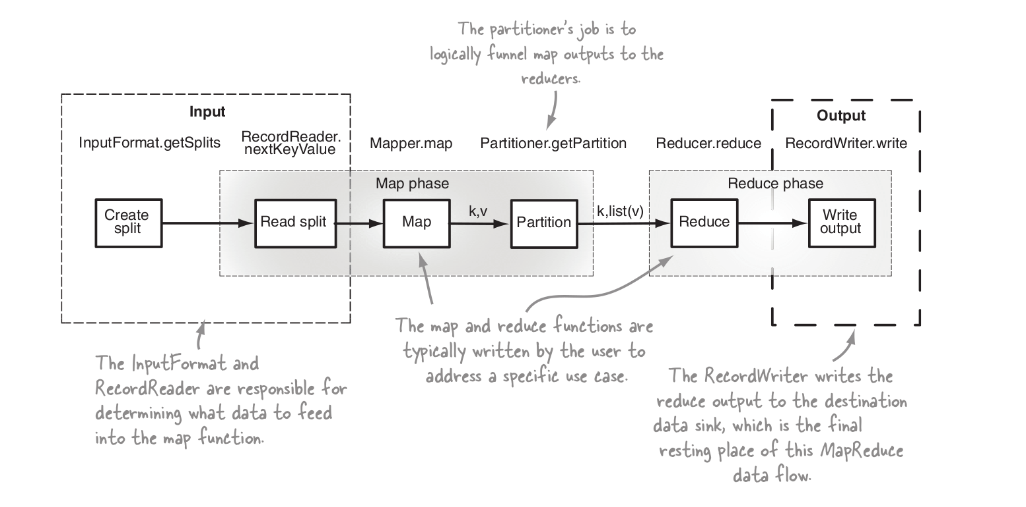
- Sd
- dfvsd

------------------------------------------------------ HDFS --------------------------------------
- Difference between -put and –copyFromLocal or -get and –copyToLocal
- copyFromLocal is similar to put command, except that the source is restricted to a local file reference.
So, basically you can do with put, all that you do with copyFromLocal, but not vice-versa.
Similarly,
- copyToLocal is similar to get command, except that the destination is restricted to a local file reference.

# reads the input from stdin.
hdfs dfs -put - hdfs://nn.example.com/hadoop/hadoopfile

# works the way I expected
akawa@hadoop:~$ tar zxvf numbers.tar.gz numbers/1.txt -O | hadoop fs -put - put-dir/1.txt
numbers/1.txt
akawa@hadoop:~$ hadoop fs -cat put-dir/1.txt
adam 3
natalia 1
tofi 2

# it suprisingly works (in contrast to what one may deduct from the HDFS Shell Guide)
akawa@hadoop:~$ tar zxvf numbers.tar.gz numbers/1.txt -O | hadoop fs -copyFromLocal - copyfromlocal-dir/1.txt
numbers/1.txt
akawa@hadoop:~$ hadoop fs -cat copyfromlocal-dir/1.txt
adam 3
natalia 1
tofi 2

So according to official doc it only copies from local when used copyfromlocal

- getmerge : merges part file into one file
Usage: hadoop fs -getmerge [-nl] <src> <localdst>
Takes a source directory and a destination file as input and concatenates files in src into the destination local file. Optionally -nl can be set to enable adding a newline character (LF) at the end of each file.
Examples:
- hadoop fs -getmerge -nl /src /opt/output.txt
- hadoop fs -getmerge -nl /src/file1.txt /src/file2.txt /output.txt
Exit Code:
Returns 0 on success and non-zero on error.

- High Availability of Name Node in Hadoop 2.x ( https://www.youtube.com/watch?v=5U6EIv_w5Bg )

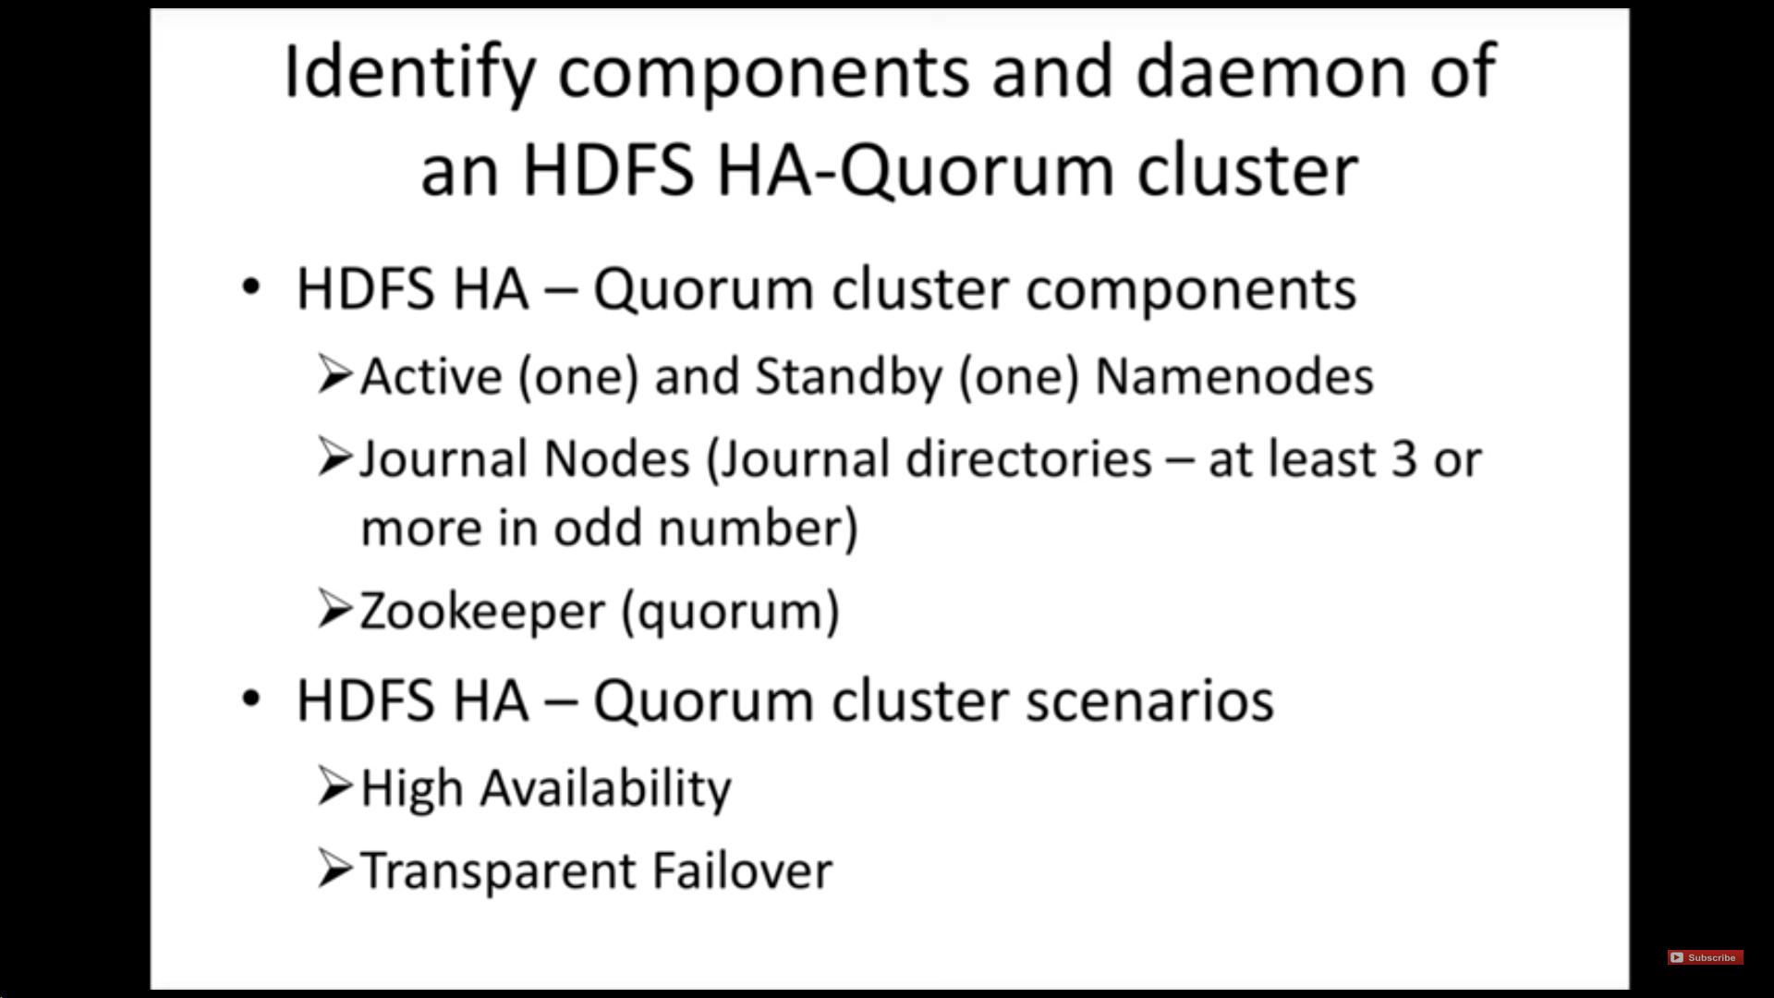

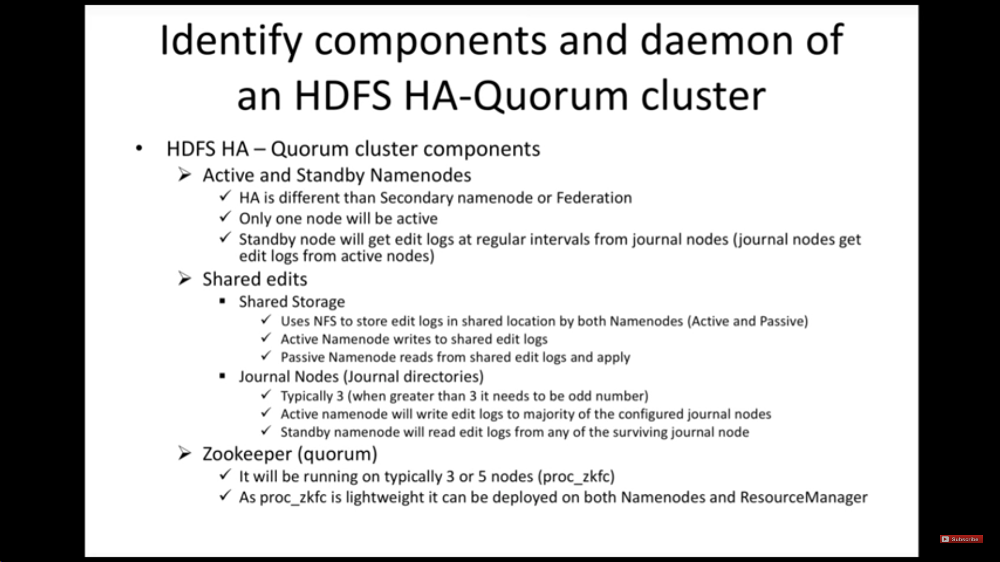

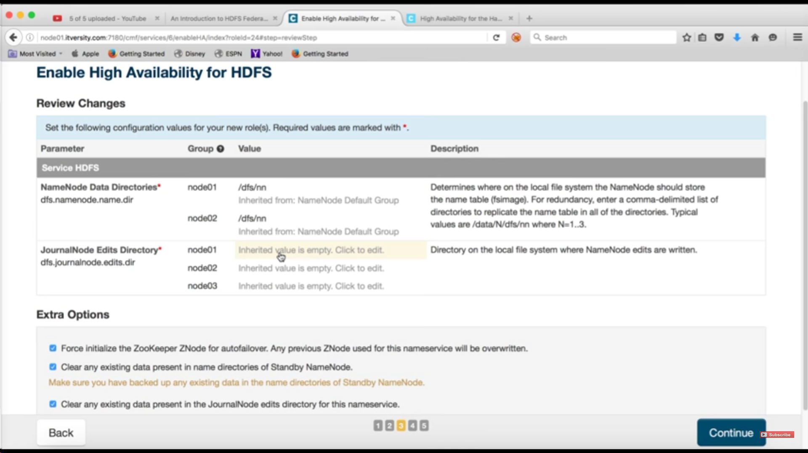

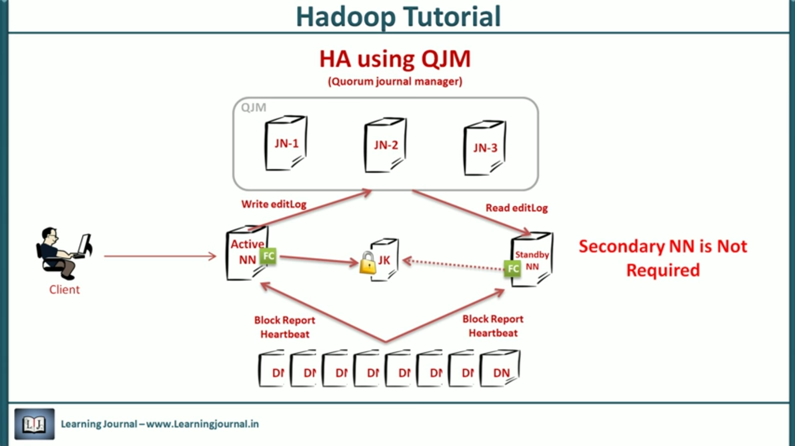

- What is Secondary Name Node

- Sdfs
- sdfs

----------------------------------------- YARN -------------------------------------------------------------

1 . HA in YARN (https://www.youtube.com/watch?v=UQDs67xZo58)

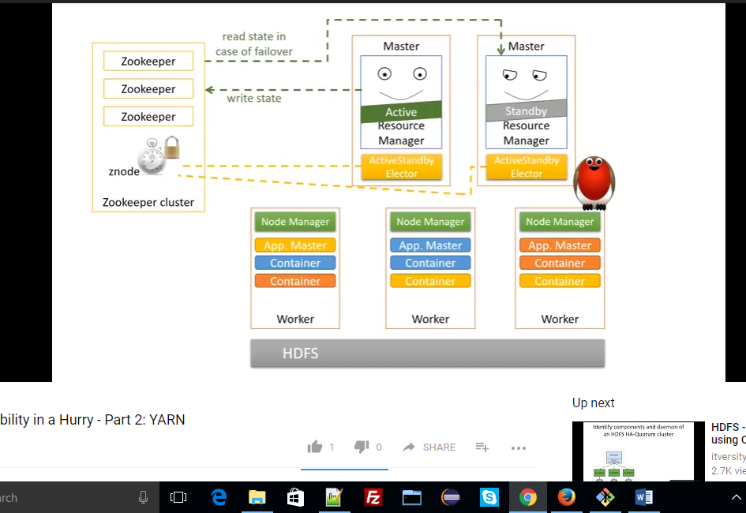
2.

