Contents
1. Intro to Docker 1
What is Docker? 2
2. Docker Installation & Commands: 4
3. Dockerfile 9
Volumes 10
Volume mounted in a container 10
Mount a Host Directory as a Volume 11
Docker Image with Volume specified in Dockerfile 11
Create the Dockerfile 11
Create an Image from the Dockerfile 12
Create a Docker container 12
Docker Container with volume from Command Line and Image 12
Create a Local directory 12
Create a Container with a Volume ubuntu2 12
Container with ReadOnly Volume 13
Volumes From Another Container 13
Docker Compose 14

1. Intro to Docker

Where Virtual Machines Fit
Containers and virtual machines both allow multiple applications to run on the same physical systems. They differ in the degree to which they meet different kinds of business and IT requirements.
Virtual machines do a great job at what they were designed to do: abstract from the underlying hardware. This lowers costs and makes it possible to automate provisioning of a complete software stack, including the operating system, the application, and all application dependencies.
Virtual machines aren’t ideal for every use case:
• Virtual machines need minutes to spin up, which can degrade the user experience and give hackers time to exploit known vulnerabilities during bootup.
• Patching and lifecycle management for virtual machines requires a significant effort. That’s because every virtualized application has at least two operating systems for operators to manage and secure: the hypervisor and the guest OS that is inside the virtual machine.
• Even the simplest OS process needs its own virtual machine. This requirement increases flexibility, but it also makes virtual machines impractical to use for microservices architectures with hundreds or thousands of processes.
• When each physical server is replaced by one virtual machine, physical resource utilization tends to remain low. Server sprawl is simply replaced with virtual machine sprawl.

Where Linux Containers Fit
Briefly, a Linux container is a set of processes that are isolated from the rest of the machine. A container can encapsulate any application dependency. For example, if a website relies on a particular version of the PHP scripting language, the container can encapsulate that version. As a result, multiple versions of the same scripting language can co-exist in the same environment - without the administrative overhead of a complete software stack, including the OS kernel. Containerized applications perform about as well as applications deployed on bare metal.
Where hypervisors provide a logical abstraction at the hardware level, containers run in isolation, sharing an operating system instance. This approach can improve application delivery in several ways:
• Lowering costs
• Speeding up application development
• Simplifying security
• Making it easier to adopt new IT models such as hybrid clouds and microservices architecture

Containers simplify IT operations:
• Fewer operating systems to manage: Each virtual machine can be carved into multiple containers, all sharing the same operating system kernel.
• Greater application mobility: You can move workload between private and public clouds more quickly, by orders of magnitude. Instead of moving gigabytes between clouds, you can move megabytes.
• Easier OS patching: A virtualized application with 10 virtual machines has 11 operating systems - the hypervisor and each guest operating system - and each needs patching. In contrast, a containerized server with 10 applications has only one operating system.
• Easier application patching: Docker container images are composed of layers, and you can patch by just adding a layer. The new layer doesn’t affect the others. The layers of a web application image, for example, might include an Apache web server, a PHP runtime system, and Redis for caching.

• Better workload visibility: Operators can’t see the workload inside a virtual machine, but they can look inside a container from the container host environment. One benefit is the ability to detect unused container instances, helping to avoid virtual machine sprawl. Another benefit is simplified dependency mapping and security maintenance.
• Improved resource utilization: Linux containers run on a single computing instance, making it easier to detect their activity and retire unused containers. Idle containers don’t take up computing, memory, and I/O resources.
• Faster provisioning: Containerized applications can boot and restart in seconds, compared to minutes for virtual machines (Figure 1). Booting and restarting are faster because containers have smaller payloads and don’t carry the overhead of a hypervisor and guest OS. Faster boot time correlates with less downtime. This benefit is especially appealing for organizations that want to use a public cloud service to handle higher-than-usual transaction volumes. In this case, faster boot and restart times can directly reduce costs.

What is Docker?

At its core, Docker is an open source project that uses several resource isolation
features of the Linux kernel to sandbox an application, its dependencies, and interfaces
inside of an atomic unit called a container. Because containers roll an application
together with its dependencies and interfaces into a single re-deployable unit, a
container can be run on any host system with the appropriate kernel components, while
shielding the application from behavioral inconsistencies due to variances in software
installed on the host. Multiple containers can be run on a single host OS without the
need of a hypervisor while being isolated from neighboring containers. This layer of
isolation introduces consistency, flexibility, and portability that enable rapid software
deployment and testing.

Use Cases for Linux Containers/Docker

Use Case | What’s New | Benefit
Development and testing | Replicate self-contained application images on any certified host platform and infrastructure. | Reduce dependency problems. Choose where to deploy.
Low-overhead Linux distributions | Encapsulate libraries and services in the container image. | Reduce OS overhead. Enable the use of small-footprint operating system.
Cloud-native applications | Abstract physical resources and create stateless web and application tiers. | Avoid being locked into a cloud application framework.
Scaling up and down | Spin up containers when workload is heavy. Retire them when they are no longer needed. | Use resources more efficiently.
PaaS | Transport application binaries and configurations in containers. Most PaaS frameworks are already container-based. | Allow PaaS frameworks to interoperate.
Intercloud portability | Natively support Docker containers in public and private clouds. | Exchange application components between clouds.
Microservices | Design applications as suites of services, each written in the best language for the task. | Scale just the microservices that need more resources, not the entire application. Allow different teams to manage different microservices.
Compute-enabled storage | Bring computing resources to data instead of bringing data to computing resources. | Speed up computing operations by not having to move large volumes of big data. Use any language or runtime system.
Shared network functions and services | Virtualize network services in containers instead of on virtual machines or network devices. | Accelerate startup and shutdown, improving user experience.
Containerized control and management planes | Transport control-plane and management-plane software. | Reduce overhead and maintain image integrity.
Edge computing and Internet of Everything solutions | Package, distribute, and run applications and services at the edge to process data closer to the origin. | Conserve bandwidth from the edge to the core. Enable the right kind of services for the particular type of data and type of analysis.
Policy-aware networks | Grant or block access to containers based on policy. For example, apply Quality of Service (QoS) to containers. | Improve the application experience by giving priority to containers with critical services. Improve security.
Network application containers | Run third-party applications in containers on the network operating system. | Add new capabilities to the base network operating system.

Souce : linux-containers-white-paper-cisco-red-hat.pdf

Terminology
The following list contains important terminology and introduces you to certain fundamental
concepts of Docker.

Cgroups
Control Groups is a Linux kernel feature that allows aggregating or partitioning tasks
(processes) and all their children into hierarchically organized groups to isolate resources.

Image
A virtual machine on the host server that can run any Linux system, for example SUSE
Linux Enterprise Server, SUSE Linux Enterprise Desktop, or openSUSE. A Docker image is
made by a series of layers built one over the other. Each layer corresponds to a permanent
change committed from a container to the image. For more details, see the official Docker
documentation at http://docs.docker.com/engine/reference/glossary/#image/.

Image Name
A name that refers to an image. The name is used by the Docker commands.

Container
A running Docker image.

Container ID
An ID that refers to a particular container. The ID is used by the Docker commands.

Tag
A string associated with an image. It is commonly used to identify a specific version of an
image (similar to tags in version control systems). It is also possible to refer to the same
image with different tags.

Kernel Namespaces
Namespaces are a kernel feature to isolate some resources like network, users, and others
for a group of processes.

Docker Host Server
The system that runs the Docker daemon, and provides images and management control
capabilities through cgroups.

Registry
A remote storage for Docker images.

Repository
Place where all the versions of a Docker image are kept.

2. Docker Installation & Commands:

Installation :

Verify docker is installed correctly.

Execute the following command.

$ sudo docker run hello-world

You should see the following outout.

Hello from Docker.
This message shows that your installation appears to be working correctly.

To generate this message, Docker took the following steps:
1. The Docker client contacted the Docker daemon.
2. The Docker daemon pulled the "hello-world" image from the Docker Hub.
(Assuming it was not already locally available.)
3. The Docker daemon created a new container from that image which runs the
executable that produces the output you are currently reading.
4. The Docker daemon streamed that output to the Docker client, which sent it
to your terminal.

Docker Commands :

- Version

$docker version

- Info :
This command gives information about the docker setup on your machine/vm

$ docker info

Docker has introduced new format for running commands, which categories command set into management commands

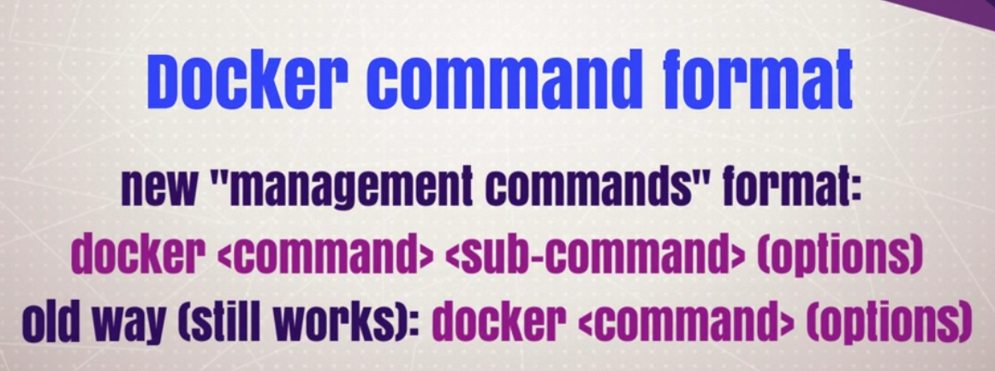

Where management commands are categories into:

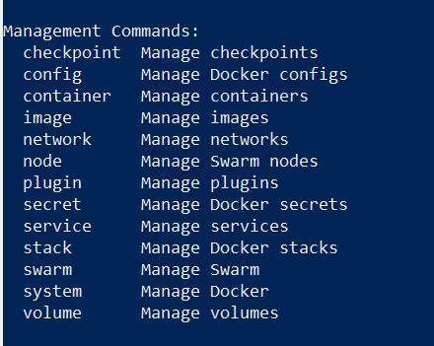

For checking the list of commands under management commands use

- Help
$docker image help

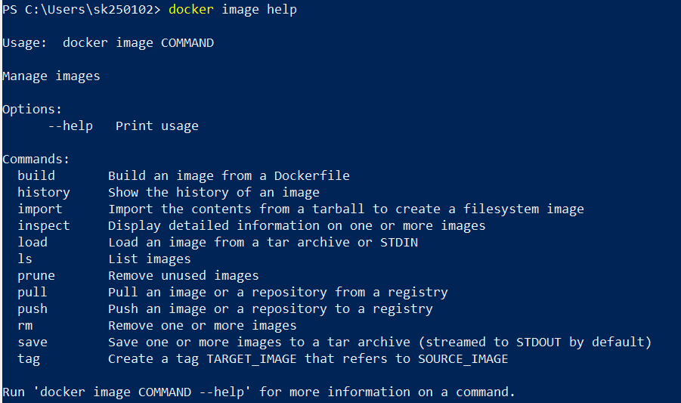

- images :
If you want to know what images are already present on your docker setup locally, try the following command:

$ docker images OR $ docker image ls

Note :
- Management command uses ‘image’ i.e singular while the old syntax used ‘images’
- The columns that the output gives (2 important ones are given below):

REPOSITORY
TAG

The REPOSITORY column is obvious since it is the name of the Image itself. The TAG is important, you will find that the TAG value is mentioned as latest. But there was no indication given by us about that.

- Pull
$ sudo docker pull debian

- run
Create a Container and enter its shell

$ sudo docker run -i -t debian /bin/bash

This should give you a new command prompt inside the container, very similar to if you had ssh‘ed into a remote machine. In this case the flags -i and -t tell Docker we want an interactive session with a tty attached. The command /bin/bash gives a bash shell. When you exit the shell the container will stop — containers only run as long as their main process

Create a container with a name

You can use -h/--name command line parameter to specify a container name.

$ docker run -h CONTAINER1 -i -t debian /bin/bash

Output of the command above will open a tty inside the container

New Format:
$docker container run -p 80:80 nginx:alpine

Where -p or --publish maps the hostPort:containerPort

However after executing the command the control is not returned back to the shell, the same can be achieved using --detach parameter

3.ps

List of docker containers running

$ docker ps -a

4. build :
Builds Docker images from a Dockerfile and a “context”. A build’s context is the files located in the specified PATH or URL.
The URL parameter can specify the location of a Git repository; the repository acts as the build context.

4.1 Build with PATH
$ docker build .

This example specifies that the PATH is ., and so all the files in the local directory get tard and sent to the Docker daemon. The PATH specifies where to find the files for the “context” of the build on the Docker daemon. Remember that the daemon could be running on a remote machine and that no parsing of the Dockerfile happens at the client side (where you’re running docker build). That means that all the files at PATH get sent, not just the ones listed to ADD in the Dockerfile.

The transfer of context from the local machine to the Docker daemon is what the docker client means when you see the “Sending build context” message.
In most cases, it’s best to put each Dockerfile in an empty directory. Then, add to that directory only the files needed for building the Dockerfile. To increase the build’s performance, you can exclude files and directories by adding a .dockerignore file to that directory as well.

4.2 Build with URL

$ docker build github.com/creack/docker-firefox

This will clone the GitHub repository and use the cloned repository as context. The Dockerfile at the root of the repository is used as Dockerfile. Note that you can specify an arbitrary Git repository by using the git:// or git@ schema.

4.3 Build with -

$ docker build - < Dockerfile

This will read a Dockerfile from STDIN without context. Due to the lack of a context, no contents of any local directory will be sent to the Docker daemon. Since there is no context, a Dockerfile ADD only works if it refers to a remote URL.

$ docker build - < context.tar.gz

This will build an image for a compressed context read from STDIN. Supported formats are: bzip2, gzip and xz.

4.4 Tag image (-t)

$ docker build -t vieux/apache:2.0 .

This will build like the previous example, but it will then tag the resulting image. The repository name will be vieux/apache and the tag will be 2.0

4.5 Specify Dockerfile (-f)

$ docker build -f dockerfiles/Dockerfile.debug -t myapp_debug .
$ docker build -f dockerfiles/Dockerfile.prod -t myapp_prod .

The above commands will build the current build context (as specified by the .) twice, once using a debug version of a Dockerfile and once using a production version.

Upload the Docker image to your Docker Hub account.

Log in to your Docker Hub account.

$ docker login

Verify that you have logged in correctly.

$ docker info

You should see "Username: my-dockerhub-username" in the output. If not, verify your Docker Hub login information and try to log in again.

Push the image.

$ docker push my-dockerhub-username/amazon-ecs-sample

5. push :

6. attach :
Usage: docker attach [OPTIONS] CONTAINER

Attach to a running container

$ sudo docker attach 665b4a1e17b6 #by ID
or
$ sudo docker attach loving_heisenberg #by Name
$ root@665b4a1e17b6:/#

7. exec :
If we use attach we can use only one instance of shell. So if we want open new terminal with new instance of container's shell, we just need run the following:
$ sudo docker exec -i -t 665b4a1e17b6 /bin/bash #by ID
or
$ sudo docker exec -i -t loving_heisenberg /bin/bash #by Name
$ root@665b4a1e17b6:/#

start
stop
rm
rmi
search :
This command will search the online Docker registry for a Image named busybox.

kill

--help=false Print usage
--no-stdin=false Do not attach STDIN
--sig-proxy=true Proxy all received signals to the process

The docker attach command allows you to attach to a running container using the container’s ID or name, either to view its ongoing output or to control it interactively. You can attach to the same contained process multiple times simultaneously, screen sharing style, or quickly view the progress of your detached process.

You can detach from the container and leave it running with CTRL-p CTRL-q (for a quiet exit) or with CTRL-c if --sig-proxy is false.

create
inspect
logs :

Docker Logs

If you run this command with the name of your container, you should get a list of commands executed in the container.

$ docker logs hopeful_pare

where hopeful_pare is the container name.

NOTE :

Detach from a Container

docker run -t -i → can be detached with ^P^Q and reattached with docker attach
docker run -i → cannot be detached with ^P^Q; will disrupt stdin
docker run → cannot be detached with ^P^Q;
can SIGKILL client; can reattach with docker attach
help for commands

docker COMMAND –help

3. Dockerfile
Understanding of Dockerfile
Here is the format of the Dockerfile:

# Comment
INSTRUCTION arguments

The instruction is not case-sensitive, however convention is for them to be UPPERCASE in order to distinguish them from arguments more easily.

Docker runs the instructions in a Dockerfile in order. The first instruction must be `FROM` in order to specify the Base Image from which you are building.

Docker will treat lines that begin with # as a comment. A # marker anywhere else in the line will be treated as an argument. This allows statements like:

Dockerfile commands :

FROM
RUN
apt-get
CMD
EXPOSE
ENV
ADD or COPY
ENTRYPOINT
VOLUME
USER
WORKDIR
ONBUILD

Volumes

Volume mounted in a container

- Execute the following command
$ docker run -v /volume1 -i -t ubuntu /bin/bash
This will mount /volume1 inside the container created from ubuntu image and launch and bash shell.
- The command above will get us into the terminal tty of the container. Run ls command and you will notice volume 1 there
$root@b979b5d735b0:/# ls
bin boot dev etc home lib lib64.. var volume1
- On inspecting the docker container you will notice that /volume1 is mounted under / and is a ReadWrite Volume
{
"Volumes": {
"/volume1": "/var/lib/docker/vfs/dir/012..5a569b392"
},
"VolumesRW": {
"/volume1": true
}
}

Mount a Host Directory as a Volume

- Create a local directory /host/logs
$ sudo mkdir -p /host/logs
$ sudo touch /host/logs/log1.txt
- Execute the following command to bind /host/logs host directory to /container/logs volume
$ docker run -v /host/logs:/container/logs -i -t ubuntu /bin/bash
- Execute ls to see the contents of mounted volume. Notice that contents are the same as created in host directory.
root@3774005dee32:/# ls
bin boot container .. srv sys tmp usr var
root@3774005dee32:/# ls container/logs/
log1.txt

Docker Image with Volume specified in Dockerfile

Create the Dockerfile

Create a Dockerfile as shown below in a directory. Make sure file1 exists in the same directory. We are gong to mount file1 as /ubuntu1/file and mount /ubuntu1 as a VOLUME.
FROM ubuntu
ADD file1 /ubuntu1/file
VOLUME /ubuntu1
CMD /bin/sh

Create an Image from the Dockerfile
Execute the command below to build the image test/volume-one-dockerfile
docker build -t test/volume-one-dockerfile .

Create a Docker container
Create a container from the image test/volume-one-dockerfile
docker run -it test/volume-one-dockerfile
This command above will launch the bash shell of the container. Check if the volume /ubuntu1 is mounted
# ls
bin boot dev etc home lib .. sbin srv sys tmp ubuntu1 usr var
# ls /ubuntu1
file

Docker Container with volume from Command Line and Image
In this section you will learn how to use command line to mount a host directory into a container created from an image

Create a Local directory
Create a local directory ubuntu2 and two files file1 and file2 in that directory.
$sudo mkdir -p /ubuntu2
[sudo] password for ubuntu:
$ sudo touch /ubuntu2/file1
$ sudo touch /ubuntu2/file2

Create a Container with a Volume ubuntu2
Create a container from the image :code:test/volume-one-dockerfile by specifying the directory to be mounted on the command line with a flag -v.
$ docker run -it -v /ubuntu2:/ubuntu2 test/volume-one-dockerfile
Check that the directory ubuntu2 got mounted in the docker container. Run ls in the container shell.
# ls
bin boot dev etc home lib sys tmp ubuntu1 ubuntu2 usr var
# ls ubuntu2
file1 file2
As you can see above both ubuntu1 and ubuntu2 got mounted as volumes.

Container with ReadOnly Volume

Specify the :ro as shown below to make the volume readonly.
$ docker run -it -v /ubuntu2:/ubuntu2:ro test/volume-one-dockerfile
Try creating a new file in that volume from the bash shell of the container.
# touch /ubuntu2/file3
touch: cannot touch '/ubuntu2/file3': Read-only file system

Volumes From Another Container

Volumes from a container can be bound to another container using --volumes-from <container-name flag. Make sure there is host directory with contents /ubuntu1/code
$ ls /ubuntu1
file
Create a Container with a Volume Create a container with name ubuntu1 from image ubuntu
$ docker run -it --name ubuntu1 -v /ubuntu1:/ubuntu1 ubuntu
root@f031b82e5da6:/# ls ubuntu1
file
Create Second Container with shared volumes
Create a second container ubuntu2 with volumes from ubuntu1
$ docker run -it --name ubuntu2 --volumes-from ubuntu1 ubuntu
Note : -volumes-from is also valid but deprecated.
Check that the ubuntu1 volume is bound as expected
root@b28ca7033e9d:/# ls
bin boot dev etc home .. ubuntu1 usr var
root@b28ca7033e9d:/# ls ubuntu1
file

Docker Link

In order to connect together multiple docker containers or services running inside docker container, ‘–link’ flag can be used in order to securely connect and provide a channel to transfer information from one container to another. The below example shows a simple application of using a Wordpress container linked to MySQL container.
Pull the latest MySql container
$ docker pull mysql:latest
latest: Pulling from mysql
..........................
Run MySql Container in detach mode
$ docker run --name mysql-container -e MYSQL_ROOT_PASSWORD=wordpress -d mysql
89c8554d736862ad5dbb8de5a16e338069ba46f3d7bbda9b8bf491813c842532
We will be running this database container with name “mysql-wordpress” and will set root password for MySQL container.
Pull Wordpress docker container
In the new terminal, pull the official wordpress container
$ docker pull wordpress:latest
latest: Pulling from wordpress
..............................
Run the wordpress container linking it to MySQL Container
$ docker run -e WORDPRESS_DB_PASSWORD=password --name wordpress-container --link mysql-container:mysql -p 8080:80 -d wordpress
189c0f04ce7694b4f9fadd36624f6f818023d8d1f3ed1c56de5a516255f328a9
As, we have linked both the container now wordpress container can be accessed from browser using the address http://localhost:8080 and setup of wordpress can be done easily.

Docker Compose

We will run the same previous application of wordpress and MySQL linking in this tutorial but with Docker compose which was launched recently and is a tool use to define and run complex linked applications with docker. With docker compose we can define the entire multi-container application in single file and then the application can be spinned up using one command.
Create a new project folder
$ mkdir dockercompose
$ cd dockercompose
Create Docker compose file
Create docker-compose.yml with preferred editor having the following contents
web:
image: wordpress
links:
- mysql
environment:
- WORDPRESS_DB_PASSWORD=sample
ports:
- "127.0.0.3:8080:80"
mysql:
image: mysql:latest
environment:
- MYSQL_ROOT_PASSWORD=sample
- MYSQL_DATABASE=wordpress
Get the linked containers up
$ docker-compose up
Creating dockercompose_mysql...
Creating dockercompose_web...
Attaching to dockercompose_mysql, dockercompose_web
mysql | Initializing database
..............
Visit the IP address http://127.0.0.3:8080 in order to see the setup page of the newly created linked wordpress container.

What is a Docker Registry?
The Docker registry is an open source project created by Docker Inc. It allows the storage and
retrieval of Docker images. By running a local instance of the Docker registry it is possible to
completely avoid usage of the Docker Hub.
The Docker registry is also used by the Docker Hub. However, the Docker Hub, as seen from
the user perspective, is made of the following parts at least:
The user interface (UI): The part that is accessed by users with their browser. The UI
provides a nice and intuitive way to browse the contents of the Docker Hub either manually
or by using a search feature. It also allows to create organizations made by different users.
This component is closed source.
The authentication component: This is used to protect the images stored inside of the
Docker Hub. It validates all push, pull and search requests.
This component is closed source.
The storage back-end: This is where the Docker images are sent and downloaded from. It
is provided by the Docker registry. This component is open source.

Docker CI

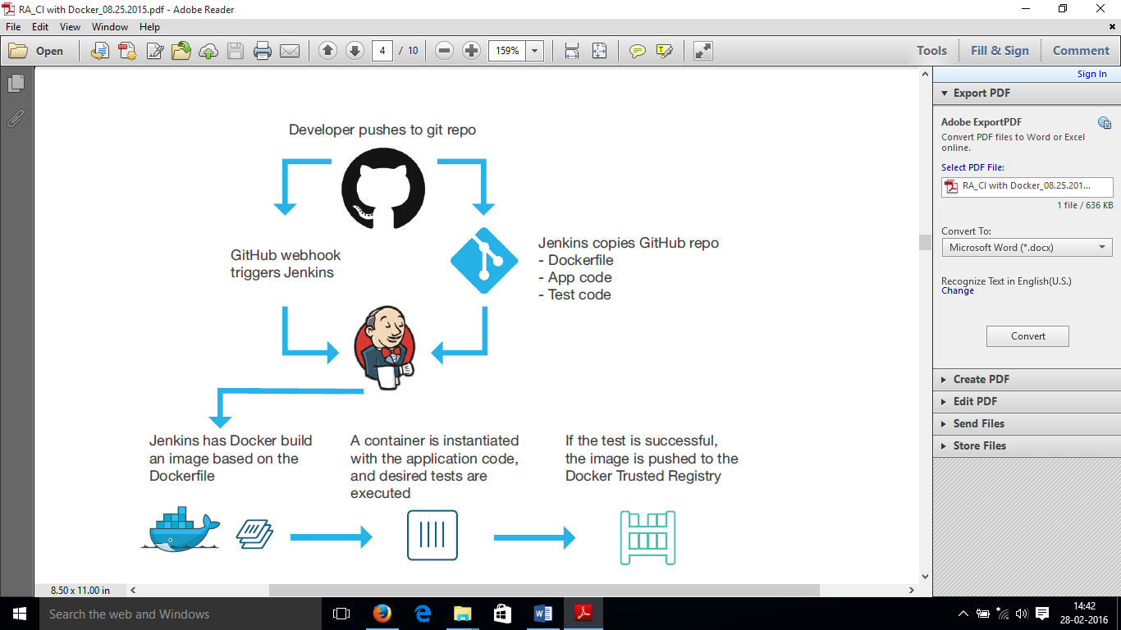

CI workflow :

The CI workflow described in this document is as follows:
1. Developer pushes a commit to GitHub
2. GitHub uses a webhook to notify Jenkins of the update
3. Jenkins pulls the GitHub repository, including the Dockerfile describing the image, as well as the application and test code.
4. Jenkins builds a Docker image on the Jenkins slave node
5. Jenkins instantiates the Docker container on the slave node, and executes the appropriate tests
6. If the tests are successful the image is then pushed up to Docker Trusted registry

Configuring GitHub
In order to create and test a target application, the GitHub repository for the target application needs to contain the following components:
- The application code
- The test code for the application
- A Dockerfile that describes how to build the application container, and copies over the necessary application and test code.

As an example, the following image depicts the repository for a very simple Node.js application:

PIC →

The Dockerfile is constructed as follows:

This Dockerfile will pull the supported Node.js image from the Docker Hub. Next, it will install any necessary dependencies (based on the package.json file), and then copy the application code and test files from the GitHub repository to the /src directory in the image. Finally, it will expose the appropriate network port, and execute the application.
Note: This Dockerfile is presented as an example, there is nothing in the file specific to enabling the CI workflow. The only requirement for this workflow is that there is a Dockerfile that will build the requisite image needed for testing.

In addition to the presence of a Dockerfile, the repository needs to be configured to notify the Jenkins server when a new commit happens. This is done via the “Webhooks and Services” section of the “Settings” page.

For Jenkins : Building a Continuous Integration Pipeline with Docker

Conclusion : The Big Questions :

Beyond Docker: are containers here to stay?

Docker in itself, but also components and concepts popularized by it, are at the heart of a multitude of projects which try to build on it. Just as Docker put a friendly face around LXC, people and companies around the world try to use it to put friendly faces around other connected areas.
For instance a consortium comprising of the technology behemoths Google, Microsoft and IBM as well as smaller companies, such as CoreOs, RedHat, Mesosphere and even the apparent Docker competitor VMWare, is supporting a project called Kubernetes (open-sourced earlier this year by Google) which tries to “dockerize” what happens above-and-beyond the container (i.e. defining logical components that run in different applications but are managed in a cluster as a single entity).

Is Docker ready for production? All the signs seem to point to YES.
Probably the largest user of containers (based on LXC, not necessarily Docker) in production is at Google, where “everything, from Search to Gmail, is packaged and run in a Linux container. Each week we launch more than 2 billion container instances across our global data centers, and the power of containers has enabled both more reliable services and higher, more-efficient scalability” (quote from Google Cloud Platform Blog).

http://googlecloudplatform.blogspot.com.au/2014/06/an-update-on-container-support-on-google-cloud-platform.html

