Contents

AWS Databases 1

15. Amazon RDS ( Relational Database Service) 1

16. Amazon Dynamo 3

17.Amazon RedShift 4

18.Amazon Aurora 4

## AWS Databases

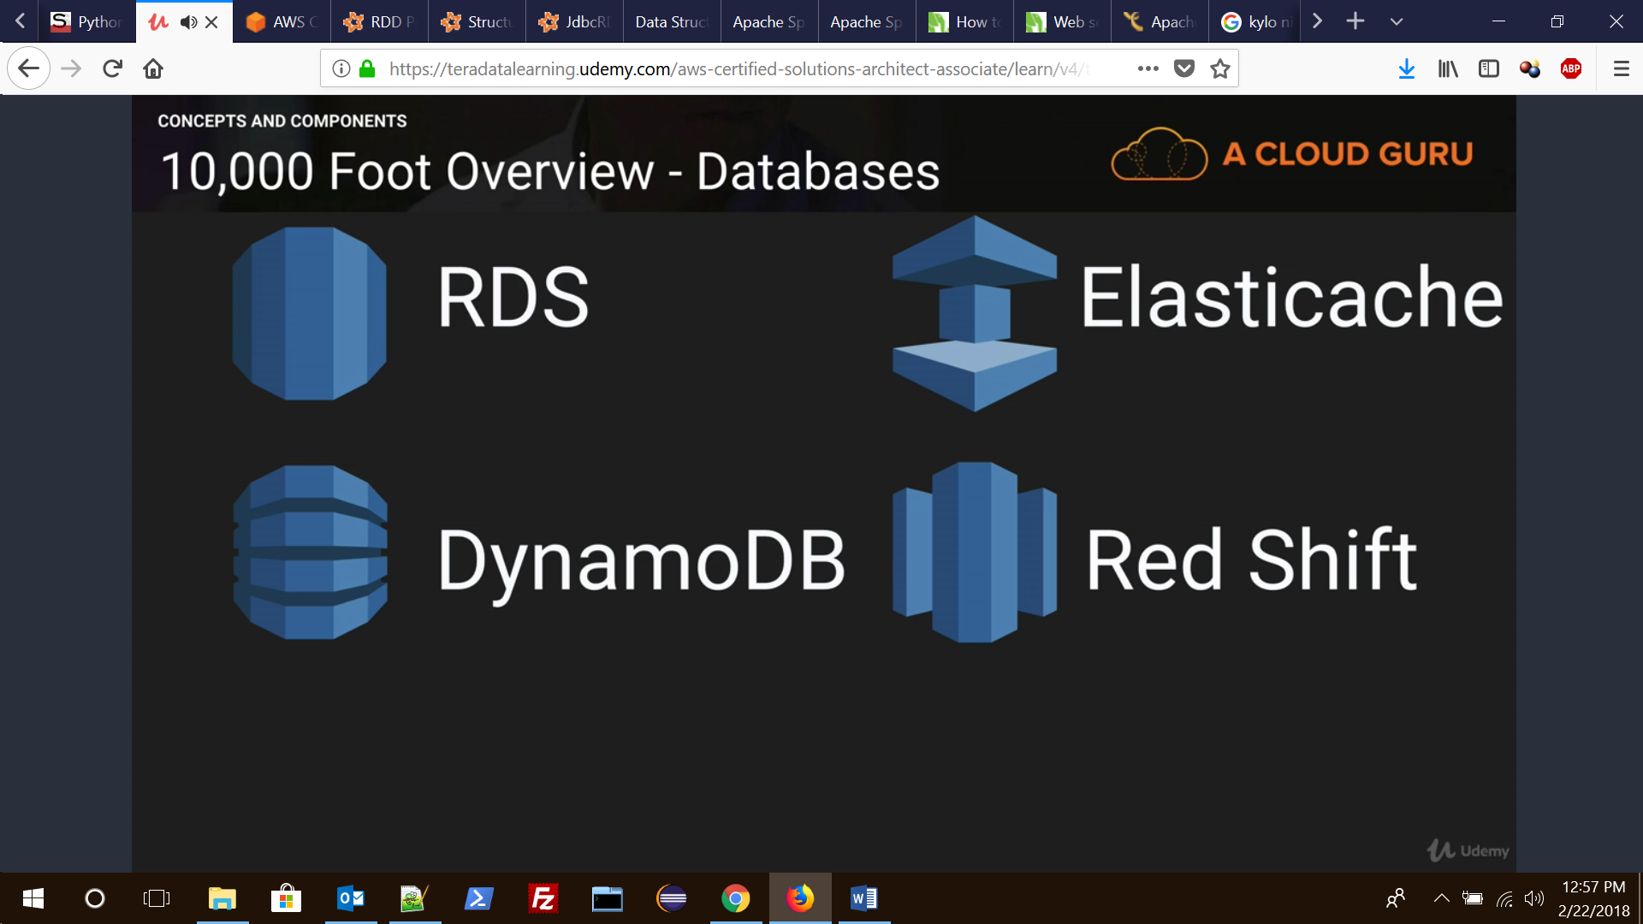

### 15. Amazon RDS (Relational Database Service)

It has two key features:

Multi AZ: For Disaster recovery, endpoint gets automatically updated to failover instance.

Read Replica: For performance, write to one/master instance while read from any replica and improving read speed. Used for scaling not for DR recovery.

**RDS is not serverless exception being Aurora DB.**

There are two types of backup:

Automated Backups: done during scheduled maintenance window.

Database Snapshots: It is done manually, and it is stored even after deleting the RDS.

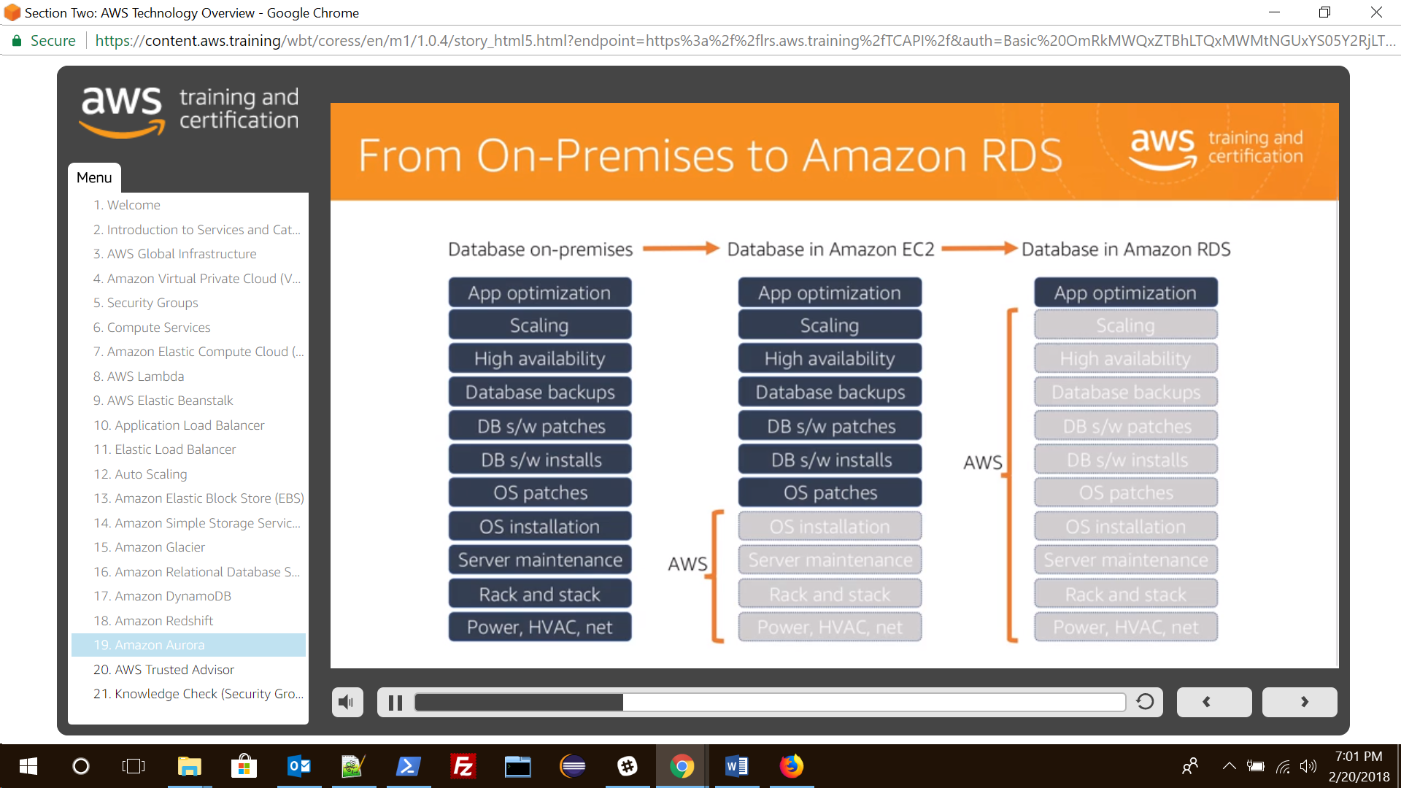

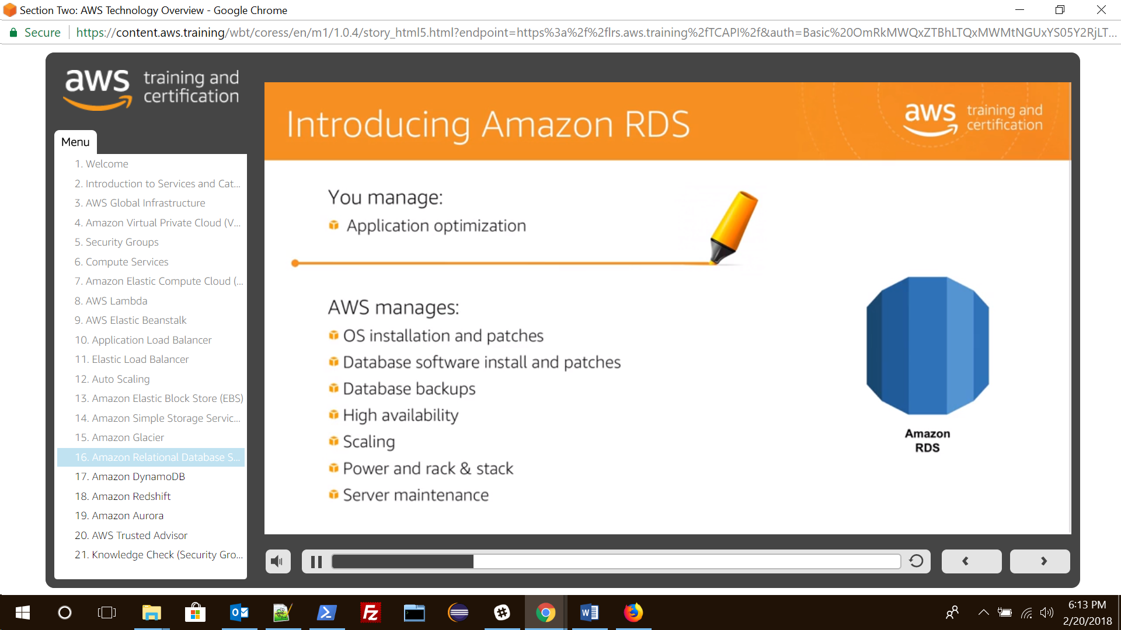

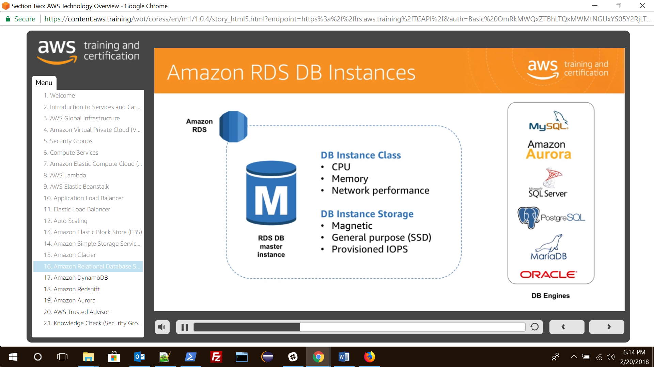

### 16. Amazon Dynamo (NoSQL)

It supports both document and key-value data models

**Types of Dynamo DB read:**

* **Eventual Consistent Reads**: consistency across all copies of data is usually reached within a second. Repeating a read after a short time should return the updated data. This gives the best-read Performance and is the default option.
* **Strongly Consistent Read**: It returns a result that reflects all the writes that received a successful response prior to the read.

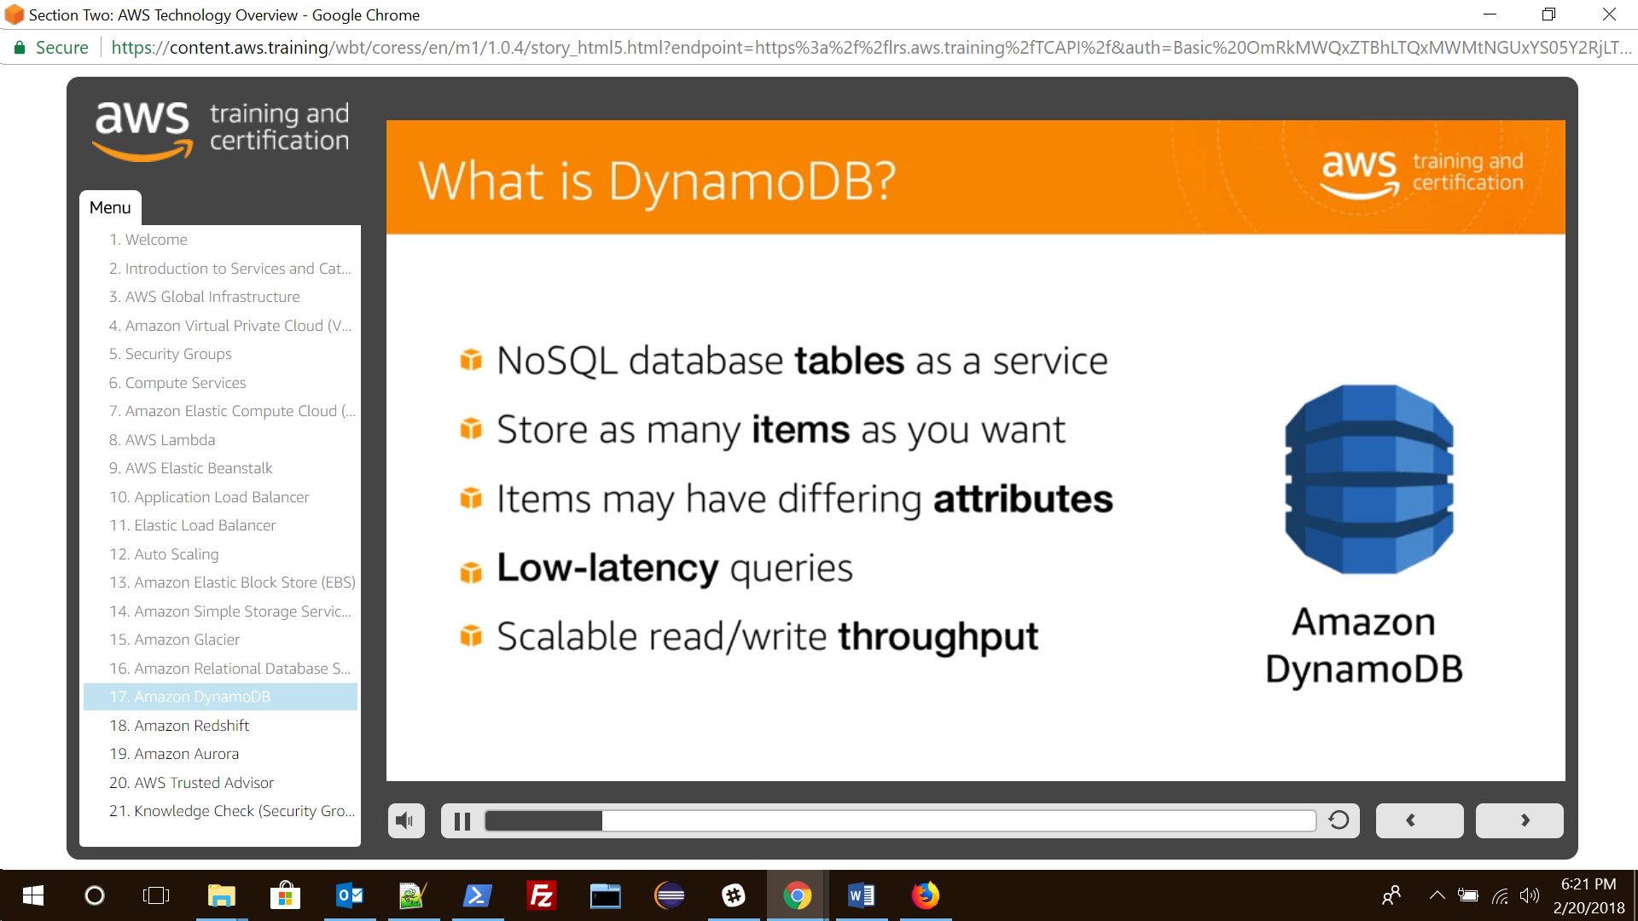

### 17.Amazon RedShift (EDW)

Its an MPP system for OLAP

It currently available only in 1 AZ however snapshots can be restored in new AZs.

Its pricing is based on compute nodes hours ( total number of hours you run across all your compute nodes for the billing period)

You are not charged for leader node hours.

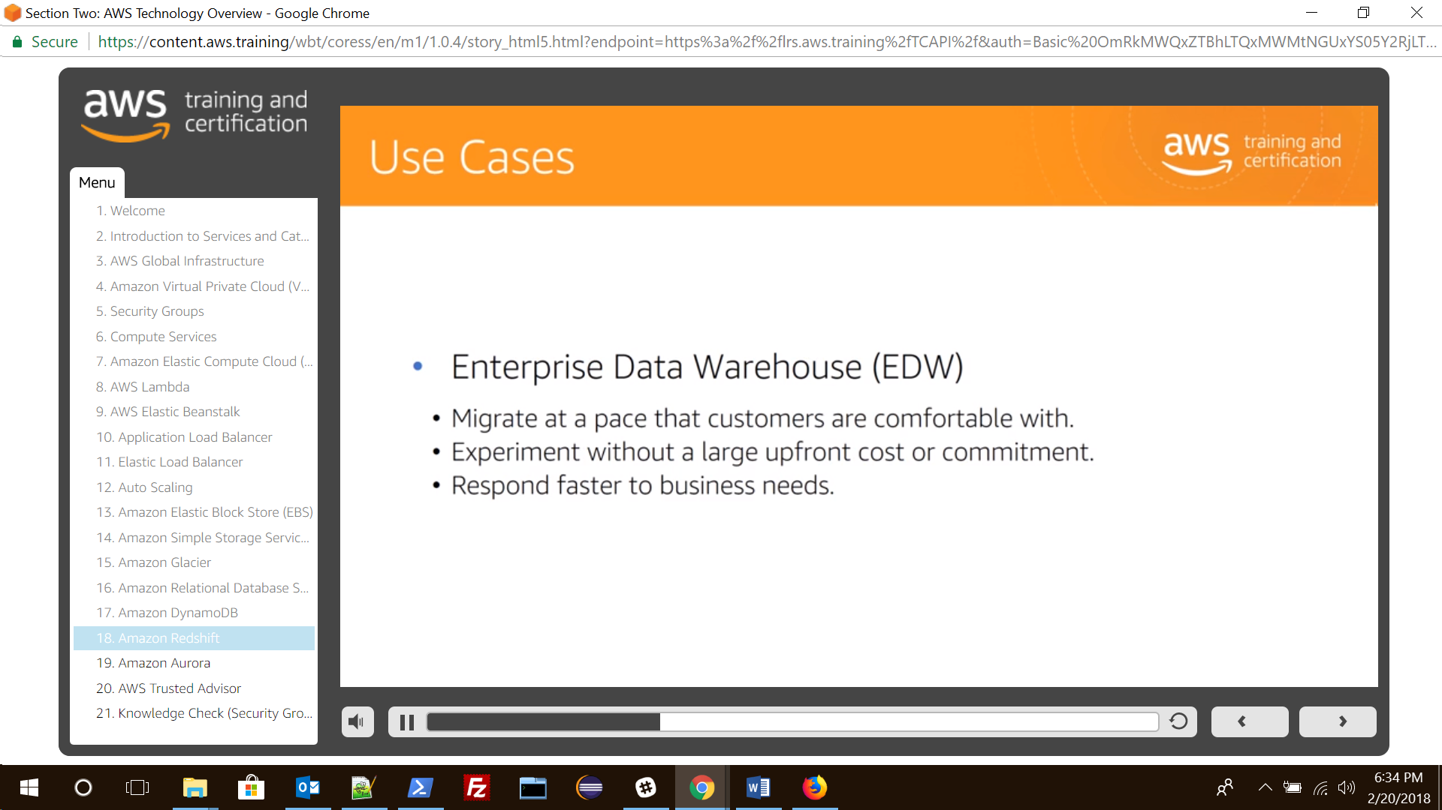

### 18.Amazon Aurora (HA-RDS)

It is HA RDS DB from Amazon

It maintains 2 copies of your data in each availability zone with minimum 3 availability zones i.e. 6 copies of data.

Two types of replicas are available i.e. Aurora Replica and MySQL replicas.

Automated failover is only available with Aurora Replicas.

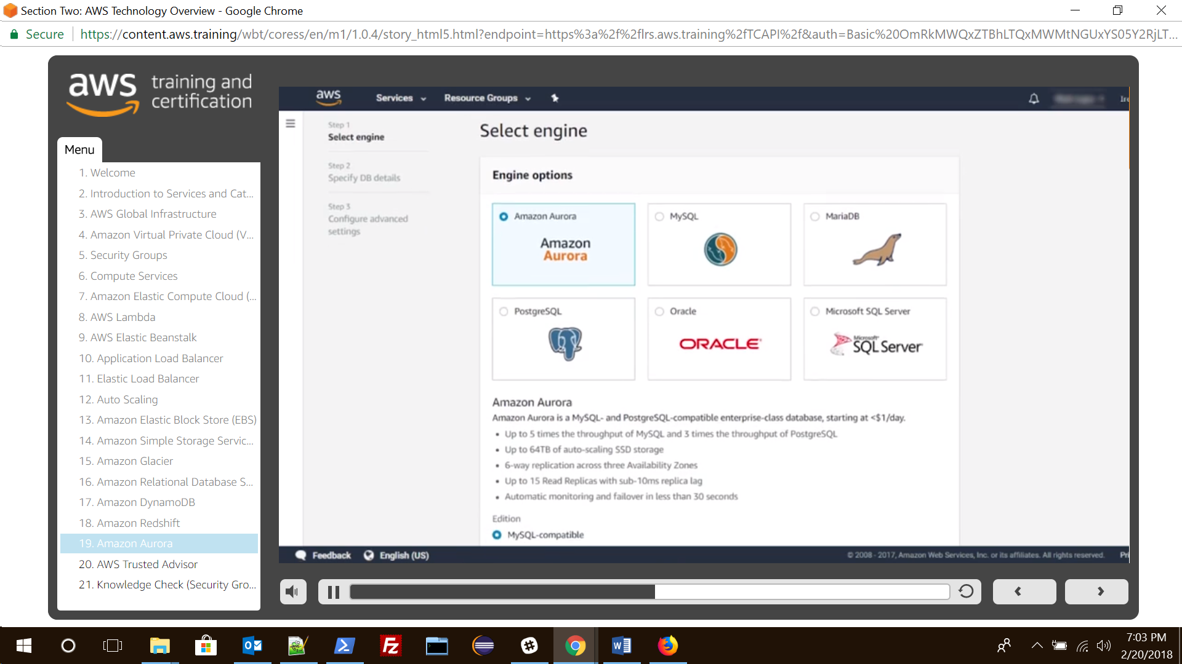

### 19. ElastiCache:

ElastiCache is an in-memory cache in the cloud. It supports two open-source in-memory caching engines:

* Redis
* Memcached