Route 53

DNS port is on 53 hence the name Route 53.

Domain Names:

The last word in a domain represents “top level domain”. e.g. In Google.com and google.co.in, “com” and “in” is Top Level Domains while “co” is second level domain and is optional.

Common DNS Types:

* SOA Records: Start of Authority Record
* NS Records: Name server Record
* A Records: A Records stands for Address Records, it translates the name of the domain to an IP address. For Eg : Google.com might get translated to http://123.456.789:80
* CName: A Canonical Name (CName) is used to resolve one domain name to another. For e.g. If a mobile site is hosted at <http://m.google.com> and we want <http://mobile.google.com> to resolve to same address we use CNames.
* Alias Records:
* MX Records:
* PTR Records: Reverse of A Record.

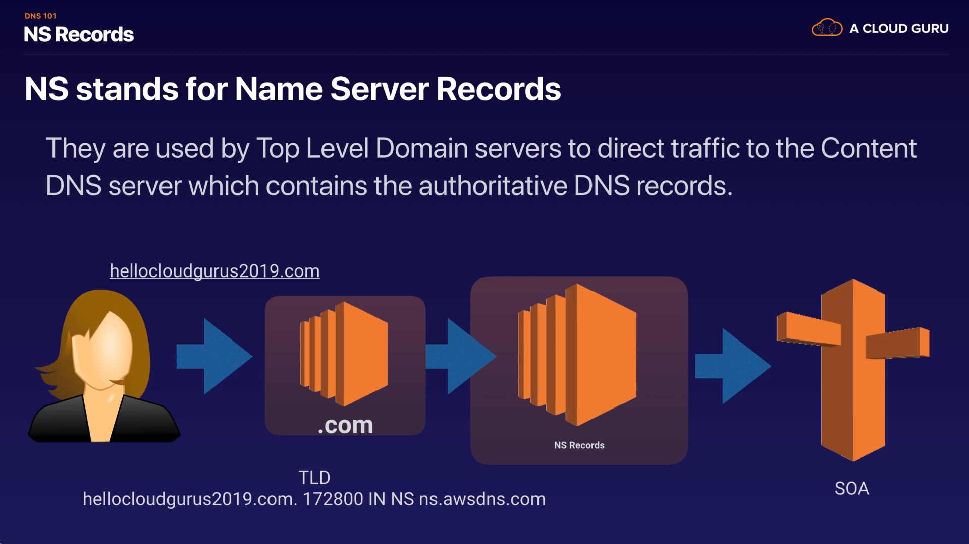

After purchasing the Domain name, **we get NS (Name Server) and SOA (Start of Authority record) records by default.**

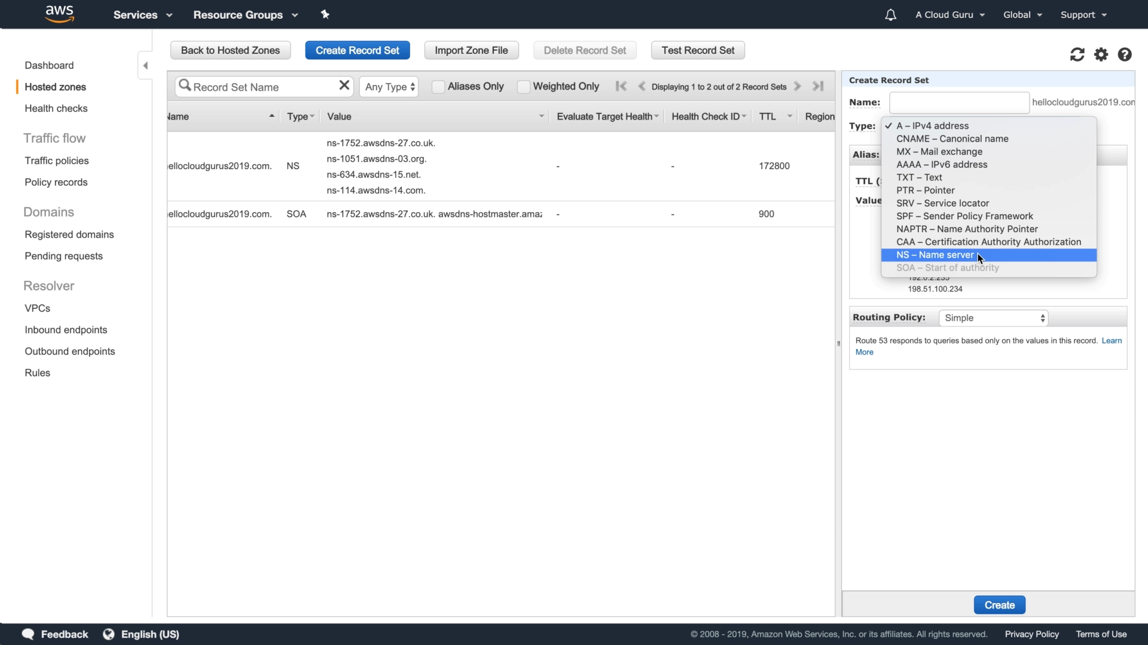

Now we need to **create a “A record” to map the Domain name with IP addresses** of the machine on which Webservers are running.

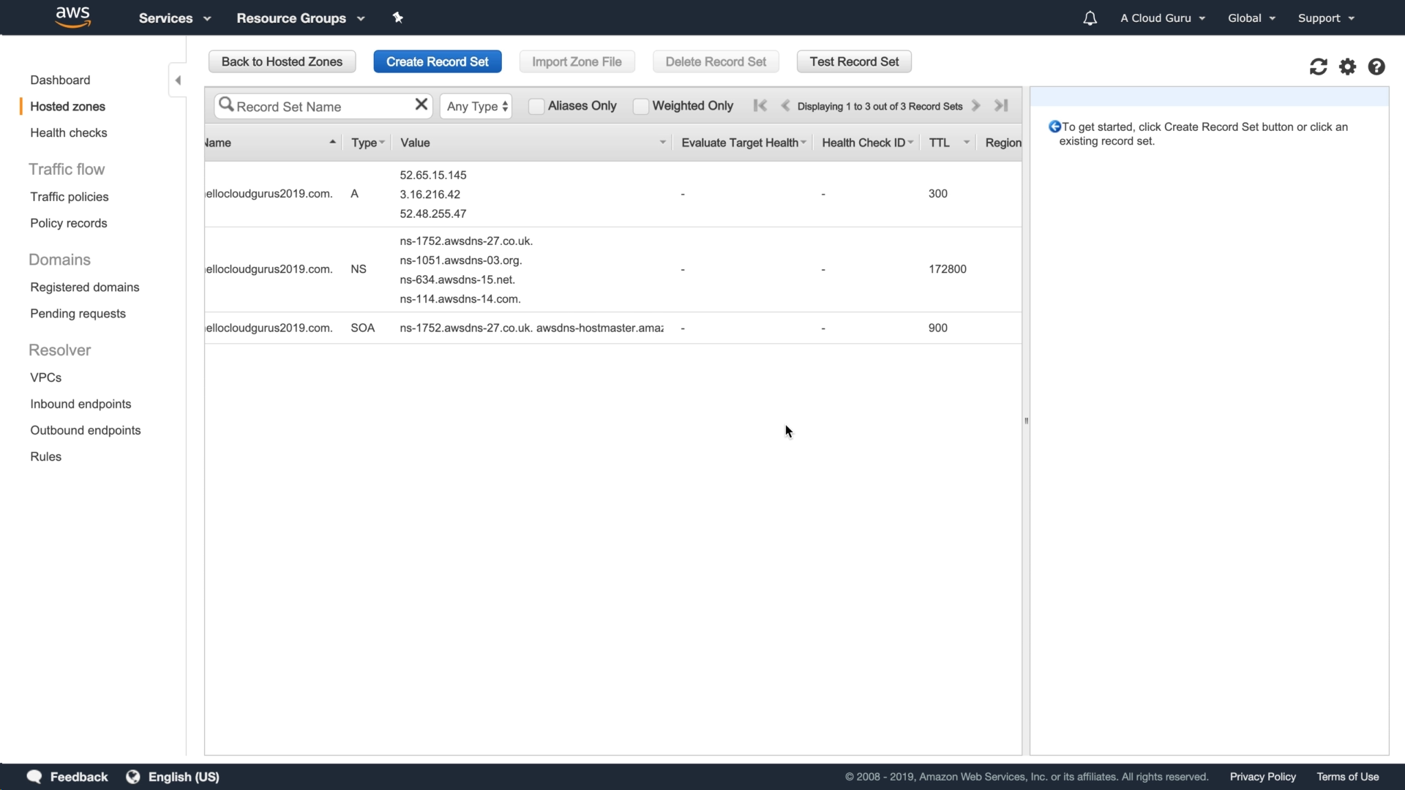

Routing Policies:

* Simple Routing: One record is mapped with multiple IPs and randomly IPs will be returned upon request. Can’t have health checks in this routing policy.
* Weighted Routing: Allows you to split traffic based on different weights assigned.
* Latency-based Routing: It allows you to route the traffic based on the lowest network latency for your end user (i.e. which region will give the fastest response time)
* Failover Routing: They are used when you want to create an active/passive set up. Depending on the heath check primary and secondary systems will be hit .
* Geolocation Routing: It lets one choose where your traffic will be sent based on the geographic location of your users (i.e. the location from which DNS queries originate).
* Geoproximity Routing (Traffic Flow Only):
* Multivalue Answer Routing: This is similar to simple rouing however it allows you to health check on each record set.

Note:

ELB do not have pre-defined IPv4 addresses, you resolve to them using a DNS name.