Contents

Overview 2

Cluster Architecture 2

Containers 2

Workloads 3

Services, Load Balancing, and Networking 3

Storage 3

Configuration 3

Security 3

Policies 4

Scheduling and Eviction 4

Cluster Administration 4

Extending Kubernetes 4

# [Overview](https://kubernetes.io/docs/concepts/overview/)

How do you explain Kubernetes and orchestration in plain terms that people can at least begin to understand? And where did this unusual name come from? [The agreed-upon origin](https://twitter.com/gregde/status/487456224368410624) is from the Greek, meaning “helmsman” or “sailing master.”

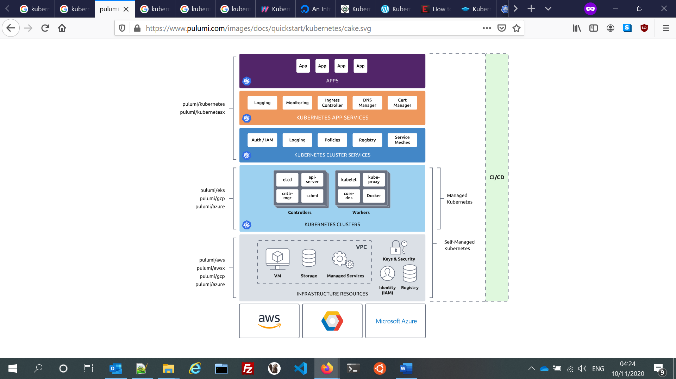

Img : <https://www.pulumi.com/docs/intro/cloud-providers/kubernetes/>

# [Cluster Architecture](https://kubernetes.io/docs/concepts/architecture/)

The architectural concepts behind Kubernetes.

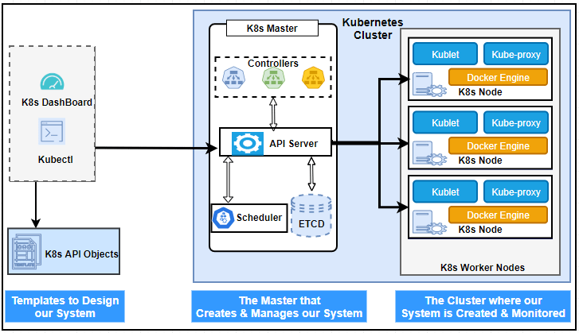

Img : <https://spectrumstutz.com/k8s/kubernetes-architecture/>

# [Containers](https://kubernetes.io/docs/concepts/containers/)

Technology for packaging an application along with its runtime dependencies.

# [Workloads](https://kubernetes.io/docs/concepts/workloads/)

Understand Pods, the smallest deployable compute object in Kubernetes, and the higher-level abstractions that help you to run them.

# [Services, Load Balancing, and Networking](https://kubernetes.io/docs/concepts/services-networking/)

Concepts and resources behind networking in Kubernetes.

# [Storage](https://kubernetes.io/docs/concepts/storage/)

Ways to provide both long-term and temporary storage to Pods in your cluster.

# [Configuration](https://kubernetes.io/docs/concepts/configuration/)

Resources that Kubernetes provides for configuring Pods.

# [Security](https://kubernetes.io/docs/concepts/security/)

Concepts for keeping your cloud-native workload secure.

# [Policies](https://kubernetes.io/docs/concepts/policy/)

Policies you can configure that apply to groups of resources.

# [Scheduling and Eviction](https://kubernetes.io/docs/concepts/scheduling-eviction/)

In Kubernetes, scheduling refers to making sure that Pods are matched to Nodes so that the kubelet can run them. Eviction is the process of proactively failing one or more Pods on resource-starved Nodes.

# [Cluster Administration](https://kubernetes.io/docs/concepts/cluster-administration/)

Lower-level detail relevant to creating or administering a Kubernetes cluster.

# [Extending Kubernetes](https://kubernetes.io/docs/concepts/extend-kubernetes/)

Different ways to change the behavior of your Kubernetes cluster.