Contents

ARM 1

ARM Syntax 1

CLI 2

Cli structure 2

Finding commands 2

Globally available arguments 2

Interactive mode 3

Power Shell 3

PS Verbs: 3

New 3

Add 3

Disable 3

Get 3

Set 4

Invoke 4

Remove 4

Similar Verbs for Different Actions 4

Common Commands 4

Get-Help 4

Get-Command 4

# ARM

## ARM Syntax

<https://docs.microsoft.com/en-us/azure/azure-resource-manager/templates/template-syntax>

# CLI

<https://docs.microsoft.com/en-us/cli/azure/get-started-with-azure-cli>

## Cli structure

**az <group> <subgroups> <commands> <parameters> <global Options>**

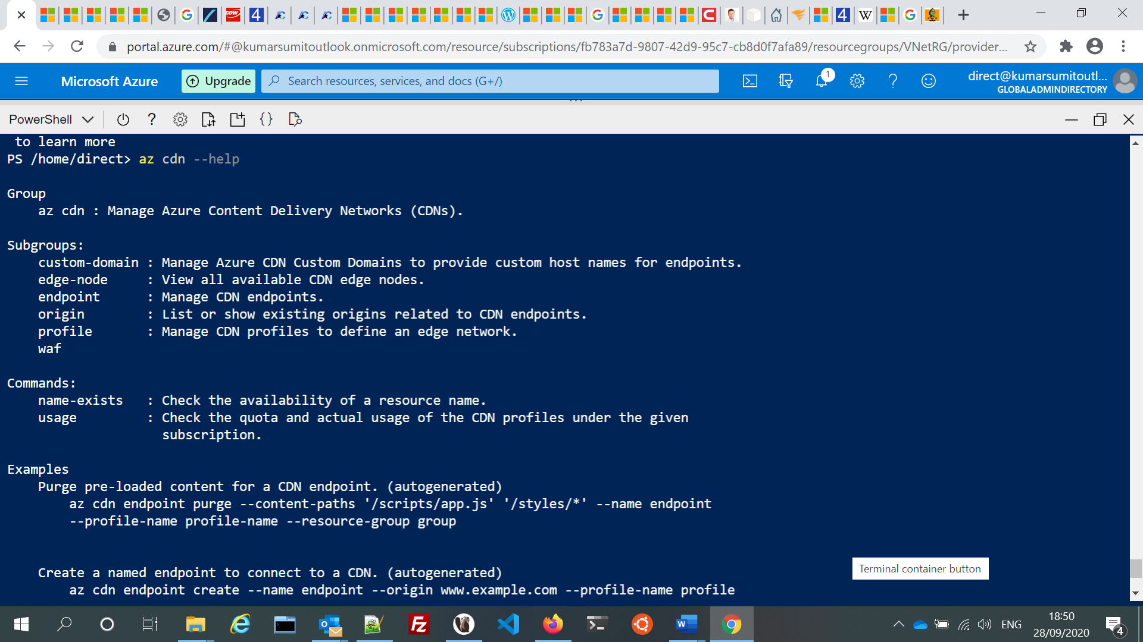

## Finding commands

To search for commands, use [az find](https://docs.microsoft.com/en-us/cli/azure/reference-index" \l "az-find).

az find secret

Use the --help argument to get a complete list of commands and subgroups of a group.

az network nsg –help

## Globally available arguments

* --help prints CLI reference information about commands and their arguments and lists available subgroups and commands.
* --output changes the output format. The available output formats are json, jsonc (colorized JSON), tsv (Tab-Separated Values), table (human-readable ASCII tables), and yaml.

## Interactive mode

The CLI offers an interactive mode that automatically displays help information and makes it easier to select subcommands.

az interactive

# Power Shell

<https://jussiroine.com/2019/03/mastering-azure-cli/>

<https://4sysops.com/archives/getting-started-with-azure-powershell/>

PowerShell has following types of commands:

* cmdlets
* aliases
* functions
* filters
* scripts
* applications

## PS Verbs:

<https://docs.microsoft.com/en-us/powershell/scripting/developer/cmdlet/approved-verbs-for-windows-powershell-commands>

### New

Creates a resource. (The Set verb can also be used when creating a resource that includes data, such as the Set-Variable cmdlet.)

### Add

Adds a resource to a container, or attaches an item to another item. For example, the Add-Content cmdlet adds content to a file. This verb is paired with Remove.

### Disable

Configures a resource to an unavailable or inactive state. For example, the Disable-PSBreakpoint cmdlet makes a breakpoint inactive. This verb is paired with Enable.

### Get

Specifies an action that retrieves a resource. This verb is paired with Set.

### Set

Replaces data on an existing resource or creates a resource that contains some data. For example, the Set-Date cmdlet changes the system time on the local computer. (The New verb can also be used to create a resource.) This verb is paired with Get

### Invoke

Performs an action, such as running a command or a method.

### Remove

Deletes a resource from a container. For example, the Remove-Variable cmdlet deletes a variable and its value. This verb is paired with Add.

## Similar Verbs for Different Actions

**New vs. Set**

The New verb is used to create a new resource. The Set verb is used to modify an existing resource, optionally creating the resource if it does not exist, such as the Set-Variable cmdlet.

**Find vs. Search**

The Find verb is used to look for an object. The Search verb is used to create a reference to a resource in a container.

**Get vs. Read**

The Get verb is used to retrieve a resource, such as a file. The Read verb is used to get information from a source, such as a file.

**Invoke vs. Start**

The Invoke verb is used to perform an operation that is generally a synchronous operation, such as running a command. The Start verb is used to begin an operation that is generally an asynchronous operation, such as starting a process.

**Ping vs. Test**

Use the Test verb.

## Common Commands

### Get-Help

<https://docs.microsoft.com/en-us/powershell/module/microsoft.powershell.core/get-help>

PS Alias : help, man

### Get-Command

<https://docs.microsoft.com/en-us/powershell/module/microsoft.powershell.core/get-command>

PS Alias