Contents

Design a solution for backup and recovery 2

Azure SQL Backup 2

Recovering Deleted DB 3

Automatic Failover 5

Design for high availability 5

# Design a solution for backup and recovery

* recommend a recovery solution for Azure hybrid and on-premises workloads that meets recovery objectives (RTO, RLO, RPO)
* design and Azure Site Recovery solution
  + recommend a site recovery replication policy
  + recommend a solution for site recovery capacity
  + recommend a solution for site failover and failback (planned/unplanned)
  + recommend a solution for the site recovery network
* recommend a solution for recovery in different regions
* recommend a solution for Azure Backup management
* design a solution for data archiving and retention
  + recommend storage types and methodology for data archiving
  + identify business compliance requirements for data archiving
  + identify requirements for data archiving
  + identify SLA(s) for data archiving
  + recommend a data retention policy

## Azure Site Recovery

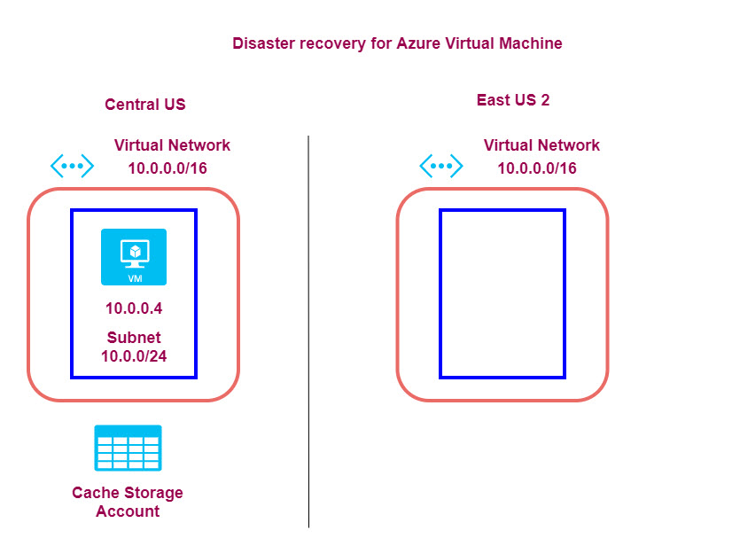

When you enable disaster recovery for an Azure virtual machine, the following takes place

* A **duplicate virtual network** along with the required subnets are created in **a new region**. Here the virtual network and subnets are being created in the East US 2 region.
* A **cache storage account** is created in the **source region**. All changes to the source virtual machine are first written to the cache storage and then replicated to the target storage.
* The replication of data from the source virtual machine is based on a **replication policy**. The default replication policy has the following definitions
  1. Keep recovery points for a duration of 24 hours
  2. Create an App-consistent snapshot every 4 hours (Configurable to every hour)
* There is a crash consistent snapshot taken every 5 minutes
* Recovery points are then created from every snapshot
* Crash consistent snapshots

1. This consists of data on the disk and not the data in memory.
2. This does not guarantee data consistency for the operating system or for the applications on the virtual machine

* App consistent snapshots - This contains all data from the crash consistent snapshot + data in memory + transactions in progress

When you perform a failover, you decide on the restore point to use. The virtual machine would then be created in the destination region.

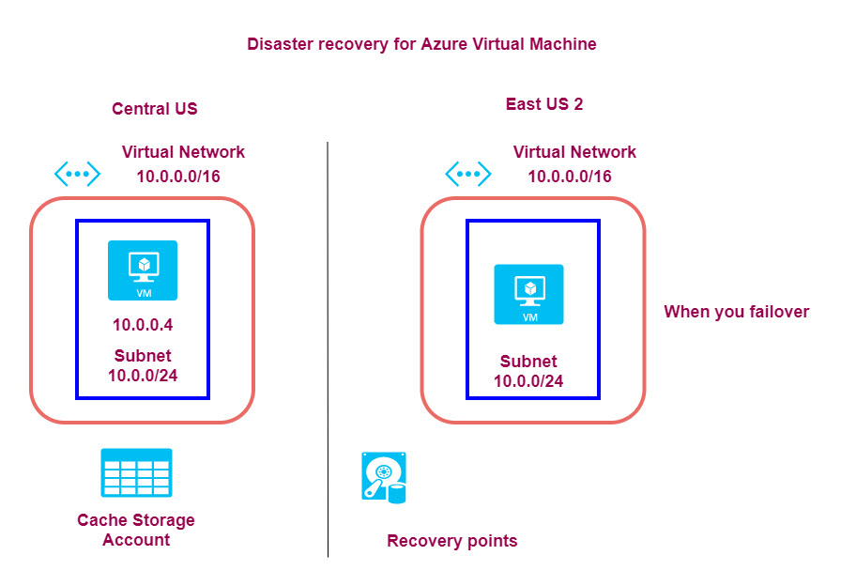

## Azure SQL Backup

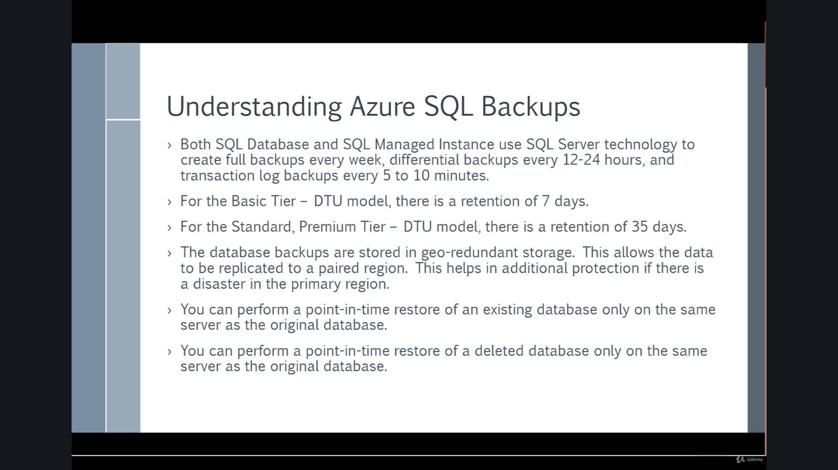

Point in Time restore is for 7 days

While long term backup can be configured for more duration.

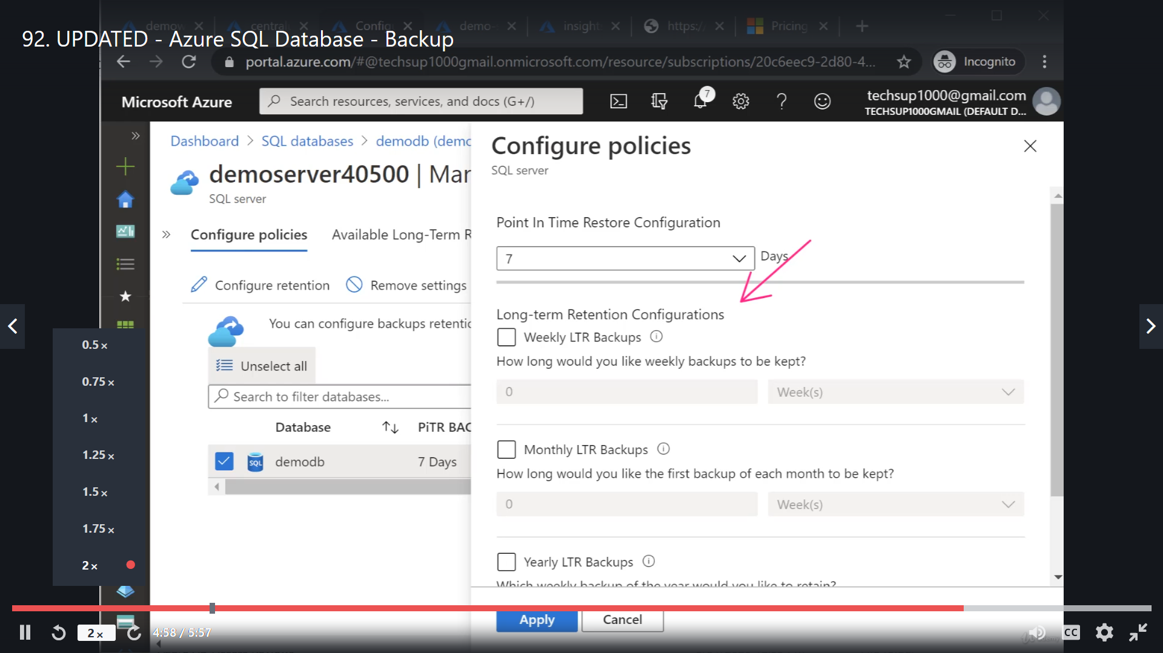

### Recovering Deleted DB

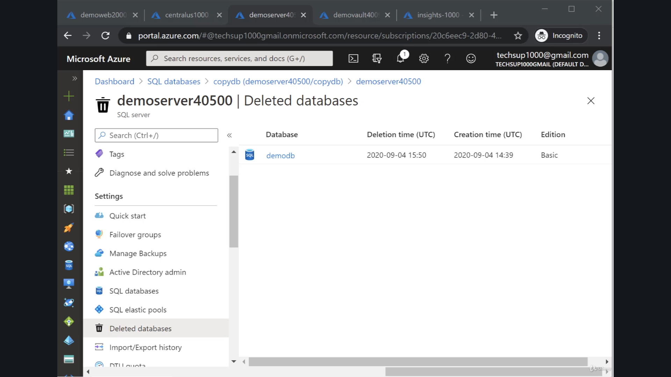

Geo Replication

The replicated DB is has read only permission.

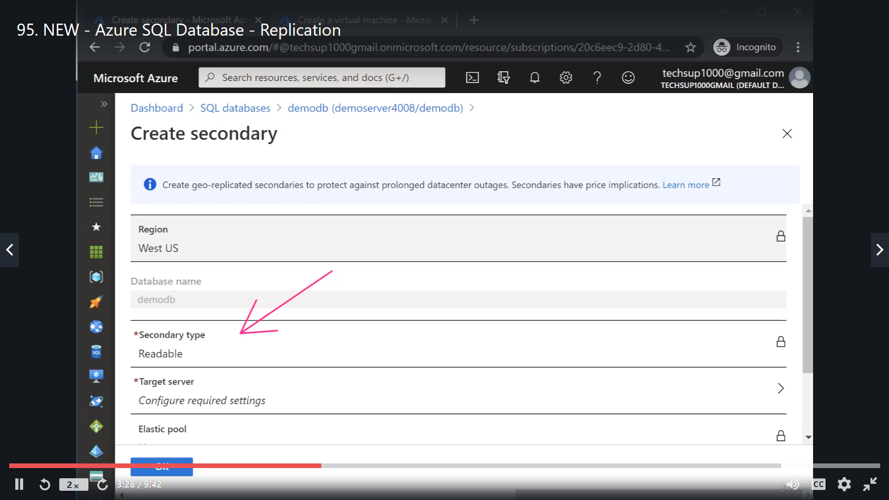

The secondary DB can be **Forced Failover** or **Stop Replication**

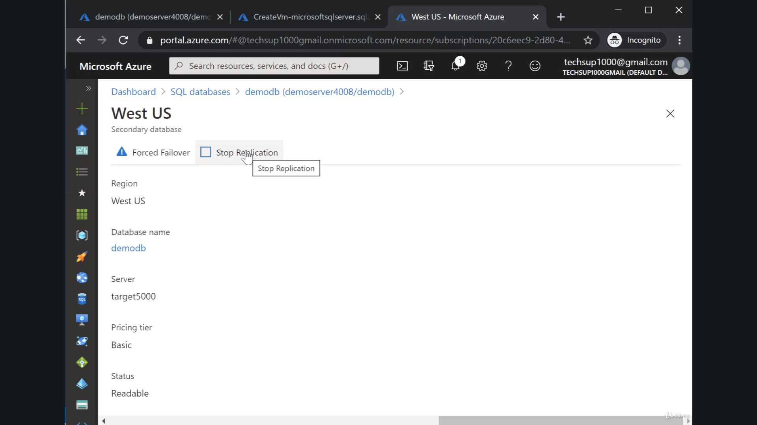

### Automatic Failover

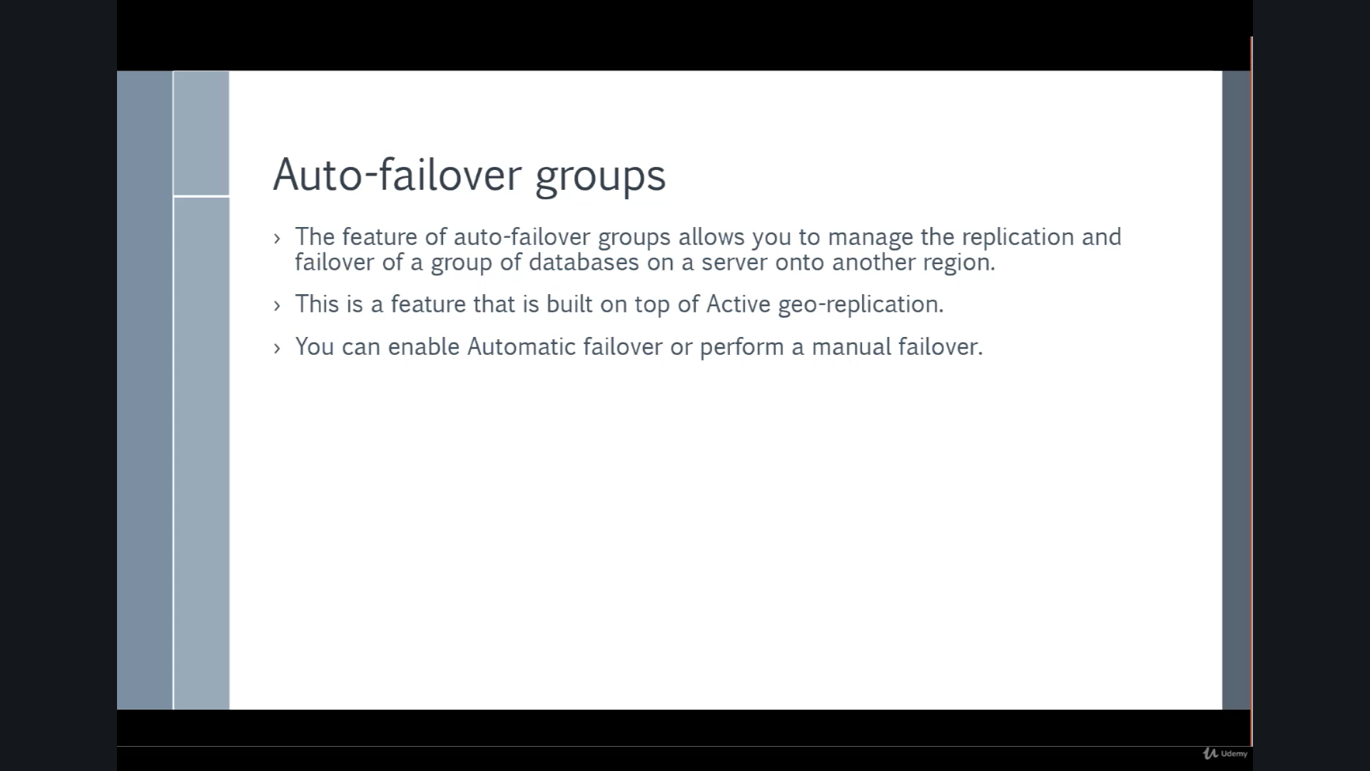

# Design for high availability

* recommend a solution for application and workload redundancy, including compute, database, and storage
* recommend a solution for autoscaling
* identify resources that require high availability
* identify storage types for high availability
* recommend a solution for geo-redundancy of workloads