Contents

Design a solution for databases 2

Always Encrypted 2

Dynamic Data Masking 3

Transparent Data Encryption 4

Design data integration 5

Azure Data Factory 5

Azure Data Bricks 5

Azure Data Lake 5

Azure Synapse Analytics 6

Select an appropriate storage account 6

# Design a solution for databases

* select an appropriate data platform based on requirements
* recommend database service tier sizing
* recommend a solution for database scalability
* recommend a solution for encrypting data at rest, data in transmission, and data in use

## Cosmos DB Migration

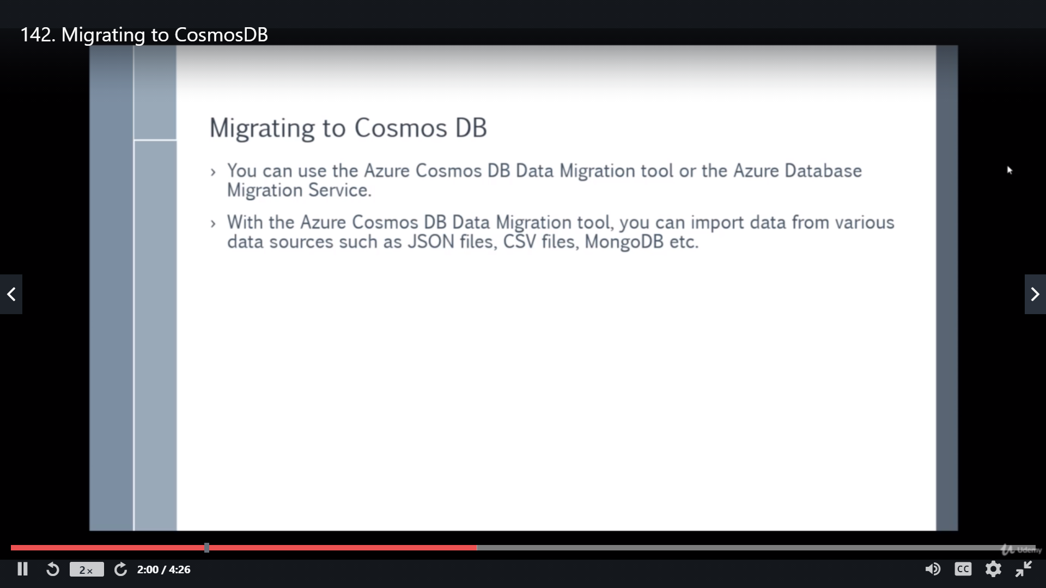

## Always Encrypted

## Dynamic Data Masking

## Transparent Data Encryption

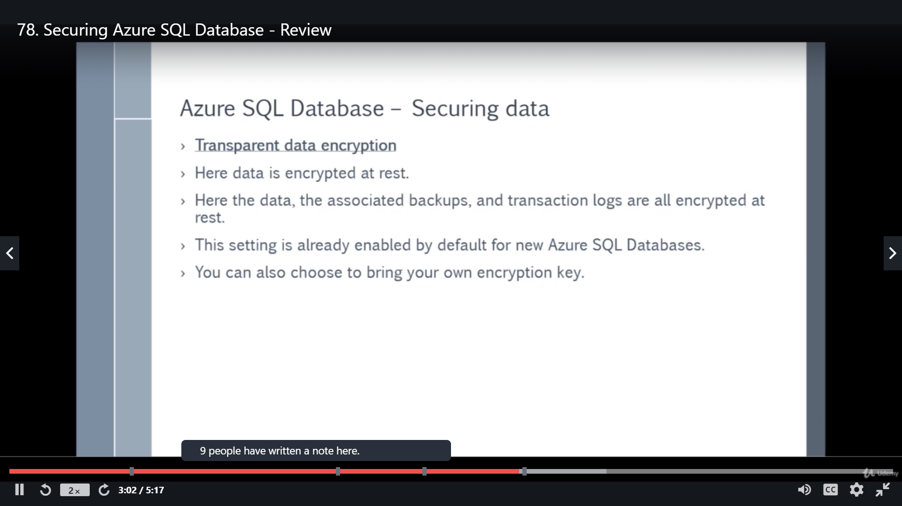

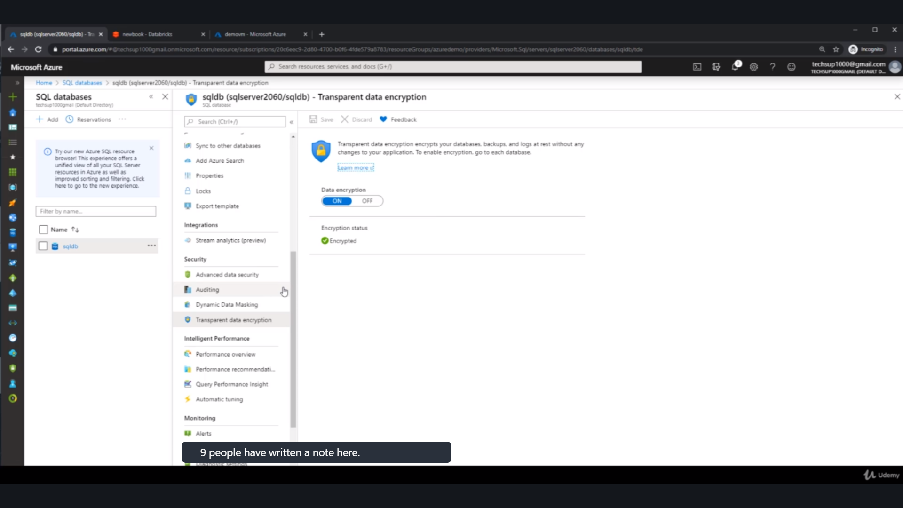

# Design data integration

* recommend a data flow to meet business requirements
* recommend a solution for data integration, including Azure Data Factory, Azure Data Bricks, Azure Data Lake, Azure Synapse Analytics

## Azure Data Factory

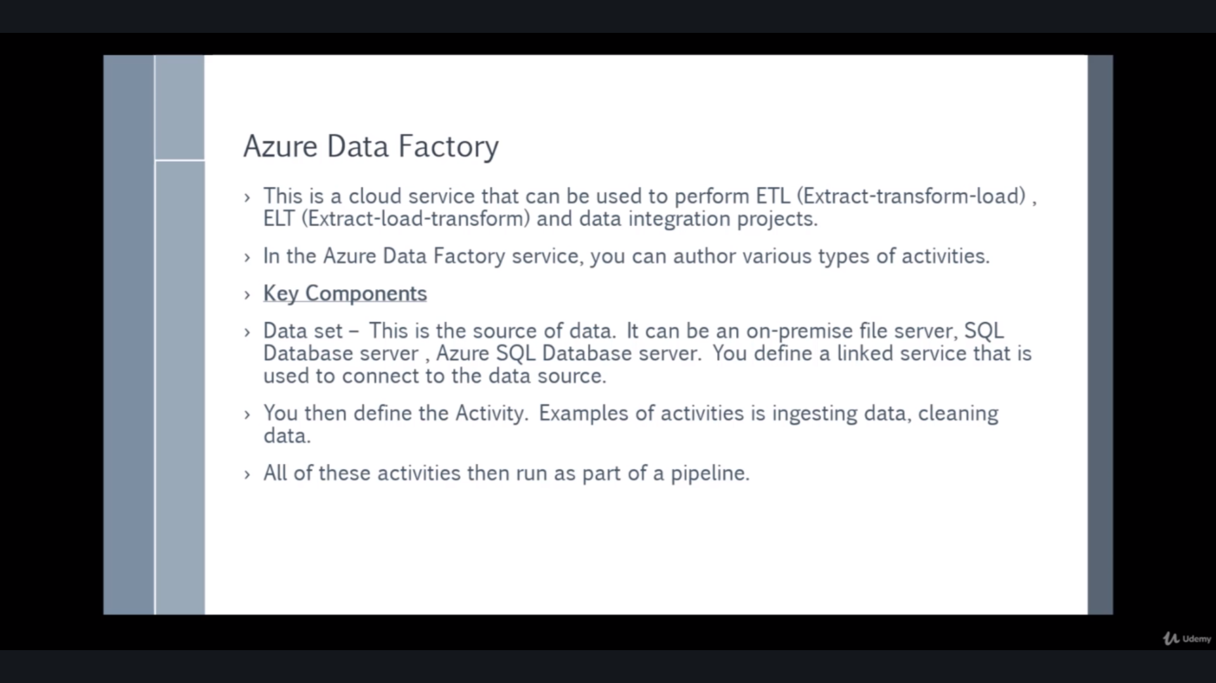

## Azure Data Bricks

## Azure Data Lake

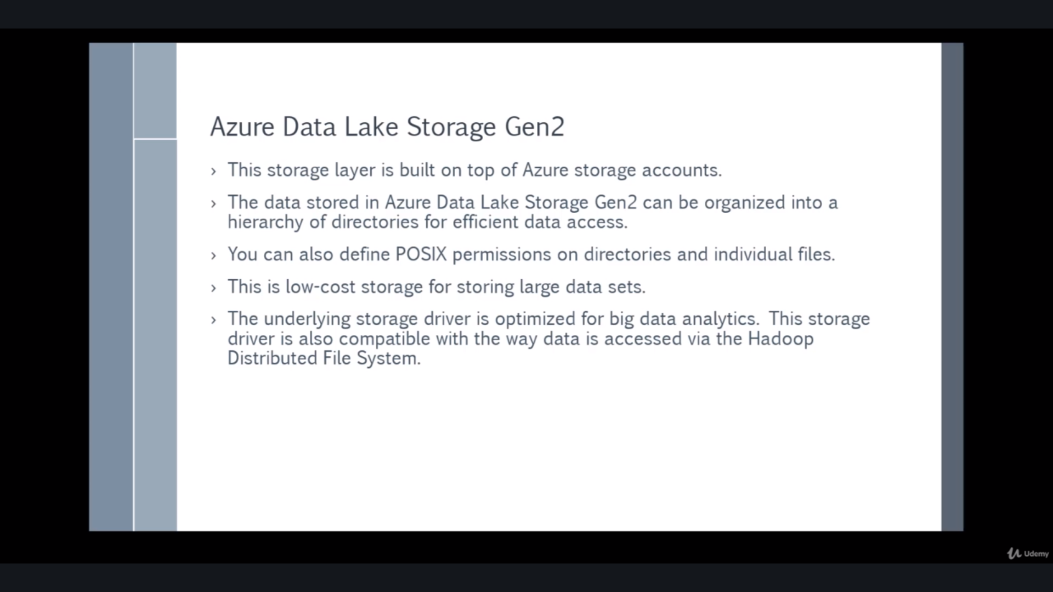

While creating a storage account enable Azure Data lake storage

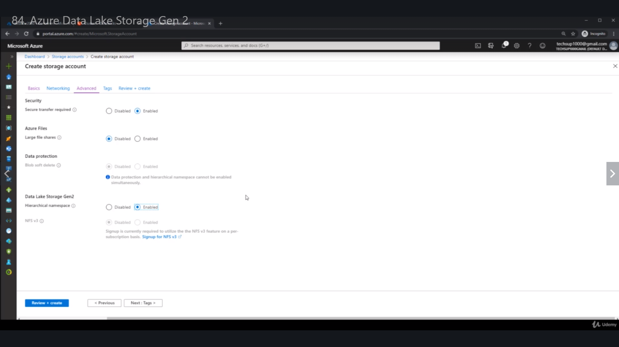

## Azure Synapse Analytics

# Select an appropriate storage account

* choose between storage tiers
* recommend a storage access solution
* recommend storage management tools