**Task 04 – Conditional GAN (cGAN) for Image-to-Image Translation**

**📌 Project Overview**

This project is part of my internship at **Prodigy Infotech**.  
In this task, I implemented a **Conditional Generative Adversarial Network (cGAN)** using the **Pix2Pix architecture** to perform **image-to-image translation** on the **CMP Facades dataset**.

The goal was to train a model that can **translate edge maps of buildings into realistic facade images**.

**📂 Dataset**

* **CMP Facades Dataset** – provided by Czech Technical University.
* Contains **paired images** of building facades and their edge maps.
* Used for **supervised training** of Pix2Pix.

**🛠️ Methodology**

* **Framework:** PyTorch
* **Generator:** U-Net architecture with skip connections
* **Discriminator:** PatchGAN (classifies image patches as real/fake)
* **Loss Functions:**
  + Adversarial Loss
  + L1 Reconstruction Loss
* **Optimizer:** Adam (lr = 0.0002, β1 = 0.5)
* **Training:** 20 epochs on GPU (Google Colab CUDA support)

**🚀 Results**

The model showed **progressive improvement** in generating realistic facades from edge maps.

**Sample Outputs**

* **Epoch 1:** Blurry, unclear structures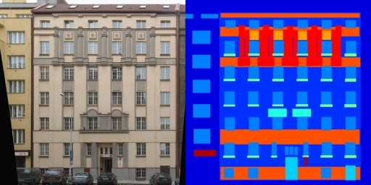
* **Epoch 5:** More details visible, but artifacts remain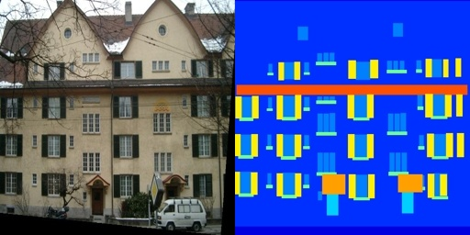
* **Epoch 20:** Clear and realistic building facades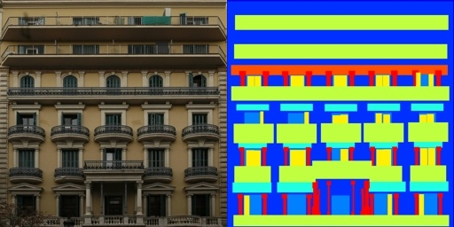

**📌 Applications**

* Architectural design automation
* Urban planning visualization
* Satellite imagery enhancement
* Artistic sketch-to-photo generation

**📖 References**

1. Goodfellow, I., et al. (2014). *Generative Adversarial Networks.*
2. Isola, P., Zhu, J., Zhou, T., & Efros, A. A. (2017). *Image-to-Image Translation with Conditional Adversarial Networks (Pix2Pix).*
3. CMP Facades Dataset – Czech Technical University.

✍️ **Author:** Sunny Kumar  
📚 **Course:** B.Tech CSE, 2nd Year  
🎯 **Internship:** Prodigy Infotech – Task 04