Components
AppCard – One Component One Responsibility.
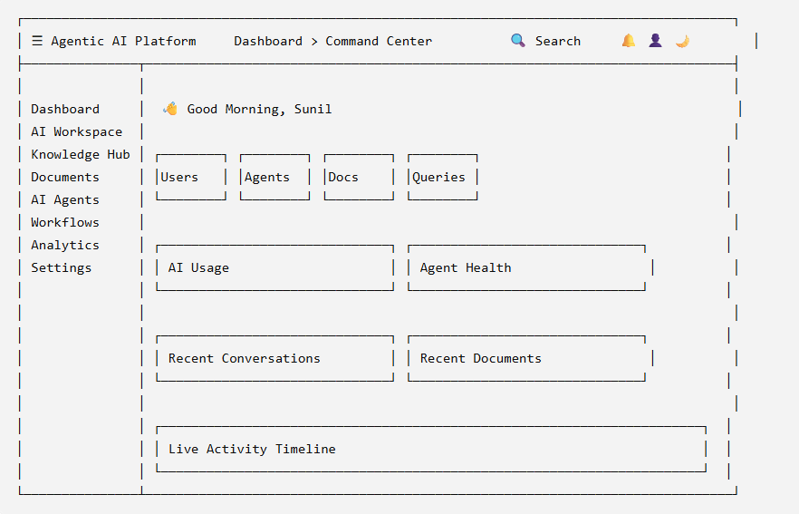

Designing the Enterprise Command Center in Figma
- Widget sizes
- Grid layout
- Responsive breakpoints
- Colors
- Typography
- Spacing
- Interactions
- Loading states
- Empty states
- Error states

Color Palette
Purpose | Color
Background | #0F172A
Surface | #1E293B
Primary | #3B82F6
Secondary | #8B5CF6
Success | #10B981
Warning | #F59E0B
Error | #EF4444
Text Primary | #F8FAFC
Text Secondary | #94A3B8

Typography
Element | Size
Dashboard Title | 32px
Widget Title | 18px
KPI Number | 36px
Section Header | 22px
Body | 14–16px

Spacing System
Instead of arbitrary values:
- Base unit: 8px
- Card padding: 24px
- Grid gap: 24px
- Section spacing: 32px
- Border radius: 12px
This keeps the interface visually consistent.

Development Roadmap

Phase 1 – Foundation
- Design System
- Theme
- Layout
- Navigation
- Reusable UI Components

Phase 2 – Enterprise Command Center
- Welcome Banner
- KPI Cards
- Charts
- Agent Health
- Recent Activity
- Timeline

Phase 3 – AI Workspace
- Chat Interface
- Streaming Responses
- Prompt History
- Conversation Management

Phase 4 – Knowledge Hub
- Document Management
- Collections
- Search
- Vector Index Status

Phase 5 – AI Agents
- Agent Registry
- Agent Monitoring
- Workflow Visualization

Phase 6 – Analytics
- Token Usage
- Cost Analysis
- Latency
- Success Rates
- System Health

Phase 7 – Administration
- Users
- Roles
- Permissions
- Audit Logs

Phase 8 – Production Readiness
- Notifications
- Observability
- Monitoring
- Docker
- Kubernetes
- CI/CD
- Deployment

