OOP PRACTICAL 12
Library Management System using C++
Student Name: Ramesh Kumar URN: E25B001202

1. Aim
To develop a console-based Library Management System using C++ classes, STL containers, CSV file storage, and exception handling.

2. Problem Statement
Create an application to add, search, list, issue, and return books. Store book ID, title, author, and availability in a file. Load saved records when the program starts and handle invalid inputs or operations safely.

3. Objectives
- Use classes and objects to organise book and library data.
- Use std::map and std::vector from the STL.
- Save and load book records using a CSV file.
- Use custom exceptions for invalid data, duplicate IDs, unknown IDs, and unavailable books.
- Test valid and invalid inputs.

4. Features
- Add a new book.
- Search for a book by ID.
- List all books.
- Issue an available book.
- Return an issued book.
- Persist data in books.csv.

5. Classes and Data Structures
Book stores id, title, author, and availability. Library manages records through std::map<int, Book> and provides the book operations. Custom exception classes inherit from LibraryException, which inherits from std::runtime_error.

6. UML Class Diagram
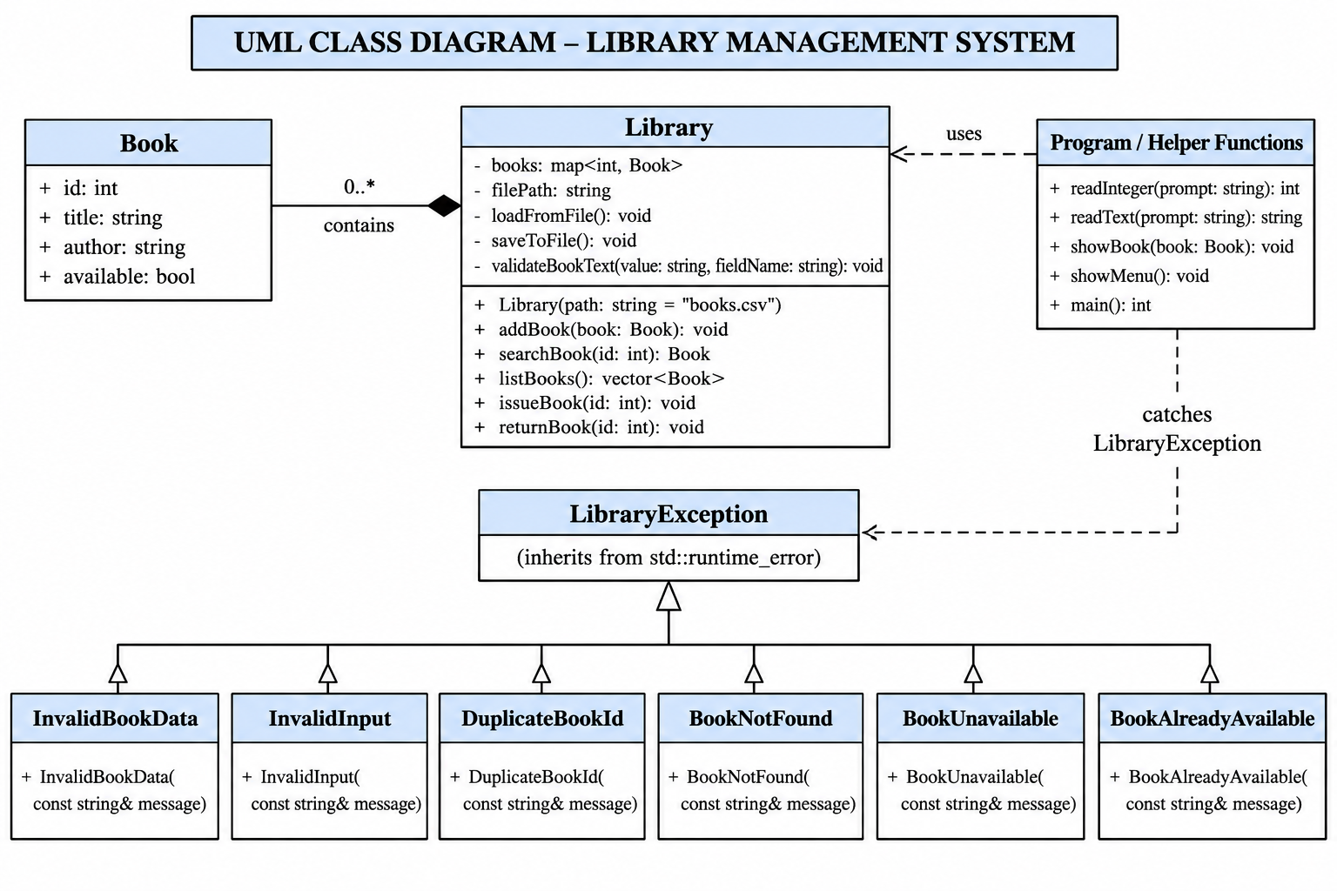
The Library class stores multiple Book records. Specific exception classes inherit from LibraryException to represent different error conditions.

7. Algorithm
- Start the application and load records from books.csv if it exists.
- Display the menu: add, search, list, issue, return, or exit.
- Read and validate the selected operation and its input.
- Call the appropriate Library method.
- For a valid change, save all records to books.csv.
- If invalid data or an invalid operation occurs, throw a custom exception and display its message.
- Repeat until the user selects Exit.

8. Compile and Run
Compile: & "C:\MinGW\bin\g++.exe" -std=c++17 main.cpp -o LibraryManagementSystem.exe
Run on Windows PowerShell: .\LibraryManagementSystem.exe

9. Sample Input and Output
Valid example: add book ID 101, title The Alchemist, author Paulo Coelho. Expected message: Book added and saved successfully.
Invalid example: choose menu option 9. Expected message: Error: Invalid menu choice. Select a number from 0 to 5.
Invalid example: search for book ID 999 when it does not exist. Expected message: Error: No book found with ID 999.
Invalid example: try issuing a book that is already issued. Expected message: Error: This book is already issued.
See Sample_Input_Output.txt for additional test cases.

10. Result
The Library Management System demonstrates OOP, STL-based storage, CSV persistence, and exception handling. It handles normal library operations and reports invalid actions without terminating the menu loop.

11. Source Files
- main.cpp — Complete single-file C++ backend: Book structure, Library class, menu, validation and custom exceptions.
- books.csv — CSV file used to load and save book records.
- README.md — Project overview, features, technologies and compile/run instructions.
- Sample_Input_Output.txt — Test cases showing valid operations and invalid-input handling.
- UML_Class_Diagram.png — Updated UML diagram matching the current consolidated implementation.
- OOP_Practical_12_Document.docx — Practical report containing the aim, problem statement, algorithm, diagram and test summary.

