Q1)whta is process?
SOL)
- A Process is a program in execution
- Process is not as same as program code but a lot more than it.
- the Attributes held by process include hardware, memory, CPU etc.

Process Memory is divided into 4 sections for efficient working:
1.Text Section
2.Data Section
3. Heap
4.Stack

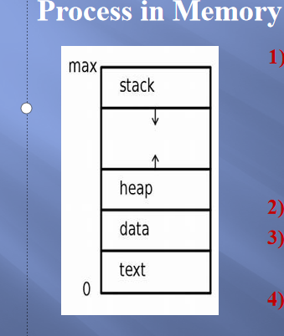

Q2)Process State?
SOL)
- The process, from its creation to completion, passes through various states.
The minimum number of states is five:
1. New

2. Ready
3. Running
4.wait
5. Completion or termination

1.NEW:
- The Process is being created
2.Ready:
- The Process is waiting to be assigned to a processor.
3.Running:
- Instructions are being executed.
4.Waiting:
- The Process is waiting for some event to occur(such as an I/O completion)
5.Terminated:
- The Process has finished execution
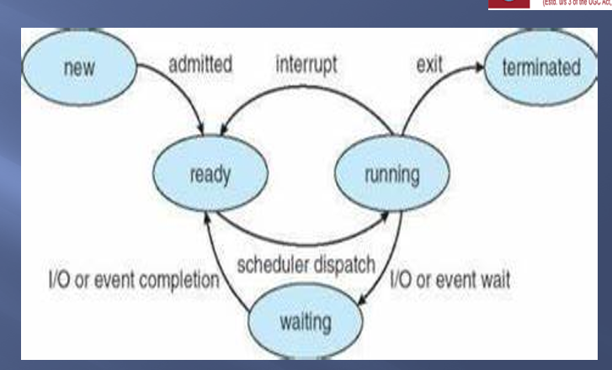

******Q3)Process Control Block(PCB) or Task Control Block(TCB):
SOL)

- The process control stores many data items that are needed for efficient process management.
- Some of these data items are explained with the help of the given diagram

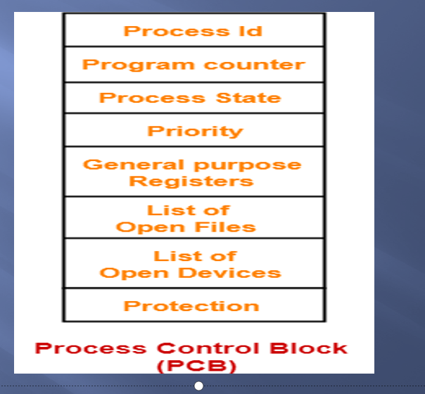

Process State:
- This specifies the process state i.e. new, ready, running, waiting or terminated.

Process Number:
- This shows the number of the particular process.
Program Counter:
- This contains the address of the next instruction that needs to be executed in the process.

List of Open Files:
- These are the different files that are associated with the process
I/O Status Information:
- This information includes the list of I/O devices used by the process, the list of files etc.

***q4)process scheduling?
sol)

- The act of determining which process in the ready state should be moved to the running state is known as Process Scheduling
- The aim of the process scheduling system is to keep the CPU busy all the time and to deliver minimum response time for all programs.

- For achieving this, the scheduler must apply appropriate rules for swapping processes IN and OUT of CPU.

***q5)Scheduling Queues?
sol)

- All Processes when enters into the system are stored in the Job Queue/Job Pool.
- Process in the Ready state are placed in the Ready Queue.
- It is represented in Linked List and PCB contain pointer field.
- Processes waiting for a device to become available are placed in Device Queues.
- The objective of multiprogramming is to have some process running at all time, to maximize the CPU utilization.
- Time sharing is used to switch CPU among the processes

For this scheduling we need Scheduling queues.

I)Job queue:
This queue keeps all the processes in the system.
II)Ready queue:
This queue keeps a set of all processes in main memory,and ready and waiting to execute.

III)Device queues:
The processes which are blocked due to unavailability of an I/O device constitute this queue.

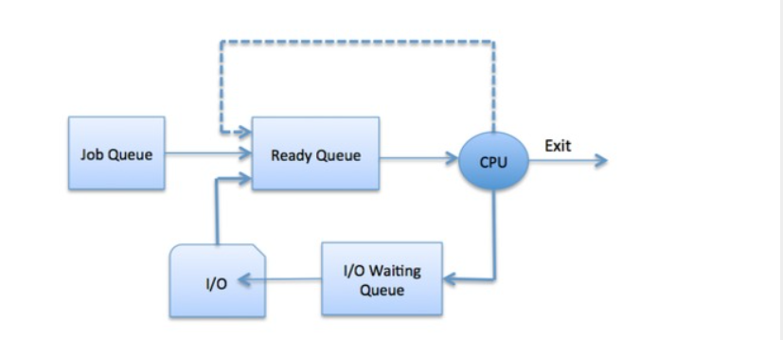

**Q6)Schedulers?
SOL)

- Schedulers are special system software which handle process scheduling in various ways
- Their main task is to select the jobs to be submitted into the system and to decide which process to run.
Schedulers are of three types
- 1.Long-Term Scheduler
- 2.Short-Term Scheduler
- 3.Medium-Term Scheduler
1.Long Term Scheduler:
- It is also called a job scheduler.
- Long Term Scheduler run less frequently.
- It selects processes from job pool and loads them into the memory for execution.

- Short-Term Scheduler:
- It is also called as CPU scheduler.
- Short-Term Scheduler run frequently.
- it increase the CPU Performance and Execution Rate.

- It used for selects from among the processes that are ready to execute and allocates the CPU to one of them.

- Medium-Term Scheduler:
- Medium-term scheduling is a part of swapping
- It removes the processes from the memory.
- It reduces the degree of multiprogramming

****Q7)COMPARISION BETWEEN Long-Term Scheduler VS medium term schedular vs long term schedular?
sol)
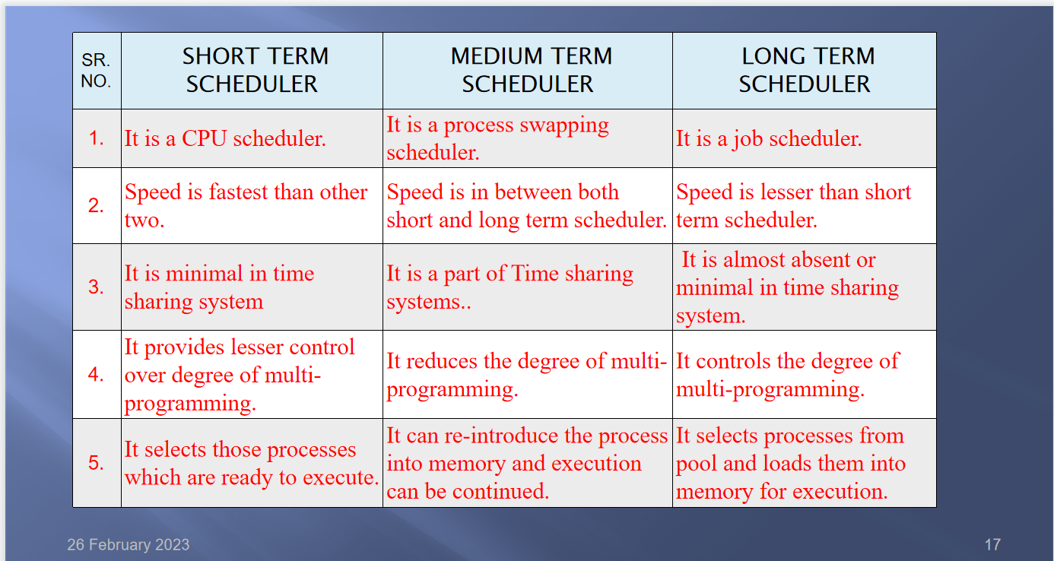
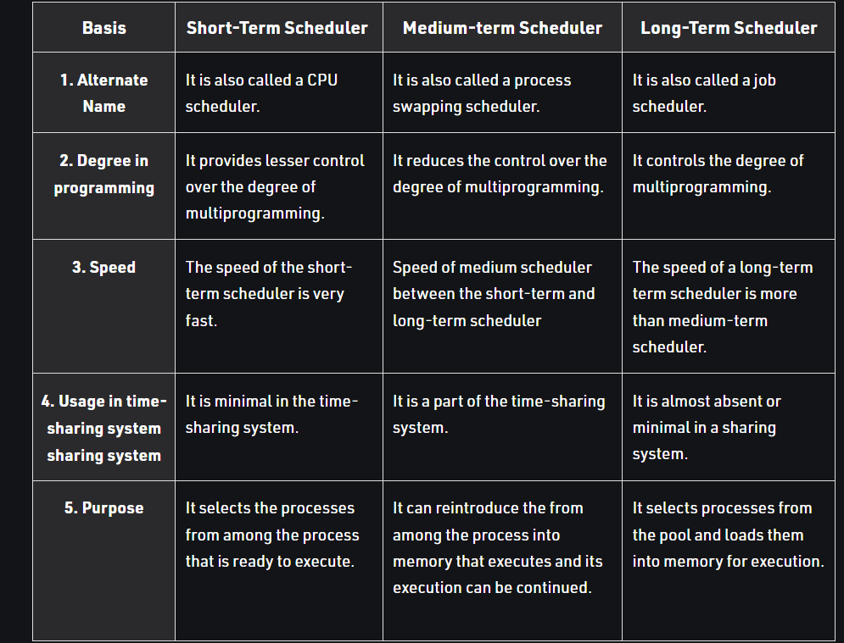

-*****q8)explain Context Switch ?
sol)
- The Context switching is a technique or method used by the operating system to switch a process from one state to another to execute its function using CPUs in the system.
- When switching perform in the system, it stores the old running process's status in the form of registers and assigns the CPU to a new process to execute its tasks.
- While a new process is running in the system, the previous process must wait in a ready queue.
- The execution of the old process starts at that point where another process stopped it.
- A context switching helps to share a single CPU across all processes to complete its execution and store the system's tasks status.
- theere are three types of context switching triggers as follows
1. Interrupts
2. Multitasking
3.Kernel/User switch
- There are several steps involves in context switching of the processes.
- The following diagram represents the context switching of two processes, P1 to P2, when an interrupt, I/O needs, or priority-based process occurs in the ready queue of PCB.

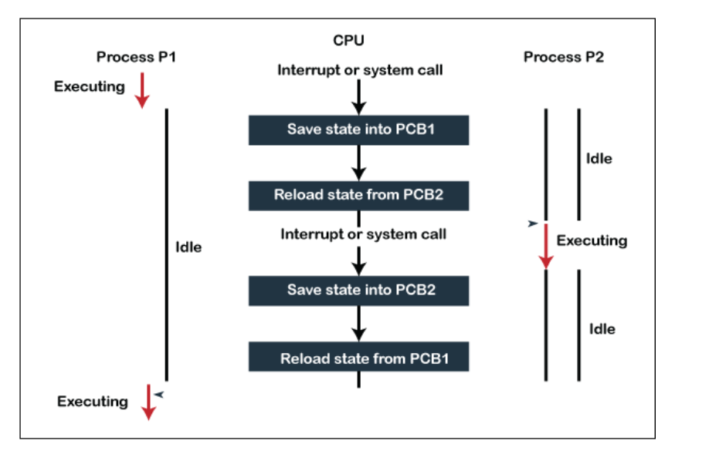

**q9)explain process creation?
sol)
- A process can create several new processes through creating process system calls during the process execution
- Creating a process we call it the parent process and the new process is a child process.
- Every new process creates another process forming a tree-like structure.
- The creating process is called Parent process.
- The new process created are called Child process of that process
- Each of this new processes may also create other processes ,which are forming a tree.
Let us consider a tree of process:

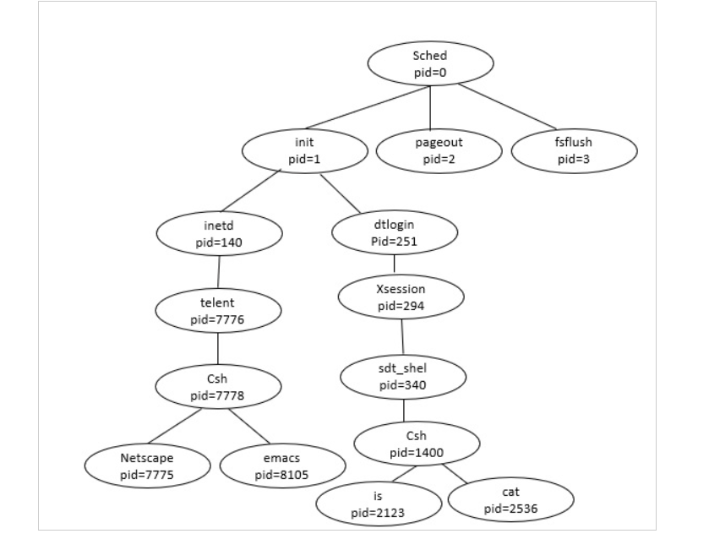

example:
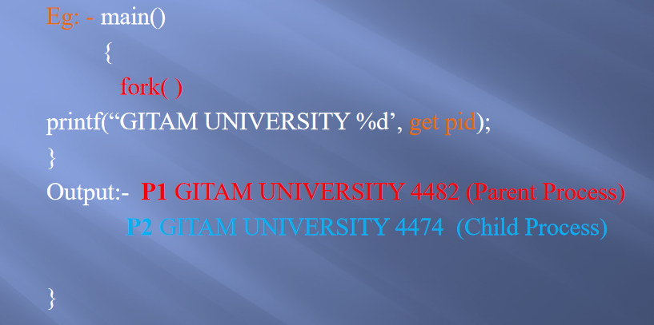

**q10)explain process termination?
sol)

- Whenever the process finishes executing its final statement and asks the operating system to delete it by using exit() system call.
- All the resources of the process including physical and virtual memory, open files, I/O buffers are deallocated by the operating system.
- When the child process terminates it has to send the status to the parent with the wait() system call.
- The child process can also terminated by the parent.
Causes for termination:
1.Time slot expired
2.Memory bound violation
3.I/O failure
4.Process request
5.Invalid instruction

q11)What is Inter Process Communication(IPC)?
sol)
- Inter Process Communication is a type of mechanism usually provided by the operating system (or OS).
- The main aim or goal of this mechanism is to provide communications in between several processes
- "Inter-process communication is used for exchanging useful information between numerous threads in one or more processes (or programs)."
- Process executing concurrently in the OS may be either independent process or cooperating process

INDEPENDENT PROCESS:
- An independent process is not affected by the execution of other processes

CO-OPERATING PROCESS:
- co-operating process can be affected by other executing processes
- Any process that share the data with other process is a cooperating process.
- IPC is required only in Cooperating process

REASONS FOR PROVIDING AN ENVIRONMENT FOR PROCESS COOPERATION:
1.INFORMATION SHARING

2.COMPUTATTION SPEED
3.MODULARITY
4.CONVINENCE

Two fundamental models for inter process communication:
1.Shared Memory
2.Message passing

- Shared Memory:
- Shared memory system is the fundamental model of inter process communication.
- Shared memory concept works on fastest inter process communication.

- In the Shared Memory system, the cooperating processes communicate, to exchange the data with each other
- The processes share data by reading and writing the data in the shared segment of the processes.

- Let us discuss it by considering two processes. The diagram is shown below
- 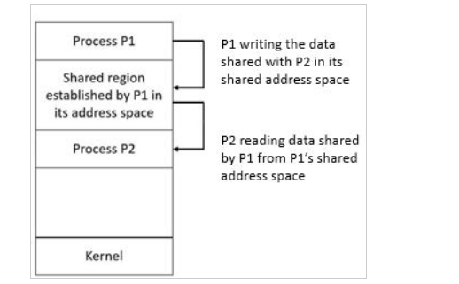
- Process P1 has some data to share with process P2
- it stores the data or information to be shared in its shared memory region.
- Now, P2 requires the information stored in the shared segment of P1
- Now, P2 can read out the data from there
- The two processes can exchange information by reading and writing data in the shared segment of the process.

The advantages of Shared Memory are as follows:
1.Shared memory is a faster inter process communication system.

2.It allows cooperating processes to access the same pieces of data concurrently.

3.Users can perform multiple tasks at a time.

- Modularity is achieved in a shared memory system.

- Message passing:
- In this method, processes communicate with each other without using any kind of shared memory.
- Message passing provides two operations which are as follows :
1.Send message
2.Receive messag
- For fixed size messages the system level implementation is straight forward but the programming task becomes more difficult
- The variable sized messages require a more system level implementation but the programming task becomes simpler.
- If process P1 and P2 want to communicate they need to send a message to and receive a message from each other that means here a communication link exists between them.
- methods for logically implementing a link and the send() and receive() operations.

Advantages of Message Passing Model :
1.Easier to implement.
2.Easier to build massively parallel hardware.
3.Message passing libraries are faster and give high performance.

****q12) what is thread?
sol)
- A thread is a single sequential flow of execution of tasks of a process
- it is also known as thread of execution or thread of control.
- There is a way of thread execution inside the process of any operating system.
- there can be more than one thread inside a process.

Types of Threads:
- there are two types of threads
1. Kernel level thread.
2.User-level thread.

1. Kernel level thread:
- The kernel thread recognizes the operating system.
- There is a thread control block and process control block in the system for each thread and process in the kernel-level thread.
- the kernel-level thread is implemented by the operating system.
- The kernel-level thread offers a system call to create and manage the threads from user-space.

2.User-level thread:
- The operating system does not recognize the user-level thread
- User threads can be easily implemented and it is implemented by the user.

- If a user performs a user-level thread blocking operation, the whole process is blocked.
- The kernel level thread does not know nothing about the user level thread.
- The kernel-level thread manages user-level threads

****q13)thread vs process?
sol)

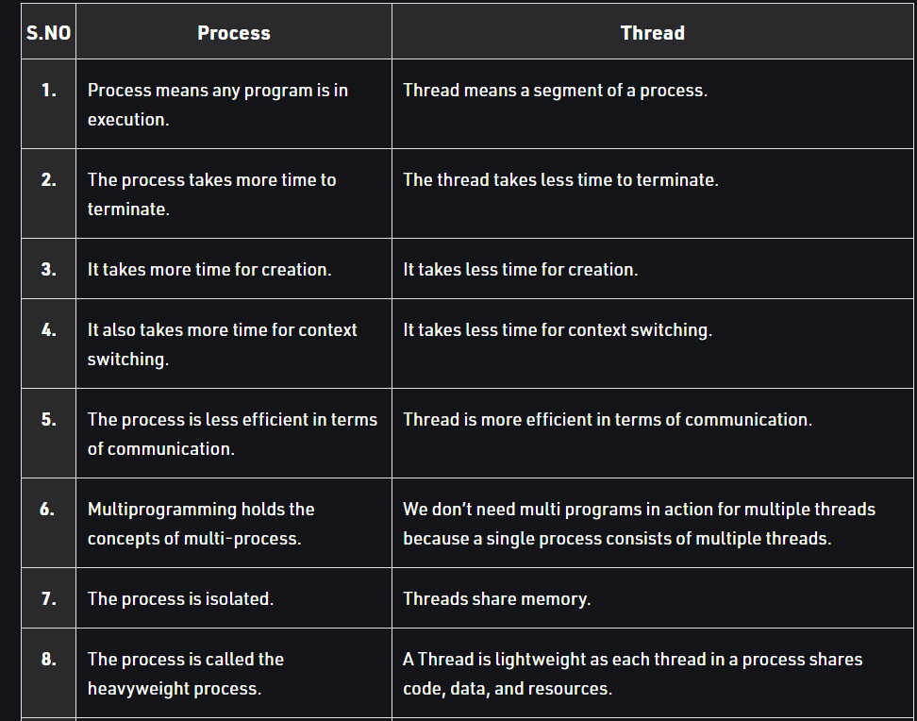
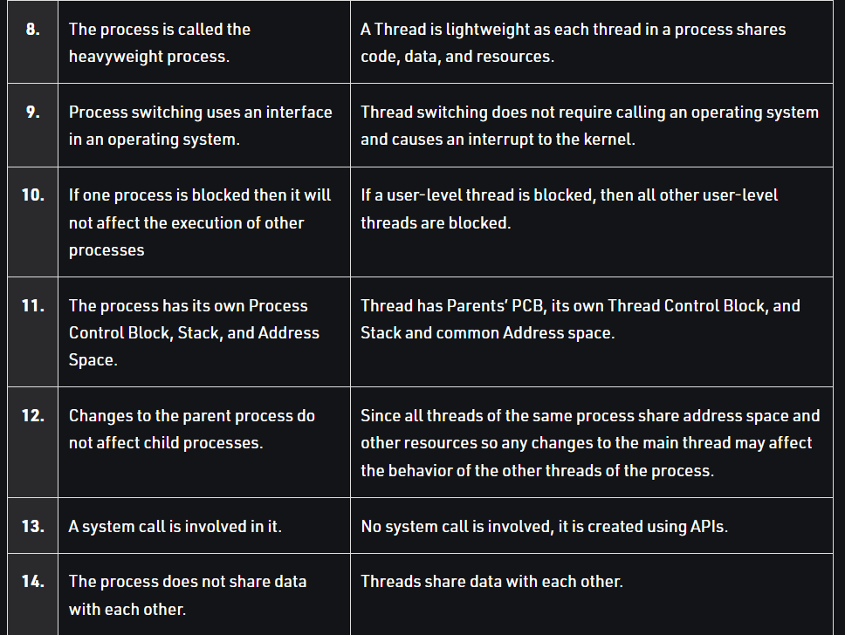

****q14)multithreading models?
sol)
- Multithreading allows the application to divide its task into individual threads.
- In multi-threads, the same process or task can be done by the number of threads
- The main drawback of single threading systems is that only one task can be performed at a time
- so to overcome the drawback of this single threading, there is multithreading that allows multiple tasks to be performed.
- we can say that there is more than one thread to perform the task in multithreading.

