**q1)what is internet?**

**sol)**

* The Internet is a computer network that interconnects hundreds of millions of computing devices throughout the world

Hosts or End systems :

1. Systems that are connected to Internet

Communication links :

1. Coaxial cable, Copper wire, Optical fiber, and Radio spectrum

Transmission rate :

1. measured in bits/second

Packet switches types :

1. Routers and Link-layer switches

2.Routers : Used in network core

3.Link layer switches : Used in access networks

Protocols :

1. controls the sending and receiving of information within the Internet

Most important protocols in the Internet :

1. Transmission Control Protocol (TCP)

2. Internet Protocol (IP)

**q2)what is protocol?**

**sol)**

* protocol is a set of rules that determine how data is transmitted between different devices in the same network.

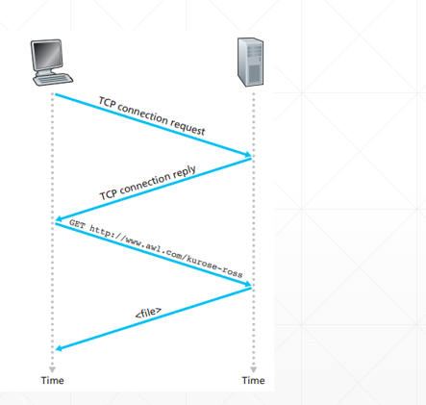

**q3)explain network edge?**

**sol)**

End systems :

* the computers and other devices connected to the Internet

End systems include:

1. desktop computers (e.g., desktop PCs, Macs, and Linux boxes),
2. servers (e.g., Web and e-mail servers), and
3. mobile computers (e.g., laptops, smartphones, and tablets).

Hosts are divided into two categories:

Clients:

* desktop and mobile PCs, smartphones, etc.

Servers:

* more powerful machines that store and distribute Web pages, stream video, relay e-mail, etc

Access Networks:

* the network that physically connects an end system to the first router
* First router is also known as the “edge router”

they are 2 types in newwork access:

1.Digital Subscriber Line (DSL)

2.Cable Internet access

1.Digital Subscriber Line (DSL)

* line carries both data and traditional telephone signals which are encoded at different frequencies:
* A high-speed downstream channel, in the 50 kHz to 1 MHz band
* A medium-speed upstream channel, in the 4 kHz to 50 kHz band
* An ordinary two-way telephone channel, in the 0 to 4 kHz band

2.Cable Internet access:

* makes use of the cable television company’s existing cable television infrastructure.
* Fiber optics connect the cable head end to neighborhood-level junctions
* Coaxial cable is then used to reach individual houses and apartments
* Each neighborhood junction typically supports 500 to 5,000 homes

**q4)explain network core?**

**sol)**

PACKET SWITCHING:

1. In a network application, end systems exchange messages with each other
2. Messages may perform a control function or can contain data, such as an email message, a JPEG image, or an MP3 audio file
3. The source breaks long messages into smaller chunks of data known as packets
4. Each packet travels through communication links and packet switches
5. Packets are transmitted at a rate equal to the full transmission rate of the link
6. The time to transmit the packet is L/R seconds
7. Packet switches use store-and-forward transmission at the inputs to the links
8. Packet switch must receive the entire packet before it can transmit
9. Packets will travel across the network, taking the shortest path as possible.
10. All the packets are reassembled at the receiving end in correct order.
11. If any packet is missing or corrupted, then the message will be sent to resend the message.
12. If the correct order of the packets is reached, then the message will be sent.

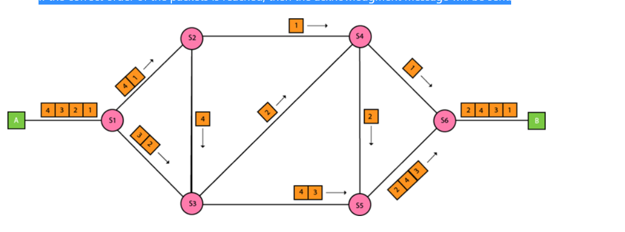

CIRCUIT SWITCHING:

1. Circuit switching is a switching technique that establishes a dedicated path between sender and receiver.
2. Traditional telephone networks are examples of circuit-switched networks
3. If each link between adjacent switches has a transmission rate of 1 Mbps
4. then each end-to-end circuit-switch connection gets 250 kbps of dedicated transmission rate.
5. Circuit switching is used in public telephone network.
6. It is used for voice transmission.
7. Fixed data can be transferred at a time in circuit switching technology.

Communication in circuit switching has 3 phases:

1.Circuit establishment

2.Data transfer

3.Circuit Disconnect

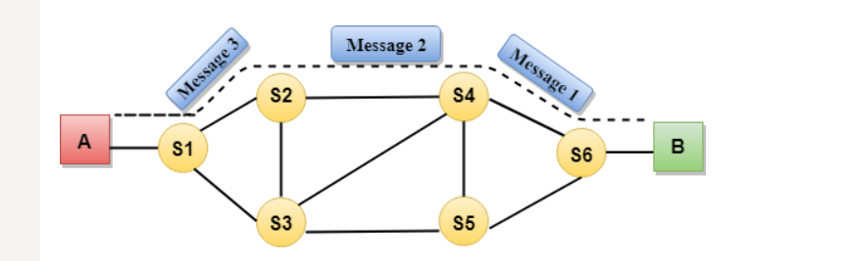

**q5)comparison between circuit switching and packet switching?**

**sol)**

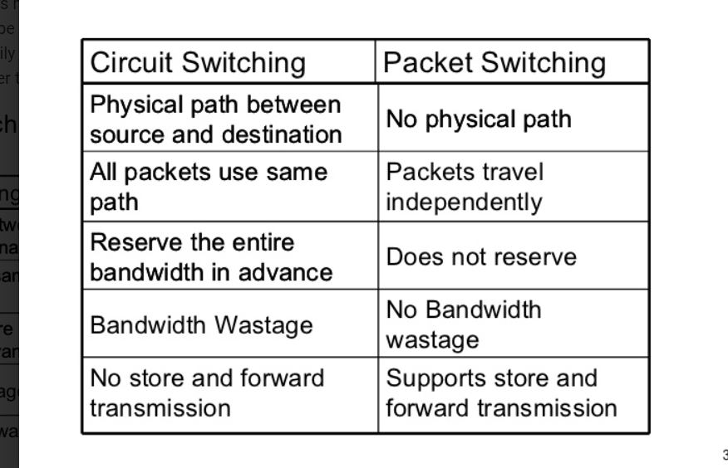

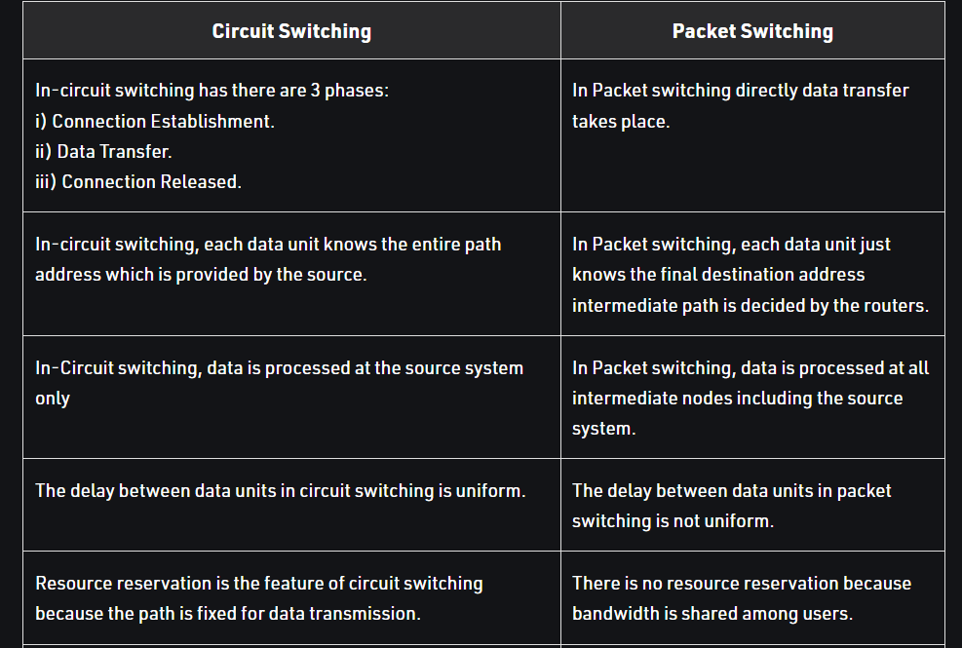

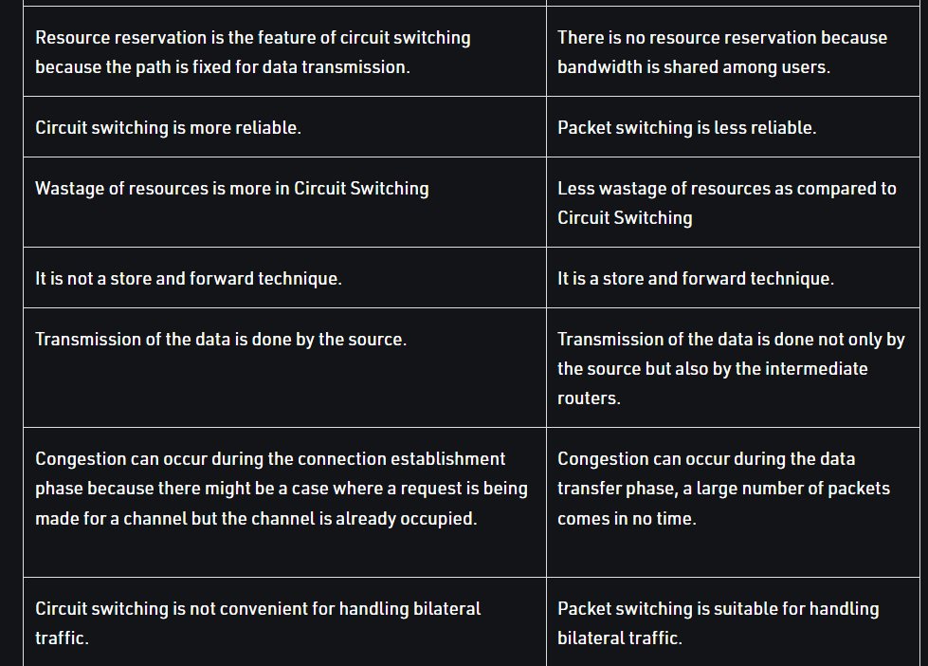

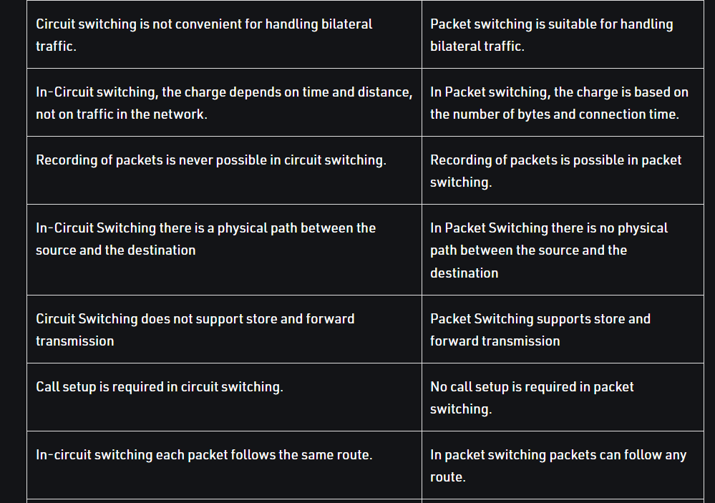

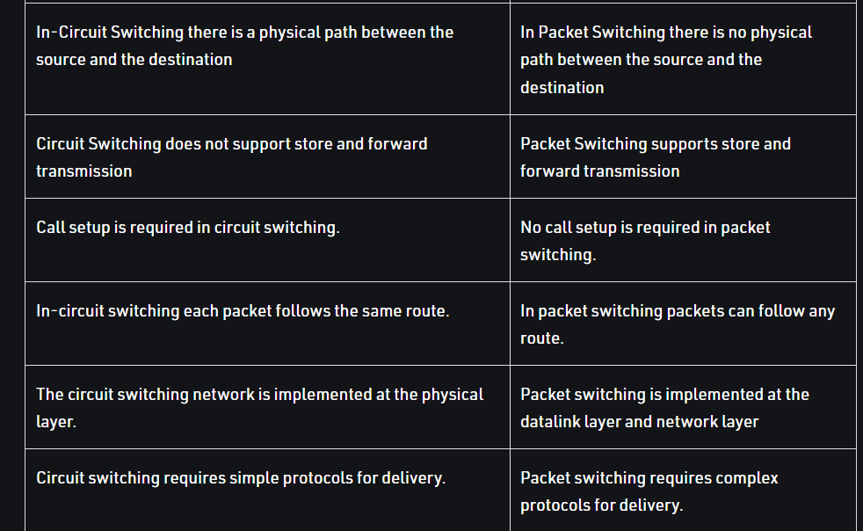

**q6)explain protocal layering?**

**sol)**

Network designers organize Protocols and The network hardware and software that implement the protocols

1.Application Layer:

* Application Layer Protocols :

1.HTTP protocol (for Web document request and transfer)

2.SMTP (for the transfer of e-mail messages)

3.FTP (for the transfer of files between two end systems)

* An application-layer protocol is distributed over multiple end systems
* packet of information at the application layer is a message

2.Transport Layer:

* Transports application-layer is the messages between application endpoints

This layer provides :

1.guaranteed delivery of messages to the destination

2.flow control

the Two transport protocols are:

1.TCP

2.UDP

* Transport-layer packet is a segment

3.Network Layer:

* this network layer is Responsible for moving datagrams from one host to another
* Network Layer Protocol are:

1.IP Protocol

* Network layer contains routing protocols that determine the routes
* Network-layer packet is a datagram

4.Link Layer:

* this link layer is Responsible for moving entire frames from one network element to an adjacent network element
* Services provided by the link layer depend on the specific link-layer protocol

Link Layer Protocols are:

1.Ethernet

2.WiFi

3.the cable access network’s DOCSIS protocol

* Link Layer packets are frames

5.Physical Layer:

* this Physical Layer is Responsible for moving the individual bits within the frame from one node to the next node
* this Protocols is link dependent
* Depends on the actual transmission medium of the link

Example :

A) twisted-pair copper wire

B) single-mode fiber optics etc

**q7)difference between TCP VS UDP?**

**SOL)**

TCP stands for Transmission Control Protocol.

The UDP stands for User Datagram Protocol.

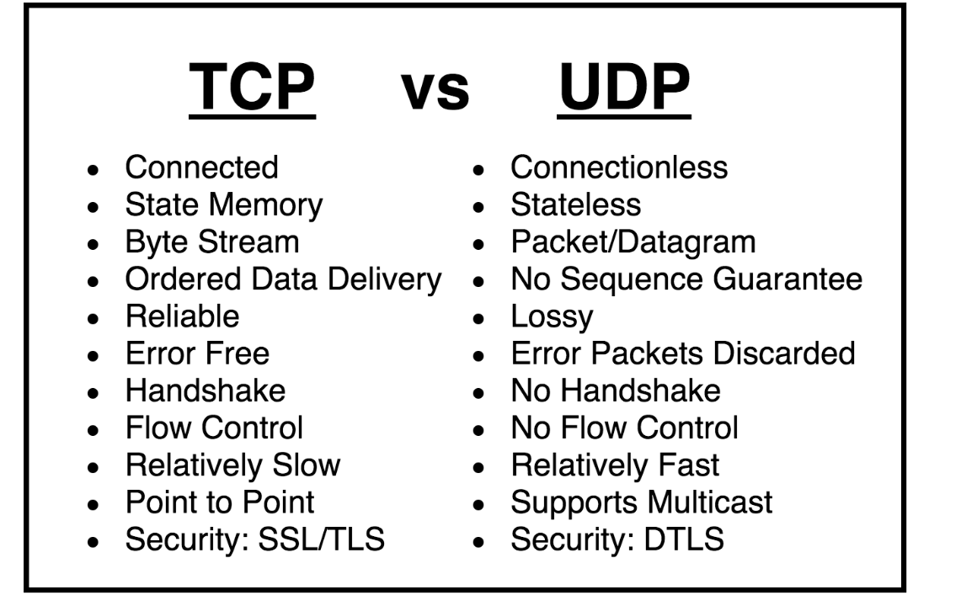

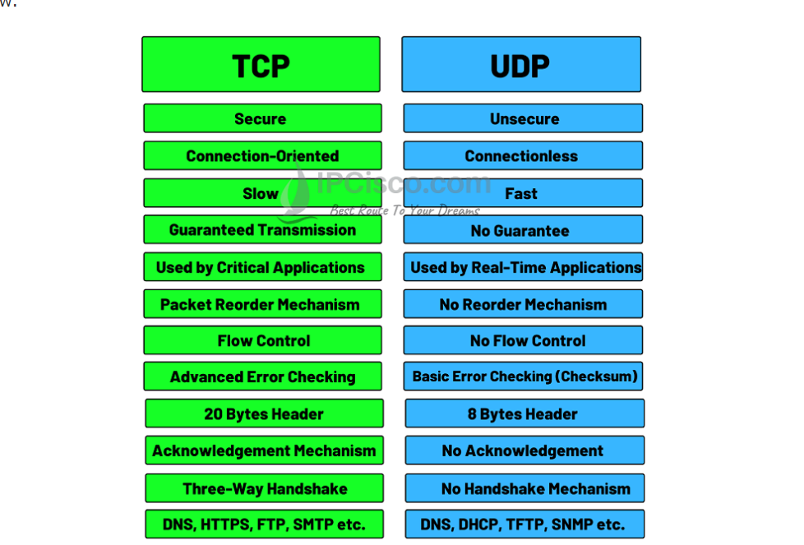

**q8)expalin about OSI model?**

**sol)**

* OSI stands for Open Systems Interconnection
* It has been developed by ISO

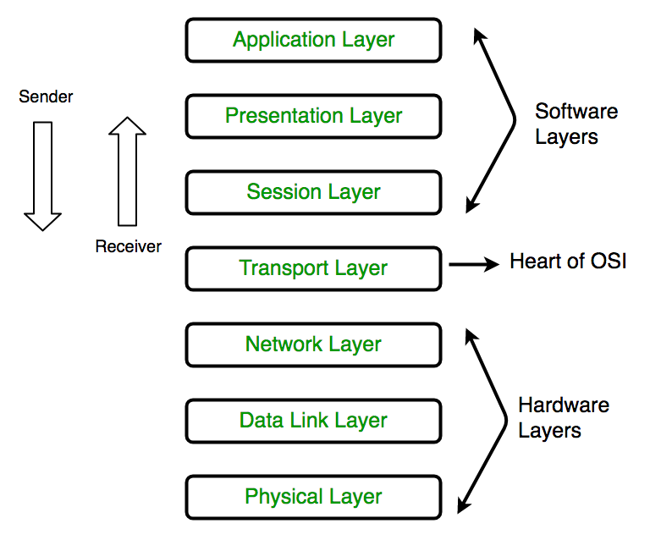

1. Physical Layer (Layer 1):

* The lowest layer of the OSI reference model is the physical layer.
* It is responsible for the actual physical connection between the devices
* The physical layer contains information in the form of bits.

1. Data Link Layer (DLL) (Layer 2) :

* The data link layer is responsible for the node-to-node delivery of the message.
* he main function of this layer is to make sure data transfer is error-free from one node to another,

1. Network Layer (Layer 3) :

* The network layer works for the transmission of data from one host to the other located in different networks
* It also takes care of packet routing
* he sender & receiver’s IP addresses are placed in the header by the network layer.

1. Transport Layer (Layer 4) :

* The transport layer provides services to the application layer and takes services from the network layer.
* The data in the transport layer is referred to as Segments
* It is responsible for the End to End Delivery of the complete message

1. Session Layer (Layer 5) :

* This layer is responsible for the establishment of connection, maintenance of sessions, authentication, and also ensures security.
* 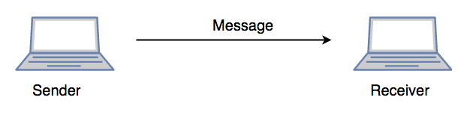

1. Presentation Layer (Layer 6):

* The presentation layer is also called the Translation layer.
* The data from the application layer is extracted here and manipulated as per the required format

1. Application Layer (Layer 7) :

* it is the very top of the OSI Model
* This layer also serves as a window for the application services to access the network and for displaying the received information to the user.

**q9 )explain TCP/IP model?**

**sol)**

* it was designed and developed by Department of Defense (DoD) in 1960s
* is based on standard protocols
* It stands for Transmission Control Protocol/Internet Protocol.
* The TCP/IP model is a concise version of the OSI model.
* It contains four layers, unlike seven layers in the OSI model.
* The layers are:
* 1.Process/Application Layer
* 2.Host-to-Host/Transport Layer
* 3.Internet Layer
* 4.Network Access/Link Layer
* The diagrammatic comparison of the TCP/IP and OSI model is as follows :
* 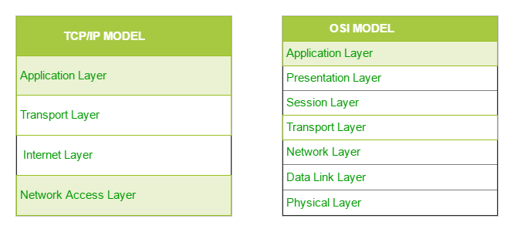

1. Network Access Layer:

* This layer corresponds to the combination of Data Link Layer and Physical Layer of the OSI model.
* It looks out for hardware addressing and the protocols present in this layer allows for the physical transmission of data.

2. Internet Layer:

* This layer parallels the functions of OSI’s Network layer.
* It defines the protocols which are responsible for logical transmission of data over the entire network.
* The main protocols residing at this layer are :

i)IP

ii)ICMP

iii)ARP

3Transport Layer:

* The transport layer is responsible for the reliability, flow control, and correction of data which is being sent over the network
* The two protocols used in the transport layer,they are

i)User Datagram protocol

ii) Transmission control protocol.

4.Application Layer:

* An application layer is the topmost layer in the TCP/IP model.
* It is responsible for handling high-level protocols, issues of representation.
* This layer allows the user to interact with the application
* the main protocols used in the application layer:

i)HTTP

ii)SNMP

iii)SMTP

iV)DNS

v)TELNET

vi)FTP

**q10)comaparision between TCP/IP and OSI model?**

**sol)**

