**what is iot?**

**sol)**

* Connecting everyday things embedded with electronics, software, and sensors to internet enabling to collect and exchange data without human interaction called as the Internet of Things (IoT).
* The term "Things" in the Internet of Things refers to anything and everything in day to day life which is accessed or connected through the internet
* IoT is an advanced automation and analytics system which deals with artificial intelligence, sensor, networking, electronic, cloud messaging etc.

Features of IOT:

1.Connectivity

2.Analyzing

3.Integrating:

4.Artificial Intelligence

5.Sensing

6.Active Engagement

7.Endpoint Management

**q2)example of iot devices?**

**sol)**

* Internet of Things Devices is non-standard devices that connect wirelessly to a network with each other and able to transfer the data.
* IoT devices are enlarging the internet connectivity beyond standard devices such as smartphones, laptops, tablets, and desktops.
* IoT devices include computer devices, software, wireless sensors, and actuators.
* These IoT devices are connected over the internet and enabling the data transfer among objects or people automatically without human intervention.
* iot devices are :

1.Google Home Voice Controller

2.Amazon Echo Plus Voice Controller

3.Amazon Dash Button

4.August Smart Lock

5. Nest Smoke Alarm

**q3)applications of IOT?**

**sol)**

Applications of IoT:

1.Smart Home Applications

2.Health care

3.Smart Cities

4. Agriculture

5.Industrial Automation

6. Hacked Car

7.Healthcare

8.Smart Retail

9. Smart Farming

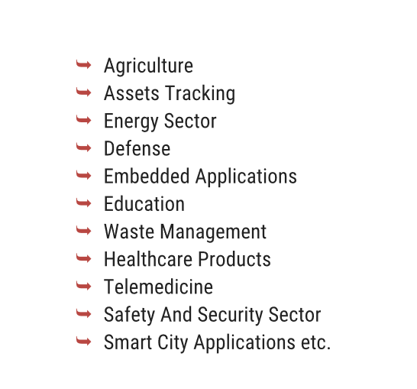

**q4)Characteristics of IOT?**

**SOL)**

Characteristics of the Internet of Things :

The Internet of Things (IoT) is characterized by the following key features:

1.Connectivity:

* Connectivity is an important and first requirement of IoT infrastructure.
* Every Things in IoT should be connected to the IoT infrastructure.
* Connectivity should be guaranteed at anywhere and anytime.

2.Identity:

* Each IoT device has a unique identity (e.g., an IP address).
* This identity is helpful in communication, tracking and to know status of the things.

3.Intelligence:

* Intelligence is Just data collection is not enough in IoT, extraction of knowledge from the generated data is very important.
* For example, sensors generate data, but that data will only be useful if it is interpreted properly.
* So intelligence is one of the key characteristics in IoT

4.Scalability:

* The number of devices connected to IoT zone is increasing day by da
* Therefore, an IoT setup should be capable of handling the expansion.

5.Architecture:

* IoT architecture is yet not uniformed and standardized.
* It should be hybrid, supporting different manufacturer’s products to function in the IoT network.

6.Safety:

* Sensitive personal information of a user might be compromised when the devices are connected to the Internet.
* So data security is a major challenge.
* This could cause a loss to the user.
* Equipment in the huge IoT network may also be at risk
* Therefore, equipment safety is also critical.

**q5)explain IOT stack?**

**Sol)**

there are 7 layers in IOT stack

1.Layer 1 (Physical or Sensor Layer)

2.Layer 2 (Processing and Control Action layer)

3.Layer 3 (Hardware Interface Layer)

4.Layer 4 (RF Layer)

5.Layer 5 (Session/Message Layer)

6.Layer 6 (User Experience Layer)

7.Layer 7 (Application Layer)

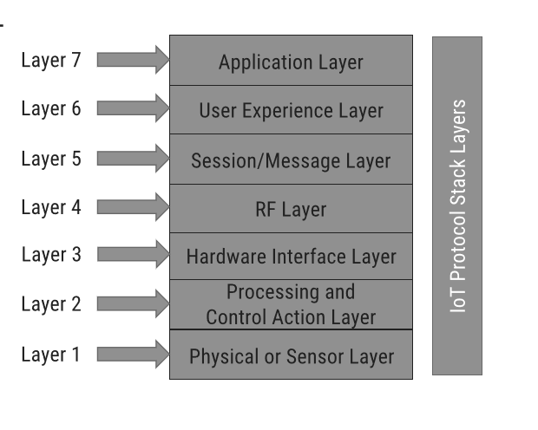

1. Layer 1 (Physical or Sensor Layer):

* This layer is concerned about the physical components, which mainly includes sensors.
* In this layer, the sensors are the core component.
* Temperature sensor, pressure sensor, humidity sensor, etc. can all be referred as physical layer components

1. Layer 2 (Processing and Control Action Layer):

* This important layer contains core components of IoT system.
* The microcontrollers or processors are found in this layer.
* The data is received by the microcontrollers from the sensors.

1. Layer 3 (Hardware Interface Layer):

* The 3rd layer in the stack is the Hardware Interface Layer.
* Hardware components and communication standards such as RS232, CAN, SPI, SCI, I 2C, etc. occupy this layer.

4.Layer 4 (RF Layer):

* It plays a major role in the communication channel – whether it is short range or long range.
* Protocols used for communication and transport of data based on RF are listed in this layer.
* Some famous and common protocols are Wi-Fi, NFC, RFID, Bluetooth, Zigbee, etc.

5.Layer 5 (Session/Message Layer)":

* computer network session management is also important in IoT.
* There are many protocols which manage how messages or data are broadcasted to the cloud.
* Layer 5 (session layer) deals with the various messaging protocols as MQTT, CoAP, etc. and also other protocols such as SSH and FTP.

6.Layer 6 (User Experience Layer):

* This layer deals with providing best experience to the end users of IoT products
* The 6th layer takes care of rich UI designs with lots of features,
* Object-oriented programming languages, scripting languages, analytics tools, etc. all should be included in this layer.
* This is also known as User Experience and Visualization Layer

7.Layer 7 (Application Layer):

* Everything comes to perfection at this layer.
* This layer utilizes the rest six layers in order to develop desired application
* It can range from a simple automation application to smart city application.

**q6)explain Enabling Technologies?**

**sol)**

IoT(internet of things) enabling technologies are

1.Wireless Sensor Network

2.Cloud Computing

3.Big Data Analytics

4.Communications Protocols

5.Embedded System

1. Wireless Sensor Network(WSN) :

* A WSN comprises distributed devices with sensors which are used to monitor the environmental and physical conditions.
* A wireless sensor network consists of end nodes, routers and coordinators.
* The coordinator also acts as the gateway that connects WSN to the internet.

Example:

1. Weather monitoring system

2. Indoor air quality monitoring system

3. Soil moisture monitoring system

4. Surveillance system

5. Health monitoring system

1. Cloud Computing :

* we can access applications as utilities over the internet.
* Cloud means something which is present in remote locations
* With Cloud computing, users can access any resources from anywhere like databases, webservers, storage, any device, and any software over the internet.

1. Big Data Analytics :

* It refers to the method of studying massive volumes of data or big data.
* Collection of data whose volume, velocity or variety is simply too massive and tough to store, control, process and examine the data using traditional databases.
* Big data is gathered from a variety of sources including social network videos, digital images, sensors and sales transaction records.

Several steps involved in analyzing big data:

1. Data cleaning

2. Munging

3. Processing

4.Visualization

Examples:

1.Bank transactions

2.Data generated by IoT systems

3.E-commerce and in Big-Basket

4.Health and fitness data generated by IoT system such as a fitness bands

1. Communications Protocols:

* They are the backbone of IoT systems and enable network connectivity and linking to applications
* Communication protocols allow devices to exchange data over the network.
* Multiple protocols often describe different aspects of a single communication.
* A group of protocols designed to work together is known as a protocol suite
* They are used in

1.Data encoding

2. Addressing schemes

5. Embedded Systems :

* It is a combination of hardware and software used to perform special tasks.
* It includes microcontroller and microprocessor memory, networking units (Ethernet Wi-Fi adapters), input output units (display keyword etc. ) and storage devices (flash memory).
* It collects the data and sends it to the internet.

Examples:

1.Digital camera

2.DVD player, music player

3.Industrial robots

4.Wireless Routers etc.

**q7)IOT challanges?**

**sol)**

1. IoT security

2. Coverage

3. Scalability

4. Interoperability

5. Bandwidth availability

6. Limited battery life

7. Remote access