NETWORK
- In Cloud we will have Vents used to develop networking in cloud.
- We break down in to segments known as Subnets.
- We create Subnets to host applications.
- We create subnets so that we can apply controls, we apply ACL (Access Control List), to control traffic that goes in and comes out of the VLAN.
- We can apply control at subnet as well as VM level.
- We will be having production and non-production network.
- We may also have separate network for application also, production network can have [subnet – web subnet, App subnet, DB subnet, Mgmt subnet ].
- On production we don’t want web-servers to communicate with DB servers, so we can restrict at DB servers using ACL.
- NSG – Network Security Group, logs from NSG are sent to LAW [Log Analytics Workspace] and from there to sentinel service.
- Traffic controlled through NSG passing from one subnet to another subnet.
- FIREWALL: Policies configured for traffic monitoring before reaching NSG.
- Bastion House: It’s a jump host provided by Microsoft helps to connect to VMs in a secured channel.
- Peering: Connecting 2VMs which are in different VLAN. The IP address should be different.
- Web-Application Firewall: Works in Application Layer, in Azure it’s part of Load Balancer [ Application Gateway].

INFORMATION AND DATAPROTECTION
Securing Data
- We need to know about Data repositories that is type of data.
- Classify and label data – Public, private, confidential.
- When we send emails we would be provided with labels like [Group use, public, private ] based on this DLP will take place and info will be protected.
- Data Loss Prevention: Helps to prevent data being transferred outside organization.
- We need to have back up and recovery of data.

COMPUTING SECURITY
- For computing we have resources like VMs, Container etc.,
- To protect VM in azure, we use network level traffic monitor, identity controls, CPU and memory.
- Firewall in VM, EDR, DLP, separate data across volumes, encrypt, backup and DR [Disaster Recovery].

GOVERNANCE AND COMPLIANCE
- There will be a separate team in SOC called GRC, which keeps track whether infrastructure adhering to LAWs or not.
- Microsoft Defender for cloud is a CSPM [Cloud Security Posture Management].
- This gives secure score about Azure resources and we can configure policies like JIT.
- 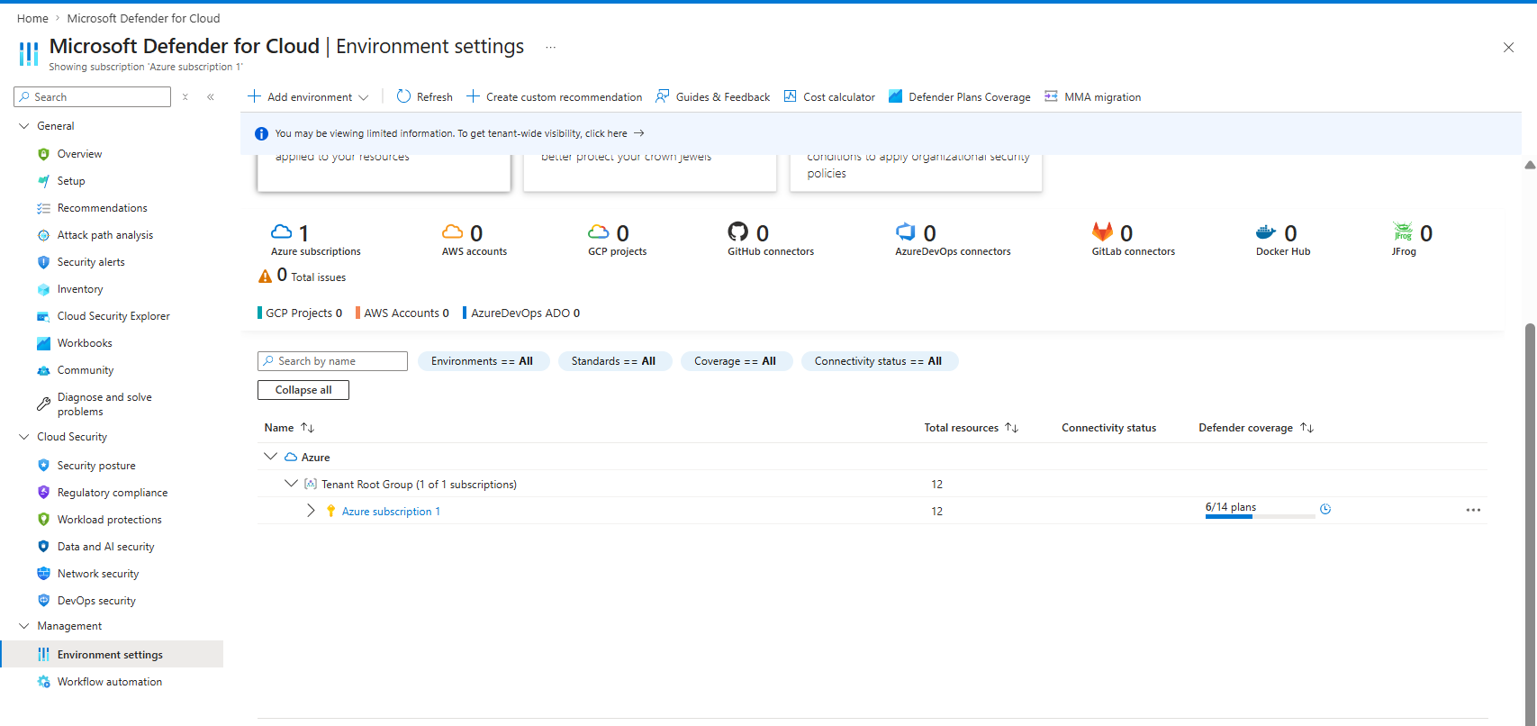
- To use defender for cloud we need to get in to Environment Setting and choose, what plan we require.
- 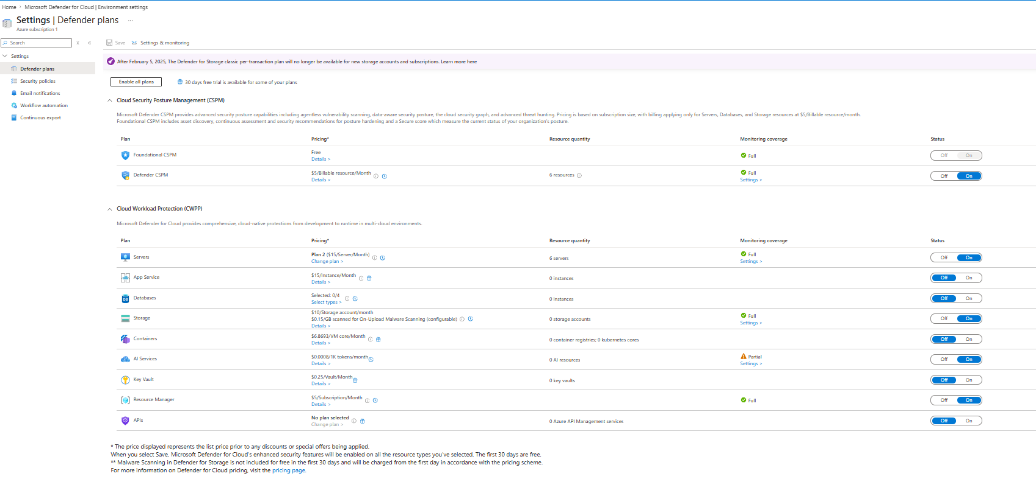
- 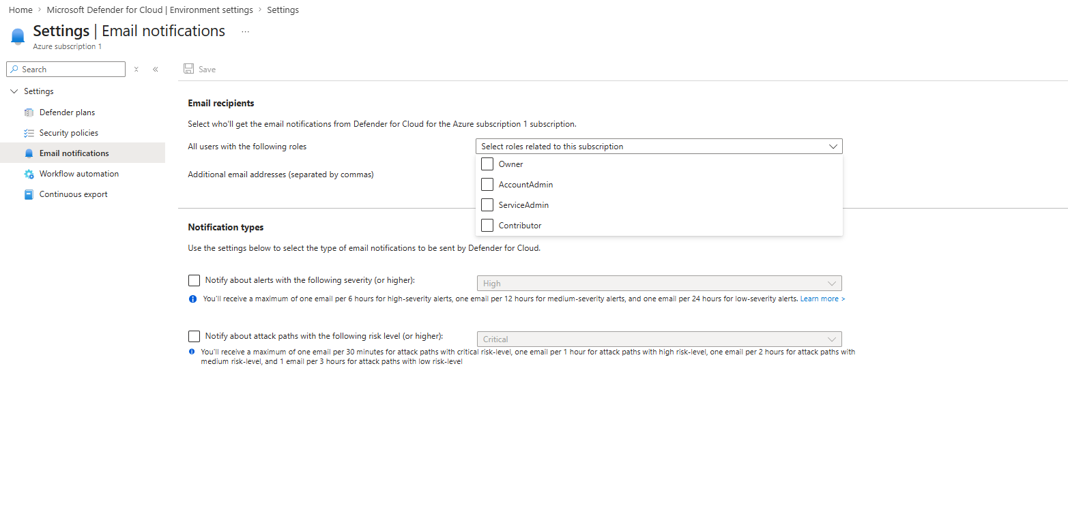we can send email notification to SOC monitoring team.
- We can add Policies and defender for cloud helps us know whether resources are compliant to the established policies like PCIDSS, HIPPA, CIS.

