______________________________________________ C Programming Mini Project Documentation
______________________________________________
1. Title Page

Project Title: ELECTRICAL BILL
Student Name: SIVAKUMAR T
Register Number: 921724115042
Department: CSD
College Name: SETHU INSTITUTE OF TECHNOLOGY
Course: Programming in C
Guide / Trainer Name: BALAJI B
Submission Date: 26-02-2026
______________________________________________

2. Abstract

The Electrical Bill Management System is a simple C program developed to calculate electricity bills based on the number of units consumed by a customer. The program accepts consumer details such as consumer number, name, and units consumed. Based on predefined slab rates, the program calculates the total bill amount including a fixed charge. This project demonstrates the use of conditional statements, user input handling, and basic arithmetic operations in C programming.
______________________________________________

3. Introduction

Electricity billing is an essential process used in households, industries, and commercial establishments. Manual calculation of electricity bills may lead to errors and inefficiencies.

This project solves the problem of calculating electricity bills automatically using slab-based tariff rates.

Why this project is useful:

Reduces manual calculation errors

Saves time

Demonstrates real-world application of C programming

Where it can be used:

Electricity board billing systems

Small-scale billing software

Academic learning purposes
______________________________________________

4. Objectives

Understand structured programming concepts

Use loops and conditional statements

Work with variables and functions

Improve logical thinking and problem-solving skills
______________________________________________

5. Tools & Technology

Programming Language: C

Compiler: GCC / Turbo C / CodeBlocks

Platform: Windows / Linux
______________________________________________

6. System Requirements
Hardware:

Basic computer with minimum 4GB RAM

Software:

C Compiler

Any IDE or Text Editor
______________________________________________

7. Methodology / Algorithm

Start the program

Display the title

Read consumer number

Read consumer name

Read units consumed

Check units consumed using conditional statements

Calculate bill according to slab rates

Add fixed charge

Display bill details

End program
______________________________________________

8. Flowchart
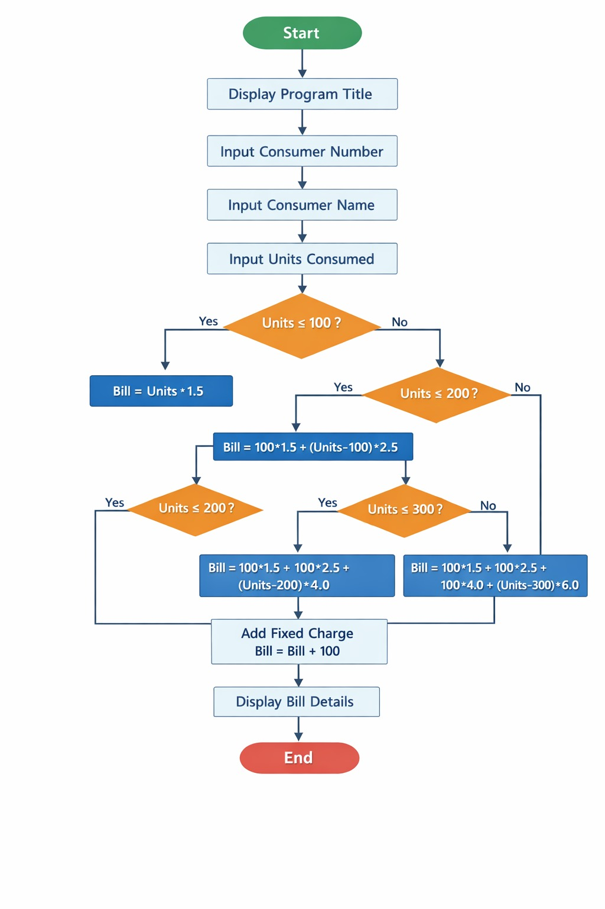
9. Program Code
#include <stdio.h>

int main()
{
int consumer_no;
char name[50];
float units, bill = 0, fixed_charge = 100;

printf("----- ELECTRICAL MANAGEMENT SYSTEM -----\n");

printf("Enter Consumer Number: ");
scanf("%d", &consumer_no);

printf("Enter Consumer Name: ");
scanf("%s", name);

printf("Enter Units Consumed: ");
scanf("%f", &units);

if (units <= 100)
{
bill = units * 1.5;
}
else if (units <= 200)
{
bill = (100 * 1.5) + (units - 100) * 2.5;
}
else if (units <= 300)
{
bill = (100 * 1.5) + (100 * 2.5) + (units - 200) * 4.0;
}
else
{
bill = (100 * 1.5) + (100 * 2.5) + (100 * 4.0) + (units - 300) * 6.0;
}

bill = bill + fixed_charge;

printf("\n----- BILL DETAILS -----\n");
printf("Consumer Number : %d\n", consumer_no);
printf("Consumer Name : %s\n", name);
printf("Units Consumed : %.2f\n", units);
printf("Total Bill : Rs. %.2f\n", bill);

return 0;
}
______________________________________________

10. Sample Input / Output
Sample Input:
Enter Consumer Number: 101
Enter Consumer Name: Ravi
Enter Units Consumed: 250
Sample Output:
----- BILL DETAILS -----
Consumer Number : 101
Consumer Name : Ravi
Units Consumed : 250.00
Total Bill : Rs. 900.00
______________________________________________

11. Result

The program executed successfully and calculated the electricity bill correctly based on the given slab rates.
______________________________________________

12. Applications

Learning C programming

Academic mini projects

Beginner-level billing system development
______________________________________________

13. Conclusion

The Electrical Bill Management System demonstrates basic C programming concepts such as input/output operations, conditional statements, arithmetic calculations, and structured program design. It provides a clear understanding of how real-world billing systems function.
______________________________________________

14. Future Enhancements

Add file handling to store customer records

Improve user interface

Add error validation

Convert into menu-driven program

Implement database connectivity
______________________________________________

15. References

C Programming Textbooks

Online C Programming Tutorials

Classroom Notes
______________________________________________

