User Authentication module:
Problem Statement:
Need to Build a User Authentication Module.
------------------------------------------------------------------------------------------------------

Tools and Technologies Used
- Spring Boot 2.3.1.RELEASE
- JDK 1.8
- Maven - 3.2+
- IDE - Eclipse or Spring Tool Suite (STS)
- MYSQL
- JAVA 8 Features
- Spring Security
------------------------------------------------------------------------------------------------------

Creating and Importing a Project
There are many ways to create a Spring Boot application. The simplest way is to use Spring Initializr at http://start.spring.io/, which is an online Spring Boot application generator.
We have specified the following details:
- Generate: Maven Project
- Java Version: 1.8 (Default)
- Spring Boot:2.3.1 Release
- Package Name: com.demo.authentication
- Packaging: jar (This is the default value)
- Dependencies: Web, JPA, MySQL, Security

Project Structure
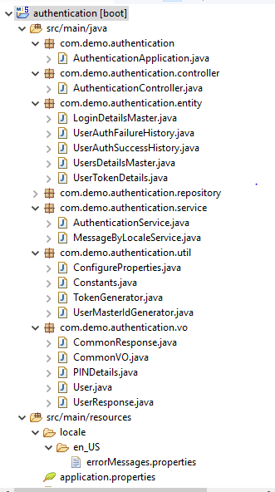
------------------------------------------------------------------------------------------------------

Database Create SQL Scripts
Table 1:
Main Table: login. users_details_master
This table is used to store the all Users information like Username, encrypted pass word etc.
CREATE TABLE `users_details_master` (
`system_id` varchar(30) NOT NULL,
`created_by` varchar(80) NOT NULL,
`created_on` datetime NOT NULL,
`modified_by` varchar(80) NOT NULL,
`modified_on` datetime NOT NULL,
`attempt_to_incorrect` int NOT NULL,
`last_updated_date` datetime DEFAULT NULL,
`password` varchar(150) NOT NULL,
`previous_password` varchar(150) NOT NULL,
`status` int NOT NULL,
`user_name` varchar(60) NOT NULL,
PRIMARY KEY (`system_id`)
) ENGINE=InnoDB DEFAULT CHARSET=utf8mb4 COLLATE=utf8mb4_0900_ai_ci;
Output:

Table 2 :
login.login_details_master;
This table is used to maintain the login information (UserName info as Email/Phone No). Its join with the table login. users_details_master. Key is system_id.
CREATE TABLE `login_details_master` (
`login_id` varchar(80) NOT NULL,
`created_by` varchar(80) NOT NULL,
`created_on` datetime NOT NULL,
`modified_by` varchar(80) NOT NULL,
`modified_on` datetime NOT NULL,
`system_id` varchar(30) DEFAULT NULL,
PRIMARY KEY (`login_id`),
KEY `FK4it48ncueb5hrke7necnic6g4` (`system_id`),
CONSTRAINT `FK4it48ncueb5hrke7necnic6g4` FOREIGN KEY (`system_id`) REFERENCES `users_details_master` (`system_id`)
) ENGINE=InnoDB DEFAULT CHARSET=utf8mb4 COLLATE=utf8mb4_0900_ai_ci;
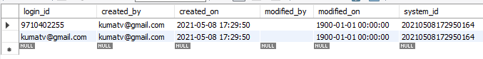
Note : We can able to use username as MobileNo/Email.

Table 3:
authentication.user_login_failure_history.
This is table is used to stored failure log information after failure authentication.

CREATE TABLE user_login_failure_history (
id bigint NOT NULL,
login_date datetime NOT NULL,
system_id varchar(30) NOT NULL,
user_name varchar(60) NOT NULL,
PRIMARY KEY (`id`)
) ENGINE=InnoDB DEFAULT CHARSET=utf8mb4 COLLATE=utf8mb4_0900_ai_ci;

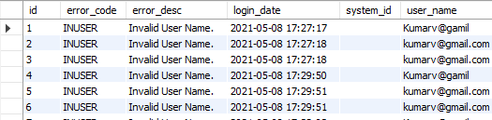

Table 4:
authentication.user_login_success_history.
This is table is used to stored successful log information after successful authentication.
CREATE TABLE user_login_success_history (
id bigint NOT NULL,
login_date datetime NOT NULL,
system_id varchar(30) NOT NULL,
user_name varchar(60) NOT NULL,
PRIMARY KEY (`id`)
) ENGINE=InnoDB DEFAULT CHARSET=utf8mb4 COLLATE=utf8mb4_0900_ai_ci;

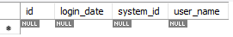

Table 5:
login.user_token_details
This table is used to stored the token details as per system id.(Unique value)
--------------------------------------------------------------------------------------------------
Token Generation Details:
Generate UUID token:
Class : TokenGenerator.class
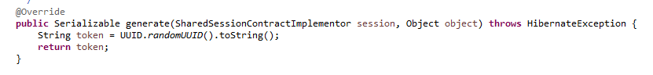
System Id Generation:
Class : UserMasterIdGenerator.class

Unique Id generation for Primary Key.
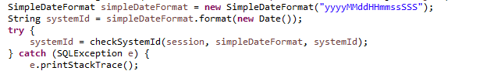
--------------------------------------------------------------------------------------------------

Spring Rest Controller - AuthController.java
Class : AuthenticationController.java
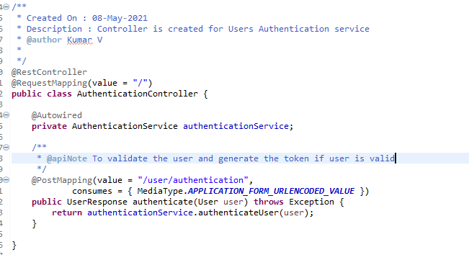

Spring Rest Service - AuthenticationService.java

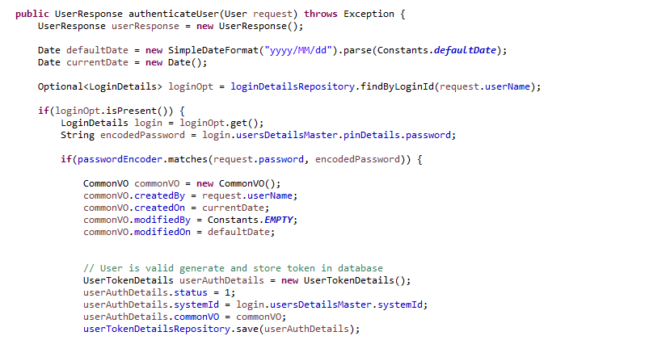
Tests :
Step 1 :
Need to do Maven build after import the Projects or run the class (UserMasterRepoTests.class) which has contains user details, Same details will be inserted into respective tables(users_details_master, login_details).
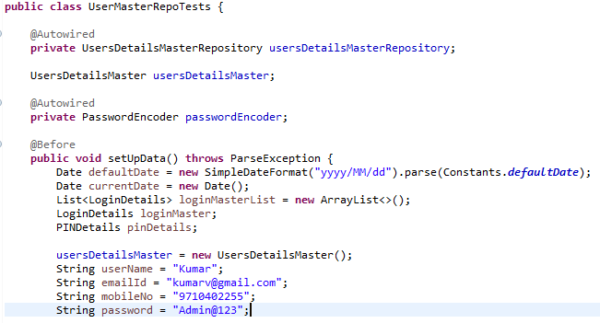

Step 2: Execute the Tests.
Test 1: Using Post Man
If User Name & Password is correct:
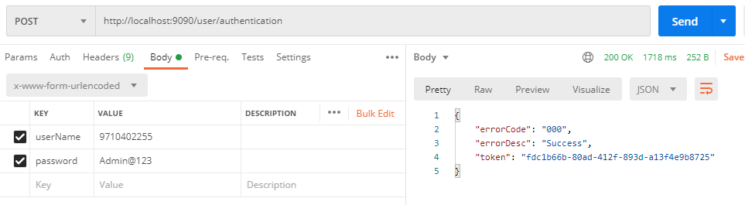

If valid UserName but Password is incorrect:
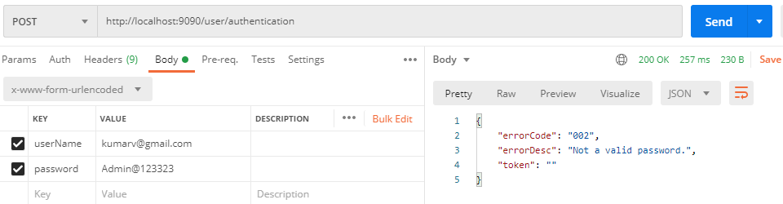

If username is incorrect:
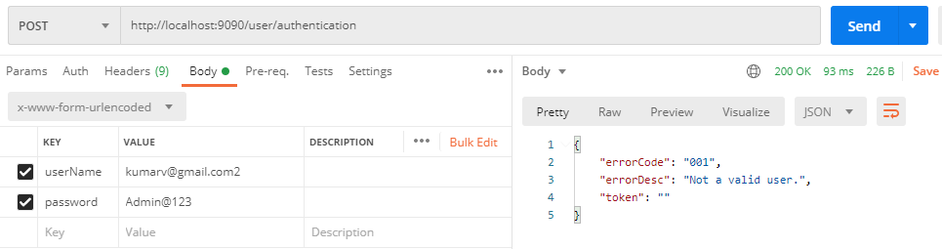

Test 2: JUNIT Test Cases:
Class : AutheniticationServiceImplTest.class

Success:
@Before
public void setUpData() {
user = new User();
user.userName = ("kumarv@gmail.com");
user.password = ("Admin@123");
}

@Test
public void verifyValidUser() throws Exception {
assertEquals("000", authenticationService.authenticateUser(user).errorCode);
}
-------------------------------------------------------------------------------------
INUSNM=Invalid User Name.
@Before
public void setUpData() {
user = new User();
user.userName = ("kumarv@gmail.com");
user.password = ("Admin@123");
}

@Test
public void verifyInvalidUser() throws Exception {
user.userName = ("Kumarv@gamil");
assertEquals("001", authenticationService.authenticateUser(user).errorCode);
}
-------------------------------------------------------------------------------------
INPASS=Invalid Password.
@Before
public void setUpData() {
user = new User();
user.userName = ("kumarv@gmail.com");
user.password = ("Admin@123");
}

@Test
public void verifyInvalidPassword() throws Exception {
user.password = ("ADMIN");
assertEquals("002", authenticationService.authenticateUser(user).errorCode);
}

