**Noise Pollution**

Noise pollution, also known as sound pollution, is the presence of unwanted, disturbing, or harmful sound in the environment. It can have various sources and can have negative effects on human health, well-being, and the environment. Here are some key aspects of noise pollution.

1. **Sources of Noise Pollution:**
   * **Transportation:** Road traffic, aircraft, trains, and ships are significant sources of noise pollution.
   * **Industrial Activities:** Factories, construction sites, and heavy machinery can generate high noise levels.
   * **Recreational Activities:** Events, concerts, and sports activities can create noise pollution.
   * **Community Noise:** Noise from neighbors, barking dogs, and other community-related sources.
2. **Effects on Health and Well-being:**
   * **Hearing Damage:** Prolonged exposure to high noise levels can lead to hearing loss.
   * **Stress and Anxiety:** Noise pollution can cause stress, anxiety, and disrupt sleep patterns, leading to various health issues.
   * **Communication Issues:** Excessive noise can interfere with communication and cause irritability.
3. **Environmental Impact:**
   * **Wildlife:** Noise pollution can disrupt ecosystems and affect wildlife, particularly species that rely on acoustic communication.
   * **Urban Development:** Noise pollution can limit the quality of life in urban areas and affect property values.
   * **Regulatory Measures:** Many countries have noise pollution regulations to limit noise levels in specific areas and during specific times.
4. **Measurement and Control:**
   * Noise pollution is typically measured in decibels (dB), and various regulations set permissible noise levels for different environments.
   * Control measures include using noise barriers, noise-reducing technologies, zoning regulations, and noise insulation in buildings.
5. **Prevention and Mitigation:**
   * Land-use planning can help separate noisy areas from quiet ones, preventing conflicts.
   * Education and awareness programs can inform the public about the effects of noise pollution.
   * Technological advancements, such as quieter transportation and machinery, can help reduce noise emissions.
6. **Personal Protection:**
   * Individuals can protect themselves from noise pollution by using hearing protection devices like earplugs and earmuffs.
   * Minimizing exposure to loud environments, especially in leisure activities, can reduce the risk of hearing damage.

Efforts to reduce and control noise pollution are essential for maintaining a healthy and peaceful living environment. Local governments and regulatory agencies play a significant role in establishing and enforcing noise regulations, while individuals can also contribute by being mindful of their noise emissions and supporting noise reduction initiatives.



Innovation ideas:

1. Sustainable Energy Solutions: Develop innovative methods for harnessing renewable energy sources like solar, wind, or tidal power to address the global energy crisis and reduce carbon emissions.
2. Healthcare Technology: Create cutting-edge healthcare devices, such as wearable health monitors, telemedicine platforms, or AI-driven diagnostic tools to improve patient care and access to medical services.
3. Sustainable Agriculture: Develop technology and techniques for more efficient and sustainable farming, including precision agriculture, vertical farming, or using biotechnology to enhance crop yields while reducing environmental impact.
4. Clean Water Access: Innovate solutions for providing clean and accessible drinking water, like advanced filtration systems or water purification technologies.
5. Education Technology: Develop interactive and personalized learning platforms, virtual classrooms, or tools to enhance remote learning experiences.
6. Transportation Solutions: Create electric or autonomous vehicles, traffic management systems, or infrastructure innovations to reduce traffic congestion and emissions.
7. Sustainable Materials: Work on eco-friendly materials and manufacturing processes that reduce waste, promote recycling, and lower the carbon footprint of various industries.
8. Artificial Intelligence and Machine Learning: Explore AI and ML applications across industries, from enhancing customer service to optimizing supply chains and predicting disease outbreaks.
9. Space Exploration: Innovate in space technology, satellite communication, or planetary exploration to expand our understanding of the universe and advance human space travel.
10. Environmental Monitoring: Develop sensors and data analysis tools to monitor and combat environmental issues like air pollution, deforestation, and climate change.

Remember that successful innovation often involves identifying specific problems or needs in your area of interest and then brainstorming creative solutions.

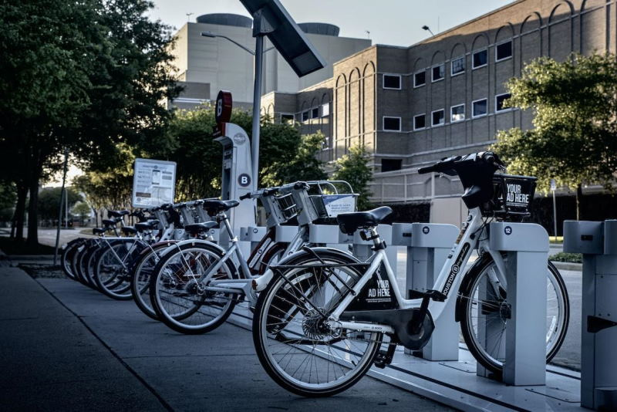

**1. Sustainable Energy Solutions:**

* Develop affordable and efficient solar energy storage systems for homes and businesses.
* Innovate wave or tidal energy harvesting technologies for renewable power generation.
* Create smart grids and energy management systems to optimize electricity usage.

**2. Healthcare and Wellness:**

* Develop wearable devices for continuous health monitoring and early disease detection.
* Create AI-powered platforms for personalized healthcare recommendations based on genetics and lifestyle.
* Design virtual reality (VR) therapies for mental health treatments and rehabilitation.

**3. Education and E-Learning:**

* Develop interactive and immersive e-learning platforms using augmented reality (AR) and VR technologies.
* Create AI-driven personalized learning apps to cater to individual student needs.
* Establish online platforms for skill-based learning and certifications in emerging fields.

**4. Environmental Sustainability:**

* Innovate biodegradable packaging materials to reduce plastic pollution.
* Develop efficient methods for recycling and repurposing electronic waste (e-waste).
* Create smart agriculture technologies using IoT devices for precision farming and water conservation.

**5. Transportation and Urban Mobility:**

* Develop autonomous vehicle technology for safer and more efficient transportation.
* Create bike-sharing or scooter-sharing programs with a focus on eco-friendly commuting.
* Implement traffic management systems using AI to reduce congestion and improve flow.

**6. Social Impact and Community Development:**

* Develop low-cost housing solutions using sustainable materials for disadvantaged communities.
* Create platforms connecting volunteers with local community projects, enhancing social engagement.
* Develop apps to facilitate food donation from restaurants and individuals to reduce food waste.

**7. Data Security and Privacy:**

* Innovate blockchain-based solutions for secure and private online transactions.
* Develop AI-driven cybersecurity tools to detect and prevent sophisticated cyber threats.
* Create user-friendly encryption tools for protecting sensitive data on personal devices.

**8. Mental Health and Well-being:**

* Develop AI chatbots or apps offering mental health support and counseling services.
* Create mindfulness and meditation apps with personalized features for stress reduction.
* Establish virtual support communities for individuals dealing with specific mental health challenges.

Remember, the key to successful innovation lies not just in the idea itself, but in its execution and the value it brings to users or society.