Bank Customer Churn Analysis Dashboard
Business Analysis Report
Prepared by: Vicky Kumar / Dataset: Bank Customer Churn Dataset — Kaggle-based, synthetically dirtied, 48,730 customer records
1. Objective:
This project analyzes a bank customer churn dataset to identify the key drivers of customer attrition, transforming raw customer-level data into an interactive Excel dashboard for churn monitoring. The goal was to practice SQL-based data cleaning and transformation, KPI design, pivot table analysis, and dashboard design skills relevant to a data analytics role.

2. Data Quality Issues:
- Geography, Gender, Card Type, and Account Type fields had inconsistent, messy category labels that needed standardizing before analysis.
- Last Transaction Date had mixed date formats, and a portion of records had it missing entirely rather than just malformed.
- Duplicate records were present and needed to be identified and removed.
- Outlier values were present in fields such as Age and Balance.
- No pre-built risk segmentation existed in the raw data — Age Band, Balance Band, and a High Churn Risk Flag all had to be derived.
3. Methodology:
Raw data was cleaned and transformed in SQL Server Management Studio (SSMS). Duplicate rows were identified using ROW NUMBER () and removed. Outlier values in Age and Balance were flagged rather than deleted, preserving them transparently rather than silently dropping records. Last Transaction Date was parsed into a clean date field, and where the date could not be recovered, it was left as null and marked with a separate Last Transaction Missing Flag instead of being filled with a placeholder, since averaging or guessing a date would have distorted any recency-based analysis. Geography, Gender, Card Type, and Account Type were standardized into clean categorical fields, with unrecognized entries grouped as "Unknown" rather than discarded. A clean analysis table, churn cleaned, was then built with derived fields — Age Band, Balance Band, and High Churn Risk Flag. Ten KPIs were calculated in Excel via pivot tables, validated against equivalent SQL aggregate queries, and assembled into a single interactive dashboard with a left-hand navigation sidebar, KPI cards, charts, and a slicer-based filter panel (Gender, Geography, Card Type, Account Type).

4. Dashboard Screenshot:
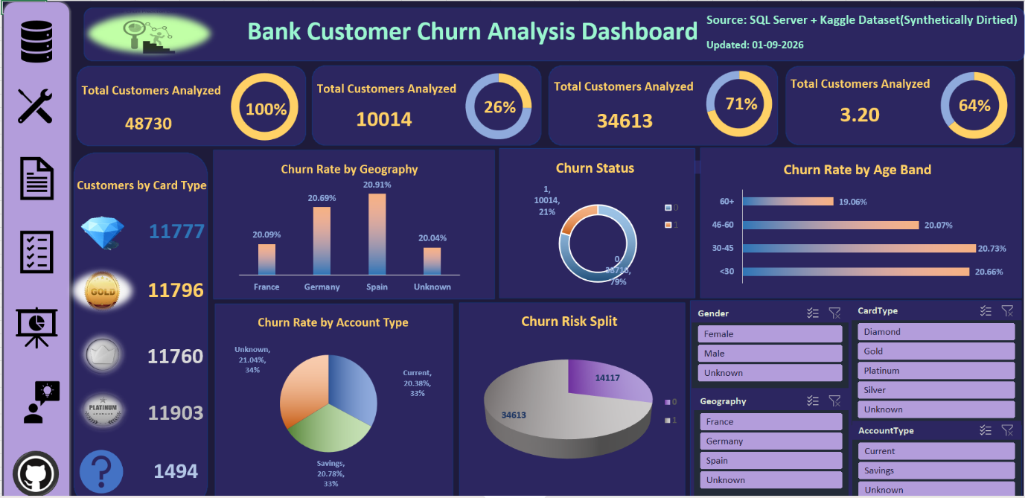
5. Key Findings:
Insight 1: Churn doesn't change much across common factors
Churn rate stays around 19–21% no matter which country (France 20.09%, Germany 20.69%, Spain 20.91%), age group (under 30: 20.66%, 60+: 19.06%), or account type (Current 20.38%, Savings 20.78%) you look at.
So what: Geography, age, and account type don't explain who leaves. The bank needs to look at behaviour data, like activity level, complaints, or satisfaction score, to find the real reason customer churn.
Insight 2: About 1 in every 5 customers has left the bank
Out of 48,730 customers, 10,014 have churned. That's 21%, which is high for a bank. A healthy churn rate is usually 5–10%.
So what: This isn't a small, isolated problem. Retention needs to become a bank-wide priority, not just a fix for one group of customers.
Insight 3: A large share of customers are already flagged as high churn risk
Around 14,117 customers, 29% of the base, are marked high-risk for churn.
So what: That's too many customers to treat the same way. The bank should rank them further, for example high-risk customers with high balances should get priority attention first.
Insight 4: Customer satisfaction is only average, not strong
The average satisfaction score is 3.20 out of 5, which is 64%.
So what: There's clear room to improve service. It's worth checking whether low-satisfaction customers are the same ones churning. If they are, satisfaction becomes an early-warning signal for who might leave next.
Insight 5: No single card tier stands out in size
Diamond, Gold, Platinum, and silver cardholders are almost equally split, roughly 11,700 to 11,900 customers each. Only a small group of 1,494 has no card type recorded.
So what: Card tier alone is unlikely to be driving churn, since the groups are so evenly sized. It's still worth checking the churn rate within each tier separately, since headcount and churn rate are different questions.
6. Recommendations:
- Investigate Behavioural and service signals — satisfaction score, complaints, and activity status — as the likely real drivers of churn, since demographic and account-type splits show almost no variation.
- Prioritize the 14,117 flagged high-risk customers by value (balance, products held) rather than treating the whole group the same way.
- Review overall service quality — an average satisfaction score of 3.20 out of 5 across the base leaves room to improve, and may be linked to churn.
- Fix data capture for Geography, Account Type, and Card Type at the source, so the "Unknown" segments shrink over time and don't need to be estimated after the fact.
- Treat the 21% overall churn rate as a portfolio-wide issue and revisit retention strategy broadly, rather than only targeting a specific segment.

7. Case Study with Stakeholder:
Stakeholder: Head of Customer Retention
"We know we're losing customers, but I can't tell if it's a specific segment we're failing, or if it's happening everywhere. I need to know where to focus first."
Approach
Cleaned and standardized a 48,730-record customer dataset in SQL Server, removing duplicates, flagging outliers transparently instead of removing them, and deriving Age Band, Balance Band, and High Churn Risk Flag fields. Built a single-page Excel dashboard with slicers so the stakeholder could filter by gender, geography, card type, and account type, and see live churn exposure across the customer base.
Findings
The dashboard showed that churn is remarkably even, around 20–21%, across geography, age band, and account type, meaning none of these alone explains why customers leave. Overall churn stands at 21% of the base, well above a healthy benchmark, and 29% of customers are already flagged high-risk. Average satisfaction sits at only 3.20 out of 5, a plausible link to why customers are leaving even though it doesn't show up in the demographic splits.
Recommendation
The Head of Customer Retention should shift focus away from demographic targeting, since it doesn't explain churn here, and toward behavioural and service signals instead — starting with the 14,117 high-risk customers, prioritized by value, and a closer look at what's driving the below-par 3.20 satisfaction score.

