HAZOP Risk Analysis Dashboard
Business Analysis Report
Prepared by: Vicky Kumar / Dataset: HAZOP Risk Register — Synthetic dataset (164 entries), generated for data cleaning practice
1 Objective:
This project cleans and analyzes a HAZOP (Hazard and Operability Study) risk register from a chemical process plant, transforming an inconsistent raw dataset into an interactive Excel dashboard. The goal was to practice real-world data cleaning, Power Query transformations, pivot table analysis, and dashboard design skills relevant to a data analytics role.
2 Data Quality Issues:
• Study Date was recorded in five different formats within the same column.
• Text fields (Node, Status, Safeguard, etc.) had inconsistent casing and near-duplicate values, e.g. "Open" vs "open" vs "OPEN".
• Severity and Likelihood were recorded as a mix of numeric values (1-5) and text labels (High/Medium/Low).
• Missing values were spread across Node, Parameter, Guide Word, Cause, Consequence, and Safeguard fields.
• Duplicate rows and duplicate HAZOP IDs were present in the raw data.
• Risk Rating values were malformed text concatenations (e.g. "3x4") instead of calculated numbers.
3 Methodology:
Raw data was cleaned in Power Query — dates were standardized using a locale-fallback formula, text fields were trimmed and standardized, and missing values were labeled transparently (e.g., "Not Documented") rather than deleted. Severity and Likelihood were mapped to a common 1-5 scale, and Risk Rating was recalculated as Severity × Likelihood. Twelve independent pivot tables were built to power four KPI cards and eight charts, assembled into a single interactive dashboard with slicers and a date timeline.

4. Dashboard Screenshot:
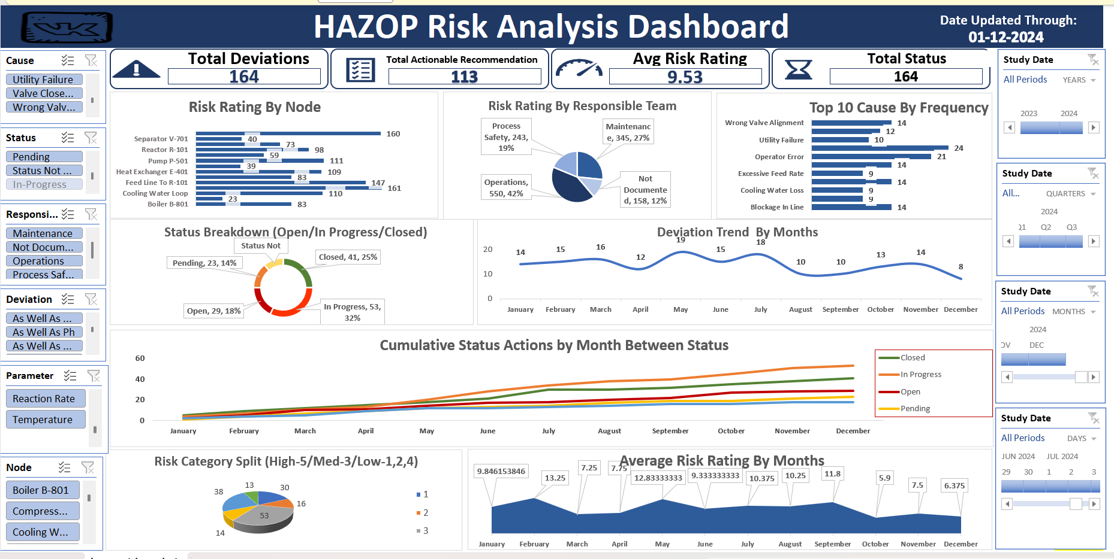
5. Key Findings:
Insight 1: Feed Line to R-101 and Separator V-701 carry the highest risk
These two spots have risk scores of 161 and 160 — the highest across all equipment. Boiler B-801 sits at the bottom (83), so it's the safest by comparison. These two areas should be first on the inspection list.
Insight 2: Operations are handling more risk than the safety team
Operations cover 42% of the total risk-weighted workload, while Process Safety — whose actual job is to manage risk — only handles 19%. Worth asking why more of this isn't going to the specialized team.
Insight 3: A small set of causes keep repeating
Utility Failure (24) and Operator Error (21) show up way more than anything else. These aren't one-off accidents — they're recurring patterns, which usually means better training or maintenance schedules could cut a good chunk of them out.
Insight 4: Only 1 in 4 risks actually gets fully closed
Open (18%) and In Progress (32%) together make up half of all cases. Only 25% are marked Closed. For every four risks identified, only about one is actually resolved.
Insight 5: 1 in 8 risks has nobody responsible for it
158 entries (12%) have no team assigned at all. Without an owner, these are the ones most likely to slip through the cracks and never get followed up on.
Insight 6: The backlog keeps growing month after month
Looking at the cumulative trend, In Progress and Open cases keep climbing faster than Closed ones. The gap between what's found and what's fixed keeps widening — not a good sign if it keeps going.

6 Recommendations:
• Prioritize inspection and mitigation resources on Feed Line to R-101 and Separator V-701, the two highest-risk nodes.
• Reassess workload distribution between Operations and Process Safety so specialized risk owners handle more high-risk items.
• Target recurring causes — Utility Failure and Operator Error — with focused training and preventive maintenance.
• Set a review cadence to close the backlog of Open/In Progress actions faster than new ones are identified.
• Make the Responsible Team field mandatory going forward so no identified risk is left without an owner.
7. Case Study with Stakeholder:
Stakeholder: Plant Safety Manager
"Our HAZOP backlog keeps growing every month and I don't know which equipment needs attention first, or why our follow-up rate on identified risks is so low."
Approach
Cleaned and standardized a 164-entry HAZOP dataset in Power Query, categorized every deviation by Node, Responsible Team, and Status, and built a single-page dashboard with slicers so the manager could filter by equipment, team, or date range and see live risk exposure and backlog status.
Findings
The dashboard showed that Feed Line to R-101 and Separator V-701 carry the highest cumulative risk, that Operations is carrying more risk-weighted workload than the specialized Process Safety team, and that only 1 in 4 identified risks are fully closed — with the backlog of Open and In Progress items widening month over month.
Recommendation
Process Safety should take direct ownership of the highest-risk nodes (Feed Line to R-101, Separator V-701), and the Responsible Team field should become mandatory at the point of data entry so no identified risk is left without a clear owner — this alone would remove the 12% of cases that currently have nobody assigned to follow up on them.

