Loan Default & Credit Risk Analysis Dashboard
Business Analysis Report
Prepared by: Vicky Kumar / Dataset: Credit Risk Dataset — Kaggle (laotse/credit-risk-dataset), 32,574 loan records
1. Objective:
This project analyzes a loan default and credit risk dataset to identify the key drivers of default risk in a lending portfolio, transforming raw loan-level data into an interactive Excel dashboard for credit risk monitoring. The goal was to practice SQL-based data cleaning and transformation, KPI design, pivot table analysis, and dashboard design skills relevant to a data analytics role.
2. Data Quality Issues:
- The dataset had no unique loan identifier at all — a loan id column was added from scratch, since individual records could not be tracked or joined reliably without one.
- Employment Length (person emp length) and Interest Rate (loan int rate) had missing values scattered across records.
- Outlier values were present in fields such as Age, Income, and Employment Length (e.g., implausible ages and employment lengths).
- No pre-built risk segmentation existed in the raw data — Income Band, Age Band, and High-Risk Grade Flag all had to be derived.
3. Methodology:
Raw data was cleaned and transformed in SQL Server Management Studio (SSMS). Since the raw dataset had no identifier column, a random unique 9-digit loan id was generated and added for every record to enable reliable tracking. Outliers were flagged rather than deleted, preserving them transparently in a credit risk flagged table, and missing Employment Length and Interest Rate values were filled using the grade-wise median. A clean analysis table, credit risk clean, was then built with derived fields — Income Band, Age Band, and High-Risk Grade Flag — excluding the flagged outlier rows. Ten KPIs were calculated in Excel via pivot tables and assembled into a single interactive dashboard with a left-hand navigation sidebar, KPI cards, charts, and a slicer-based filter panel.

4. Dashboard Screenshot:
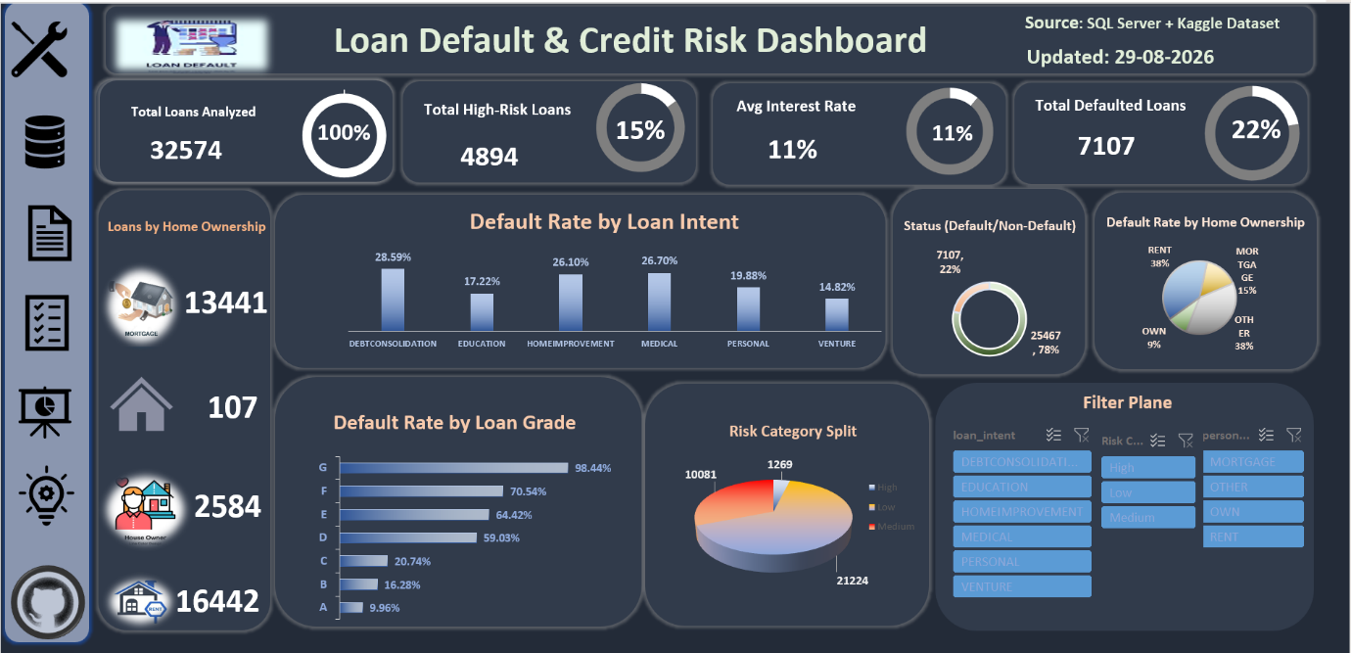

5. Key Findings:
Insight 1: Lower loan grades have much higher default rates
Grade A loans default only 9.96% of the time. Grade G loans default 98.44% of the time — almost all of them.
So what: Grade F and G loans are very risky. The company should either stop giving these loans or ask for extra security before approving them.
Insight 2: People who rent are more likely to default
Renter default 38% of the time. People who own their home default only 9% of the time.
So what: When approving a loan, the company should pay more attention to whether the person rents or owns a home.
Insight 3: The reason for the loan affects the risk too
Loans taken to pay off other debts (debt consolidation) default the most, at 28.59%. Loans taken to start a business default the least, at 14.82%.
So what: People asking for debt consolidation loans may already be in financial trouble. These applications need extra checking.
Insight 4: About 1 in every 5 loans is defaulting
Out of 32,574 loans, 7,107 have defaulted. That's 22%, which is much higher than a normal, healthy rate (3-5%).
So what: The company's loan approval rules may be too loose overall, not just for one group of borrowers.
Insight 5: A small group of loans is causing most of the problems
Only 15% of loans are marked "high-risk," but these loans have default rates between 59% and 98%.
So what: If the company reduces or removes these high-risk loans, the overall default rate could drop a lot.
Insight 6: Almost one-third of all loans are high-risk
21,224 loans are low-risk, and 10,081 are high-risk. That means around 31% of the total loans are risky.
So what: This is too much risk in one place. The company should spread out its risk or charge different rates based on risk level.
Insight 7: Interest rates don't change much even when risk is very different
Grade A loans (very safe, 9.96% default) and Grade G loans (very risky, 98.44% default) are both charged around the same interest rate, about 11%.
So what: The company should charge higher interest rates for riskier loans. This would help cover the losses from loans that don't get repaid.
6. Recommendations:
- Tighten or restrict lending to Grade F and G borrowers, or require additional collateral before approval.
- Weight home ownership status more heavily in the approval decision, given the gap between renter and owner default rates.
- Apply extra scrutiny to debt-consolidation applications, since they carry the highest default rate by loan purpose.
- Review overall approval criteria — a 22% portfolio-wide default rate points to a systemic issue, not an isolated segment.
- Introduce risk-based pricing so interest rates rise with grade and risk category, rather than staying flat across the board.
7. Case Study with Stakeholder:
Stakeholder: Head of Credit Risk
“Our default rate keeps climbing and I don’t have a clear view of which loans are driving it, or whether our pricing actually reflects the risk we’re taking on.”
Approach
Cleaned and standardized a 32,574-record loan dataset in SQL Server, generating a unique loan id for tracking, flagging outliers transparently instead of removing them, and deriving Income Band, Age Band, and High-Risk Grade Flag fields. Built a single-page Excel dashboard with slicers so the stakeholder could filter by loan grade, intent, and home ownership and see live default exposure across the portfolio.

Findings
The dashboard showed that default risk is heavily concentrated in Grade F/G loans and renters, that debt-consolidation loans default more than any other loan purpose, and that the portfolio's overall 22% default rate is well above a healthy benchmark — driven largely by the 15% of loans flagged high-risk, which default at rates of 59-98%. Interest rates, however, stay roughly flat across grades, so pricing isn't compensating for this risk.
Recommendation
The Head of Credit Risk should tighten approval criteria for Grade F/G and renter segments, require extra documentation for debt-consolidation applications, and move to risk-based pricing so interest rates scale with loan grade — this alone would help interest income properly cover the losses from the riskiest 15% of the book.

