Data Varidation Sheet
KPI SQL QUERY
1.Total Loans Analyzed:
SELECT COUNT(*) AS Total_Loans_Analyzed FROM credit_risk_cleaned;
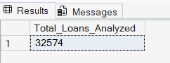
2. Total High-Risk Loans:
SELECT SUM(High_Risk_Grade_Flag) AS Total_High_Risk_Loans FROM credit_risk_cleaned;
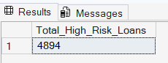
3. Average Risk Rating (Avg Interest Rate):
SELECT CAST(AVG(loan_int_rate) AS DECIMAL(5,2)) AS Avg_Risk_Rating FROM credit_risk_cleaned;
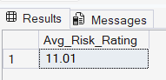
4. Total Defaulted Loans:
SELECT SUM(CAST(loan_status AS INT) ) AS Total_Defaulted_Loans FROM credit_risk_cleaned;
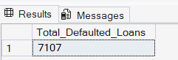
5. Loans by Home Ownership:
SELECT person_home_ownership, COUNT(*) AS Total_Loans FROM credit_risk_cleaned
GROUP BY person_home_ownership ORDER BY Total_Loans DESC;
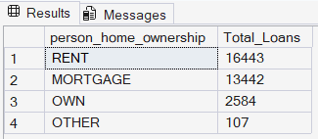
6. Default Rate by Loan Grade:
SELECT loan_grade, CAST(AVG(CAST(loan_status AS FLOAT))*100 AS DECIMAL(5,2)) AS Default_Rate_Pct
FROM credit_risk_cleaned GROUP BY loan_grade ORDER BY loan_grade;
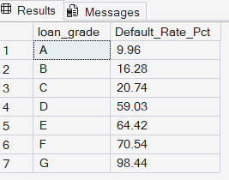
7. Default Rate by Loan Intent:
SELECT loan_intent, CAST(AVG(CAST(loan_status AS FLOAT))*100 AS DECIMAL(5,2)) AS Default_Rate_Pct
FROM credit_risk_cleaned GROUP BY loan_intent ORDER BY Default_Rate_Pct DESC;
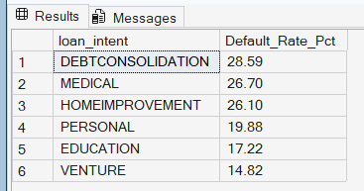
8. Status Breakdown (Default / Non-Default):
SELECT CASE WHEN loan_status = 1 THEN 'Default' ELSE 'Non-Default' END AS Status,
COUNT(*) AS Total_Loans FROM credit_risk_cleaned GROUP BY loan_status;
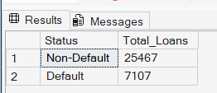
9. Default Rate by Home Ownership:
SELECT person_home_ownership,
CAST(AVG(CAST(loan_status AS FLOAT))*100 AS DECIMAL(5,2)) AS Default_Rate_Pct
FROM credit_risk_cleaned GROUP BY person_home_ownership;
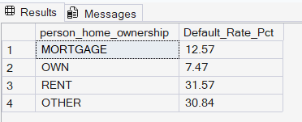
10. Risk Category Split (Low/Med/High):
SELECT
CASE
WHEN loan_grade IN ('A','B') THEN 'Low'
WHEN loan_grade IN ('C','D') THEN 'Medium'
ELSE 'High'
END AS Risk_Category,
COUNT(*) AS Total_Loans
FROM credit_risk_cleaned
GROUP BY
CASE
WHEN loan_grade IN ('A','B') THEN 'Low'
WHEN loan_grade IN ('C','D') THEN 'Medium'
ELSE 'High'
END;
