Retail Store Sales Dashboard
Business Analysis Report
Prepared by: Vicky Kumar / Dataset: Retail Store Sales (Kaggle)
1. Objective
This project analyzes retail store transaction data to understand key revenue drivers across product categories, sales channels, and payment methods, while identifying data quality issues that affect the reliability of the analysis. The goal is to translate raw transaction-level data into an interactive dashboard and a set of actionable business findings.
2. Data Quality Issues Found
Before cleaning, the raw dataset (12,575 rows) contained missing values across several columns, summarized below:
Column |  | Missing % (Before Cleaning)
Discount Applied | 33.39%
Item | 9.65%
Price Per Unit | 4.84%
Quantity | 4.80%
Total Spent | 4.80%
Payment Method | 0%
Location | 0%
Transaction Date | 0%
Customer ID | 0%
Category | 0%

Discount Applied had the highest missing rate (33.4%), followed by Item (9.6%) and the numeric fields Price Per Unit, Quantity, and Total Spent (4.8% each). Missing values were not deleted, since each row still carried valid transaction data. Instead: categorical gaps (Item, Payment Method, Location, Discount Applied) were labeled 'Unknown' or 'Not Applicable', and numeric gaps were derived where possible using the relationship Total Spent = Quantity × Price Per Unit.
3. Methodology
- Data collected from Kaggle (Retail Store Sales — Dirty for Data Cleaning) and imported into Excel via Power Query for a refreshable, live connection.
- Profiled using Power Query's Column Quality, Column Distribution, and Column Profile tools to identify nulls, duplicates, and data types across the full dataset.
- Cleaned by handling missing values, correcting data types, and extracting Year, Quarter, Month Name, Day Name, and Week of Year from Transaction Date.
- Converted to a structured Excel Table for reliable pivot table and chart refresh.
- Built 10 pivot tables — 4 supporting the KPI number cards (Total Revenue, Total Transactions, Average Transaction Value, Total Quantity Sold) and 6 feeding the dashboard charts (Category, Item, Location, Payment Method, Discount status, and Monthly Trend).

- Added 4 separate Timeline slicers (Year, Quarter, Month, and Day) based on Transaction Date, allowing date filtering at different levels of granularity.
Assembled an interactive dashboard with 4 KPI cards, 6 charts, and category-based slicers (Category, Item, Payment Method, Location, Discount Applied) alongside the 4 date timelines
4. Dashboard
The findings above are drawn from the interactive dashboard shown below, which includes KPI summary cards, category and item breakdowns, channel and payment splits, discount impact, and a monthly revenue trend — all filterable by Category, Item, Payment Method, Location, Discount status, Year, Quarter, Month, and Day.
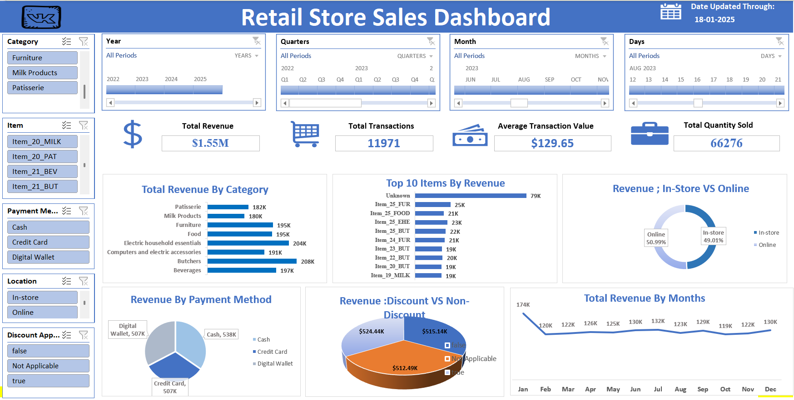
5. Key Findings
Insight 1: Daily-use categories drive the most revenue
Butchers (₹208K) and Electric Household Essentials (₹204K) bring in the most revenue. Interestingly, Milk Products (₹180K) — something people buy often — actually brings in the least. This suggests customers spend more per visit on Butchers and Electronics, even if they buy Milk more frequently. Bundling small daily items with higher-value products could help increase the average order size.
Insight 2: In-store and online sales are almost equal
In-store (49%) and Online (51%) are nearly split down the middle. Neither channel is being ignored, which is a good sign for the business. Since both are performing similarly, the store could test different promotions on each channel separately without worrying about hurting the other.
Insight 3: Customers don't favor one payment method
Cash (₹538K), Credit Card (₹507K), and Digital Wallet (₹507K) are all close in value. Customers seem comfortable using any payment method, so there's no real need to push one option over another right now.
Insight 4: Discounts aren't clearly boosting sales
Revenue from discounted orders (₹512K) and non-discounted orders (₹515K) are almost the same. This raises a fair question — are discounts actually bringing in more sales, or are they just cutting into profit on purchases that would have happened anyway? To really know for sure, the store could run a simple A/B test — offer a discount on a set of products for a while, keep another similar set at full price, then compare how each group performs. That would give a much clearer answer than looking at past data alone.
Insight 5: A lot of discount data is missing
Here's something odd — the single biggest chunk of revenue (₹524K) comes from orders where nobody even recorded whether a discount was applied or not. It's marked "Not Applicable," and it's bigger than both the "discount given" and "no discount" groups combined would suggest. This isn't really a sales pattern, it's more likely a gap at the billing counter — someone isn't filling this field in consistently. Until that gets fixed, it's hard to fully trust the discount findings above, since we're missing context on a third of all orders.
Insight 6: Many products aren't being tracked properly
The top-selling "item" in the data isn't a real product — it's just labeled "Unknown" (₹79K). This means a good chunk of sales can't be linked to an actual product, which makes it hard to know which items are truly the best sellers.
Insight 7: January stands out with a revenue spike
Revenue is way higher in January (₹174K) compared to the rest of the year, which mostly stays between ₹119K and ₹131K. October is the lowest point (₹119.41K). This is a bit unusual — normally you'd expect December to be the strongest month for retail, not January. It might be worth checking if there was some kind of promotion or New Year rush that caused this. Going forward, the store could stock up more before January and maybe run small promotions in slower months like October and February to even things out.

6. Recommendations
- Investigate why 33% of transactions lack a recorded discount status — likely a point-of-sale data capture gap rather than a true business pattern.
- Fix item-level tracking before making product decisions, since 'Unknown' is currently the top revenue-generating line item.
- Run a controlled discount test (same items, with and without discount) since discounted and non-discounted revenue are nearly equal — current discounting may not be driving incremental sales.
- Explore category-specific bundling for high-frequency, lower-value categories like Milk Products to lift average transaction value.
- Continue monitoring the In-store vs Online balance so future marketing spend is not skewed toward the channel that already performs well.
7. Case Study with Stakeholder:
Stakeholder: Store Operations Manager
"Our discount strategy has been running for a while now. Is it actually helping us sell more, or is it just cutting into our profit? And separately — why do a third of our transactions have no discount record at all?" — Store Operations Manager

Approach
- Cleaned and profiled all 12,575 transactions, flagging columns with high rates of missing data.
- Built a pivot comparison of revenue from discounted vs. non-discounted transactions.
- Separately examined the transactions with no discount status recorded, to check whether this was a data issue or a real pattern.
What I Found
- Discounted transactions brought in ₹512K, non-discounted brought in ₹515K — essentially no difference.
- ₹524K in revenue — the single largest slice — came from transactions where discount status was never recorded at all.
- This missing data is spread in a way that looks like a checkout-process gap, not a deliberate business decision.
Recommendation
- I'd hold off on expanding the discount strategy for now— the data doesn't show it's driving extra sales.
- I'd suggest running an A/B test: apply discounts to one set of products and not another, over the same time period, then compare.
- I’d fix the point-of-sale process so every transaction logs discount status — without this, future analysis will keep running into the same blind spot.
- I'd revisit these numbers again in 60 days, once cleaner data is coming in, to make a more confident call.

