CodeScanner Application Overview

One liner summary
CodeScanner turns a ZIP archive or public GitHub repository into a prioritized AI code review by running bug, security, and test specialists in parallel and consolidating their findings into a downloadable report.

Architecture overview
The application combines a React chat interface with a FastAPI backend and a LangGraph review workflow. REST handles submissions and downloads; WebSocket events keep the interface updated as the review progresses.
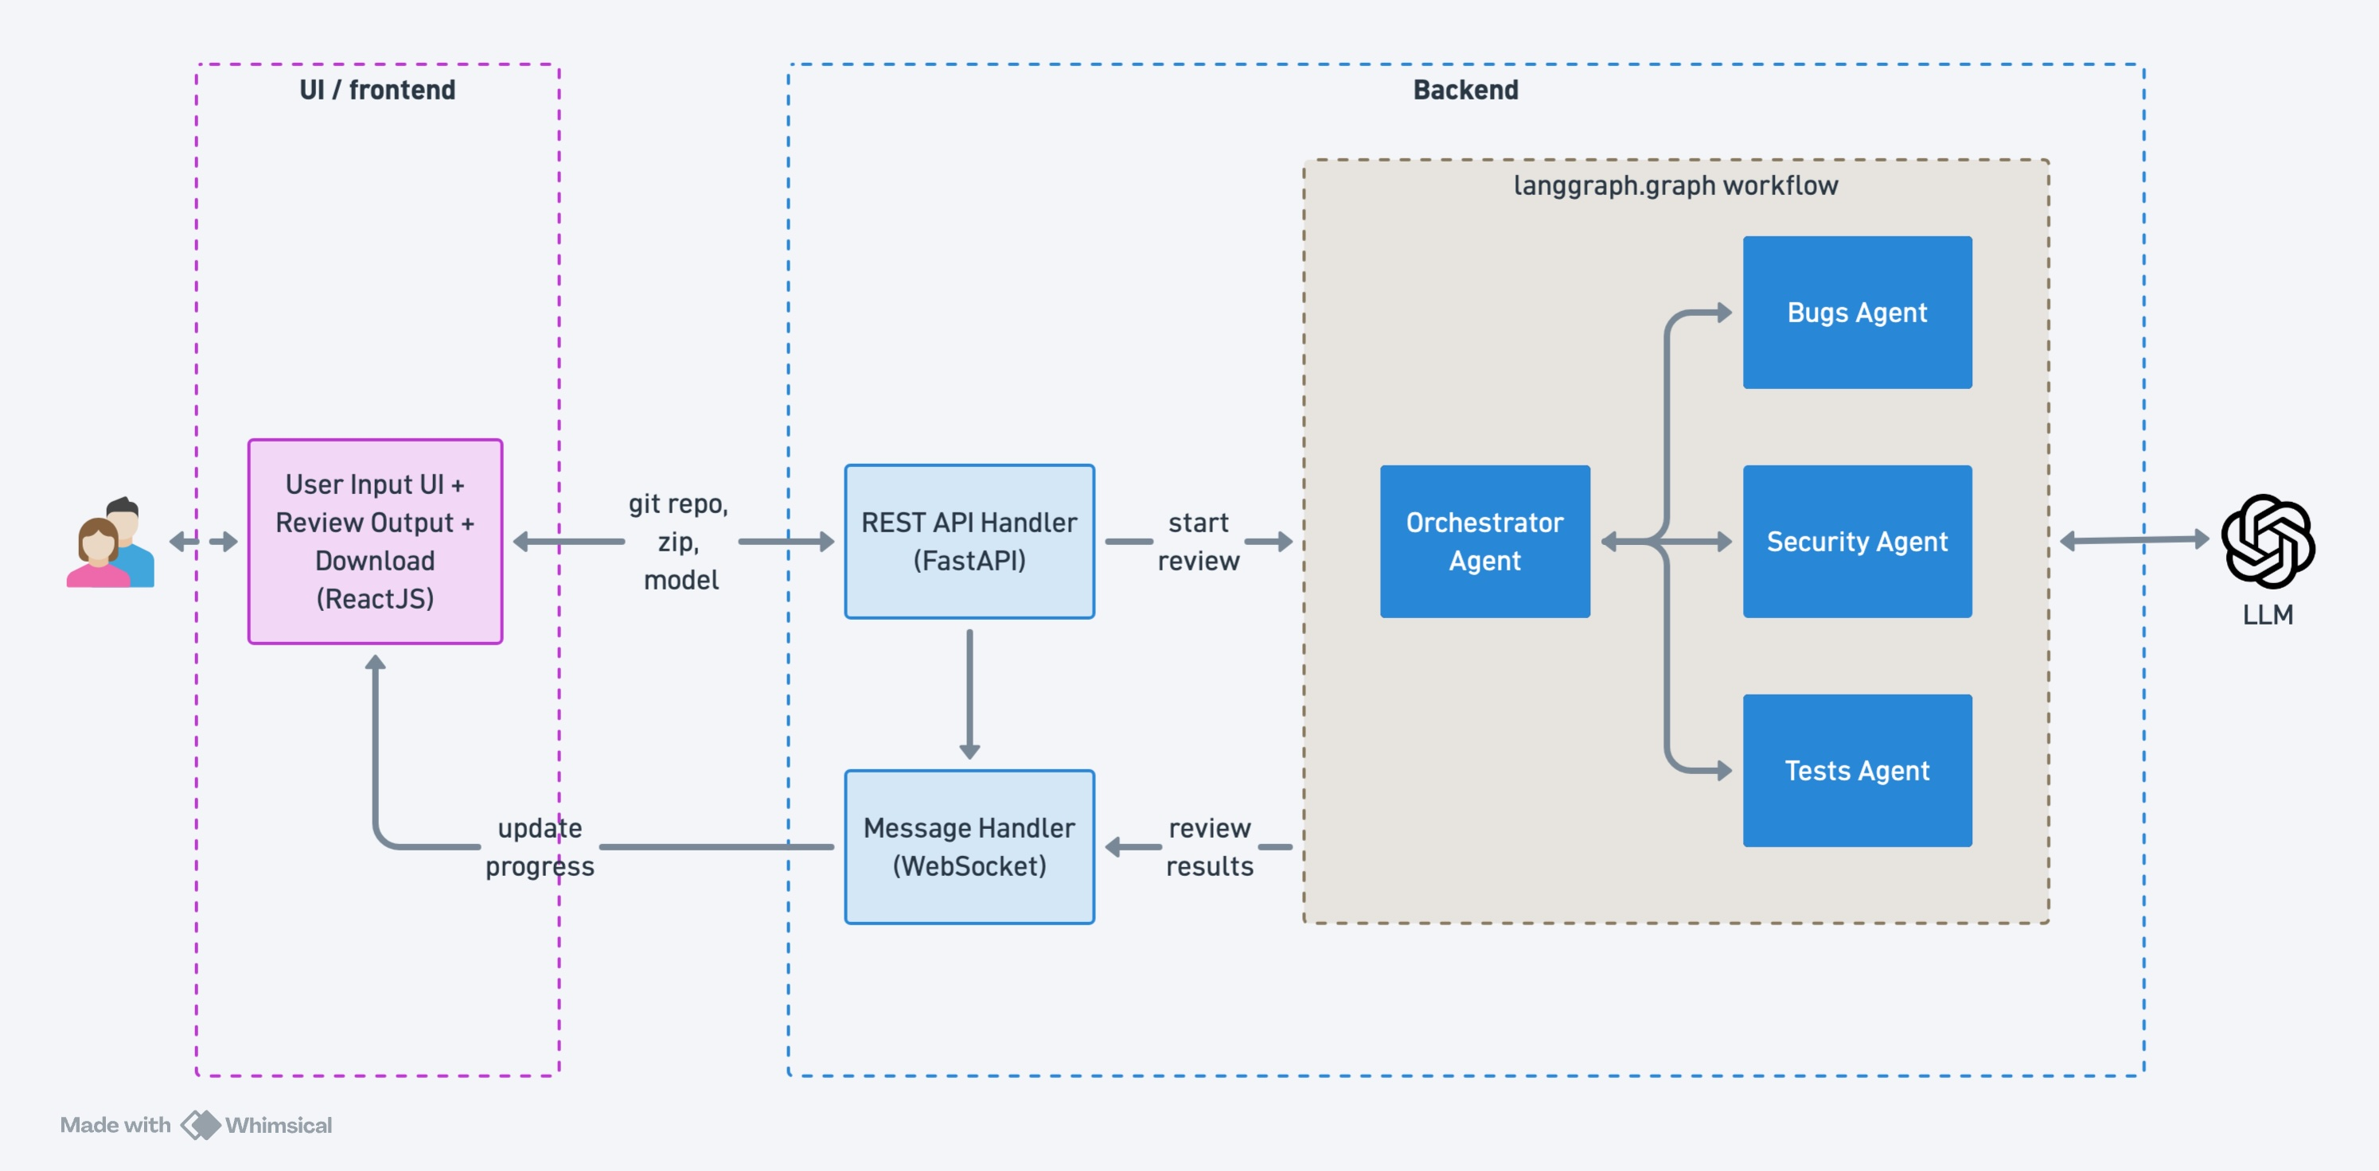
Figure 1 CodeScanner architecture from docs/architecture.jpg
Frontend. React, Tailwind CSS, and Vite provide source input, model selection, session history, progress indicators, and report exploration. The development server proxies /api and /ws to FastAPI.
API and source reader. FastAPI validates submissions, manages background jobs in memory, and serves events and reports. The source reader downloads public GitHub archives or reads uploaded ZIP files without extracting or executing them.
Agent workflow. LangGraph starts the bugs, security, and tests specialists together with the same line-numbered source context. After all three finish, the orchestrator consolidates their results. LangChain connects each agent to the selected OpenAI model using Pydantic structured output.
Runtime and storage. The API key remains on the backend. The application uses one backend worker, retains completed jobs for one hour, and has no persistent job database or authentication. Restarting the server clears its jobs and reports.

UI workflow
1 Select the source. Attach or drag in a ZIP up to 20 MB, or paste a public GitHub repository URL. GitHub reviews use the default branch; private repositories and branch URLs are unsupported.
2 Configure and submit. Choose a model, optionally enter a review focus, and press the send arrow. The UI posts the source, focus, and model to /api/reviews and adds the returned review ID to session history.
3 Follow progress. The chat shows source preparation, specialist status, and report consolidation. WebSocket reconnection and REST recovery retrieve missed events.
4 Inspect and export. Read the summary, filter by severity, expand findings and suggested fixes, and inspect specialist summaries and excluded files. Download Word or JSON reports. UI history clears on reload.
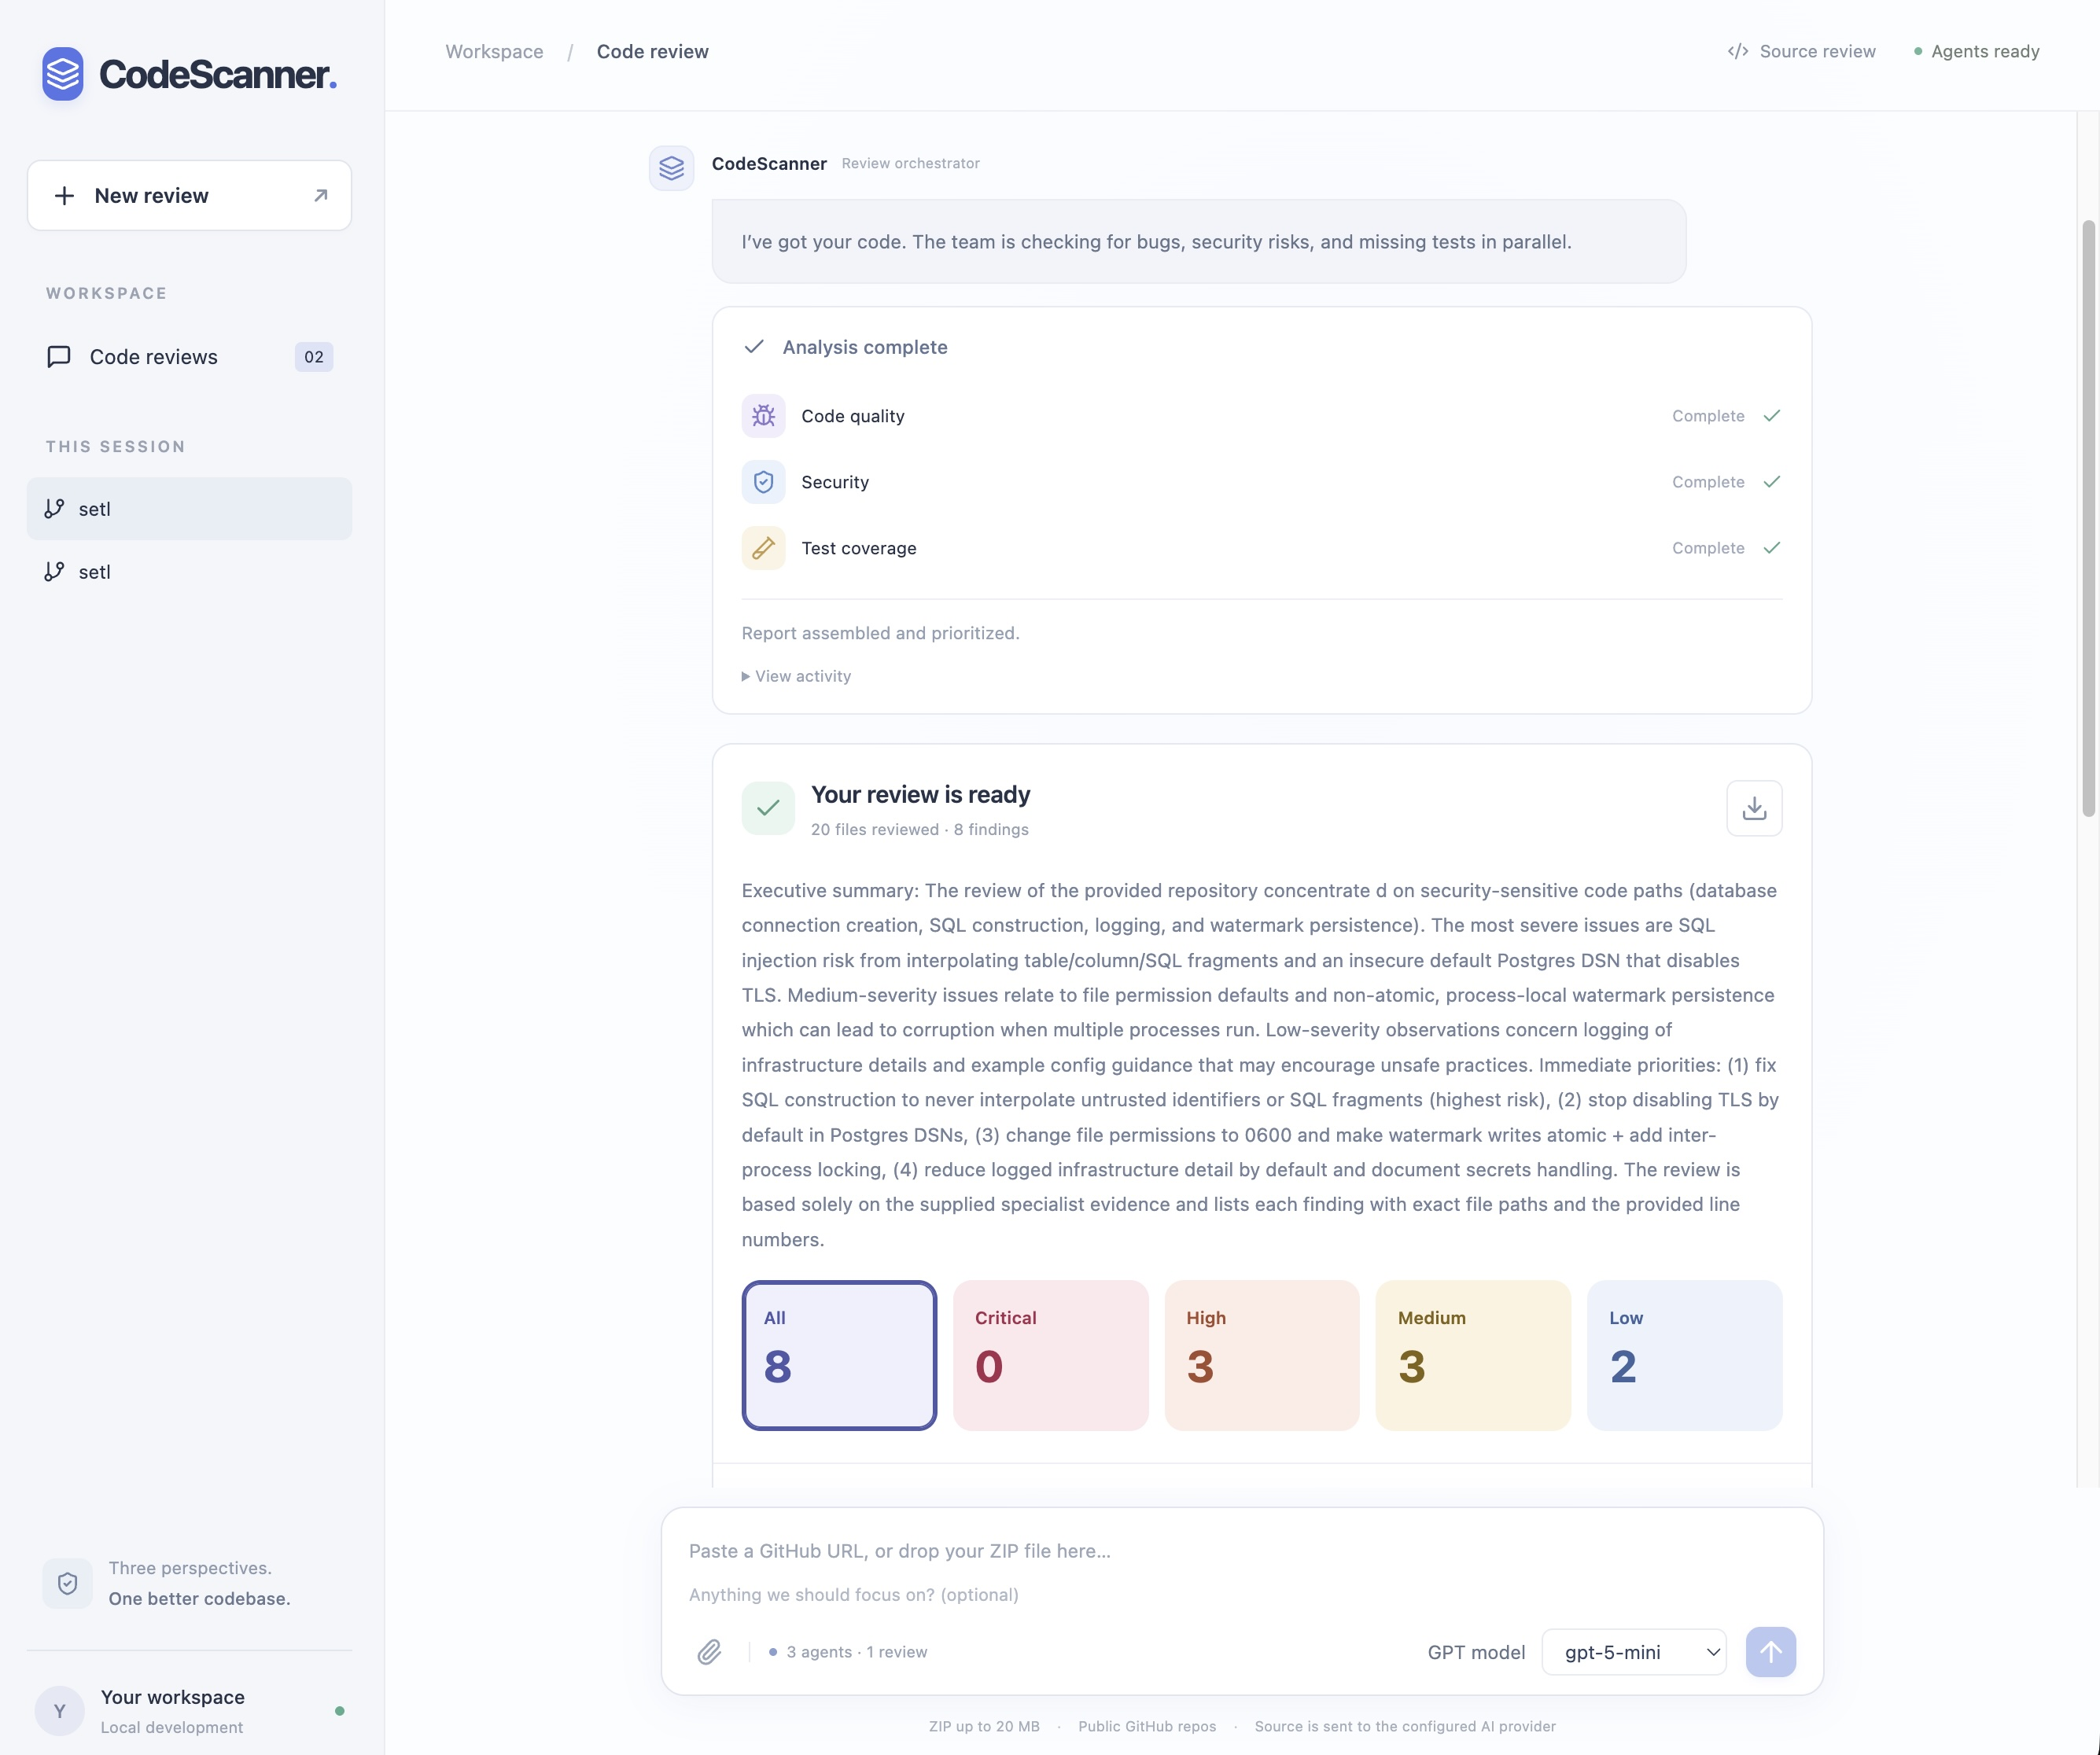
Figure 2 Application screenshot from docs/screenshot.jpg

Backend workflow
1 Validate and queue. POST /api/reviews accepts exactly one ZIP file or repository URL, plus optional focus and model fields. The backend checks the model, API key presence, input limits, and queue capacity, then creates an in-memory job and returns HTTP 202 with its ID and selected model. A background task performs the review.
2 Prepare the review scope. For GitHub input, download the default-branch archive. Validate archive paths and reject unsafe or invalid entries. Select up to 150 UTF-8 source, configuration, and documentation files, with a 100 KB per-file limit and a 180,000-character context budget. Dependencies, generated files, common lockfiles, .env files, and key files are excluded; the report records excluded paths and reasons.
3 Run the specialists in parallel. LangGraph sends the shared line-numbered context and optional focus to three agents: bugs identifies correctness defects and consequential anti-patterns; security looks for exploitable vulnerabilities; tests identifies missing behavioral tests and edge cases. Each specialist returns a structured summary and up to 25 findings, with file, line, severity, explanation, and recommendation. Findings with invalid source locations are filtered out.
4 Consolidate and prioritize. After all specialists return, the orchestrator merges their evidence into a summary and up to 75 findings. The backend validates locations again, deduplicates matching file, line, and title combinations, and sorts findings from critical through high, medium, and low severity.
5 Publish and deliver. The completed report includes the source, model, review scope, specialist summaries, and completion flags. The backend stores it on the job and emits a complete event. GET /api/reviews/{id} exposes status, event history, and the report; GET /api/reviews/{id}/report supports docx, json, and markdown downloads.

Progress and recovery
WS /ws/reviews/{id}?after={last_event_id} replays missed events and streams new progress, complete, or error events. Sequential event IDs prevent duplicate processing, and heartbeats keep idle connections active. The UI retrieves REST event history after disconnection before reconnecting.

Failure handling and review boundaries
A failed specialist produces a partial report; failure of all three fails the review. If only synthesis fails, specialist findings are combined and sorted automatically. The graph has an eight-minute execution timeout. The backend allows up to three active reviews and 100 retained jobs per process.
Selected source text is sent to the configured model. Analysis is static: code and tests are never executed, and test coverage is not measured as a percentage. Findings require human validation; excluded files limit the scope of the review.
Implementation references: README.md; backend/main.py, sources.py, workflow.py, review_agent.py, orchestrator_agent.py, models.py, and reports.py; ui/src/App.jsx and components/Report.jsx.

