21CSE525T – AGENT TECHNOLOGY
ASSIGNMENT 5.2
Capstone Project Consolidation and Secure Deployment
CipherMesh: The Privacy Control Plane for Enterprise AI
Submitted by
KUMAR WAIBHAV AKSHAT [RA2212704010027]
M.Tech (Integrated) Computer Science & Engineering
with specialization in Data Science
Under the Guidance of
Dr. Prabhu Kavin B
Assistant Professor
Department of Data Science and Business Systems

DEPARTMENT OF DATA SCIENCE AND BUSINESS SYSTEMS
COLLEGE OF ENGINEERING AND TECHNOLOGY
SRM INSTITUTE OF SCIENCE AND TECHNOLOGY
KATTANKULATHUR - 603 203
NOVEMBER 2026

TABLE OF CONTENTS
1 INTRODUCTION 1
1.1 Objective 1
1.2 The platform journey from Unit 1 to Unit 5 1
1.3 The problem in CipherMesh terms 1
2 REQUIREMENTS AND TRACEABILITY 2
3 UNIFIED ARCHITECTURE 3
3.1 System schematic 3
3.2 Unit to module map 3
3.3 AgentHost internals 4
3.4 Host topology and trust model 5
3.5 Coordination protocol 6
4 IMPLEMENTATION 6
4.1 Modules 6
4.2 Key code 7
4.3 UI layer 8
4.4 Deployment 10
5 PRODUCTION EXECUTION CYCLE 11
5.1 How the cycle runs 11
5.2 P0 Boot and self-attestation 12
5.3 P1 Live knowledge 12
5.4 P2 Autonomous processing 13
5.5 P3 Coordination and load sharing 14
5.6 P4 Environmental change: provider outage 14
5.7 P5 Security 15
5.8 P6 Lockdown drill and graceful shutdown 16
5.9 Results across the cycle 16
6 TESTING 17
7 VIDEO PRESENTATION 17
8 SUBMISSION ANALYSIS 18
8.1 Requirement, evidence and status 18
8.2 Strengths 19
8.3 Honest limitations 19
8.4 Lessons learned 19
8.5 Future work 19
9 CONCLUSION 20
REFERENCES 21
App. A HOW TO RUN 22
App. B FILE LISTING 23
App. C REPOSITORY AND PUBLISHING 24
LIST OF FIGURES
Figure 3.1 CipherMesh v3.0 system architecture: hosts, unit layers, flows and trust boundary 3
Figure 3.2 Path of one prompt through the layers of an AgentHost 4
Figure 3.3 Hosts, roles and permitted commands in the capstone trust store 5
Figure 3.4 Heartbeat, policy sync and Contract-Net load sharing over signed commands 6
Figure 4.1 Web ops dashboard during P2: pipeline counters, current intention with step progress, beliefs 8
Figure 4.2 Dashboard during P4: intention shift, circuit breaker and belief sync to the peer 9
Figure 4.3 Dashboard after the attack battery in P5 (dark theme) 9
Figure 4.4 Final dashboard state after P6 (light theme) 10
Figure 5.1 The seven phases of the production execution cycle 11
Figure 5.2 Timeline of the recorded run (one tick per event; xN marks a burst) 12
Figure 5.3 End-to-end time per P2 request by decision 13
Figure 5.4 Hostile frames blocked per checkpoint in P5 16
Figure 5.5 Policy decisions per phase in the recorded run 16
Figure 7.1 Key frames: title card, P4 outage on the live dashboard, security stream close-up 18
LIST OF TABLES
Table 1.1 CipherMesh units and their role in the capstone 1
Table 2.1 Assignment lines, where they are satisfied and the evidence 2
Table 3.1 Unit to module map of the unified codebase 4
Table 3.2 State model of one AgentHost 5
Table 4.1 New modules in backend/ciphermesh/capstone/ 6
Table 4.2 Deployment changes for v3.0 11
Table 5.1 Contract-Net capacity contracts negotiated at boot (USD per 1,000 requests) 12
Table 5.2 Live feeds fetched in P1 13
Table 5.3 P2 outcome by decision 13
Table 5.4 Tasks delegated to gateway-beta in P3 14
Table 5.5 Intention shifts recorded in P4 15
Table 5.6 Attack battery against gateway-alpha 15
Table 5.7 Final state of the gateways after the drain 16
Table 6.1 Test counts by unit 17
Table 6.2 Capstone tests 17
Table 7.1 Video storyboard 18
Table 8.1 Requirement, evidence and status 18
Table 9.1 Course concepts and where the capstone demonstrates them 20
Table A.1 Commands that produced each output 22
Table B.1 Main files of the submission 23

1 INTRODUCTION

1.1 Objective
CipherMesh is a provider-neutral privacy agent that sits between enterprise applications and AI providers. It inspects every prompt, blocks secrets, masks personal data, holds internal links for a human and routes the rest to the best provider that the policy allows. Over five units I built this agent one capability at a time. Each unit was tested on its own, in its own folder. This capstone, CipherMesh v3.0, joins all of them into one codebase and runs them together as a small, multi-host, production-style system.
The assignment asks for four things: a unified codebase that assembles the core features of Units 1 to 5, a clean UI layer that shows the live state of the agent, a final production execution cycle in which the agent works on its own, coordinates with other hosts, updates its intentions and acts safely, and a set of deliverables (source package, repository link, a 3-minute video and an architecture schematic). This report explains how each one was built and shows the evidence from a real run.

1.2 The platform journey from Unit 1 to Unit 5
An agent perceives its environment and acts on it to reach its goals [1]. Table 1.1 lists what each unit added to CipherMesh and how that piece is used inside one capstone host. The capstone does not rewrite any of them: it imports their public APIs and wires them together.
Table 1.1: CipherMesh units and their role in the capstone
Unit | What it added | Role inside an AgentHost
1.1 / 1.2 Core loop | PEAS model; simple-reflex loop: perceive, match R1-R5, act | Admission reflex on every prompt; policy decides ALLOW, REDACT, REVIEW or BLOCK
2.1 Workers | Bounded queue, non-daemon worker pool, daemon monitor | Runs every request; monitor probes providers and feeds the circuit breaker
2.2 Sockets | Length-prefixed TCP frames, typed envelopes, HMAC | Frame format of every host-to-host and console message
3.1 Cooperation | Contract-Net negotiation of provider capacity | Capacity contracts per provider; load sharing between gateways
3.2 Optimisation | Constrained utility router with residency rules | Chooses the provider inside each BDI plan
4.1 BDI | Beliefs, desires D1-D5, plans, intentions, reconsideration | One deliberation per request; re-plans when a belief changes
4.2 Knowledge | Ontology, triple store, six live feeds, adapter | Turns live facts into beliefs: posture, budget, provider status
5.1 Security | Ed25519 identities, 13 checkpoints, self-attestation | Trust gate on every inbound command; signed replies; start-up attestation

1.3 The problem in CipherMesh terms
Separately, each unit worked. Together, they raise new questions. A belief learned from a live feed must reach a plan that is already running on a worker thread. A host that is too busy should share work, but a peer must never receive a secret or a review-only prompt. Hosts must trust each other enough to share beliefs, yet a stolen peer key must not be enough to lock the whole mesh down. And an operator needs to see all of this while it happens. The capstone answers these questions with one class, AgentHost, a small coordination protocol on top of the Unit 5.1 signed commands, a thread-safe StateBus, and a web and terminal dashboard.
IN PLAIN WORDS
Five working parts become one working machine. Two CipherMesh gateways, a security console and an attacker run on real network addresses. The gateways process 82 real requests, share work, learn from live data, change their plans when a provider fails, accept only signed commands and block every attack, while a live dashboard shows each step.

2 REQUIREMENTS AND TRACEABILITY
Table 2.1 copies each line of the assignment brief and shows where it is met and which file proves it. Section 8 returns to the same lines with a status for each.
Table 2.1: Assignment lines, where they are satisfied and the evidence
Brief line (verbatim) | Where it is satisfied | Evidence
Objective: Consolidate multiple modular agent capabilities developed throughout the units into a unified, production-ready system. | backend/ciphermesh/capstone/ wires Units 1-5; one FastAPI app, Docker, Vercel and CI | logs/production_cycle.log, Figure 3.1
Assemble core features (Unit 1 Core Loop, Unit 2 Workers/Sockets, Unit 3 Cooperation, Unit 4 Knowledge/BDI, Unit 5 Security) into a unified codebase. | AgentHost in capstone/host.py; unit packages in ciphermesh/{bdi,knowledge,trust} | tests/capstone/test_host.py::test_every_unit_is_wired_into_one_host
Develop a clean UI layer (CLI dashboard or simple web GUI) to visualize the live states of the agent. | Both: web dashboard at /ops (SSE) and python -m ciphermesh.capstone.dashboard | logs/dashboard_snapshots/*.png, logs/cli_dashboard_snapshot.txt
Perform a final production execution cycle where the agent independently processes inputs, coordinates with other hosts, updates its intents, and executes actions safely. | demo/run_production_cycle.py runs P0-P6 with no manual step | logs/production_summary.json, production_events.jsonl
Deliverable: Final working source code package | Whole repository folder (backend, frontend, demo, docs) | logs/pytest_results.txt (563 passed)
Deliverable: repository link | README and docs/SUBMISSION.md (publish steps) | https://github.com/kumarwaibhav/CipherMesh
Deliverable: a 3-minute video presentation outlining the complete lifecycle | video/CipherMesh_Capstone_Lifecycle.mp4 (3:05) | video/narration_script.md, video/captions.srt
Deliverable: a concise system architecture schematic | docs/architecture/CipherMesh_v3_Architecture.png / .pdf / .html | Figure 3.1

3 UNIFIED ARCHITECTURE

3.1 System schematic
Figure 3.1 is the architecture schematic delivered with the submission. The red dashed line is the organisation trust boundary. Inside it run the two gateways and the local Ollama tier. Outside it are the security console, the attacker, the enterprise applications, the live knowledge feeds and the external AI providers. Solid blue arrows carry prompts and data; dashed purple arrows carry signed commands; the red cross marks where hostile frames stop. No arrow crosses another.
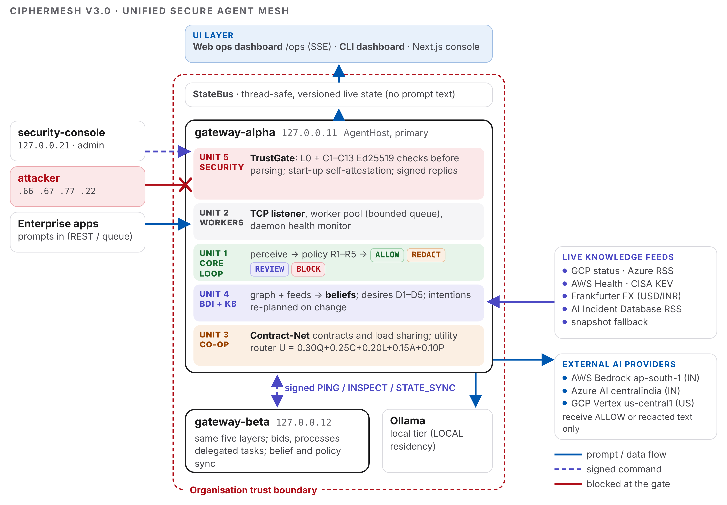
Figure 3.1: CipherMesh v3.0 system architecture: hosts, unit layers, flows and trust boundary
The UI layer never talks to an agent directly. Every host writes its state model to the StateBus, and both dashboards read only the bus through GET /api/v1/ops/state and the Server-Sent Events stream GET /api/v1/ops/stream [2]. A slow or broken browser can therefore never slow down or break a host.

3.2 Unit to module map
Table 3.1 maps each unit to the modules that implement it in the unified codebase. Units 1 to 3 were already in the engine package; Units 4.1, 4.2 and 5.1 are copied unchanged from their final submissions; everything in capstone/ is new.
Table 3.1: Unit to module map of the unified codebase
Unit | Modules (backend/ciphermesh/...) | Used by
1 Core loop | detector.py, policy.py, stream.py | AgentHost.reflex, BDI step prepare_payload
2 Workers / sockets | runtime.py, transport.py, server.py, client.py, security.py | worker pool, health monitor, frame format
3 Cooperation | negotiation/, procurement.py, optimization/, routing.py | contracts, router, coordination.py
4 Knowledge / BDI | bdi/ (beliefs, desires, plans, intentions, engine), knowledge/ (ontology, graph, feeds, adapter) | DeliberationProcessor, BeliefSink, KnowledgeBridge
5 Security | trust/ (keys, envelope, verifier, integrity, secure agent) | TrustGate, provision_mesh, attack battery
Capstone (new) | capstone/: host, deliberation, beliefs, coordination, trustmesh, statebus, mesh, actors, cycle, dashboard, workload, providers | demo, FastAPI ops routes, tests

3.3 AgentHost internals
Figure 3.2 follows one prompt through a host. The admission reflex is the pure Unit 1 policy call, so the decision is known before any work is queued. If the queue has reached its high-water mark and the prompt may leave the host, it is offered to a peer; otherwise it goes to the Unit 2 worker pool. Each worker hands the prompt to a fresh Unit 4.1 BDIAgent. The agent copies the host's world beliefs, keeps receiving their changes while it runs, chooses an intention and executes its plan one step per cycle. The plan steps call the real Unit 3 procurement and router and the simulated provider adapters, and inspect the reply before it is delivered.
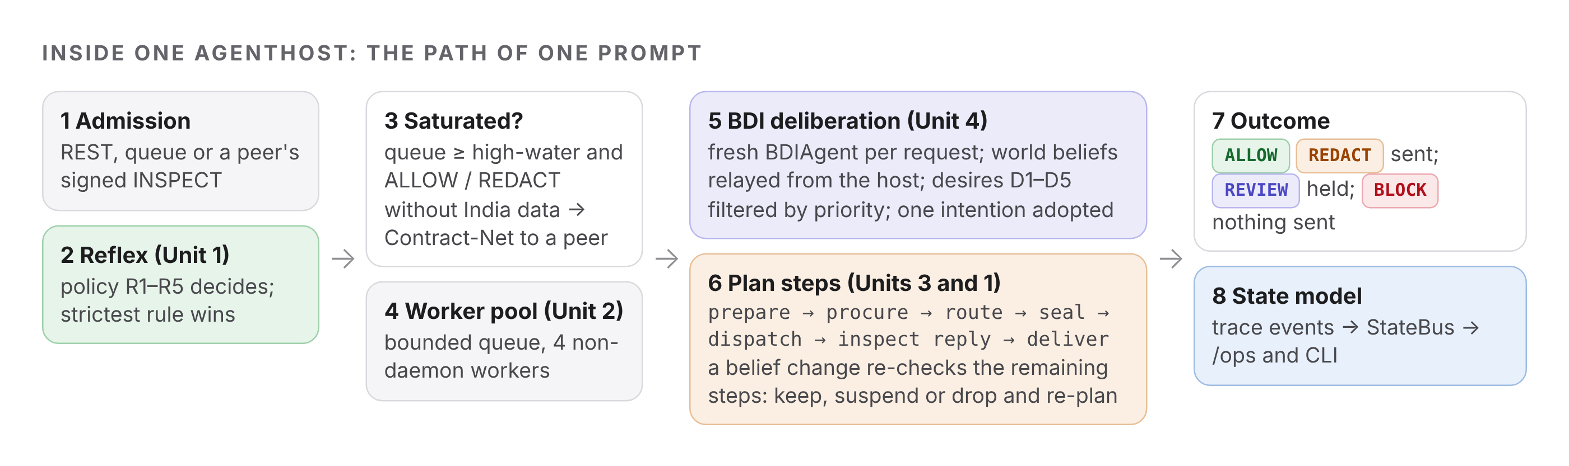
Figure 3.2: Path of one prompt through the layers of an AgentHost
Table 3.2 lists the pieces of state that one host keeps and publishes. This is the state model the assignment asks the UI to visualise.
Table 3.2: State model of one AgentHost
Part | Source | Shown on the dashboard as
Beliefs snapshot | host BeliefBase (engine seed, feeds, monitor, peers) | beliefs table; recent changes highlighted
Desires D1-D5 | ciphermesh_desires() with live activity | desire list with priority, kind, active state
Intentions | live trace events of every running BDIAgent | current intention with step cursor; shift timeline
Queue and workers | ConcurrentRuntime metrics | host cards (queue, workers, completed)
Provider health | circuit breaker + belief provider.<id>.status | provider table with utility bars
Contracts and load sharing | ContractBook, task records | Contract-Net counters and task list
Threat posture and feeds | knowledge adapter records | posture badge, FX, budget, R5 limit, feed table
Security events | trust gate verdicts (no payloads) | ACCEPTED / BLOCKED stream with checkpoint
Peers and counters | signed heartbeats, decision counters | host cards, pipeline tiles, event log

3.4 Host topology and trust model
The four hosts run on real TCP loopback with distinct 127.0.0.x addresses. Each client binds its source address before it connects, so checkpoint C7 compares the peer address that the kernel reports with the CIDR blocks in the trust store. Figure 3.3 shows each host's role and which commands that role may send. The roles come from Unit 5.1 and follow least privilege [3]: a gateway can ping, ask for an inspection and synchronise four non-weakening policy fields, but it can never lock down or change redaction patterns. Only the security console holds those rights.
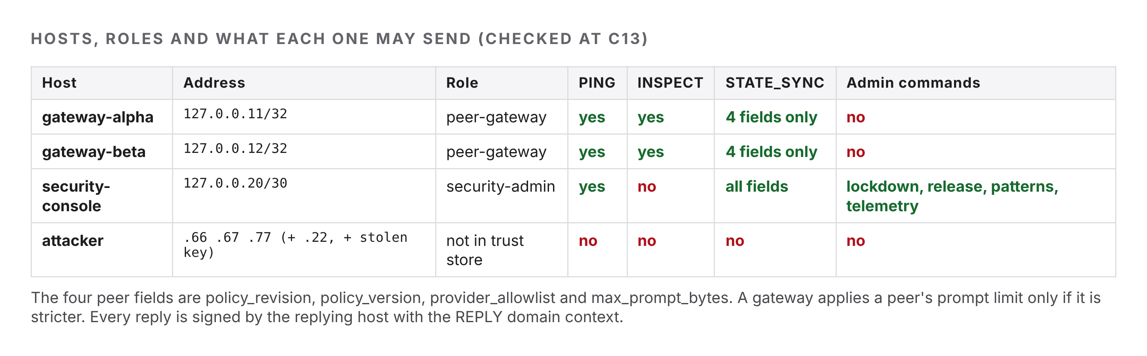
Figure 3.3: Hosts, roles and permitted commands in the capstone trust store
Every key is an Ed25519 key [4] generated at start-up into a runtime directory with mode 0600, encrypted with a passphrase and never shipped. The release key signs a manifest of every source file; each gateway attests its own code against it before it starts, in the style of the RATS architecture [5]. A host that finds a changed file, a missing file or any compiled artefact next to its sources starts in SAFE MODE.

3.5 Coordination protocol
Unit 5.1 defines a fixed command vocabulary, and its final audit made STATE_SYNC field-level: a peer gateway may only send policy_revision, policy_version, provider_allowlist and max_prompt_bytes. The capstone therefore adds no new command. Figure 3.4 shows how heartbeats, policy sync and Contract-Net load sharing [6] map onto PING, STATE_SYNC and INSPECT, with all data that a host reports carried in its signed reply.
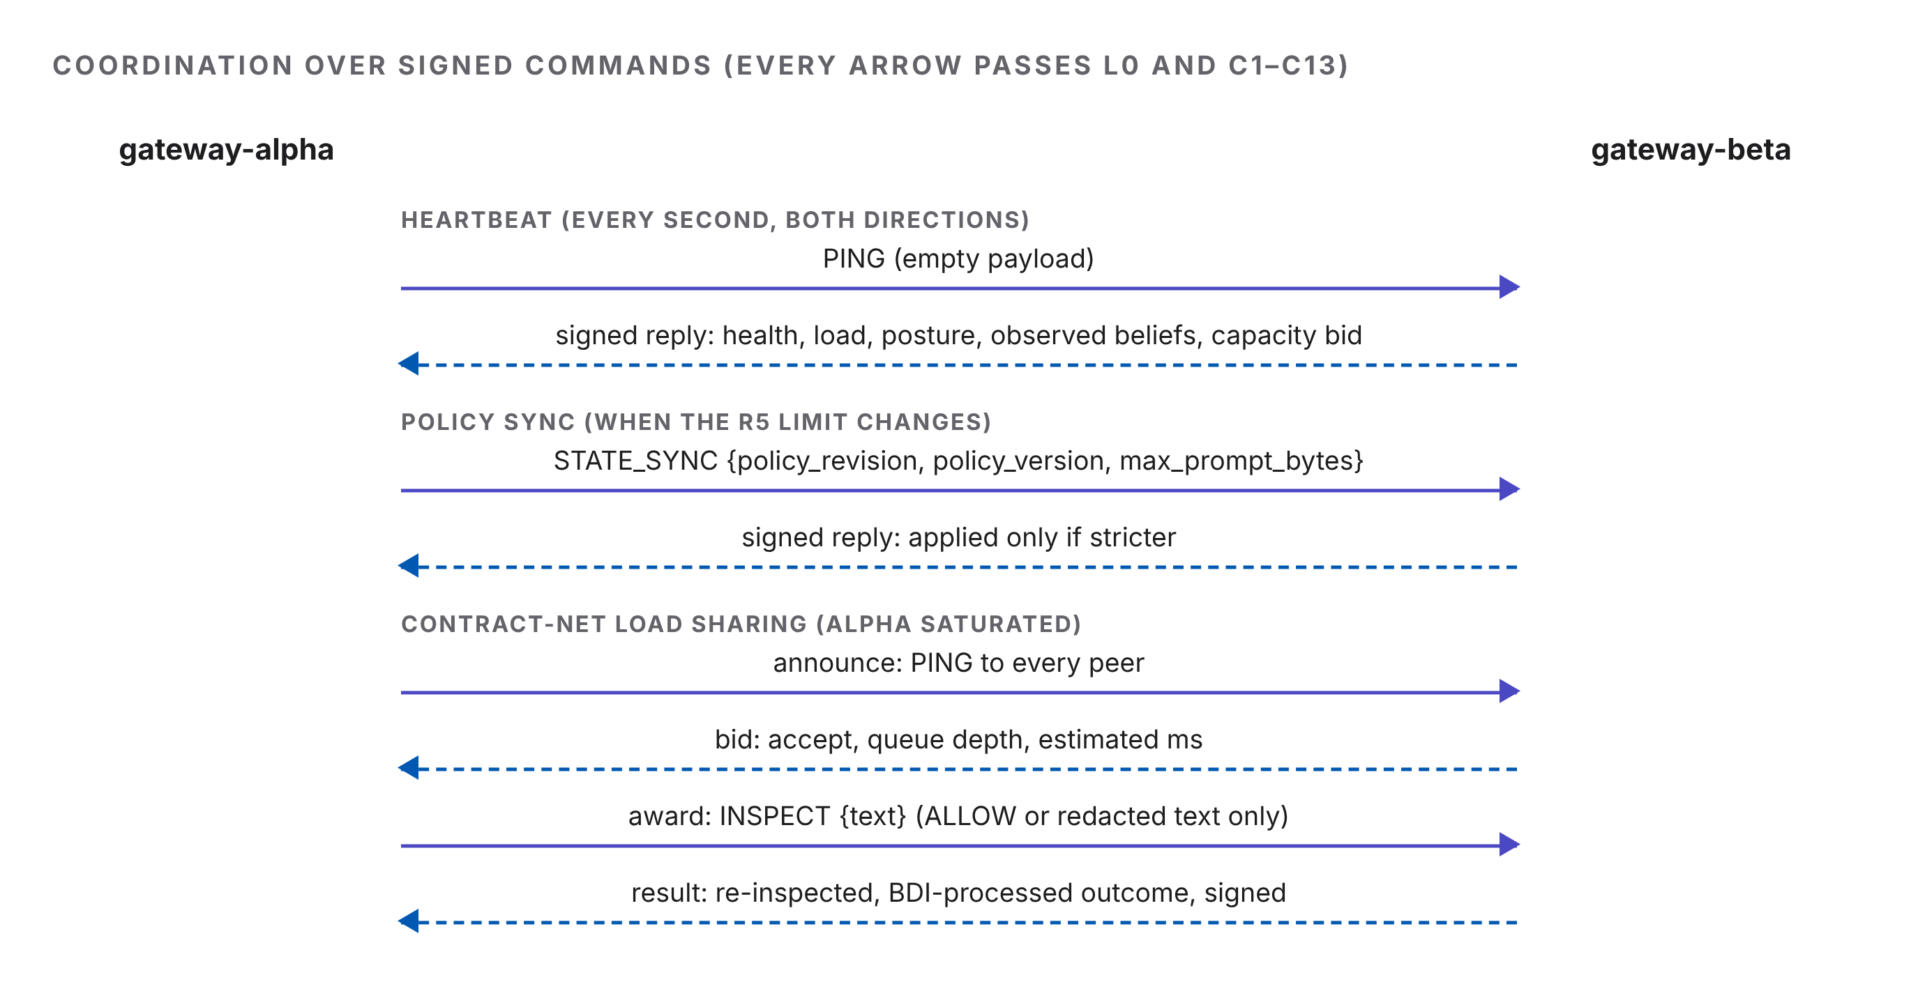
Figure 3.4: Heartbeat, policy sync and Contract-Net load sharing over signed commands
Three rules keep sharing safe. First, only ALLOW text or REDACT-sanitised text may be awarded, and never text whose original findings include Aadhaar, PAN or an Indian phone number, because desire D2 keeps Indian personal data on the home host. Second, the receiving gateway re-inspects the awarded text with its own policy and refuses anything that is not ALLOW or REDACT. Third, a peer's belief snapshot only contains observed knowledge (feed results, monitor results, derived posture and budget), never engine seeds, local configuration or beliefs that were themselves learned from a peer, so a belief cannot echo back and overwrite its own source.

4 IMPLEMENTATION

4.1 Modules
Table 4.1 lists the new capstone package. It has 12 modules and about 2,300 lines; the unit packages it uses are unchanged.
Table 4.1: New modules in backend/ciphermesh/capstone/
File | Purpose | Key classes / functions
host.py | one autonomous node: trust gate, listener, worker pool, BDI, knowledge, coordination, state model | AgentHost
deliberation.py | per-request BDI run behind the worker pool; live trace forwarding | DeliberationProcessor, HostOutcome
beliefs.py | knowledge -> beliefs bridge; host-to-request belief relay | BeliefSink, KnowledgeBridge, BeliefRelay
coordination.py | heartbeat, bid and task-result schemas; sharing rules | Heartbeat, Bid, TaskResult, may_delegate
trustmesh.py | mesh provisioning, trust gate, signed transport | provision_mesh, TrustGate, verify_reply
statebus.py | thread-safe versioned state for the UI | StateBus, default_bus
mesh.py | builds and connects the hosts; publishes state 4 times a second | Mesh
actors.py | security console and attacker hosts | SecurityConsole, Attacker
providers.py | simulated adapters with a labelled outage switch | SwitchableAdapter, host_registry
cycle.py | production execution cycle P0-P6 and its outputs | ProductionCycle
dashboard.py | CLI dashboard (standard library only) | render, main
workload.py | synthetic enterprise prompts with expected decisions | BATCH, BURST, OUTAGE

4.2 Key code
Listing 1 is the heart of the BDI integration. Each request gets its own belief base, filled from the host's world beliefs, and a BeliefRelay keeps forwarding host changes while the deliberation runs. This is how a provider outage that the health monitor detects on another thread reaches an intention that is already half-way through its plan.
def process(self, text, provider=None, request_id=None) -> HostOutcome:
request_id = request_id or f"req-{uuid4().hex[:10]}"
beliefs = BeliefBase()
relay = BeliefRelay(self.world, beliefs)
agent = BDIAgent(services=self.services, beliefs=beliefs,
tracer=LiveTracer(request_id, self.on_trace),
max_cycles=self.max_cycles)
...
try:
context = agent.submit(text, request_id)
result = agent.run(environment)
finally:
relay.close()
return self._outcome(agent, context, result)
Listing 1: DeliberationProcessor.process (capstone/deliberation.py, abridged)
Listing 2 shows the two sharing rules that the coordination code enforces before anything leaves a host, and the policy-sync payload that stays inside the Unit 5.1 field allow-list.
def may_delegate(decision: str, categories) -> bool:
return decision in SHARED_DECISIONS and not (set(categories) & INDIA_CATEGORIES)

def shareable(key: str, value, source: str) -> bool:
"""Observed knowledge only: never engine seeds, local config, or peer beliefs."""
return (shareable_key(key) and isinstance(value, (str, int, float, bool))
and not source.startswith(LOCAL_ONLY_SOURCES) and "peer:" not in source)

def policy_sync_payload(revision, version, max_prompt_bytes) -> dict:
return {"state": {"policy_revision": int(revision), "policy_version": str(version),
"max_prompt_bytes": int(max_prompt_bytes)}}
Listing 2: sharing rules (capstone/coordination.py)
Listing 3 is the bridge from the Unit 2.1 health monitor to the BDI belief base. When the circuit breaker opens, the monitor writes the belief major_outage; when a probe succeeds again, it restores operational, but only for a belief that a monitor wrote, so it never overrides a status page.
for pid, health in (record.get("provider_health") or {}).items():
circuit = health.get("circuit", "CLOSED")
...
if circuit == "OPEN":
self.event("CIRCUIT", f"circuit breaker OPEN for {pid} ...", "block")
self.world.set(key, "major_outage", "monitor:circuit-breaker")
else:
held = self.world.belief(key)
if held and held.source.startswith("monitor:") and held.value != "operational":
self.world.set(key, "operational", "monitor:circuit-breaker")
Listing 3: AgentHost._on_monitor_sample (capstone/host.py, abridged)

4.3 UI layer
Web ops dashboard. GET /ops returns one self-contained HTML page with inline CSS, JavaScript and SVG logo, so it works offline with no build step and no CDN. The page loads the state once and then follows the SSE stream; the server sends at most four state events per second. It uses the CipherMesh brand colours and type from the existing console, has a light and a dark theme, and keeps every text pairing at WCAG AA contrast. It is served with a nonce-based Content-Security-Policy [7] that allows only its own inline script and style and no unsafe-inline. Figure 4.1 shows the dashboard during P2, in the middle of the batch.
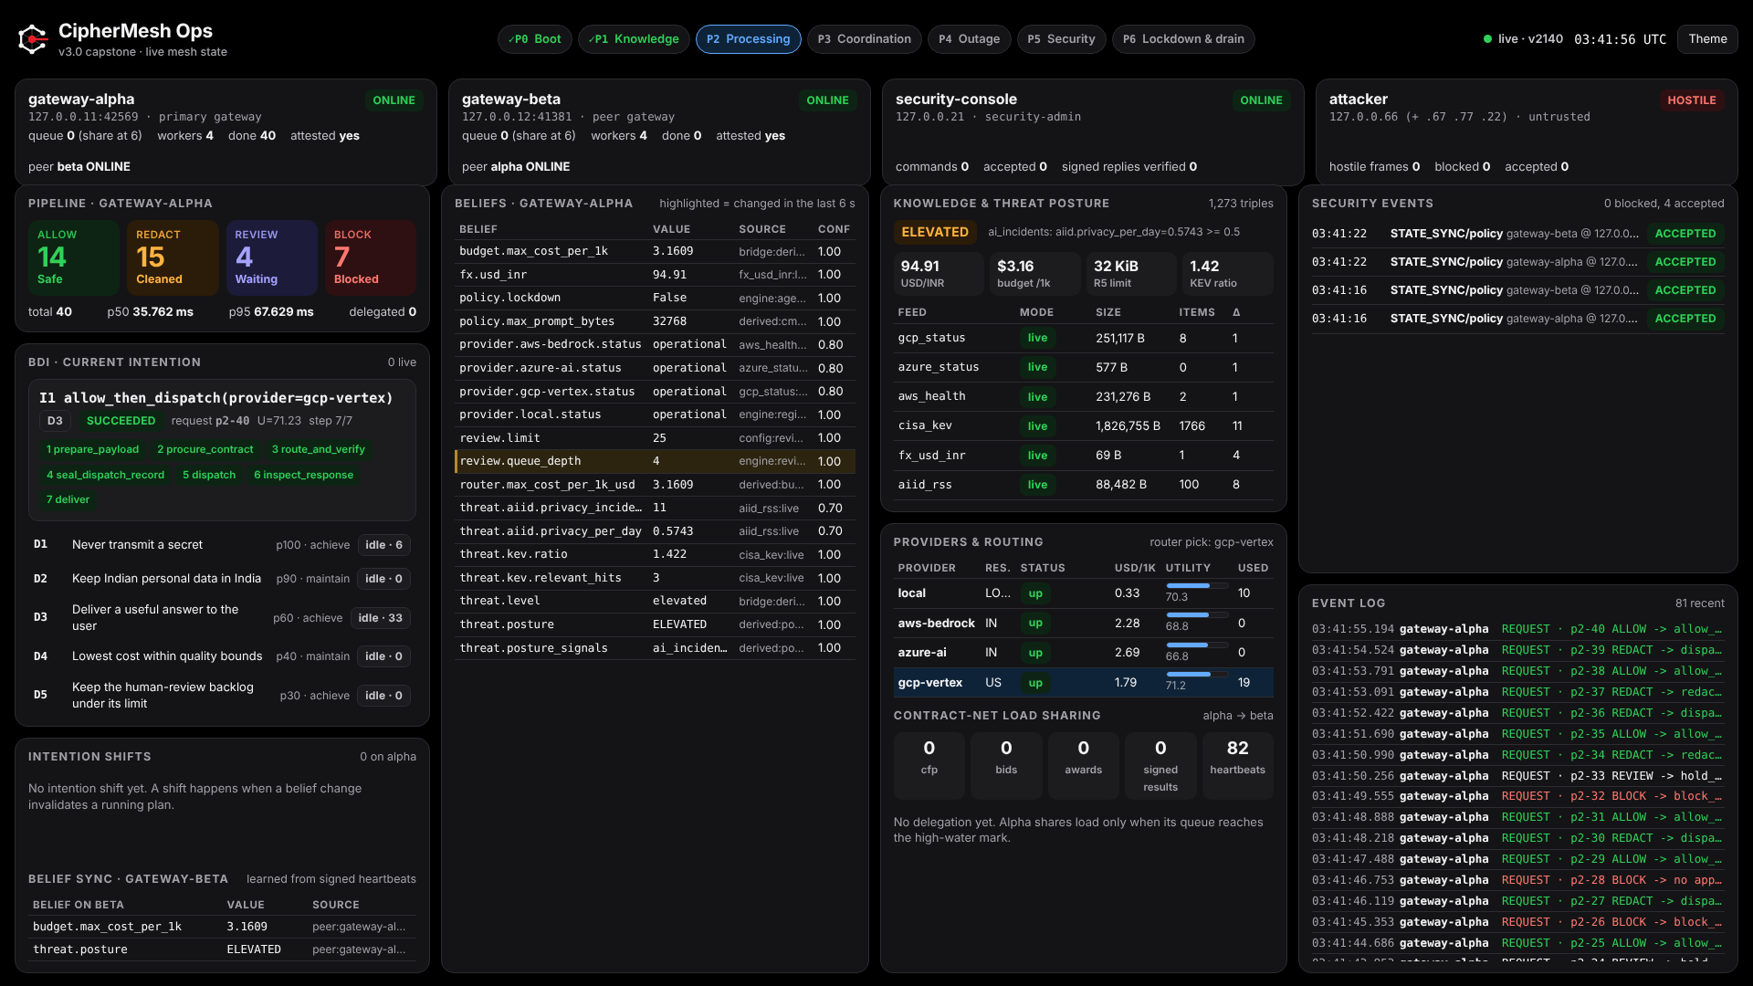
Figure 4.1: Web ops dashboard during P2: pipeline counters, current intention with step progress, beliefs
Figure 4.2 is the same page at the moment of the provider outage in P4. The intention-shift panel shows the dropped plan struck through, the new plan and the belief that caused the change; the beliefs table highlights provider.gcp-vertex.status, and the lower table shows that gateway-beta learned the same belief from alpha's signed heartbeat.
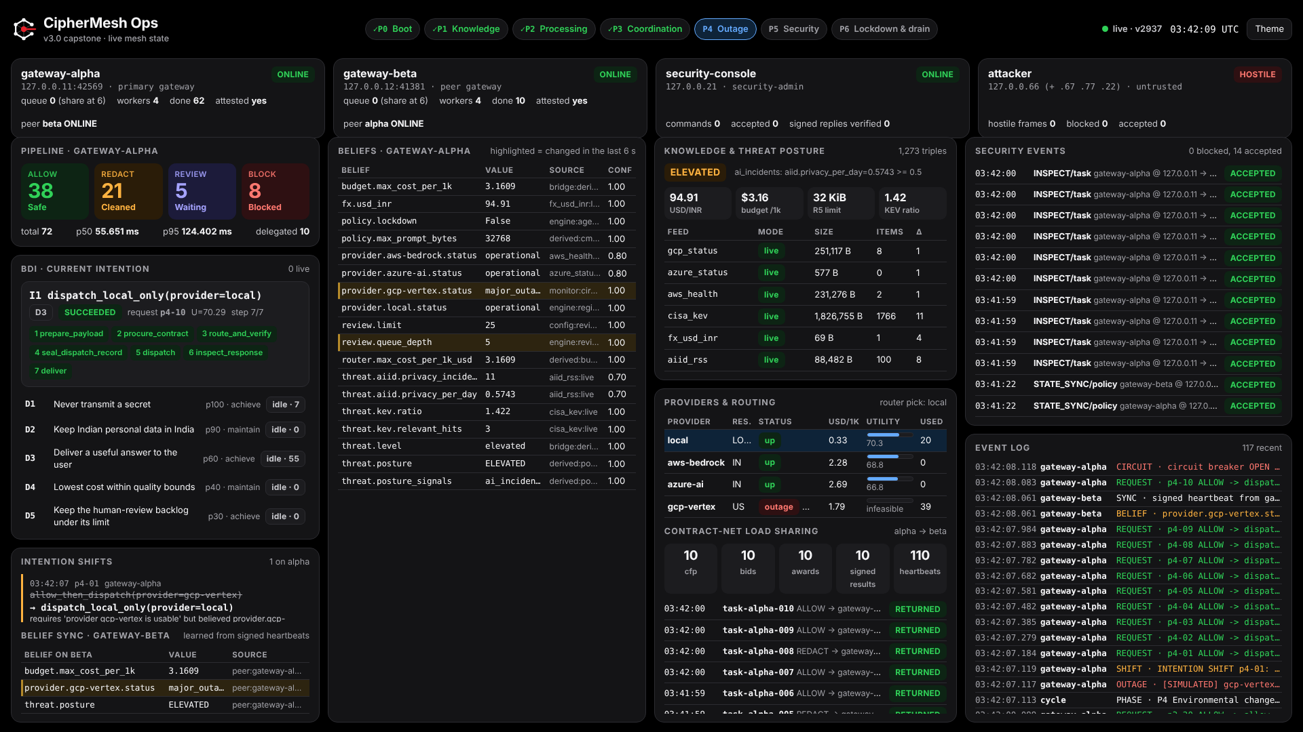
Figure 4.2: Dashboard during P4: intention shift, circuit breaker and belief sync to the peer
Figure 4.3 shows the end of the attack battery in P5. The security stream on the right lists each blocked frame with the checkpoint that stopped it, and the attacker card counts 18 hostile frames, 18 blocked.
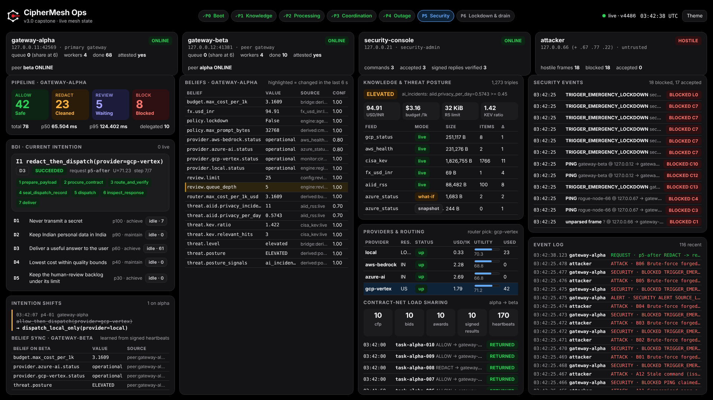
Figure 4.3: Dashboard after the attack battery in P5 (dark theme)
Figure 4.4 is the final state after the graceful drain, in the light theme. Both gateways show STOPPED, the pipeline totals and the Contract-Net counters are final, and the security stream ends with the accepted lockdown and release commands of P6.
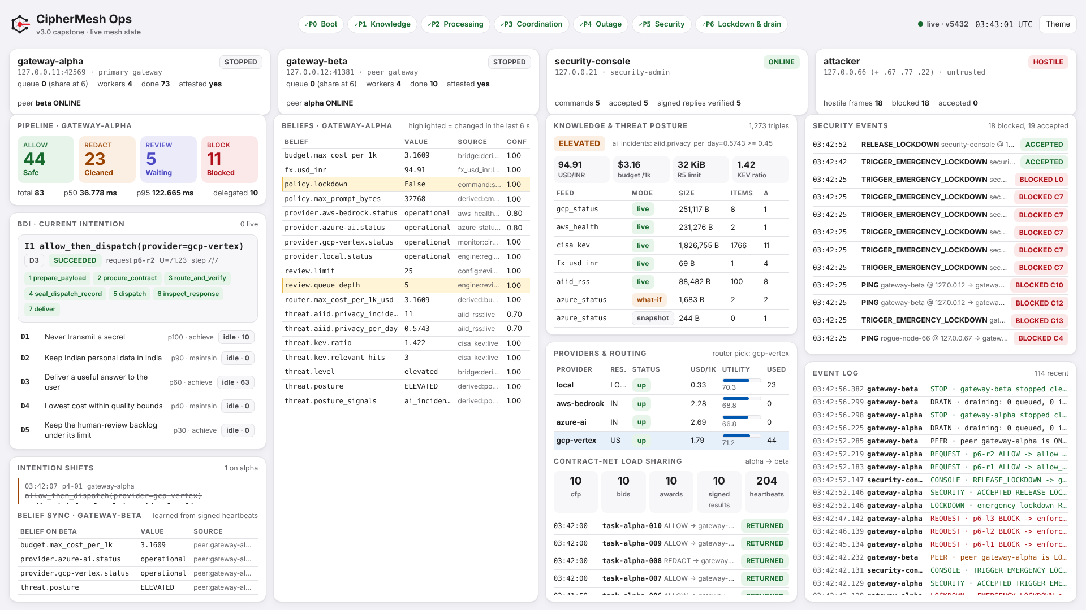
Figure 4.4: Final dashboard state after P6 (light theme)
Protection. When CIPHERMESH_API_TOKEN is set, the page, the state endpoint and the stream all require it, either as the X-CipherMesh-Token header or as ?token= (browsers cannot add headers to EventSource); the page forwards its own token to its API calls. Without a token the routes are open, like the rest of the development API.
CLI dashboard. python -m ciphermesh.capstone.dashboard uses only the standard library. On a terminal it redraws the same state every second with ANSI colour; in a pipe or a file it prints plain snapshots separated by a rule. Listing 4 is the top of the snapshot that the production cycle wrote at the end of the run.
CipherMesh v3.0 ops | phase DONE Cycle complete | bus v5432 | 2026-11-03T03:42:56.392Z
-------------------------------------------------------------------------------------...
gateway-alpha STOPPED queue 0/6 workers 4 done 73 attested True posture ELEVATE...
gateway-beta STOPPED queue 0/6 workers 4 done 10 attested True posture ELEVATE...
security-console ONLINE commands 5 accepted 5 verified replies 5
attacker HOSTILE hostile frames 18 blocked 18 accepted 0
-------------------------------------------------------------------------------------...
PIPELINE ALLOW 44 REDACT 23 REVIEW 5 BLOCK 11 total 83 p50 36.778 ms p95...
INTENTION I1 allow_then_dispatch(provider=gcp-vertex) [D3] SUCCEEDED [#######] next: ...
DESIRES D1(p100) D2(p90) D3(p60) D4(p40) D5(p30) (* = active now)
SHIFT p4-01: allow_then_dispatch(provider=gcp-vertex) -> dispatch_local_only(prov...
-------------------------------------------------------------------------------------...
Listing 4: CLI dashboard snapshot (logs/cli_dashboard_snapshot.txt, first lines)

4.4 Deployment
The existing deployment paths still work, and Table 4.2 lists what changed. The FastAPI app keeps every v2 route; /ops and /api/v1/ops/* are added and read the process-wide bus. On a plain deployment with no cycle attached the dashboard says so instead of showing empty numbers.
Table 4.2: Deployment changes for v3.0
Target | Change | Why
Docker (backend/Dockerfile) | copies data/ too; PYTHONDONTWRITEBYTECODE=1 already set | feed snapshots for offline fallback; no .pyc next to attested sources
Vercel (backend/vercel.json) | includeFiles adds data/** | same reason in the serverless bundle
CI (.github/workflows/ci.yml) | pytest with -B, then a CLI dashboard smoke run | whole suite incl. units 4-5 and capstone; UI entry point checked
Requirements | jsonschema==4.26.0 added; cryptography already present | ontology schema validation (Unit 4.2)
Frontend (Next.js) | unchanged | existing console keeps working against the same API

5 PRODUCTION EXECUTION CYCLE

5.1 How the cycle runs
One command, python -B demo/run_production_cycle.py --serve 8000 --pace 2, runs the seven phases in Figure 5.1 with no manual step. The --pace option only adds pauses between steps so a person can follow the dashboard; it changes no decision. The recorded run took 100.96 s, handled 82 requests and wrote logs/production_cycle.log (phase banners, timestamps), logs/production_events.jsonl, logs/production_summary.json and the dashboard screenshots. No log contains prompt text: only the synthetic labels written for the workload, hashes, categories and decisions.
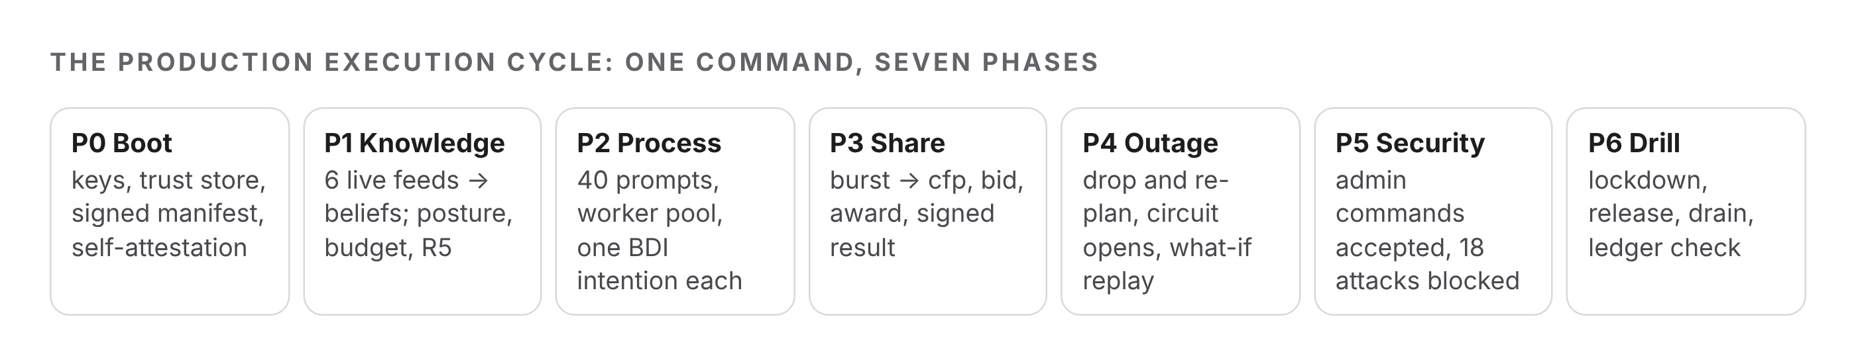
Figure 5.1: The seven phases of the production execution cycle
Figure 5.2 is the timeline of the recorded run, drawn from the event stream. Requests in P2 are spread out by the demo pacing; the P3 burst arrives at once, which is what saturates the queue.
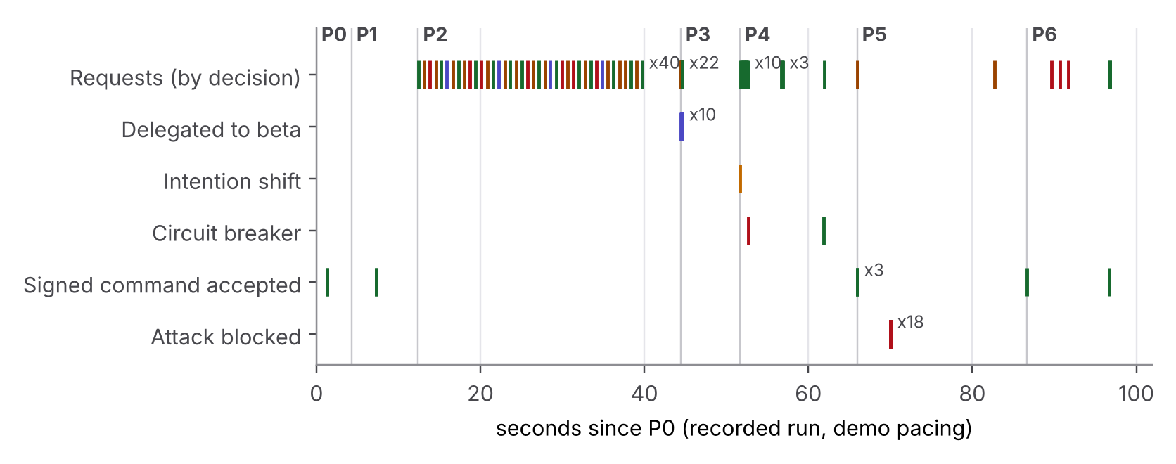
Figure 5.2: Timeline of the recorded run (one tick per event; xN marks a burst)

5.2 P0 Boot and self-attestation
The mesh provisioned three host identities and a release key, wrote the trust store and signed a manifest over 86 source files. Both gateways passed self-attestation in NORMAL mode, loaded the ontology graph (1170 triples, 29 classes) and negotiated a Contract-Net capacity contract with every provider. Table 5.1 shows the contracts the router then used.
Table 5.1: Contract-Net capacity contracts negotiated at boot (USD per 1,000 requests)
Provider | Status | Agreed price | List price
local | AGREED | 0.33 | 0.40
aws-bedrock | AGREED | 2.28 | 2.80
azure-ai | AGREED | 2.69 | 3.30
gcp-vertex | AGREED | 1.79 | 2.20

03:41:15.418 [gateway-alpha] ATTEST self-attestation PASSED: 86 source files match...
03:41:15.430 [gateway-beta] ATTEST self-attestation PASSED: 86 source files match ...
Listing 5: P0 attestation lines from logs/production_cycle.log

5.3 P1 Live knowledge
Gateway-alpha fetched all six public feeds live over TLS (Table 5.2). The live data moved the threat posture to ELEVATED, converted the INR 300 budget at the live rate of 94.91 INR per USD to USD 3.1609 per 1,000 requests, and tightened the R5 prompt limit from 65,536 to 32,768 bytes. Gateway-beta learned the posture and the budget from alpha's signed heartbeat replies and accepted the tighter R5 limit through a field-limited STATE_SYNC. Only counts and tags are logged; no headline or description from any feed is stored.
Table 5.2: Live feeds fetched in P1
Feed | Mode | HTTP | Bytes | Items | Relevant | Belief changes
gcp_status | live | 200 | 251,117 | 8 | 0 | 1
azure_status | live | 200 | 577 | 0 | 0 | 1
aws_health | live | 200 | 231,276 | 2 | 0 | 1
cisa_kev | live | 200 | 1,826,755 | 1766 | 3 | 11
fx_usd_inr | live | 200 | 69 | 1 | 1 | 4
aiid_rss | live | 200 | 88,482 | 100 | 18 | 8

03:41:21.826 [P1] threat posture -> ELEVATED (ai_incidents: aiid.privacy_per_day=0.57...
03:41:21.826 [P1] fx USD/INR 94.91 -> budget USD 3.1609 per 1k (was 6.0); R5 prompt l...
03:41:23.834 [P1] gateway-beta learned posture=ELEVATED budget=3.1609 from alpha's si...
03:41:23.834 [P1] policy STATE_SYNC alpha -> beta (fields policy_revision, policy_ver...
Listing 6: P1 adaptation lines

5.4 P2 Autonomous processing
Forty enterprise prompts went through alpha's four-worker pool: clean questions, e-mail and phone numbers, Aadhaar and PAN, internal URLs, an AWS key, a GitHub token, a Slack token, a database URL, an oversized log and three obfuscated secrets (spaced letters, [at]/[dot], Base64). Every prompt got its own BDI deliberation, and every policy decision matched the expectation written in the workload. Table 5.3 summarises the outcome.
Table 5.3: P2 outcome by decision
Decision | Requests | BDI desire and plan | Result
ALLOW | 14 | D3: allow_then_dispatch (best feasible cloud) | sent clean; reply inspected
REDACT | 15 | D3 under D2: redact_then_dispatch or dispatch_local_only | masked copy sent; India data only to IN/LOCAL
REVIEW | 4 | D3: hold_for_review | review ticket; nothing sent
BLOCK | 7 | D1: block_and_advise_rotation | evidence sealed; nothing sent

Indian personal data was never routed outside IN or LOCAL providers (residency violations: 0). Figure 5.3 shows the time per request. Blocked and held requests finish in about two milliseconds because nothing is sent; dispatched requests include the simulated provider latency.
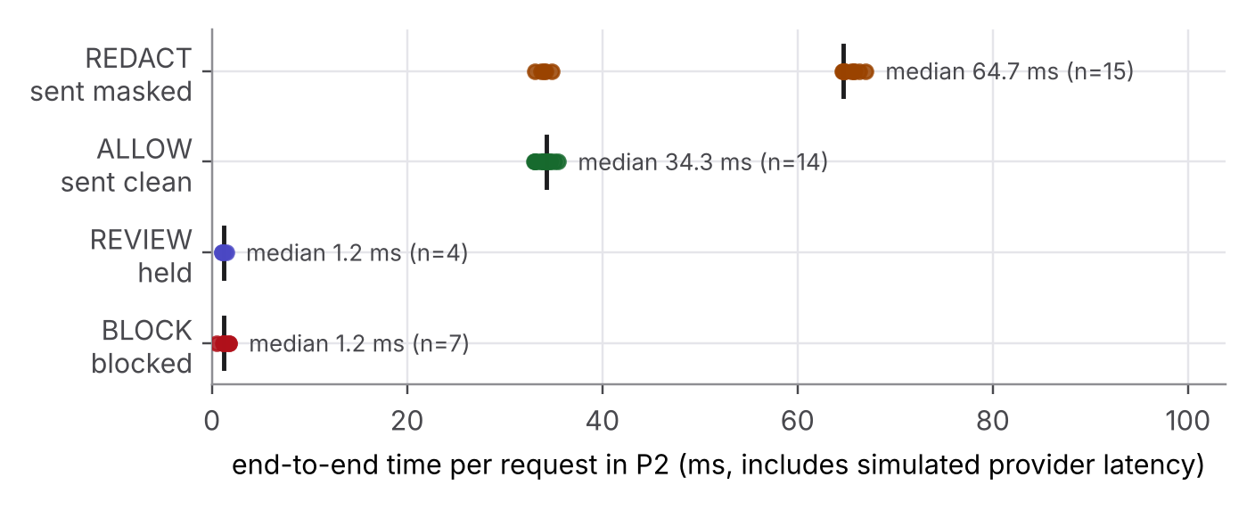
Figure 5.3: End-to-end time per P2 request by decision
03:41:55.858 [P2] 03:41:29.942 c01 INTEND I1 adopted for D3: dispatch_local_o...
03:41:55.858 [P2] 03:41:29.943 c01 STEP I1 dispatch_local_only(provider=loc...
03:41:55.858 [P2] 03:41:29.943 c02 STEP I1 dispatch_local_only(provider=loc...
03:41:55.858 [P2] 03:41:29.944 c03 STEP I1 dispatch_local_only(provider=loc...
03:41:55.858 [P2] 03:41:29.944 c04 STEP I1 dispatch_local_only(provider=loc...
03:41:55.858 [P2] 03:41:30.005 c05 STEP I1 dispatch_local_only(provider=loc...
Listing 7: BDI trace of the Aadhaar request p2-04 (no prompt text)

5.5 P3 Coordination and load sharing
A burst of 22 prompts arrived at once. When alpha's queue reached the high-water mark of six, alpha announced each shareable task with a signed PING, gateway-beta replied with a signed bid, alpha awarded the task as a signed INSPECT and beta returned a signed result after its own BDI deliberation. 10 tasks were processed on beta; the 2 BLOCK and REVIEW prompts in the burst stayed on alpha (left the host: 0). Table 5.4 lists the delegated tasks.
Table 5.4: Tasks delegated to gateway-beta in P3
Task | Decision | Bid (ms) | Round trip (ms) | Result
task-alpha-001 | ALLOW | 20 | 52.1 | COMPLETED
task-alpha-002 | ALLOW | 20 | 85.7 | COMPLETED
task-alpha-003 | ALLOW | 20 | 84.2 | COMPLETED
task-alpha-004 | ALLOW | 25.5 | 86.1 | COMPLETED
task-alpha-005 | REDACT | 18.6 | 58.5 | COMPLETED
task-alpha-006 | ALLOW | 18.6 | 76.7 | COMPLETED
task-alpha-007 | ALLOW | 29.1 | 43.8 | COMPLETED
task-alpha-008 | REDACT | 28.2 | 48.6 | COMPLETED
task-alpha-009 | ALLOW | 28 | 39.4 | COMPLETED
task-alpha-010 | ALLOW | 27.6 | 52.3 | COMPLETED

03:41:59.864 [gateway-alpha] CFP task-alpha-001: queue saturated (depth >= 6); ...
03:41:59.865 [gateway-alpha] CFP task-alpha-002: queue saturated (depth >= 6); ...
03:41:59.867 [gateway-alpha] CFP task-alpha-003: queue saturated (depth >= 6); ...
03:41:59.876 [gateway-alpha] BID task-alpha-001: gateway-beta bids accept=True ...
Listing 8: one Contract-Net round from the log

5.6 P4 Environmental change: provider outage
While clean traffic was running, a labelled drill switched the simulated GCP Vertex adapter into an HTTP 503 outage just before an intention bound to it reached its dispatch step. The belief provider.gcp-vertex.status = major_outage reached the running intention through the belief relay, the intention was dropped before transmitting and the agent re-planned (Table 5.5). The health monitor saw consecutive failed probes and opened the circuit breaker. A clearly labelled what-if replay of the Azure status feed then took Azure down too, and beta learned the GCP outage from alpha. After the drill the next healthy probe closed the circuit, Azure was restored from the P1 live snapshot and traffic returned to GCP.
Table 5.5: Intention shifts recorded in P4
Request | Dropped intention | Adopted intention | Reason
p4-01 | allow_then_dispatch(provider=gcp-vertex) | dispatch_local_only(provider=local) | requires 'provider gcp-vertex is usable' but believed provider.gcp-vertex.status=major_...

During the outage, successful transmissions to GCP Vertex: 0; circuit opened: true; closed again after recovery: true; beta learned the outage: true.
03:42:08.118 [P4] 03:42:07.117 c05 DROP I1 allow_then_dispatch(provider=gcp...
03:42:08.118 [P4] 03:42:07.119 c06 REPLAN I1 allow_then_dispatch(provider=gcp...
03:42:08.118 W [gateway-alpha] CIRCUIT circuit breaker OPEN for gcp-vertex after 3 ...
Listing 9: the intention shift and the circuit breaker in the log

5.7 P5 Security
The security console sent three signed commands (a redaction-pattern update, a telemetry dump and a ping), and all were accepted with verified signed replies. A project-codename probe was then redacted by the new pattern. Next the attacker sent 18 hostile frames from untrusted addresses, from a foothold inside the console subnet and with a stolen peer-gateway key. All 18 were blocked, each at the expected checkpoint, and the engine state fingerprint was identical before and after (Table 5.6).
Table 5.6: Attack battery against gateway-alpha
Id | Attack | Source | Check | Reason code
A01 | Replay of a captured console command | 127.0.0.22 | C11 | REPLAY_MSG_ID
A02 | Forged console signature | 127.0.0.22 | C8 | BAD_SIGNATURE
A03 | Payload tampered after signing | 127.0.0.22 | C8 | BAD_SIGNATURE
A04 | Unsigned garbage command | 127.0.0.66 | C2 | SCHEMA_VIOLATION
A05 | Unknown host identity | 127.0.0.66 | C5 | UNKNOWN_HOST
A06 | Captured console frame replayed from outside | 127.0.0.66 | C7 | ORIGIN_NOT_ALLOWED
A07 | Oversized frame (declares 1 MiB) | 127.0.0.66 | C1 | FRAME_TOO_LARGE
A08 | Protocol downgrade (cm-sig/0) | 127.0.0.67 | C3 | UNSUPPORTED_VERSION
A09 | Wrong recipient | 127.0.0.67 | C4 | WRONG_RECIPIENT
A10 | Privilege escalation with a peer key | 127.0.0.12 | C13 | COMMAND_NOT_PERMITTED
A11 | Compromised peer code | 127.0.0.12 | C12 | ATTESTATION_MISMATCH
A12 | Stale command (issued 10 minutes ago) | 127.0.0.12 | C10 | STALE_MESSAGE
B01-B05 | Brute-force forged admin command (5 frames) | 127.0.0.77 | C7 | ORIGIN_NOT_ALLOWED
B06 | Brute-force forged admin command | 127.0.0.77 | L0 | SOURCE_LOCKED_OUT

Figure 5.4 counts the frames per checkpoint. Every checkpoint from C1 to C13 except C6 and C9 stopped at least one frame in this battery, and the lockout gate L0 stopped the sixth brute-force attempt; C6 and C9 are covered by the Unit 5.1 battery and its tests.
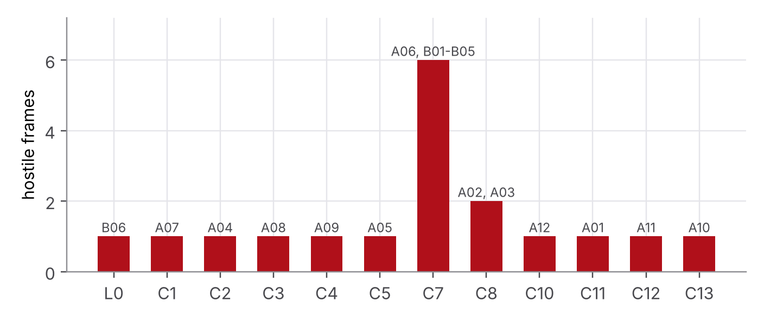
Figure 5.4: Hostile frames blocked per checkpoint in P5

5.8 P6 Lockdown drill and graceful shutdown
The console sent TRIGGER_EMERGENCY_LOCKDOWN. Three clean prompts were then BLOCKED by desire D1 with enforce_lockdown_block, and provider transmissions during the lockdown were 0. The console released the lockdown with RELEASE_LOCKDOWN and the next two prompts completed. Both gateways then drained their queues, stopped their workers and verified their evidence ledgers (Table 5.7).
Table 5.7: Final state of the gateways after the drain
Gateway | Completed | Failed | p50 / p95 (ms) | Ledger records | Ledger check
gateway-alpha | 73 | 0 | 36.778 / 122.665 | 125 | VERIFIED
gateway-beta | 10 | 0 | 35.78 / 46.376 | 20 | VERIFIED

5.9 Results across the cycle
Figure 5.5 shows the decisions per phase. Across the whole run the mesh handled 82 requests (ALLOW 44, REDACT 22, REVIEW 5, BLOCK 11), recorded 1 intention shift, delegated 10 tasks, exchanged 204 signed heartbeats and blocked 18 of 18 attacks. The p50 and p95 request times were 35.5 ms and 69.7 ms.
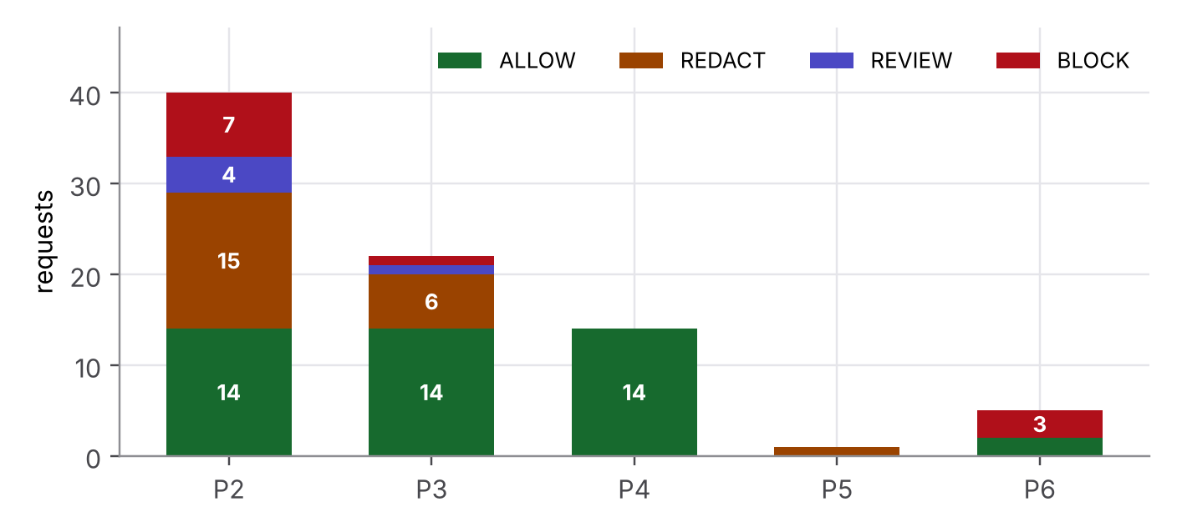
Figure 5.5: Policy decisions per phase in the recorded run

6 TESTING
The full suite is the existing backend tests plus the unit tests copied from Units 4.1, 4.2 and 5.1 and 39 new capstone tests. All 563 pass (logs/pytest_results.txt). Table 6.1 gives the counts by unit.
Table 6.1: Test counts by unit
Group | Folder | Tests | What they cover
Units 1-3 engine | tests/engine/ | 112 | detector, policy, transport, negotiation, routing, pipeline
v2 API and graph | tests/test_*.py | 49 | REST routes, LangGraph flow, vault
Unit 4.1 BDI | tests/bdi/ | 76 | beliefs, desires, plans, intentions, reconsideration
Unit 4.2 Knowledge | tests/knowledge/ | 130 | ontology, graph, parsers, fallback, adapter
Unit 5.1 Trust | tests/trust/ | 157 | keys, envelope, checkpoints, integrity, breach run
Capstone | tests/capstone/ | 39 | host wiring, StateBus, sync, load sharing, ops API, CLI, cycle
Total |  | 563

Table 6.2 lists the new capstone tests. Hosts in the tests attest a clean copy of the package, because the test process itself may write bytecode caches into the source tree and the Unit 5.1 attestation correctly refuses those.
Table 6.2: Capstone tests
Test file | Tests | Edge cases covered
test_statebus.py | 6 | deep-copy snapshots, version wake-up, bounded ring buffer, faulty subscriber, 6 concurrent writers
test_coordination.py | 10 | policy-sync fields inside the allow-list; India data never delegated; peer and engine beliefs never shared; strict schemas
test_host.py | 12 | all units wired; each decision class; belief sync and policy sync (tighten only); load sharing keeps BLOCK, REVIEW and Aadhaar home; unsigned, weakening, unbound-key and escalation frames blocked; peer refuses BLOCK content; attack battery; lockdown; outage shift; no prompt text in state; .pyc forces SAFE MODE
test_ops_api.py | 5 | nonce CSP and no CDN; state JSON; SSE event; token by header and query; v2 routes unchanged
test_dashboard_cli.py | 4 | all sections rendered; ANSI only on a TTY; non-TTY snapshots; unreachable API
test_cycle.py | 2 | workload expectations match the real policy; full P0-P6 cycle offline; no prompt text in logs

7 VIDEO PRESENTATION
The video video/CipherMesh_Capstone_Lifecycle.mp4 lasts 3:05 at 1920x1080, 30 fps, H.264. Its middle part is a real Playwright recording of the live dashboard during the production cycle whose logs are in logs/; title and section cards frame it. Captions are burned in, and video/narration_script.md gives a timed voice-over to read aloud. Table 7.1 is the storyboard and Figure 7.1 shows three key frames.
Table 7.1: Video storyboard
Time | Scene | Content
0:00-0:08 | Title | project, student, course, guide, institute
0:08-0:22 | Problem | what a prompt can leak; five units become one agent
0:22-0:40 | Architecture | the schematic of Figure 3.1
0:40-0:46 | Lifecycle | the seven phases
0:46-2:26 | Live run P0-P6 | dashboard recording with one caption per phase
2:26-2:43 | Breach blocked | security card and close-up of the security stream
2:43-2:57 | Results | numbers from the run summary
2:57-3:05 | Close | tagline and repository

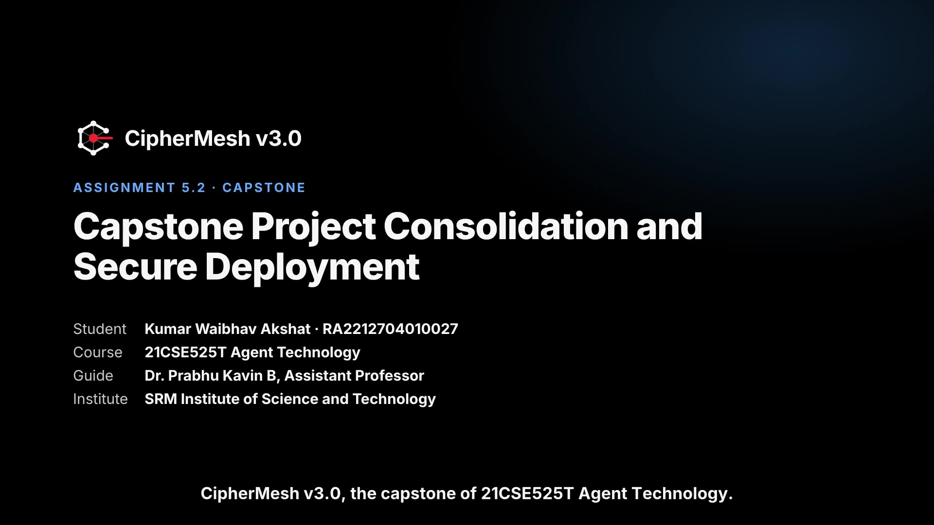 | 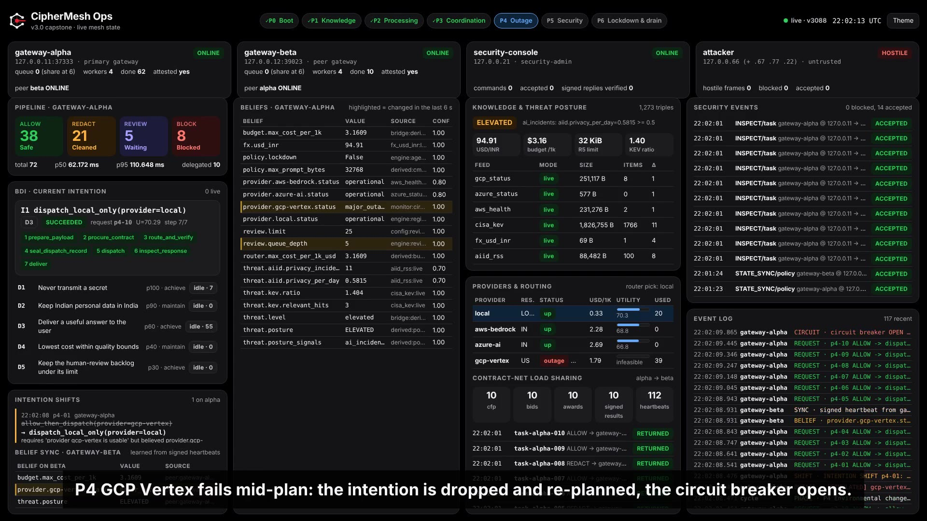 | 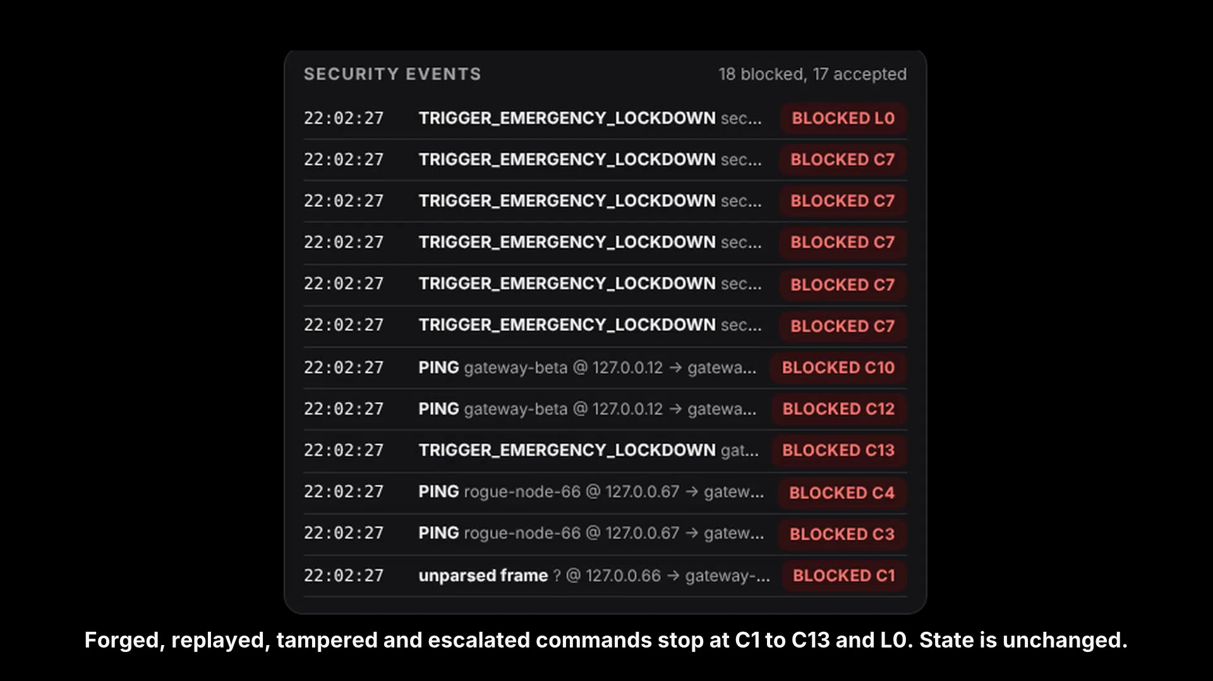
Figure 7.1: Key frames: title card, P4 outage on the live dashboard, security stream close-up

8 SUBMISSION ANALYSIS

8.1 Requirement, evidence and status
Table 8.1 checks each line of the brief against its evidence.
Table 8.1: Requirement, evidence and status
Requirement | Evidence | Status
Unified codebase of Units 1-5 | AgentHost; unit packages unchanged; wiring test | PASS
Clean UI layer with live states | /ops (SSE) and CLI; Figures 4.1-4.4; Listing 4 | PASS
Agent processes inputs independently | P2: 40 prompts, all expectations met | PASS
Coordinates with other hosts | P1 belief and policy sync; P3 10 delegated tasks, signed results | PASS
Updates its intents | P4: 1 intention shift, circuit breaker | PASS
Executes actions safely | P5 18/18 blocked, state unchanged; P6 0 transmissions in lockdown | PASS
Source code package and tests | 563 tests pass | PASS
Repository link | README and docs/SUBMISSION.md | PASS
3-minute video | 3:05, captions, narration script | PASS
Architecture schematic | PNG, PDF and HTML source | PASS

8.2 Strengths
- Real integration, not glue scripts. Every unit runs through its own public API inside one host; a belief from a live feed or a monitor reaches a running plan through the relay.
- Least privilege between peers. Coordination needs no new command and no wider role; the field-level STATE_SYNC rule of Unit 5.1 is respected, and a stolen peer key cannot lock the mesh down (attack A10).
- Privacy survives sharing. Only ALLOW or redacted text crosses hosts, Indian personal data never does, and the receiver re-inspects whatever it is given.
- Observable. Both dashboards read one bus; nothing on screen or in the logs contains prompt text.
- Reproducible. One command produces every log; the tests run the whole cycle offline.

8.3 Honest limitations
- Cloud providers are simulated adapters with illustrative prices and latencies, as in Units 3 to 4; the local tier calls a real Ollama only when CIPHERMESH_OLLAMA=1.
- The GCP outage is a labelled drill on the simulated adapter, and the Azure outage is a labelled what-if replay of a hand-written fixture; on the day of the run the real provider feeds were quiet.
- All hosts run on one machine over loopback. Distinct source addresses make checkpoint C7 meaningful, but a production mesh would add mutual TLS between hosts.
- Attestation is software-only (no TPM), and replay caches and the state bus are in memory, so a restart forgets them.
- Only 1 intention shift happened in the recorded run because only one request was mid-plan when the outage started; the tests and earlier runs show several concurrent shifts.
- The video is silent with burned-in captions; the narration script is provided for a voice-over.

8.4 Lessons learned
- Integration needs a belief path, not just function calls. The units fitted together only after host beliefs could reach a running intention on another thread; the BeliefRelay is small but it is what makes reconsideration work across the whole host.
- Security rules shape the protocol. When the trust unit made STATE_SYNC field-level, the first coordination design no longer fitted. Moving reported data into signed replies kept the roles narrow instead of widening them.
- Provenance prevents echoes. Without the source of each belief, two gateways would keep sending the same value back and forth and overwrite where it came from. Sharing only observed knowledge solved it.
- Compiled caches are code. Self-attestation correctly treats a stray .pyc as untrusted, so every run and test uses -B or a clean copy of the sources.
- Show the state, then trust the demo. The dashboard made bugs visible during development: an empty load-sharing panel exposed that paced submissions never filled the queue.

8.5 Future work
- Mutual TLS and certificate pinning between hosts, with Ed25519 commands on top.
- A persistent, replicated state bus and audit store for more than two gateways.
- Real provider adapters behind the same interface, with budget enforcement on actual invoices.
- Hardware-backed attestation (TPM quotes) feeding checkpoint C12.

9 CONCLUSION
CipherMesh v3.0 joins the reflex policy, the worker pool and sockets, Contract-Net cooperation and utility routing, BDI deliberation with live knowledge, and Ed25519 trust into one autonomous host, and runs two such hosts as a mesh. In the recorded production cycle the agent processed 82 requests on its own, shared 10 tasks with its peer under signed messages, changed its plan when a provider failed mid-execution, and blocked every one of 18 hostile frames without any change to its state. The web and terminal dashboards show all of this live, and the video, logs and tests make it easy to check. The result is a system in which each part from the earlier units is still recognisable, and the whole works as one agent [8] [9].
Table 9.1 maps the main ideas of the course to the place where the recorded run demonstrates them.
Table 9.1: Course concepts and where the capstone demonstrates them
Concept | Demonstrated by | Evidence
Simple-reflex agent | admission reflex on every prompt (R1-R5) | P2 decisions, Table 5.3
Concurrency and daemons | worker pool, daemon health monitor, graceful drain | P6 drain, Table 5.7
Agent communication | typed, signed frames over TCP between four hosts | security events, P5
Negotiation (Contract-Net) | provider contracts; announce, bid, award, result | Tables 5.1 and 5.4
Utility-based choice | constrained router inside every dispatch plan | utility bars, Figure 4.1
BDI and reconsideration | intention dropped and re-planned on a belief change | Table 5.5, Listing 9
Knowledge representation | ontology graph and live feeds turned into beliefs | Table 5.2, Listing 6
Agent security | Ed25519 trust gate, self-attestation, least privilege | Table 5.6, Figure 5.4

Seen through the course, the capstone is a complete agent in the classical sense. It perceives prompts, feeds and peer heartbeats; it keeps beliefs about providers, threats and budgets; it pursues prioritised desires through plans that it revises when the world changes; it cooperates with another agent through a negotiation protocol; and it protects its own percept channel and its own code with cryptography. Each of those ideas was first built and tested alone. The capstone shows that they still hold when they share threads, sockets and state, and that an operator can watch them do so in real time.

REFERENCES
[1] S. Russell and P. Norvig, Artificial Intelligence: A Modern Approach, 4th ed. Hoboken, NJ, USA: Pearson, 2020.
[2] WHATWG, "Server-sent events," in HTML Living Standard. Accessed: Nov. 2, 2026. [Online]. Available: https://html.spec.whatwg.org/multipage/server-sent-events.html
[3] S. Rose, O. Borchert, S. Mitchell, and S. Connelly, "Zero Trust Architecture," NIST Special Publication 800-207, National Institute of Standards and Technology, Aug. 2020, doi: 10.6028/NIST.SP.800-207.
[4] S. Josefsson and I. Liusvaara, "Edwards-Curve Digital Signature Algorithm (EdDSA)," Internet Engineering Task Force, RFC 8032, Jan. 2017. [Online]. Available: https://www.rfc-editor.org/rfc/rfc8032
[5] H. Birkholz, D. Thaler, M. Richardson, N. Smith, and W. Pan, "Remote ATtestation procedureS (RATS) Architecture," Internet Engineering Task Force, RFC 9334, Jan. 2023. [Online]. Available: https://www.rfc-editor.org/rfc/rfc9334
[6] R. G. Smith, "The Contract Net Protocol: High-level communication and control in a distributed problem solver," IEEE Transactions on Computers, vol. C-29, no. 12, pp. 1104-1113, Dec. 1980.
[7] W3C, "Content Security Policy Level 3," W3C Working Draft. Accessed: Nov. 2, 2026. [Online]. Available: https://www.w3.org/TR/CSP3/
[8] M. Wooldridge, An Introduction to MultiAgent Systems, 2nd ed. Chichester, U.K.: Wiley, 2009.
[9] A. S. Rao and M. P. Georgeff, "BDI agents: From theory to practice," in Proc. 1st Int. Conf. Multi-Agent Systems (ICMAS-95), San Francisco, CA, USA, 1995, pp. 312-319.

APPENDIX A HOW TO RUN
All commands run from the repository root. The platform needs Python 3.12 or later with backend/requirements-dev.txt; the recorder and the video build also need the Python playwright package with Chromium and ffmpeg.
cd backend && pip install -r requirements-dev.txt && cd ..
# production cycle (fast) -> logs/
python -B demo/run_production_cycle.py
# production cycle with the live dashboard at http://127.0.0.1:8000/ops
python -B demo/run_production_cycle.py --serve 8000 --pace 2
# recorded run (cycle + dashboard screenshots + JPEG frames for the video)
PY=python REC_PY=python3 bash demo/record_production_cycle.sh /path/to/frames
# CLI dashboard (live, or one snapshot from a saved state)
cd backend && python -B -m ciphermesh.capstone.dashboard --url http://127.0.0.1:8000
python -B -m ciphermesh.capstone.dashboard --state-file ../logs/ops_state_final.json --once
# tests
python -B -m pytest -v -rs --no-header -p no:logging -o addopts="" > ../logs/pytest_results.txt
# API + /ops with Docker
cd .. && docker compose up --build
Listing 10: commands
Table A.1 lists the exact command that produced each output in the submission.
Table A.1: Commands that produced each output
Output | Command (from the repository root)
logs/production_*, ops_state_final.json, cli_dashboard_snapshot.txt, security_audit_*.jsonl, dashboard_snapshots/ | PY=backend/.venv/bin/python REC_PY=python3 bash demo/record_production_cycle.sh <frames>
logs/pytest_results.txt | cd backend && python -B -m pytest -v -rs --no-header -p no:logging -o addopts="" -p no:cacheprovider
video/CipherMesh_Capstone_Lifecycle.mp4, captions.srt | python3 video/src/build_video.py --frames <frames>
docs/architecture/CipherMesh_v3_Architecture.png / .pdf | render CipherMesh_v3_Architecture.html with Playwright (element #arch, scale 3)
docs/figures/chart_*.png | python3 docs/figures/make_charts.py <reportkit>/chart_style.py
docs/figures/fig_*.png diagrams | node render_diagrams.js docs/figures/diagrams.html docs/figures <ids>
report .docx / .pdf | bash make_report.sh docs/report_src/content.js docs <name> (course report kit)

APPENDIX B FILE LISTING
Table B.1: Main files of the submission
Path | Content
backend/ciphermesh/capstone/ | the unified platform (12 modules)
backend/ciphermesh/{bdi,knowledge,trust}/ | Units 4.1, 4.2 and 5.1 (unchanged)
backend/app/ops/ | ops routes and the self-contained dashboard page
backend/tests/ | engine, API, bdi, knowledge, trust and capstone tests
demo/ | production cycle runner, recorder and wrapper script
logs/production_cycle.log | readable log of the recorded run with phase banners
logs/production_events.jsonl | every StateBus event of the run, tagged with its phase
logs/production_summary.json | per-phase counts, latencies, decisions, shifts, attacks, tasks
logs/ops_state_final.json, cli_dashboard_snapshot.txt | final dashboard state as JSON and as CLI text
logs/security_audit_{alpha,beta}.jsonl | metadata-only trust-gate audit of each gateway
logs/dashboard_snapshots/ | PNG screenshots at key moments and the capture timeline
logs/pytest_results.txt | full test run
video/ | video, captions, narration script, card and build sources
docs/architecture/ | schematic PNG, PDF and HTML source
docs/figures/, docs/report_src/ | report figures, chart and diagram sources, report content
docs/SUBMISSION.md | how to publish the repository
frontend/ | the existing Next.js console (unchanged)

APPENDIX C REPOSITORY AND PUBLISHING
The repository is published at https://github.com/kumarwaibhav/CipherMesh. docs/SUBMISSION.md lists the commands to initialise the repository with the author's name and e-mail, commit, push to the main branch and tag the release v3.0.0; Listing 11 repeats them, one command per line. Private keys are created at run time in a temporary directory and are never committed; .gitignore also excludes key files, caches and build output.
git init
git config user.name "Kumar Waibhav Akshat"
git config user.email "kwa.waibhav@gmail.com"
git checkout -b main
git add .
git status
git commit -m "CipherMesh v3.0 capstone release (Assignment 5.2)"
git remote add origin https://github.com/kumarwaibhav/CipherMesh.git
git push -u origin main
git tag -a v3.0.0 -m "CipherMesh v3.0.0 capstone release"
git push origin v3.0.0
Listing 11: publishing commands (docs/SUBMISSION.md)
Before pushing, git status must not list key files, virtual environments, node_modules/, .next/ or Python caches. The video is about 9 MB, well within the normal GitHub file limit. After the push, the README on the repository page shows the architecture image, the live app and API links, the video path and the commands that produced each log.

