
Integration Solution Document
HRMS TO TMS INTEGRATION
Kumaresan Murugan
Contents
1. Objective 2
2. Integration Approach Overview 2
3. Solution Breakdown 3
3.1. Solution 1 – Initial Sync from TMS to HRMS 3
3.2. Solution 2 – Real-Time Update 4
4. Sequence Diagram 5

1. Objective
To implement a real-time, direct integration between HRMS (Rymnet) to TMS.
The integration ensures that whenever employee or related data is created or updated in HRMS, the same changes are immediately reflected in TMS through a secure POST API call.
2. Integration Flow
- Event Trigger in HRMS (Rymnet):
- Whenever a new employee is created or existing employee details are updated, HRMS generates an event.
- Data Preparation:
- Relevant employee data is extracted and transformed into the required JSON payload format.
- API Call to TMS:
- HRMS sends a POST request to the TMS endpoint with the JSON payload.
- TMS Data Update:
- TMS validates the payload and updates its database.
- Returns a success or error response.
- Error Handling:
- Failed API calls are logged.

3. Solution Breakdown

3.1. Solution 1 – Initial Sync from TMS to HRMS

Solution 1 – Initial Sync via Excel Upload

Objective: TMS extracts employee information from HRMS using an Excel-based exchange.

Process:

TMS team will provide an Excel file containing employee information with the following:

Required columns for update/insert.

Primary key (e.g., staff number, Email ID) for record identification.

HRMS team will:

Fill in the data in the provided template.

Return the completed Excel file.

TMS team will:

Validate the file.

Update existing records or insert new employee data into HRMS accordingly.

Solution 2 – Initial Sync via GET API

Objective: Automate synchronization using an API-driven approach.

Process:

HRMS will expose a GET API that provides the required employee data.

TMS will:

Call the GET API to retrieve all employee information.

Compare with its own database.

If record exists → Update.

If record does not exist → Insert.

TMS will provide an update response back to HRMS (success/failure report).

3.2. Real-Time Update

Whenever a new employee is created or an existing employee’s details are updated in HRMS, the system generates an event.

This event immediately triggers an update in TMS to ensure both systems remain synchronized.

Sequence Diagram

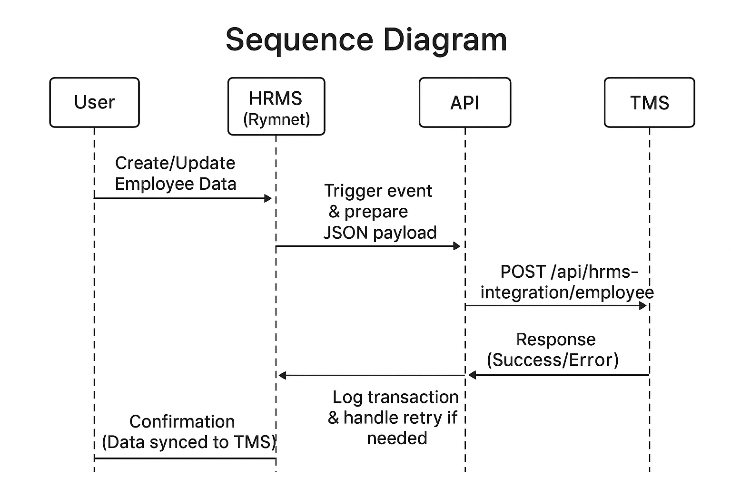

5. Data Sync Columns

Details from HRMS (Rymnet) | New Recruit | Resignation | Change in Details
Status (automated) | Active | Inactive | –
Staff Name | ✔ | – | –
Staff ID | ✔ | – | –
Photo | ✔ | – | ✔
Date of Birth | ✔ | – | –
Address | ✔ | – | –
Identification Card (IC) | ✔ | – | –
E-mail | ✔ | – | ✔
Phone Number | ✔ | – | ✔
Current Position | ✔ | – | ✔
Date Joined | ✔ | – | –
Educational Details | ✔ | – | ✔
Prior Experience | ✔ | – | –
Career Experience | ✔ | – | ✔

Legend:
✔ = Field is required to be inserted or updated.
"–" = No action is needed for this field based on event type.

