**Test Case 1**: Basic cluster initialization on EC2 instances.

* Expected Result: Master and worker nodes should join successfully, and Kubernetes should report Ready nodes.
* Command - sudo kubectl get nodes
* Result below -

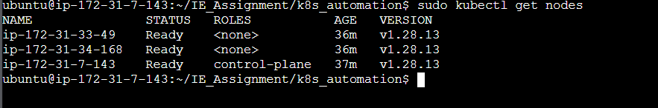

**Test Case 2**: Create a simple deployment with a Docker image (e.g., nginx) and specific resource limits.

* Expected Result: Deployment should be successfully created, and pods should run as expected.
* Commands –
  + sudo ./scripts/create_deployment.sh test-ns test-deployment nginx:latest 100m 500m 128Mi 512Mi 80 50
  + sudo kubectl get pods -n test-ns
  + sudo kubectl get deployment test-deployment -n test-ns
* Result below –

  
  
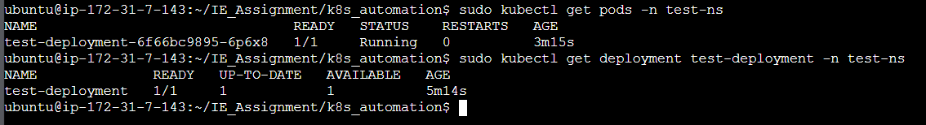

**Test Case 3**: Retrieve health status of an existing deployment.

* Expected Result: The health check script should return the status of pods and related resources.
* Command – sudo ./scripts/get_health_status.sh test-namespace test-deployment
* Result below -   
    
  