**Assignment** **1**

Mastering Advanced Java with Object-Oriented Programming

Submitted by: Vinit Kumawat

**Problem statement 1:**

Implement a Java program that demonstrates single inheritance and method overriding. Create a base class "Vehicle" with attributes and methods, then derive a class "Car" from it and override certain methods.

**Code:**

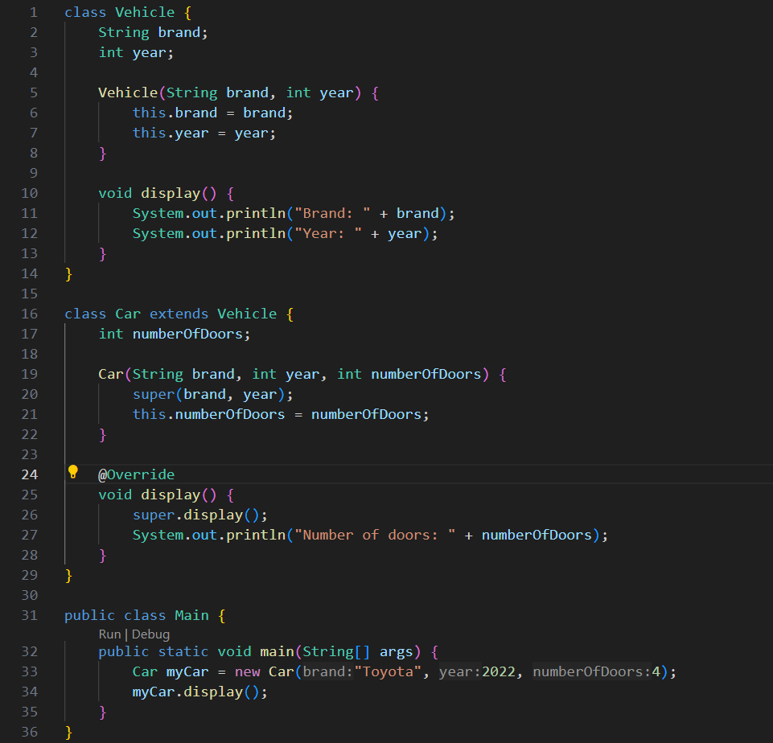

**Input:**

Brand: String

Year: Integer

numberOfDoors: Integer

**Output:**

**Display()** method is overridden in derived class **Car**

