**Assignment**-**3**

Mastering Advanced Java with Object-Oriented Programming

Submitted by: Vinit Kumawat

**Problem statement 3:**

Design a Java program illustrating the concept of encapsulation. Create a class "BankAccount" with private attributes like balance and methods for deposit and withdrawal, ensuring encapsulation principles are followed.

**Code:**

BankAccount class

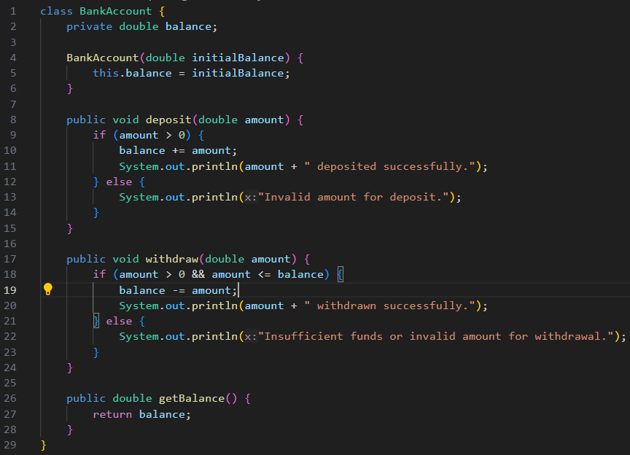

The **BankAccount** class encapsulates the **balance** attribute and ensures that it cannot be accessed directly from outside the class.

**getBalance()** getter is provided to ensure encapsulation.

**Testing:**

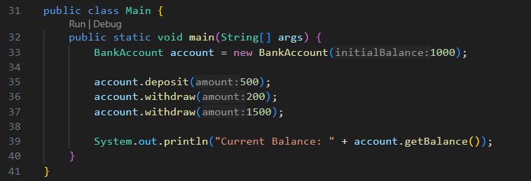

**Input:**

initialBalance: Integer

amount: Integer for **withdraw()** or **deposit()** methods

**Output:**

