**Assignment** **1**

Java Mastery Intermediate Methods, Collections, and Beyond

Submitted by: Vinit Kumawat

**Problem statement 1:**

Implement a Java method that calculates the factorial of a given number.

**Code:**

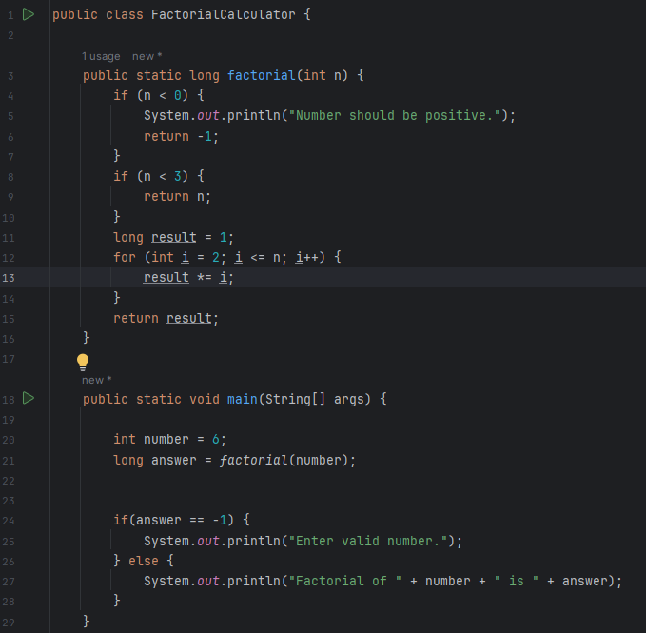

**Input:**

Number: int

**Output:**

