**Assignment** **2**

Java Mastery Intermediate Methods, Collections, and Beyond

Submitted by: Vinit Kumawat

**Problem statement:**

Develop a Java program that demonstrates the usage of ArrayList to store and manipulate a list of student names.

**Code:**

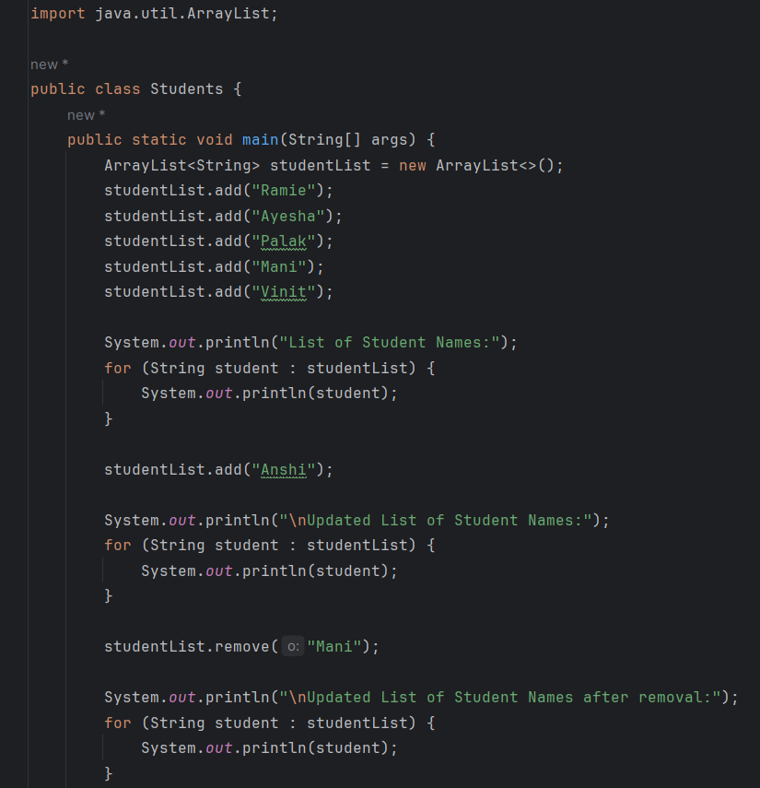

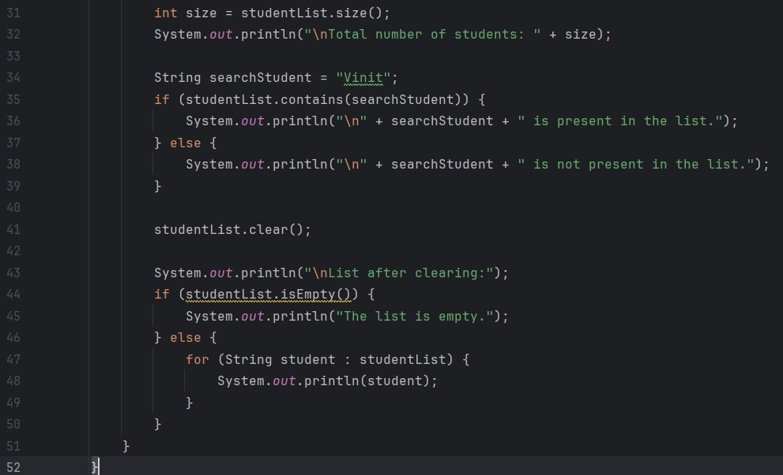

**Output:**

