**Assignment** **3**

Java Mastery Intermediate Methods, Collections, and Beyond

Submitted by: Vinit Kumawat

**Problem statement:**

Create a Java application that reads a text file, counts the occurrences of each word and displays the frequency of each word.

**Code:**

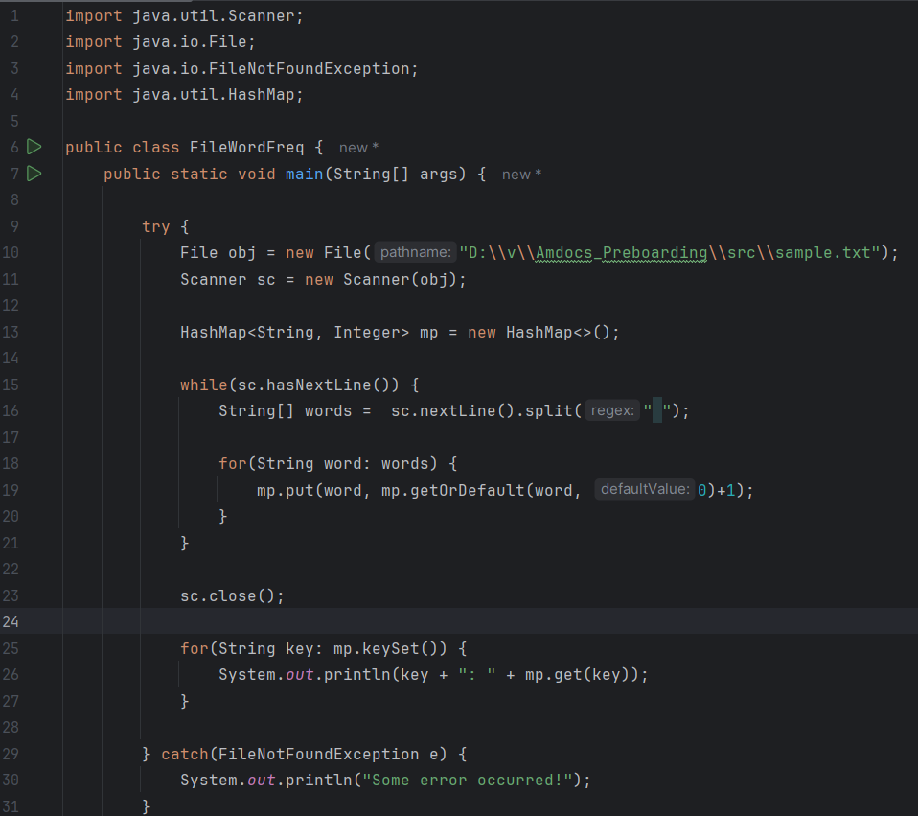

**Output:**

