SRE Automation

Readme - Execution Steps

This readme file provides detailed instructions for executing a particular program.

Please Follow the steps below to successfully execute the program and achieve the desired results.

# Prerequisites:

**Before proceeding with the execution, ensure that you have the following prerequisites in place**:

1. **Operating System**: The program is compatible with Windows, macOS, and Linux operating systems.
2. **Software Dependencies**: Make sure you have the necessary software and libraries installed as specified in the program documentation.  
   i.e. **GitBash (windows) / Shell (Unix OS based)**

# Configuration / Input files:

## 1. Input CSV file:

1. Fill required field details for specific tables in a sheet.  
   i.e.  
   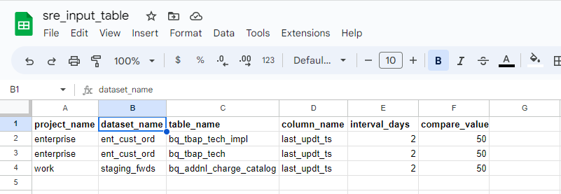  
     
   Note:- **column_value** can be provided as input or it can find out from the table.
2. **Download above sheet as TSV (tab separated values)** and Replace **TAB** delimiter with **|** (pipe) using Notepad ++   
   **OR** use Excel to export csv as pipe delimited.  
     
   (Note: This is due to download as pipe separated unavailable for google sheet.)  
     
   – This step optional if csv file already delimited by | (pipe) **OR**  
     
   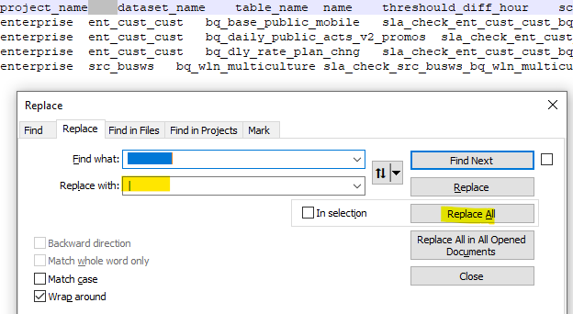  
     
   **i.e.**  
   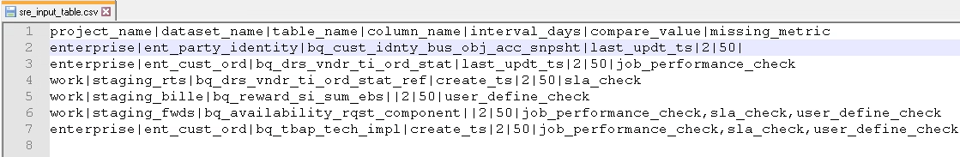
3. Save file named as **sre_input_table.csv** inside **code_base_sre_scratch** directory:  
   I.e.  
     
   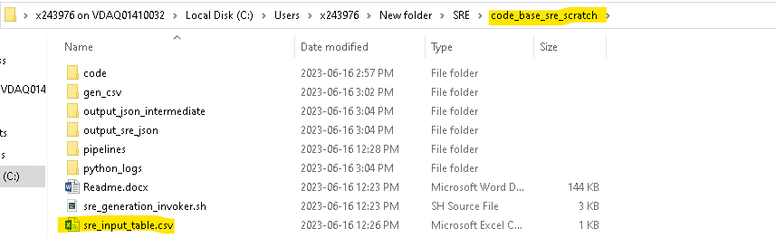

## 2. Git Pipelines (YAML):

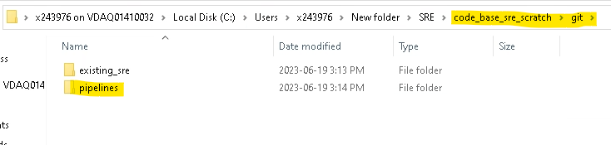

**i.e.**  
  
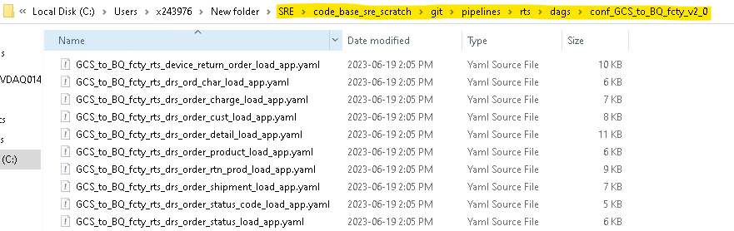

## 

# Execution:

1. Execute **sre_generation_invoker.sh** Open Bash Terminal at **code_base_sre_scratch** Location and execute it.  
     
   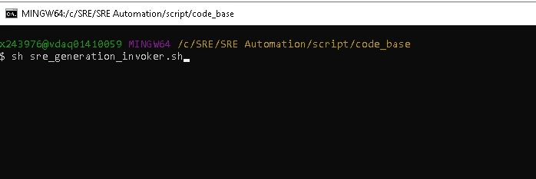

# Output:

1. Please find the output files at location: **\SRE\code_base_sre_scratch\output_sre_json  
     
   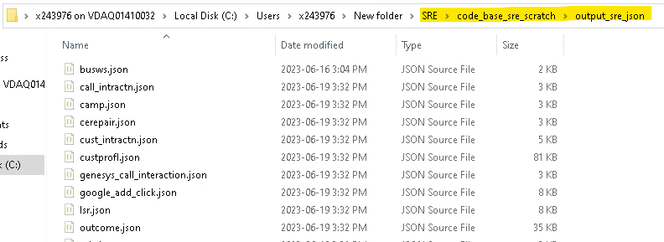**

# Logging:

Please find the execution logs at :  
  
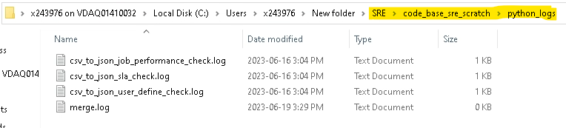

# Miscellaneous:

Note: **sre_file_generation_multiple_table_input_final**.sh contains default/constant values for below fields, Please change accordingly with your requirement.  
  
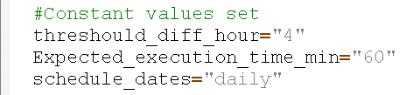

# Error Troubleshooting:

### raise JSONDecodeError("Expecting value", s, err.value) from None:

**Solution:**

If Existing SRE.json contains extra “,” (comma) at the end of any Matrix Check?

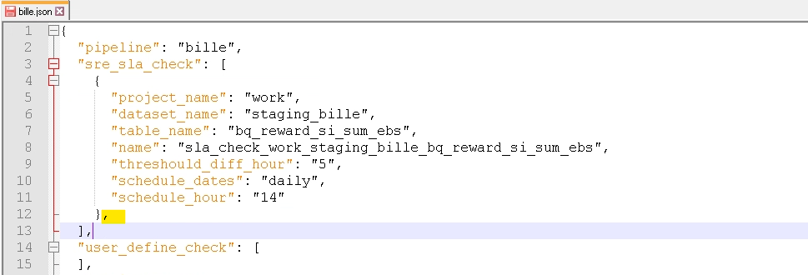

Remove that comma manually and make sure if there aren’t present before executing utility.

# Conclusion:

By following these execution steps, you should be able to successfully execute the program and obtain the desired results. Remember to review any additional documentation or guides provided along with the program for more specific instructions or advanced usage.