xx电路参数 | T的取值 | 传递函数G(s)
R₁ = R₂ = 100kΩ, C = 0.1μF | 0.01 | $$\frac{-100}{s}$$
R₁ = R₂ = 100kΩ, C = 1μF | 0.1 | $$\frac{-10}{s}$$
R₁ = R₂ = 100kΩ, C = 10μF | 1 | $$\frac{-1}{s}$$
R₁ = R₂ = 100kΩ, C = 100μF | 10 | $$\frac{-1}{10s}$$
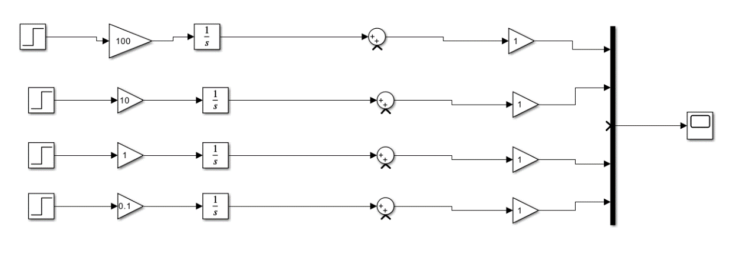
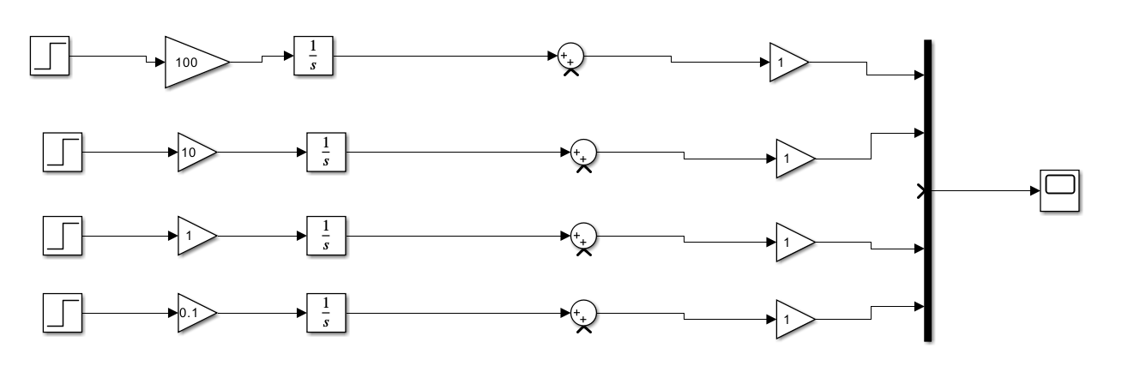

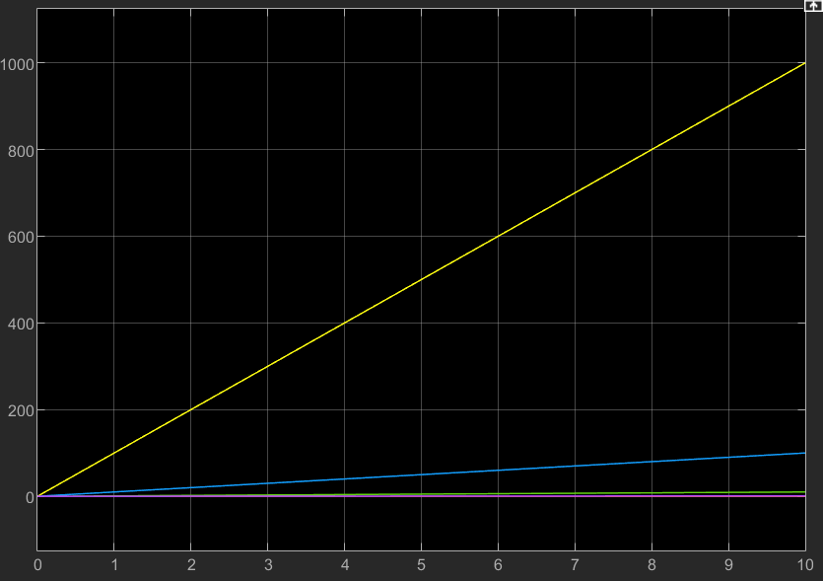

xx电路参数 | K的取值 | T的取值 | 传递函数G(s)
R₁ = R₂ = 100kΩ, C = 0.1μF | 1 | 0.01 | $$\frac{-100}{s}$$
R₁ = R₂ = 100kΩ, C = 1μF | 1 | 0.1 | $$\frac{-10}{s}$$
R₁ = R₂ = 100kΩ, C = 10μF | 1 | 1 | $$\frac{-1}{s}$$
R₁ = R₂ = 100kΩ, C = 100μF | 1 | 10 | $$\frac{-1}{10s}$$
