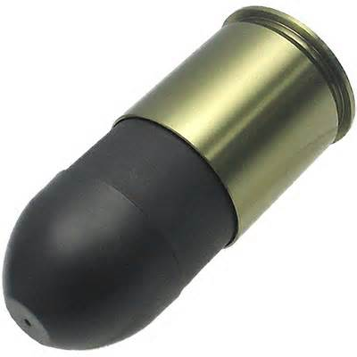**CSULB Programming Practice**

**Sept 10, 2014 – Problem #2**

**Rubber Bullets**

The Department of Defense in conjunction with the Department of Police, have devised a brilliant method of saving money on crowd control - really bouncy rubber bullets. They had noticed that the rubber bullets they had been using were largely being wasted - those that hit anyone or anything usually just fell to the ground, whereas if they were really, really bouncy, they would bounce off and possibly hit several more people before their energy was spent.

They decided to test this idea by building a special circular test rig. The bullet would be fired into the rig horizontally and at some predetermined angle to the tangent to the rig at that point. It would have sufficient energy to travel some considerable distance before stopping. (You may assume cartoon physics, i.e. that it travels horizontally until it reaches the end of its travel, at which time it drops to the floor.) However, as so often happens with lucrative defense contracts, the contractor made off with the money, so they decided to simulate the whole process on a computer. This is where you come in.

Write a program that will read in details of a test rig and a series of test firings and determine how many times the rubber bullet would bounce before it stops. You may assume that the bullet is a point and that, because of problems in determining the exact sequence of events, any test firing where the bullet stops within 1 mm of the rig is deleted from consideration.

**Input**

Input will be a series of tests, each test consisting of a series of test firings. Each test starts with an integer specifying the radius of the test rig in millimeters and a value of 0 for the radius terminates the input. Each test firing occurs on a line by itself and consists of a distance in millimeters (between 100 and 10000 inclusive) that the bullet will travel, and an angle, in degrees, (between 10 and 170 inclusive, where 90 means directly towards the centre of the rig). The series of test firings will be terminated by a line containing two zeroes (0 0).

**Output**

For each test rig, output a line with the words "Test Rig" followed by a space and then the number of the test rig (a running number starting at 1) followed by a series of lines, one for each test firing for that rig with each line giving the number of times a bullet bounces off a wall before it stops. This number is to be written without any leading or trailing spaces. A blank line should appear between test rigs. Follow the example given below.

**Sample Output**

Test Rig 1

12

8

**Sample Input**

100

1000 23

1200 47

0 0

0