Validation results:
We get what we expected:

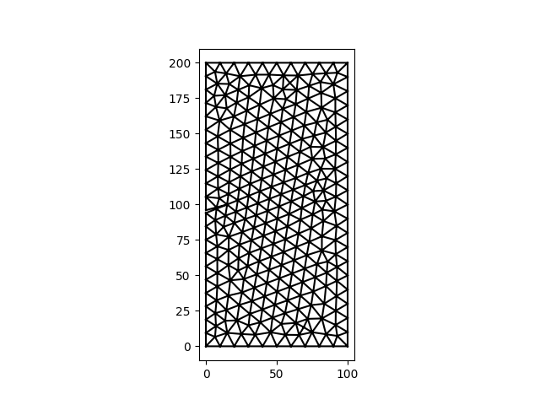
#name\t K1\t K2\t theta
valMesh. 3.57624E-03 7.16457E-04 -2.11191E+01

As the angle is negative, we can see the angles are are defined as usual

