REFLEXIO
  - Devansh Gupta, Mengxiang Jiang, Arthur Lanclos, Alan Liang, Brendan Viscomi

High Concept Statement

Kidnapped from his home, a baby koala must fight and outwit his way to freedom from a hostile alien planet. Armed with nothing but a magical umbrella, guide Joey through the strange reflective landscapes of unknown origin...

Features

- Wave your umbrella to reflect the world around you
- Use your magical umbrella to reach impossible locations
- Use intellect to overcome unsurpassable obstacles and enemies
- Outsmart your alien captors and return to Earth

Overview

Genre

2D Puzzle Platformer

Competition

  - And Yet It Moves includes a world-rotation mechanic, but contains no enemies. The levels are purely about making it to the end. Reflexio, however, places more of an emphasis on the action aspect, requiring the user to outwit or battle various enemies.

  - Rolando is a puzzle platformer in which the user rotates the world to roll balls around the world and get them to the ultimate goal. The primary difference is the use of rotation in Rolando rather than the reflection mechanic in Reflexio. Players reflect across the center, which allows them to pass through walls and past enemies.

Unique Selling Points

General Gameplay

  - Your primary ability is to reflect the world
  - Strategically utilize the power of reflection to warp across walls and past enemies

Puzzle Elements

- Certain environmental objects and enemies are not affected by reflection
- Player is only allowed a certain number of reflections per level – the umbrella has a limited number of charges
- Combine reflection with running, jumping, or climbing to overcome seemingly impossible obstacles

Additional Items

- Some powerful enemies are able to reflect the world to prevent you from reaching your goal

Design Goals

- Quick – Levels will be short so puzzles will quick and to the point - improving pick-up-and-playability
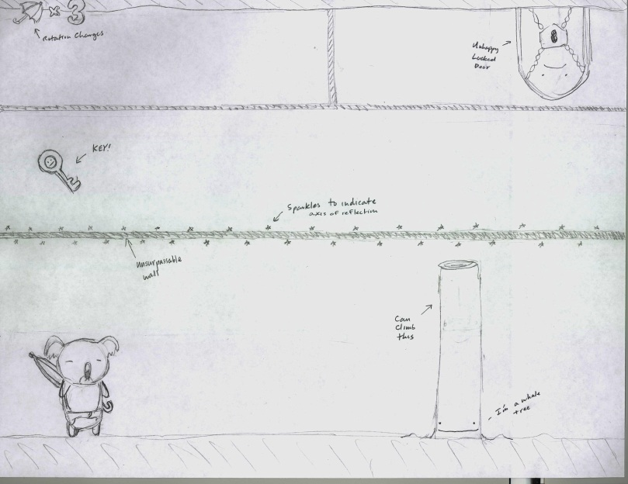
- Multiple Solutions – puzzles can be solved by multiple methods

Gameplay Sketch
Shown to the right is a player mode sketch of the game. The shimmering line in the center is the line of reflection, across which the world gets reflected. In the top left is the number of reflection charges remaining in the umbrella.

Additional Details
- Player death results in a level restart

