


System requirements
Directx 9.0c and Shader Model 1.1
512 Mb of Ram
100 Mb
Vista/XP/7
Keyboard

Installation Guide
Download Reflexio from www.reflexio.wikidot.com
Extract the contents of the zip file
Run Reflexio.exe
Game on!

Gameplay

Simple: Reach the exit door!
Use your powers of reflection to:
- Bypass walls and gaps
- Reach keys in impossible locations
Be sure to avoid:
- Spikes
- Bottomless pits
- Crushing yourself


Game Elements

Control this cute, lovable koala!

Blocks – the building blocks of the world, these objects can be reflected across the axis to act as either floors or walls!

Non-Reflectable Blocks – these blocks are not affected by your powers of reflection and will remain stationary despite your best efforts to move them…
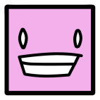
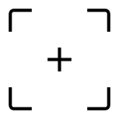
Buddy Block + Switch – Place the Buddy Block on the switch to activate doors!

Zipper – collect this to open the exit door!


Door – Reach this to complete the level!
Controls

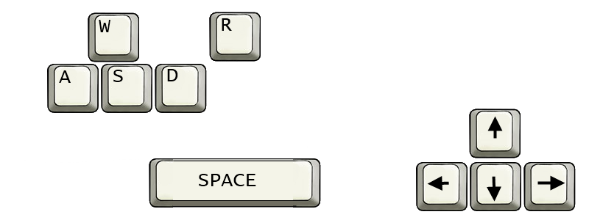
MOVE REFLECTION LINE
RESTART
MOVEMENT
REFLECT
Box Jellyfish Studios

Brendan Viscomi – Team Leader, Musician
Devansh Gupta – Lead Programmer
Alan Liang – Artist
Arthur Lanclos – Programmer
Mengxiang Jiang - Programmer

