Mini Project Report on
Obstacle Detection using Arduino
Submitted in partial fulfillment of the requirement for the award of the degree of

BACHELOR OF TECHNOLOGY

IN

COMPUTER SCIENCE & ENGINEERING

Submitted by: University Roll No.

KUMKUM 2019676

Under the Mentorship of

Dr. UPMA JAIN
Assistant Professor



Department of Computer Science and Engineering
Graphic Era (Deemed to be University)
Dehradun, Uttarakhand
January 2023



CANDIDATE’S DECLARATION

I hereby certify that the work which is being presented in the project report entitled “Obstacle Detection using Arduino” in partial fulfillment of the requirements for the award of the Degree of Bachelor of Technology in Computer Science and Engineering of the Graphic Era (Deemed to be University), Dehradun shall be carried out by the under the mentorship of Dr.Upma Jain, Assistant Professor, Department of Computer Science and Engineering, Graphic Era (Deemed to be University), Dehradun.

Name University Roll no
KUMKUM 2019676

Table of Contents

Chapter No. | Description | Page No.
Chapter 1 | Introduction | 4-5
Chapter 2 | Literature Survey | 6-7
Chapter 3 | Methodology | 8-16
Chapter 4 | Result and Discussion | 17
Chapter 5 | Conclusion and Future Work | 18
 | References | 19

Chapter 1
Introduction
In the last decade, with the development of technology, sensors used with electronic devices have been used in many areas to facilitate life. Sensors are devices that convert energy forms into electrical energy. The sensors serve as a bridge connecting the environment and various electronic devices. The environment can be any physical environment such as military areas, airports, factories, hospitals, shopping malls, etc. Today, there are hundreds of types of sensors produced by the development of technology such as heat, pressure, obstacle recognizer, human detecting. Sensors were used for lighting purposes in the past, but now they are used to make life easier.
Today, robot systems are developed with the use of artificial intelligence algorithms. The robotics field is one of them. The most important part of the robot is the perception. Perceive of the environment will be important for a robot design. For instance, it is very important to identify explosives by a robot to detect a terrorist in the military field by using sensors. A robot has to perceive some variables (like heat changes) around it, interpret it, and then decide to act accordingly. In this article, robotic robot has been presented in terms of obstacle detection and avoidance by using sensors which works automatically, the user leaves the robot control and the robot finds its way without hitting the obstacles. The robot detects living beings that are encountered and finds its way without hitting spot and when it comes to the obstacle it perceives and stops.

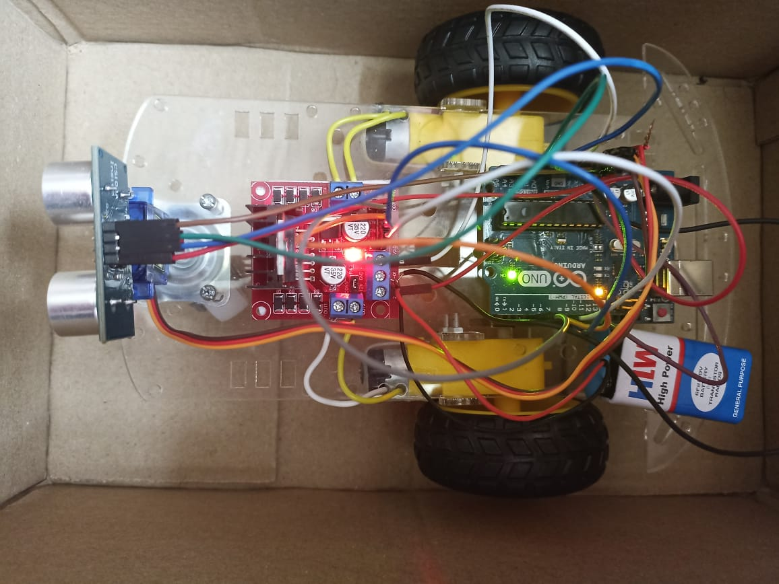
Fig. 1.1 Obstacle Avoiding Car using Arduino
Obstacle avoidance means to be able to identify and detect any kind of interference, which can also be termed as obstacles, and either avoid crashes into it or even selects its path around it. Such a project would be very helpful in helping robots in factories and even in day to day house chores. Our project uses ultrasonic sensors in support with Arduino Uno Com 3 development board. It works on a very simple principle. An ultrasonic sensor has a source and an echo receiver. It sends bursts of ultrasonic signals and the echo receiver receives it and determines how far or how close any object reflecting the signals is in front of it. It is controlled by an Arduino Uno board, which is programmed to control the motors in the robot, to stop or proceed as per information received by the sensor. The programming involved follows a very simple algorithm. If a distance is fixed as a threshold, say 15cm by the ultrasonic sensor, it will give a high signal if distance is more than it, otherwise it give a low signal. If the signal received is high, the Arduino signals the motor driver module to move forward, or else stop. If the signal received is low, that is, if any obstruction is found, first the robot moves to right, and if the signal is still low, it moves to left. If there are obstacle both sides of the robot , it reverses back and then takes a turn.

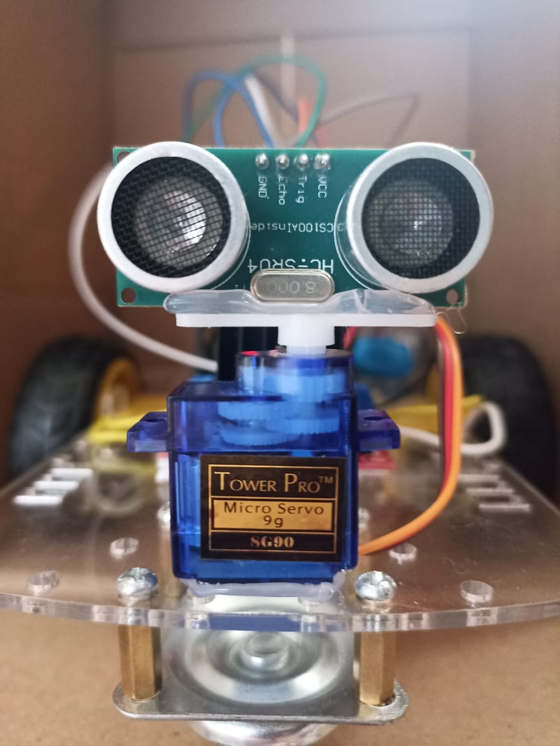
Fig. 1.2 Obstacle Avoiding Car using Arduino

Chapter 2
Literature Survey
“line follower and obstacle avoidance bot using arduino” has been designed and developed by Aamir attar, Aadil ansari, Abhishek desai, Shahid khan, Dipashrisonawale to create an autonomous robot which intelligently detects the obstacle in its path and navigates according to the actions that user set for it. So this system provides an alternate way to the existing system by replacing skilled labor with robotic machinery ,which in turn can handle more patients in less time with better accuracy and a lower per capita cost .
“Obstacle-avoiding robot with IR and PIR motion Sensors” has been designed and developed by Aniket D.Adhvaryu et al has proposed that developed robot platform was not designed for specific task but as a general wheeled autonomous platform. It can therefore be used for educational, research or industrial implementation. Students can use it to learn the microcontroller programming using C++, Arduino Uno 1.6.5 compiler, IR and PIR sensors characteristics, motor driving circuit and signal condition circuit design. Research on obstacle avoidance robot at the polytechnic level can help students to develop communication, technical skills and teamwork. The design of such robot is very flexible and various methods can be adapted for another implementation. It shows that PIR sensors are more sensitive compared to IR sensors while detecting human being .
As described by Aniket D. Adhvaryu in "Obstacle-avoiding robot using IR and PIR motion Sensors" . PIR sensors were suggested for use in the project because they were more capable of identifying people (as well as other things generating heat) than other types of sensors, but was less precise when dealing with more common obstructions like walls and strewn objects.
The adaptability of this project is demonstrated by the remotely operated gadget that Vaghela Ankit, Patel Jigar, and Vaghela Savan designed and created in "Obstacle Avoidance Robotic Vehicle Using Ultrasonic Sensor, Android, and Bluetooth For Obstacle Detection" [2]. This gadget has many different applications and may be utilised in many work contexts. It can be used in modular forms and can be customised to carry out various types of jobs. In this project, manual control is combined with the operation of an obstacle-avoiding robot vehicle.
“Obstacle Avoidance Robotic Vehicle Using Ultrasonic Sensor, Android and Bluetooth for Obstacle Detection” has been designed and developed by Vaghela et.al has mentioned that enormous amount of work has been done on wireless gesture controlling of robots. Various methodologies have been analyzed and reviewed with their merits and demerits under various operational and functional strategies. Thus, it can be concluded that features like user friendly interface light weight and portability of android OS based smart phone has overtaken the sophistication of technologies like programmable glove, static cameras etc., making them obsolete. Although recent researches in this field have made wireless gesture controlling a ubiquitous phenomenon, it needs to acquire more focus in relevant areas of applications like home appliances, wheelchairs, artificial nurses, table top screens etc. in a collaborative manner.
“Obstacle Avoidance Robot” has been designed and developed by Paul Kinsky, Quan Zhou mentioned that robot with a few mechanical components to add two more functions to the main body, namely the laptop holder and the camera holder. AT89S52 development board is designed ,developed and tested in a large scale, which was used to control the motors smoothly. the cameras with relatively low cost are fixed and adjusted on the camera holder for good calibration of the computer vision. Users establish the serial communication method between the upper laptop and the lower development board with USB port. The laptop will send out a signal of the motor condition to the development board.
“obstacle avoidance robot” has been designed and developed by Faiza Tabassum, et.al has mentioned that Obstacle Avoidance Robot successfully detects and avoids obstacles. Simple algorithms used to steer and reducing the turning radius, successfully navigated the vehicle. Inconclusion, the group successfully interfaced every component that was originally planned. Timer interrupts for IR pulse generation. Obstacle detection using IR transceiver. Servo mechanism using PWM. Steering system using Servo Motor.

Chapter 3
Methodology
This section included the details of the hardware and software implementations utilised in the project's planning and development. It is also described how the system's chassis and shell are made.

Table 3.1

S.NO | COMPONENTS USED | QUANTITY
1. | Arduino Uno | 1
2. | 24V DC Motors | 2
3. | Ultrasonic sensors | 1
4. | Motor Driver(L293D) | 1
5. | Wheels | 2
6. | Power Source for Arduino and Motors | _
7. | Servo Motor | 1

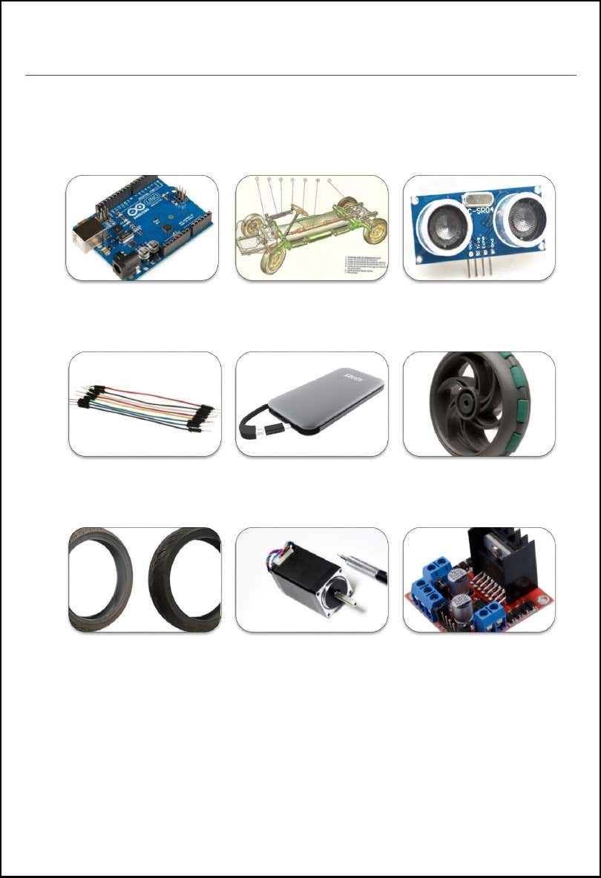
Power Supply
DC Motor
LM298N Motor Driver
Wheel X2
Castor Wheel
Jumper Wires
Chassis
Ultrasonic Sensor
Components Used
Arduino Uno
Fig. 3.1 Components Used

3.1 COMPONENTS DESCRIPTION

3.1.1.Arduino Uno
An Arduino is an open-source microcontroller development board. The most common version of Arduino is the Arduino Uno. It is relatively cheap, plugs straight into a computer's USB port, and it is simple to setup and use when compared toother development boards. It features 14 digital and 6 analogue pins for connecting to various devices as input-output ports. It was first launched in 2005 to give a simple and affordable means for students, amateurs, and experts alike to construct devices operating with various actuators and sensors. It needs an external power supply with a voltage of between 9 and 12 volts. In addition to the fourteen and six digital it contains a power jack, and a reset button in addition to its pins.
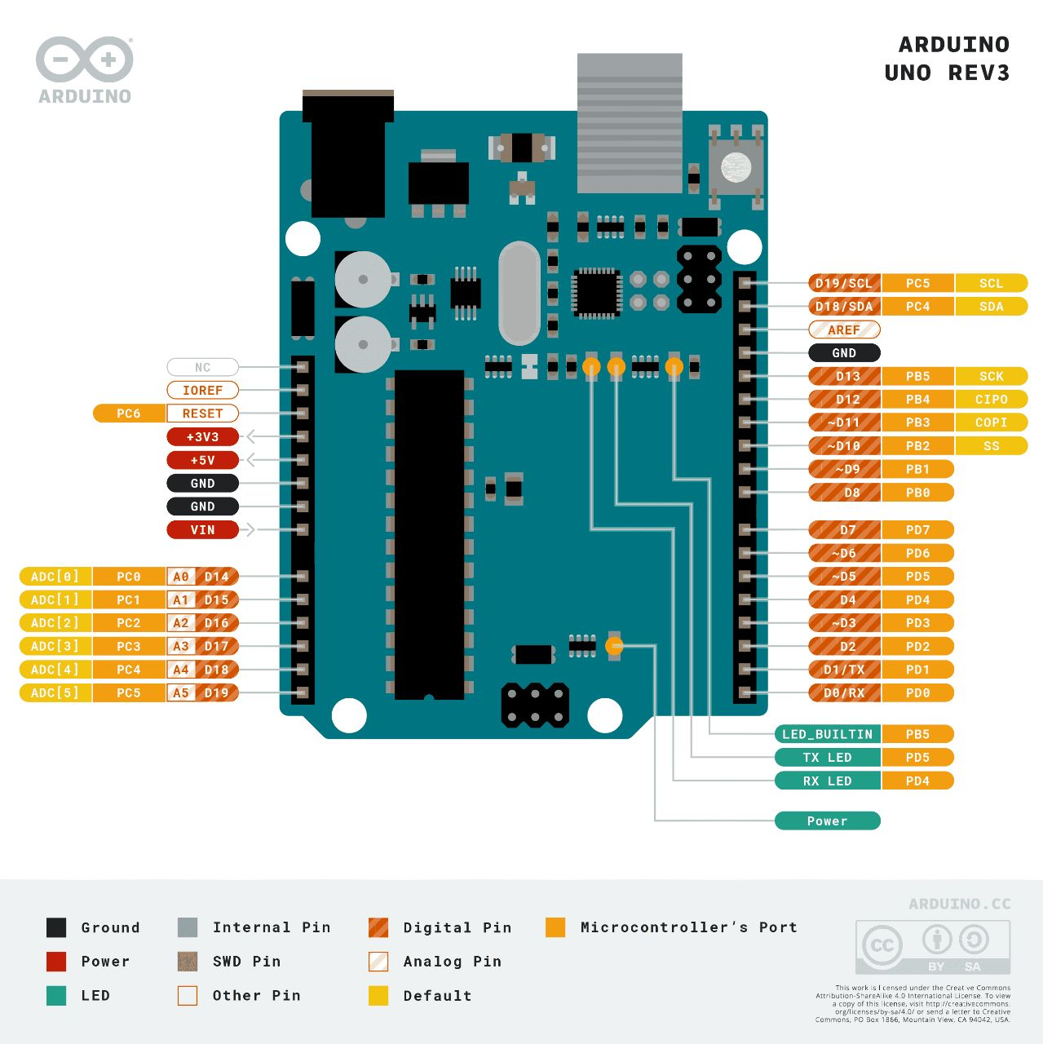
Fig. 3.2 Arduino Uno

3.1.2. HC-SR04 Ultrasonic Sensor
The Ultrasonic Sensor sends out a high-frequency sound pulse and then times how long it takes for the echo of the sound to reflect back. The sensor has two openings on its front.
1. Tiny speaker to transmit opening ultrasonic waves
2. Microphone to receive the ultrasonic waves
The ultrasonic sensor calculates distances by -The speed of sound is approximately 341 meters per second in air. The ultrasonic sensor uses this information along with the time difference between sending and receiving the sound pulse to determine the distance to an object.

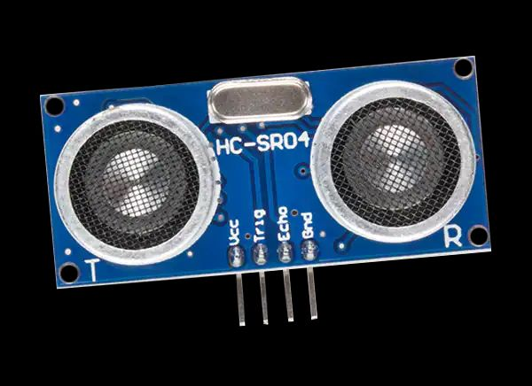
Fig. 3.3 Ultrasonic Sensor
The limitations of an ultrasonic sensor is some objects might not be detected it which are shaped or positioned in such a way that the sound wave bounces off the object, but are deflected away from the sensor. It is also possible for the object to be too small to reflect enough of the soundwave back to the sensor to be detected. Objects can absorb the sound wave all together (cloth, robot peting, etc), which means that there is no way for the sensor to detect them accurately.
these are important factors to consider when designing and programming a car using an ultrasonic sensor.

3.1.3. LM298N Motor Driver Module

An arduino pin is able to deliver only 40mA current but a DC motor requires more current so we use a motor driver module shield called the LM298N which may be connected to an Arduino Uno board.. It is like a current amplifier which drives the motor according to signals from the Arduino. It is a twin full bridge driver with a high voltage and high current. It has an operating voltage range of 5-35V and an output current of 2-3A. Due to the HBridge circuit's switching transistors, it has a voltage loss of roughly 2V. It may be used to simultaneously drive two DC motors.
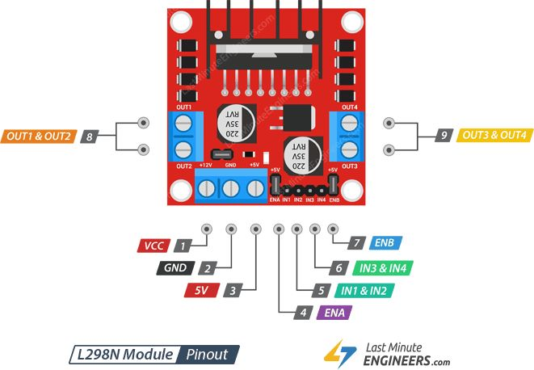
Fig. 3.4 Motor Driver

3.1.4. Servo Motor
It is a type of actuator that allows to control the angular position control precisely. It contains a motor that coupled with a sensor that helps for the proper position feedback. This feedback enables the servo motors to rotate very precisely. A servo motor is used to rotate an item at predetermined angles or distances. It is only composed of a straightforward motor that operates a servo mechanism.
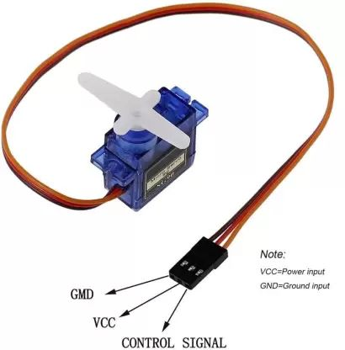
Fig. 3.5 Servo Motor

3.1.5. DC Motors
Any of a group of rotating electric motors that use direct current (DC) electricity to create mechanical energy is referred to as a DC motor. The most prevalent kinds depend on the forces created by induced magnetic fields brought on by current flowing through the coil. For a portion of the motor's current to sometimes shift direction, almost all types of DC motors contain an internal mechanism that is either electromechanical or electronic.

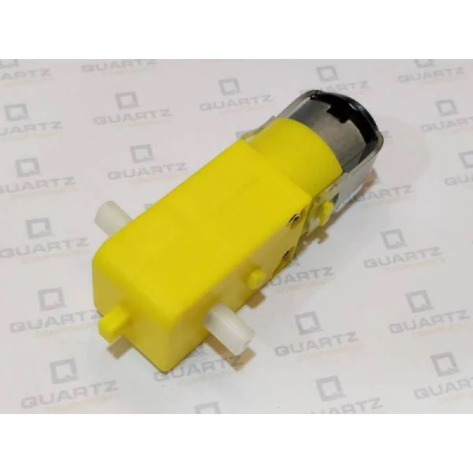
Fig. 3.6 DC Motor

3.2 Working
- The car is switched on by giving it 5V DC power from an external battery.The motors starts rotating and thus the car starts moving forward.
- During this time, the ultrasonic sensors continuously keep calculating the distance between the car and the reflective surface.
- This information gets processed by the ARDUINO.
- If the distance between the car and the obstacle is less than the specified value, the car changes its path(moves towards the back).Here, we have kept the minimum distance to be of 15cm.
- This process continues forever and the car keeps moving without danger
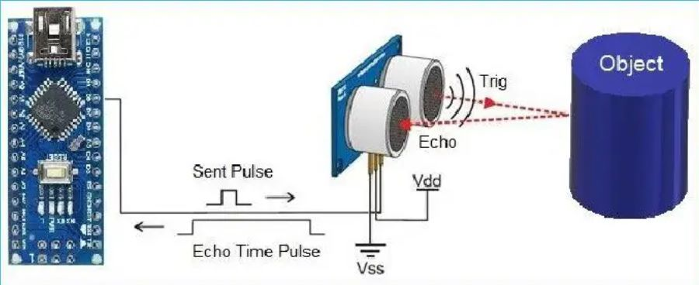
Fig. 3.7 Working of Ultrasonic Sensor

3.3 Block Diagram:-

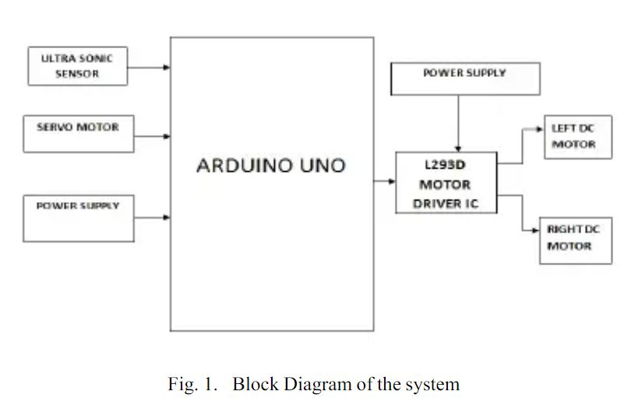

3.4 Component Arrangement:-

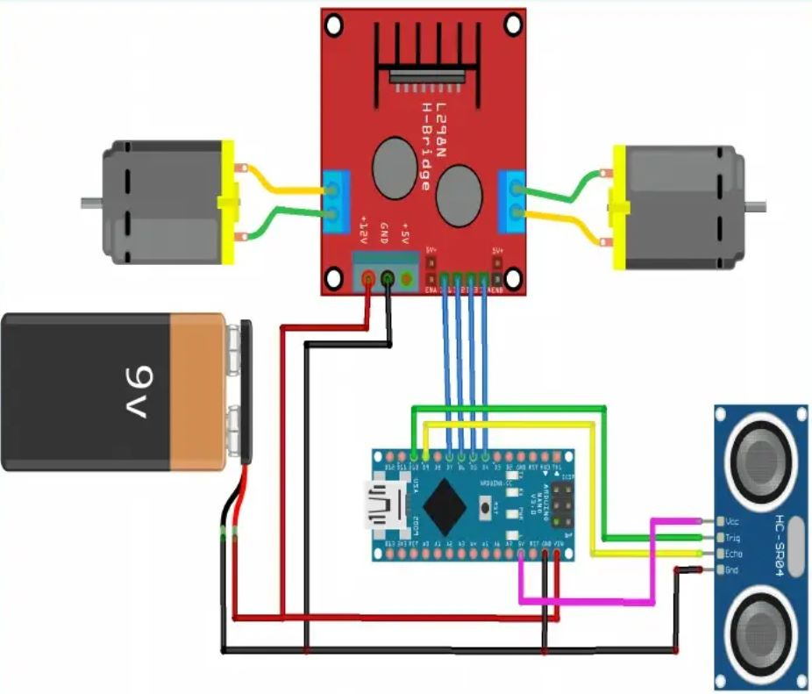
Fig. 3.9 Components Arrangement

Chapter 4
Result and Discussion
The result is obtained for obstacle avoidance car using Arduino, if the car moves forward if any obstacle detect it check for other directions and moves where there is no obstacles it moves in forward direction, to sense the obstacle ultrasonic sensor is used. We used servo motor to rotate the ultrasonic sensor.
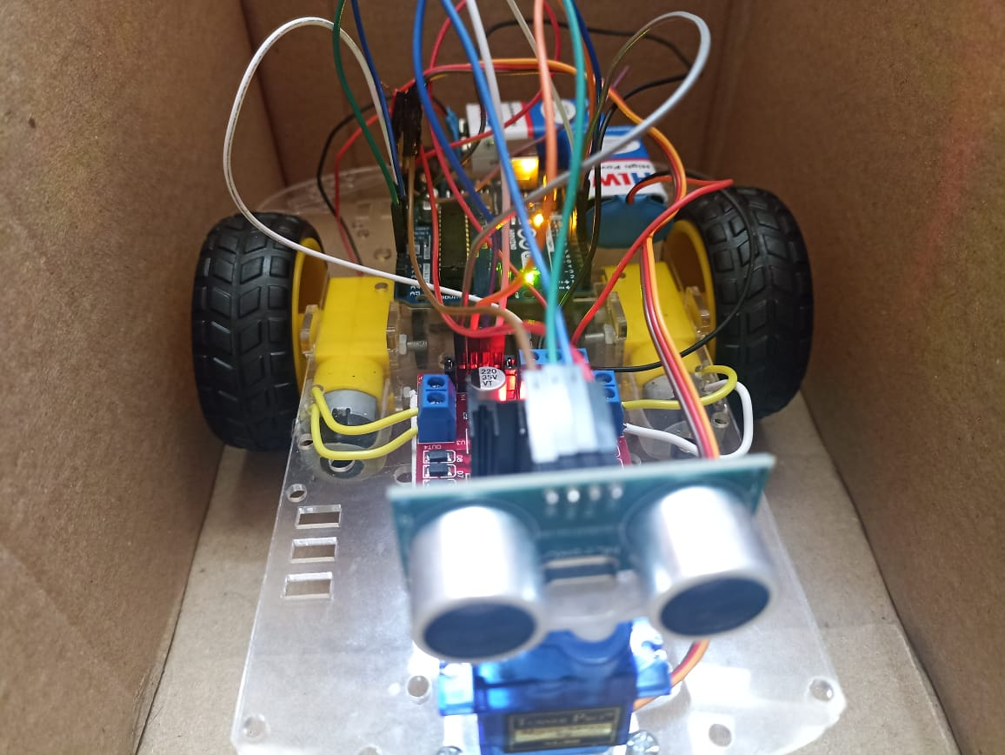
Fig. 4.1 Obstacle Detection using Arduino

The project hardware performed as per our expectations, and worked autonomously, that is, after feeding the code, it required no human interaction and could work on its own, even in unknown and dynamic environments.

Chapter 5
Conclusion and Future Work
This project developed an obstacle avoiding car to detect and avoid obstacles in its path. The car is built on the Arduino platform for data processing and its software counter part helped to communicate with the robot to send parameters for guiding movement. For obstacle detection ,one ultrasonic distance was used and a servo motor provided a wider field of detection. The robot is fully autonomous and after the initial loading of the code, it requires no user intervention during its operation. When placed in unknown environment with obstacles, car uses ultrasonic sensor to calculate the distance and detect the obstacles around it and is also capable of taking it’s own decisions regarding changing the directions to make a movement. The vehicle routes itself with the help of input from the ultrasonic sensor. The input from the ultrasonic sensor is passed to arduino where it is processed and then the commands by the arduino are passed to the motors. In this way the car operates and takes decisions to move in any of the directions. In order to optimize the movement of the car, we have many considerations for improvement. However, most of these ideas will cost more money and time as well. In future cameras can be used to detect the obstacle however, it is better to get CCD or industrial use ones to get clear and fast pictures. Even the ones we mentioned in the camera holder part will be better because of the special software.
This model was a very basic one, saving both time and money, and clearly demonstrates the idea we had. For better and more accurate results, preferable three ultrasonic sensors can be used for a wider field of view, to cover a greater region.Also, otherwise it can be fitted with camera modules and AI can be implemented so that it can be used in real life applications, like on roads, judging other vehicles speed, potholes, speed breakers, traffic light signals and even change lanes, which is same as the technology used in currently some of the most advanced autonomous driving robots made by tech giants. Further for military uses, it can be fixed with a GSM Module or a Radio Module and be provided with a manual control, for even better maneuvers. We can conclude that this project of ours has a vast scope in future applications

References
[1] https://www.wikipedia.org

[2] Vaghela Ankit1, Patel Jigar2, Vaghela Savan3 “Obstacle Avoidance Robotic Vehicle Using Ultrasonic Sensor, Android and Bluetooth for Obstacle Detection” International Research Journal of Engineering and Technology (IRJET), vol. A247, pp. 29-32, 2005.

[3] Bhagya shree S R , Manoj kollam “Zigbee Wireless Sensor Network For Better Interactive Industrial Automation” , proc.of IEEE ICoAC2011,pp 304-308,2011.

[4] Paul Kinsky,Quan Zhou “Obstacle Avoidance Robot” Worcester polytechnic institute.

[5] FaizaTabassum, SusmitaLopa, Muhammad MasudTarek& Dr. Bilkis Jamal Ferdosi “obstacle avoidance robot” Global Journal of Researches in Engineering: HRobotics & Nano-Tech.

[6] Louis, Leo, “Working Principle of Arduino and Using it As a Tool for Study and Research”. DOI: 10.5121/ijcacs.2016.1203.

[7] Aniket D. Adhvaryu et al “Obstacle-avoiding robot with IR and PIR motion Sensors” IOP Conference Series: Materials Science and Engineering, vol. A247, pp. 529- 551, April 2005.

