**Hotel_Booking_Cancellation.**

**Business Problem:**

In recent years, City Hotel and Resort Hotel have been seen high Cancellation rates. Each hotel is now dealing with a number of issues as a result, including fewer revenues and less than ideal hotel room use. Consequently, lowering cancellations rates is both hotels primary goal in order to increase their efficiency in generating revenue, and for us to offer through business to address this problem.

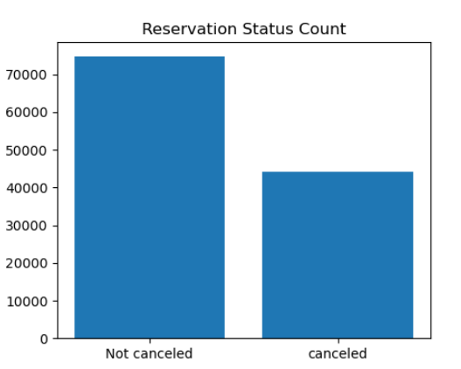

The accompanying bar graph shows the percentage of reservations that are canceled and those that are not. It is obvious that there are still a significant number of reservations that have not been canceled. There are still 37% of clients who canceled their reservation, which has a significant impact on the hotels earnings.

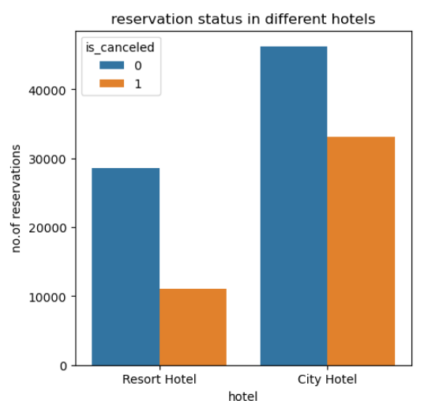

In comparison to resort hotels,city hotels have more bookings.it's possible that resort hotels more expensive than those in cities.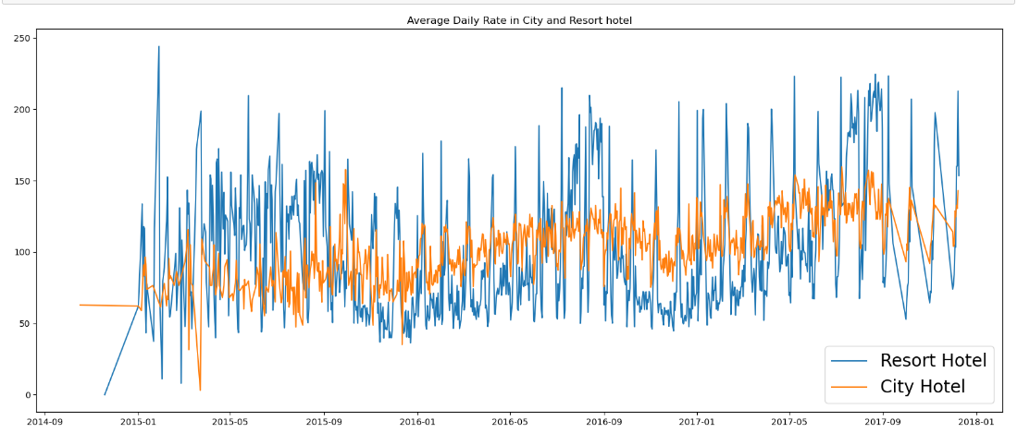 The line graph above shows that,on certain days,the average daily rate for a city hotel is less than that of a resort hotel,and on other days,it is even less. It goes without saying that weekends and hoildays may see a rise in resort hotel rates.

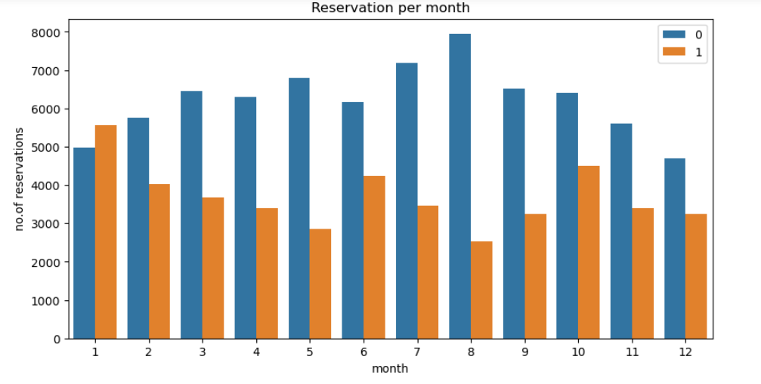 We have developed the grouped bar graph to analyze the months with the highest and lowest reservation levels according to reservation status. As can be seen, both the no.of confirmed reservations and the no.of canceled reservations are largest in the month of august. whereas january is the month with the most canceled reservations.

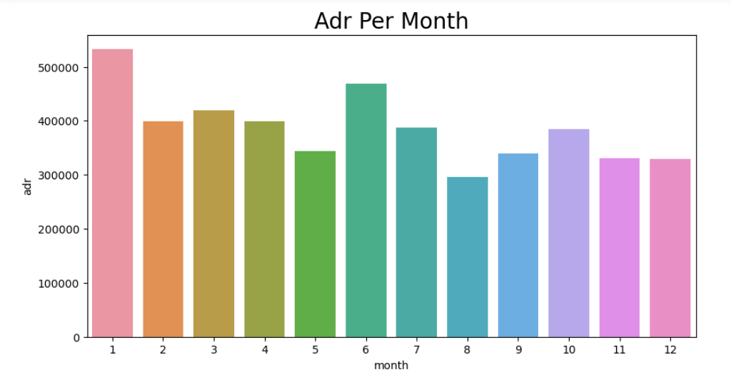

This bar graph demonstrates that cancellations are most common when prices are greatest and are least common when they are lowest. therefore, the cost of the accommodation is solely responsible for the cancellation.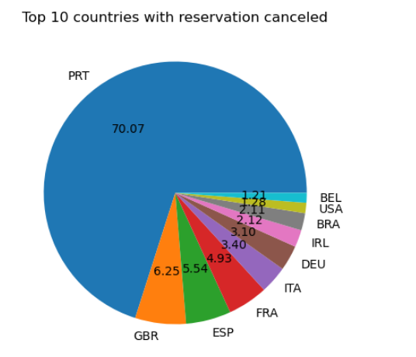

Portugal is the top country with highest number of cancellations.

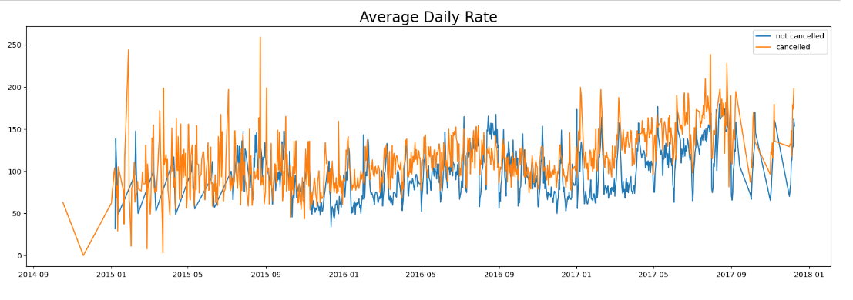

As seen in the graph, reservations are canceled when the averages daily rate is higher than when it is not canceled.it clearly proves all the above analysis, that the higher price leads to higher cancellations.

SUGGESTIONS.

1.Cancellation rates rise as the price does. In order to prevent cancellations of reservations, hotels could work on their pricing strategies and try to lower the rates for specific hotels based on locations. They can also provide some discounts to the consumers.

2. As the ratio of cancellation and not cancellation of the resort hotel is higher in the resort hotel than the city hotels. So the hotels should provide a reasonable discount on the room prices on weekends or on Holidays.

​