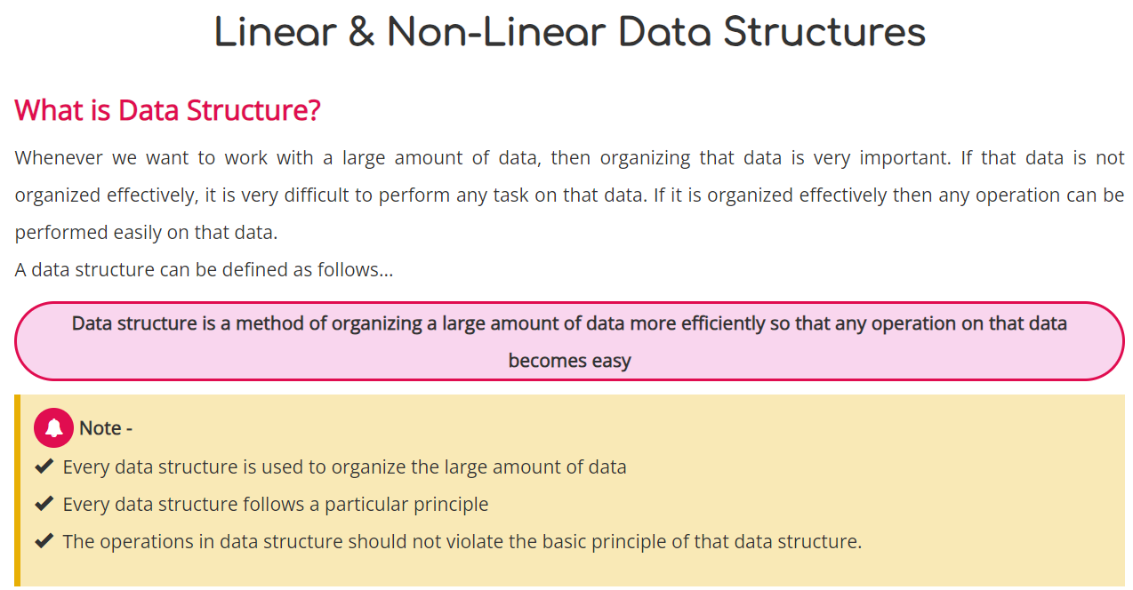
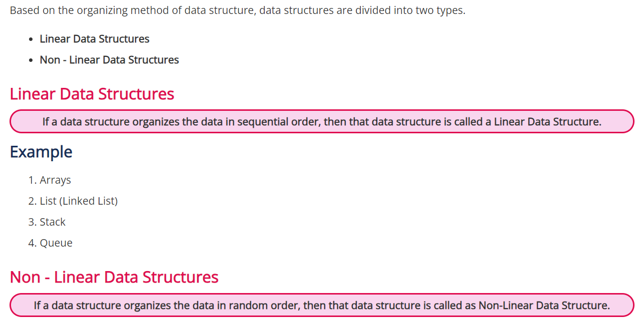
Examples : Trees , Graphs.
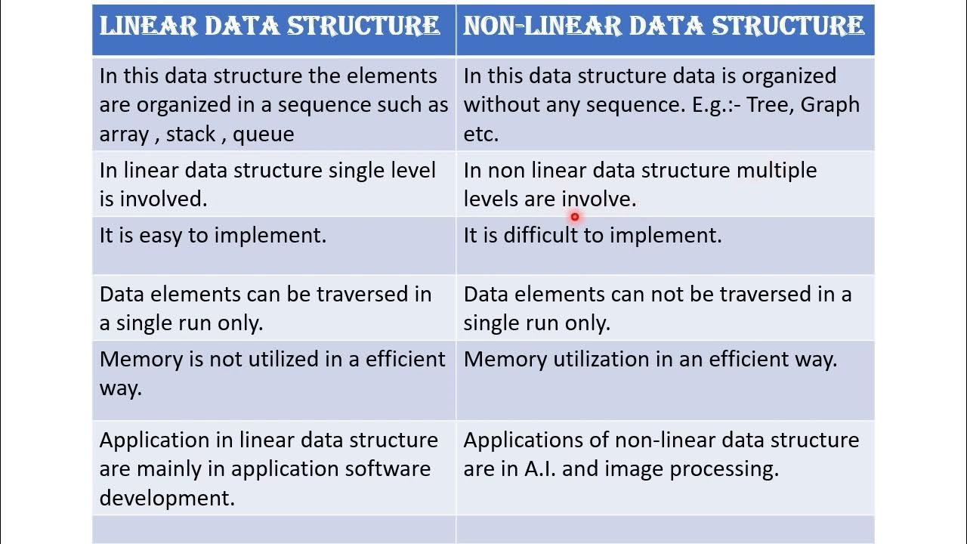

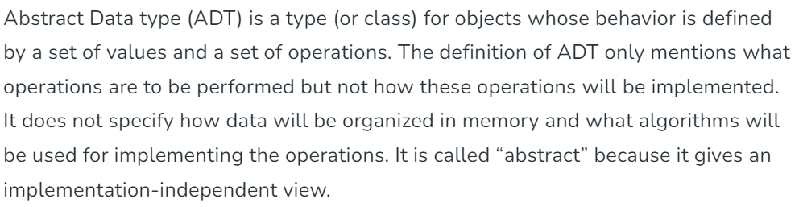

Stack ADT
A stack is a linear data structure that only allows data to be accessed from the top. It simply has two operations: push (to insert data to the top of the stack) and pop (to remove data from the stack). (used to remove data from the stack top).
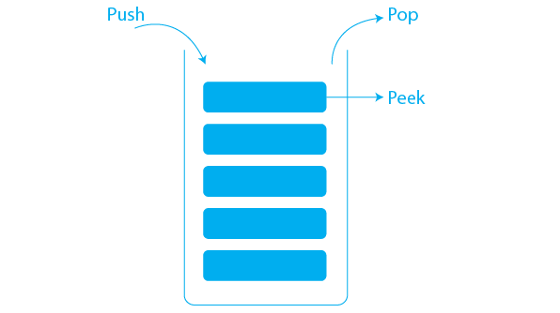
Some of the most essential operations defined in Stack ADT are listed below.
- top(): returns the value of the node present at the top of the stack.
- push(int val): creates a node with value = val and puts it at the stack top.
- pop(): removes the node from the top of the stack.
- empty(): returns true if the stack is empty, otherwise returns false.
- size(): returns the number of nodes that are present in the stack.

- Best case time complexity of different data structures for different operations
Data structure | Access | Search | Insertion | Deletion
Array | O(1) | O(1) | O(1) | O(1)
Stack | O(1) | O(1) | O(1) | O(1)
Queue | O(1) | O(1) | O(1) | O(1)
Singly Linked list | O(1) | O(1) | O(1) | O(1)
Doubly Linked List | O(1) | O(1) | O(1) | O(1)

Worst Case time complexity of different data structures for different operations
Data structure | Access | Search | Insertion | Deletion
Array | O(1) | O(N) | O(N) | O(N)
Stack | O(N) | O(N) | O(1) | O(1)
Queue | O(N) | O(N) | O(1) | O(1)
Singly Linked list | O(N) | O(N) | O(N) | O(N)
Doubly Linked List | O(N) | O(N) | O(1) | O(1)
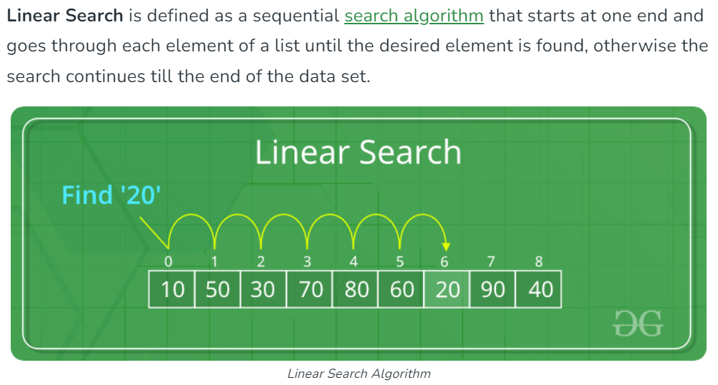
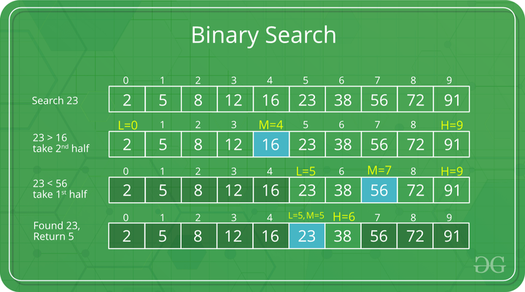
Bubble sort:
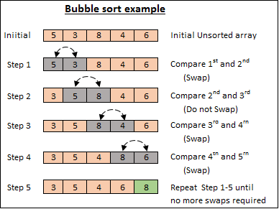

Selection sort:
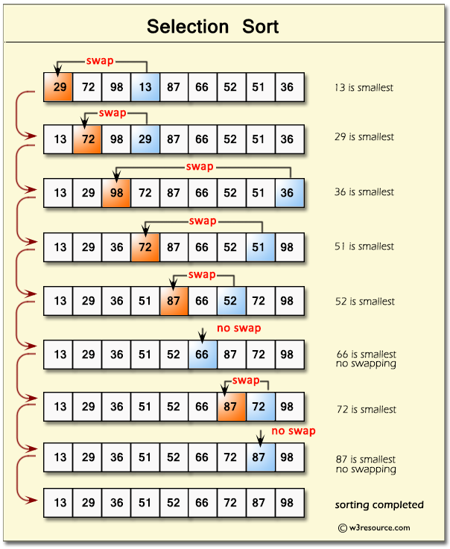
Inserton sort:
