Linked Lists
Single Linked Lists:

What is Single Linked List?
Simply a list is a sequence of data, and the linked list is a sequence of data linked with each other.
The formal definition of a single linked list is as follows...
Single linked list is a sequence of elements in which every element has link to its next element in the sequence.
In any single linked list, the individual element is called as "Node". Every "Node" contains two fields, data field, and the next field. The data field is used to store actual value of the node and next field is used to store the address of next node in the sequence.
The graphical representation of a node in a single linked list is as follows...

Important Points to be Remembered
In a single linked list, the address of the first node is always stored in a reference node known as "front" (Some times it is also known as "head").
Always next part (reference part) of the last node must be NULL.

Example
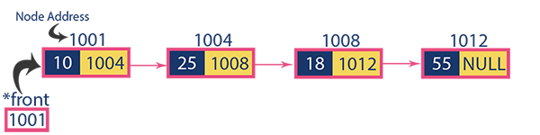

Operations on Single Linked List
The following operations are performed on a Single Linked List
- Insertion
- Deletion
- Display

What is Double Linked List?
In a single linked list, every node has a link to its next node in the sequence. So, we can traverse from one node to another node only in one direction and we can not traverse back. We can solve this kind of problem by using a double linked list. A double linked list can be defined as follows...
Double linked list is a sequence of elements in which every element has links to its previous element and next element in the sequence.
In a double linked list, every node has a link to its previous node and next node. So, we can traverse forward by using the next field and can traverse backward by using the previous field. Every node in a double linked list contains three fields and they are shown in the following figure...

Here, 'link1' field is used to store the address of the previous node in the sequence, 'link2' field is used to store the address of the next node in the sequence and 'data' field is used to store the actual value of that node.
Example


Importent Points to be Remembered
In double linked list, the first node must be always pointed by head.
Always the previous field of the first node must be NULL.
Always the next field of the last node must be NULL.

Operations on Double Linked List
In a double linked list, we perform the following operations...
- Insertion
- Deletion
- Display

Circular Linked List

What is Circular Linked List?
In single linked list, every node points to its next node in the sequence and the last node points NULL. But in circular linked list, every node points to its next node in the sequence but the last node points to the first node in the list.
A circular linked list is a sequence of elements in which every element has a link to its next element in the sequence and the last element has a link to the first element.
That means circular linked list is similar to the single linked list except that the last node points to the first node in the list

Example
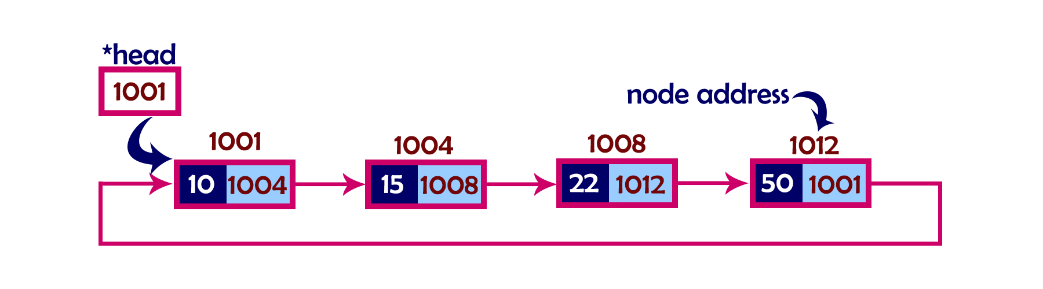

Operations
In a circular linked list, we perform the following operations...
- Insertion
- Deletion
- Display

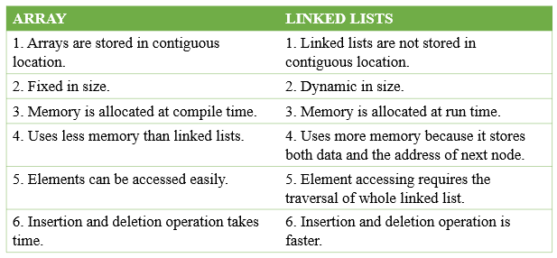

Linked list is used in a wide variety of applications such as
- Polynomial Manipulation representation
- Addition of long positive integers
- Representation of sparse matrices
- Addition of long positive integers
- Symbol table creation
- Mailing list
- Memory management
- Linked allocation of files
- Multiple precision arithmetic etc

Polynomial Addition:
Given two polynomial numbers represented by a linked list. Write a function that add these lists means add the coefficients who have same variable powers.
Example:
- Input:
- 1st number = 5x² + 4x¹ + 2x⁰
- 2nd number = -5x¹ - 5x⁰
- Output:
- 5x²-1x¹-3x⁰
- Input:
- 1st number = 5x³ + 4x² + 2x⁰
- 2nd number = 5x^1 - 5x^0
- Output:
- 5x³ + 4x² + 5x¹ - 3x⁰
- 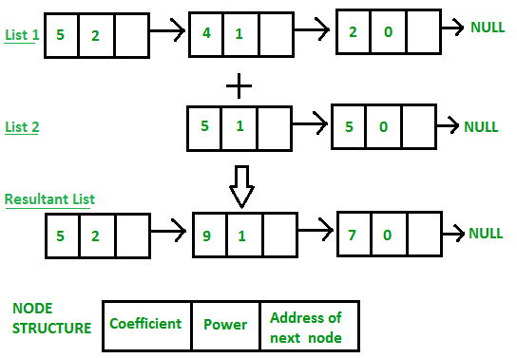

Polynomial Multiplication:



What is Sparse Matrix?
Sparse matrix is a matrix which contains very few non-zero elements.

Sparse Matrix Representations
A sparse matrix can be represented by using TWO representations, those are as follows...
- Triplet Representation (Array Representation)
- Linked Representation

Triplet Representation (Array Representation)
In this representation, we consider only non-zero values along with their row and column index values. In this representation, the 0th row stores the total number of rows, total number of columns and the total number of non-zero values in the sparse matrix.
For example, consider a matrix of size 5 X 6 containing 6 number of non-zero values. This matrix can be represented as shown in the image...
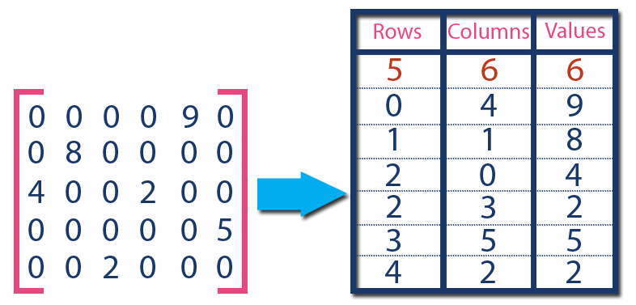
In above example matrix, there are only 6 non-zero elements ( those are 9, 8, 4, 2, 5 & 2) and matrix size is 5 X 6. We represent this matrix as shown in the above image. Here the first row in the right side table is filled with values 5, 6 & 6 which indicates that it is a sparse matrix with 5 rows, 6 columns & 6 non-zero values. The second row is filled with 0, 4, & 9 which indicates the non-zero value 9 is at the 0th-row 4th column in the Sparse matrix. In the same way, the remaining non-zero values also follow a similar pattern.

Linked List representation of the sparse matrix
In a linked list representation, the linked list data structure is used to represent the sparse matrix. The advantage of using a linked list to represent the sparse matrix is that the complexity of inserting or deleting a node in a linked list is lesser than the array.
Unlike the array representation, a node in the linked list representation consists of four fields. The four fields of the linked list are given as follows -
- Row - It represents the index of the row where the non-zero element is located.
- Column - It represents the index of the column where the non-zero element is located.
- Value - It is the value of the non-zero element that is located at the index (row, column).
- Next node - It stores the address of the next node.
The node structure of the linked list representation of the sparse matrix is shown in the below image -
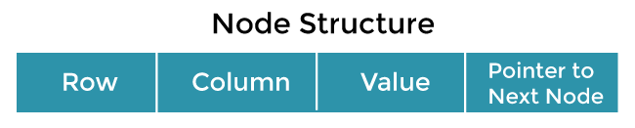
Example -
Let's understand the linked list representation of sparse matrix with the help of the example given below -
Consider the sparse matrix -
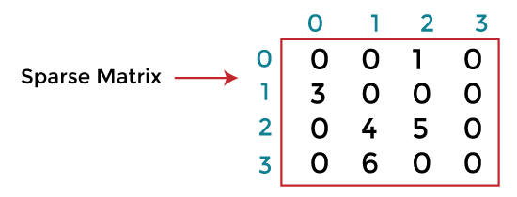
In the above figure, we can observe a 4x4 sparse matrix containing 5 non-zero elements and 11 zero elements. Above matrix occupies 4x4 = 16 memory space. Increasing the size of matrix will increase the wastage space.
The linked list representation of the above matrix is given below -
In the above figure, the sparse matrix is represented in the linked list form. In the node, the first field represents the index of the row, the second field represents the index of the column, the third field represents the value, and the fourth field contains the address of the next node.
In the above figure, the first field of the first node of the linked list contains 0, which means 0th row, the second field contains 2, which means 2nd column, and the third field contains 1 that is the non-zero element. So, the first node represents that element 1 is stored at the 0th row-2nd column in the given sparse matrix. In a similar manner, all of the nodes represent the non-zero elements of the sparse matrix.

