Stacks

What is a Stack?
Stack is a linear data structure in which the insertion and deletion operations are performed at only one end. In a stack, adding and removing of elements are performed at a single position which is known as "top". That means, a new element is added at top of the stack and an element is removed from the top of the stack. In stack, the insertion and deletion operations are performed based on LIFO (Last In First Out) principle.
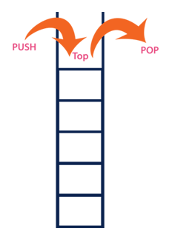
In a stack, the insertion operation is performed using a function called "push" and deletion operation is performed using a function called "pop".
In the figure, PUSH and POP operations are performed at a top position in the stack. That means, both the insertion and deletion operations are performed at one end (i.e., at Top)
A stack data structure can be defined as follows...
Stack is a linear data structure in which the operations are performed based on LIFO principle.
Stack can also be defined as
"A Collection of similar data items in which both insertion and deletion operations are performed based on LIFO principle".

Example
If we want to create a stack by inserting 10,45,12,16,35 and 50. Then 10 becomes the bottom-most element and 50 is the topmost element. The last inserted element 50 is at Top of the stack as shown in the image below...
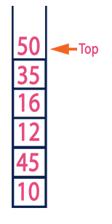

Operations on a Stack
The following operations are performed on the stack...
- Push (To insert an element on to the stack)
- Pop (To delete an element from the stack)
- Display (To display elements of the stack)
Stack data structure can be implemented in two ways. They are as follows...
- Using Array
- Using Linked List
When a stack is implemented using an array, that stack can organize an only limited number of elements. When a stack is implemented using a linked list, that stack can organize an unlimited number of elements.

Application of the Stack
- A Stack can be used for evaluating expressions consisting of operands and operators.
- Stacks can be used for Backtracking, i.e., to check parenthesis matching in an expression.
- It can also be used to convert one form of expression to another form.
- It can be used for systematic Memory Management.

Convert Infix expression to Postfix expression

Write a program to convert an Infix expression to Postfix form.
Infix expression: The expression of the form “a operator b” (a + b) i.e., when an operator is in-between every pair of operands.
Postfix expression: The expression of the form “a b operator” (ab+) i.e., When every pair of operands is followed by an operator.
Examples:
Input: A + B * C + D
Output: ABC*+D+
Input: ((A + B) – C * (D / E)) + F
Output: AB+CDE/*-F+

Why postfix representation of the expression?
The compiler scans the expression either from left to right or from right to left.
Consider the expression: a + b * c + d
- The compiler first scans the expression to evaluate the expression b * c, then again scans the expression to add a to it.
- The result is then added to d after another scan.
The repeated scanning makes it very inefficient. Infix expressions are easily readable and solvable by humans whereas the computer cannot differentiate the operators and parenthesis easily so, it is better to convert the expression to postfix(or prefix) form before evaluation.
The corresponding expression in postfix form is abc*+d+. The postfix expressions can be evaluated easily using a stack.

How to convert an Infix expression to a Postfix expression?
To convert infix expression to postfix expression, use the stack data structure. Scan the infix expression from left to right. Whenever we get an operand, add it to the postfix expression and if we get an operator or parenthesis add it to the stack by maintaining their precedence.
Below are the steps to implement the above idea:
- Scan the infix expression from left to right.
- If the scanned character is an operand, put it in the postfix expression.
- Otherwise, do the following
  - If the precedence and associativity of the scanned operator are greater than the precedence and associativity of the operator in the stack [or the stack is empty or the stack contains a ‘(‘ ], then push it in the stack. [‘^‘ operator is right associative and other operators like ‘+‘,’–‘,’*‘ and ‘/‘ are left-associative].
    - Check especially for a condition when the operator at the top of the stack and the scanned operator both are ‘^‘. In this condition, the precedence of the scanned operator is higher due to its right associativity. So it will be pushed into the operator stack.
    - In all the other cases when the top of the operator stack is the same as the scanned operator, then pop the operator from the stack because of left associativity due to which the scanned operator has less precedence.
  - Else, Pop all the operators from the stack which are greater than or equal to in precedence than that of the scanned operator.
    - After doing that Push the scanned operator to the stack. (If you encounter parenthesis while popping then stop there and push the scanned operator in the stack.)
- If the scanned character is a ‘(‘, push it to the stack.
- If the scanned character is a ‘)’, pop the stack and output it until a ‘(‘ is encountered, and discard both the parenthesis.
- Repeat steps 2-5 until the infix expression is scanned.
- Once the scanning is over, Pop the stack and add the operators in the postfix expression until it is not empty.
- Finally, print the postfix expression.

Evaluation of a Postfix notation

Postfix notation:
The general mathematical way of representing algebraic expressions is to write the operator between operands: Example: a + b. Such representation is called the Infix representation. If we write the operator after the operands Example: a b +, it is called the Postfix representation. It is also called the "Reverse Polish notation".

Why Postfix?
Representing an algebraic expression in postfix eliminates parentheses and the need of precedence. The evaluation becomes simple. It is the ideal notation a computer uses to evaluate complex algebraic expressions using stacks. There are a lot of algorithms defined to convert an infix notation into postfix. This article explains the Dijkstra's algorithm and then we'll also see how to evaluate a postfix notation with Python codes for both conversion and evaluation.

What is Backtracking?
Backtracking is a problem-solving algorithmic technique that involves finding a solution incrementally by trying different options and undoing them if they lead to a dead end. It is commonly used in situations where you need to explore multiple possibilities to solve a problem, like searching for a path in a maze or solving puzzles like Sudoku. When a dead end is reached, the algorithm backtracks to the previous decision point and explores a different path until a solution is found or all possibilities have been exhausted.
Backtracking can be defined as a general algorithmic technique that considers searching every possible combination in order to solve a computational problem.

Basic Terminologies
- Candidate: A candidate is a potential choice or element that can be added to the current solution.
- Solution: The solution is a valid and complete configuration that satisfies all problem constraints.
- Partial Solution: A partial solution is an intermediate or incomplete configuration being constructed during the backtracking process.
- Decision Space: The decision space is the set of all possible candidates or choices at each decision point.
- Decision Point: A decision point is a specific step in the algorithm where a candidate is chosen and added to the partial solution.
- Feasible Solution: A feasible solution is a partial or complete solution that adheres to all constraints.
- Dead End: A dead end occurs when a partial solution cannot be extended without violating constraints.
- Backtrack: Backtracking involves undoing previous decisions and returning to a prior decision point.
- Search Space: The search space includes all possible combinations of candidates and choices.
- Optimal Solution: In optimization problems, the optimal solution is the best possible solution.

Types of Backtracking Problems
Problems associated with backtracking can be categorized into 3 categories:
- Decision Problems: Here, we search for a feasible solution.
- Optimization Problems: For this type, we search for the best solution.
- Enumeration Problems: We find set of all possible feasible solutions to the problems of this type.

How does Backtracking works?
As we know backtracking algorithm explores each and every possible path in order to find a valid solution, this exploration of path can be easily understood via given images:
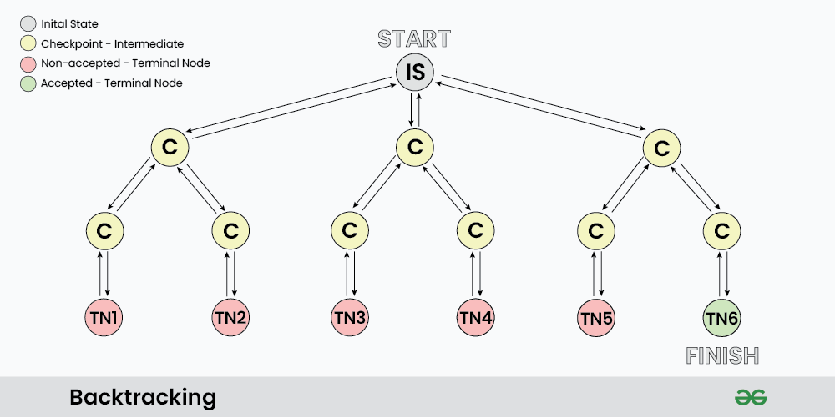
As shown in the image, “IS” represents the Initial State where the recursion call starts to find a valid solution.
C : it represents different Checkpoints for recursive calls
TN: it represents the Terminal Nodes where no further recursive calls can be made, these nodes act as base case of recursion and we determine whether the current solution is valid or not at this state.
At each Checkpoint, our program makes some decisions and move to other checkpoints untill it reaches a terminal Node, after determining whether a solution is valid or not, the program starts to revert back to the checkpoints and try to explore other paths. For example in the above image TN1…TN5 are the terminal node where the solution is not acceptable, while TN6 is the state where we found a valid solution.
The back arrows in the images shows backtracking in actions, where we revert the changes made by some checkpoint.

Pseudocode for Backtracking
The best way to implement backtracking is through recursion, and all backtracking code can be summarized as per the given Pseudocode:

void FIND_SOLUTIONS( parameters):
if (valid solution):
store the solution
Return
for (all choice):
if (valid choice):
APPLY (choice)
FIND_SOLUTIONS (parameters)
BACKTRACK (remove choice)
Return

Applications of Backtracking
- Creating smart bots to play Board Games such as Chess.
- Solving mazes and puzzles such as N-Queen problem.
- Network Routing and Congestion Control.
- Decryption
- Text Justification

Must Do Backtracking Problems
- N-Queen Problem
- Solve Sudoku
- M-coloring problem
- Rat in a Maze
- The Knight’s tour problem
- Permutation of given String

