QUEUE

What is a Queue?
Queue is a linear data structure in which the insertion and deletion operations are performed at two different ends. In a queue data structure, adding and removing elements are performed at two different positions. The insertion is performed at one end and deletion is performed at another end. In a queue data structure, the insertion operation is performed at a position which is known as 'rear' and the deletion operation is performed at a position which is known as 'front'. In queue data structure, the insertion and deletion operations are performed based on FIFO (First In First Out) principle.
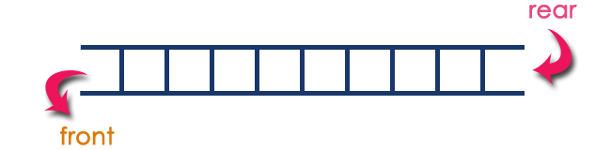
In a queue data structure, the insertion operation is performed using a function called "enQueue()" and deletion operation is performed using a function called "deQueue()".
Queue data structure can be defined as follows...
Queue data structure is a linear data structure in which the operations are performed based on FIFO principle.

Operations on a Queue
The following operations are performed on a queue data structure...
- enQueue(value) - (To insert an element into the queue)
- deQueue() - (To delete an element from the queue)
- display() - (To display the elements of the queue)
Queue data structure can be implemented in two ways. They are as follows...
- Using Array
- Using Linked List

Queue Operations using Array
Queue data structure using array can be implemented as follows...
Before we implement actual operations, first follow the below steps to create an empty queue.
- Step 1 - Include all the header files which are used in the program and define a constant 'SIZE' with specific value.
- Step 2 - Declare all the user defined functions which are used in queue implementation.
- Step 3 - Create a one dimensional array with above defined SIZE (int queue[SIZE])
- Step 4 - Define two integer variables 'front' and 'rear' and initialize both with '-1'. (int front = -1, rear = -1)
- Step 5 - Then implement main method by displaying menu of operations list and make suitable function calls to perform operation selected by the user on queue.

enQueue(value) - Inserting value into the queue
In a queue data structure, enQueue() is a function used to insert a new element into the queue. In a queue, the new element is always inserted at rear position. The enQueue() function takes one integer value as a parameter and inserts that value into the queue. We can use the following steps to insert an element into the queue...
- Step 1 - Check whether queue is FULL. (rear == SIZE-1)
- Step 2 - If it is FULL, then display "Queue is FULL!!! Insertion is not possible!!!" and terminate the function.
- Step 3 - If it is NOT FULL, then increment rear value by one (rear++) and set queue[rear] = value.

deQueue() - Deleting a value from the Queue
In a queue data structure, deQueue() is a function used to delete an element from the queue. In a queue, the element is always deleted from front position. The deQueue() function does not take any value as parameter. We can use the following steps to delete an element from the queue...
- Step 1 - Check whether queue is EMPTY. (front == rear)
- Step 2 - If it is EMPTY, then display "Queue is EMPTY!!! Deletion is not possible!!!" and terminate the function.
- Step 3 - If it is NOT EMPTY, then increment the front value by one (front ++). Then display queue[front] as deleted element. Then check whether both front and rear are equal (front == rear), if it TRUE, then set both front and rear to '-1' (front = rear = -1).

display() - Displays the elements of a Queue
We can use the following steps to display the elements of a queue...
- Step 1 - Check whether queue is EMPTY. (front == rear)
- Step 2 - If it is EMPTY, then display "Queue is EMPTY!!!" and terminate the function.
- Step 3 - If it is NOT EMPTY, then define an integer variable 'i' and set 'i = front+1'.
- Step 4 - Display 'queue[i]' value and increment 'i' value by one (i++). Repeat the same until 'i' value reaches to rear (i <= rear)
- Circular Queue
- In a normal Queue Data Structure, we can insert elements until queue becomes full. But once the queue becomes full, we can not insert the next element until all the elements are deleted from the queue. For example, consider the queue below...
The queue after inserting all the elements into it is as follows...
- 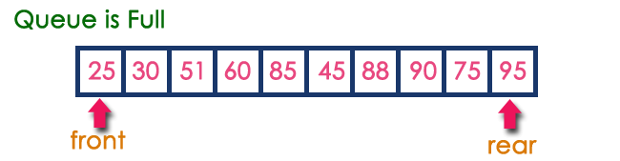
- Now consider the following situation after deleting three elements from the queue...
- 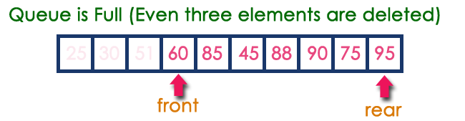
- This situation also says that Queue is Full and we cannot insert the new element because 'rear' is still at last position. In the above situation, even though we have empty positions in the queue we can not make use of them to insert the new element. This is the major problem in a normal queue data structure. To overcome this problem we use a circular queue data structure.
- What is Circular Queue?
- A Circular Queue can be defined as follows...
- A circular queue is a linear data structure in which the operations are performed based on FIFO (First In First Out) principle and the last position is connected back to the first position to make a circle.
- Graphical representation of a circular queue is as follows...
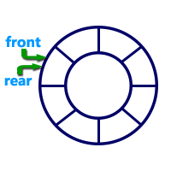

Applications of Circular Queue
The circular Queue can be used in the following scenarios:
- Memory Management: The unused memory locations in the case of ordinary queues can be utilized in circular queues.
- Traffic system: In a computer-controlled traffic system, circular queues are used to switch on the traffic lights one by one repeatedly as per the time set.
- CPU Scheduling: Operating systems often maintain a queue of processes that are ready to execute or that are waiting for a particular event to occur.
Priority Queue
Priority queue is a variant of a queue data structure in which insertion is performed in the order of arrival and deletion is performed based on the priority.
There are two types of priority queues they are as follows...
- Max Priority Queue
- Min Priority Queue

1. Max Priority Queue
In a max priority queue, elements are inserted in the order in which they arrive the queue and the maximum value is always removed first from the queue. For example, assume that we insert in the order 8, 3, 2 & 5 and they are removed in the order 8, 5, 3, 2.
The following are the operations performed in a Max priority queue...
- isEmpty() - Check whether queue is Empty.
- insert() - Inserts a new value into the queue.
- findMax() - Find maximum value in the queue.
- remove() - Delete maximum value from the queue.

2. Min Priority Queue Representations
Min Priority Queue is similar to max priority queue except for the removal of maximum element first. We remove minimum element first in the min-priority queue.
The following operations are performed in Min Priority Queue...
- isEmpty() - Check whether queue is Empty.
- insert() - Inserts a new value into the queue.
- findMin() - Find minimum value in the queue.
- remove() - Delete minimum value from the queue.
Breadth First Search (BFS)
Breadth First Search (BFS) is a fundamental graph traversal algorithm. It involves visiting all the connected nodes of a graph in a level-by-level manner. BFS uses a queue data structure for traversal.

How Does the BFS Algorithm Work?
Starting from the root, all the nodes at a particular level are visited first and then the nodes of the next level are traversed till all the nodes are visited.
To do this a queue is used. All the adjacent unvisited nodes of the current level are pushed into the queue and the nodes of the current level are marked visited and popped from the queue.
Illustration:
Let us understand the working of the algorithm with the help of the following example.
Step1: Initially queue and visited arrays are empty.
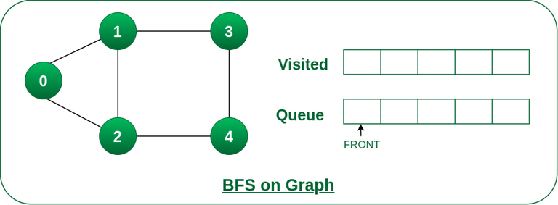
Queue and visited arrays are empty initially.
Step2: Push node 0 into queue and mark it visited.
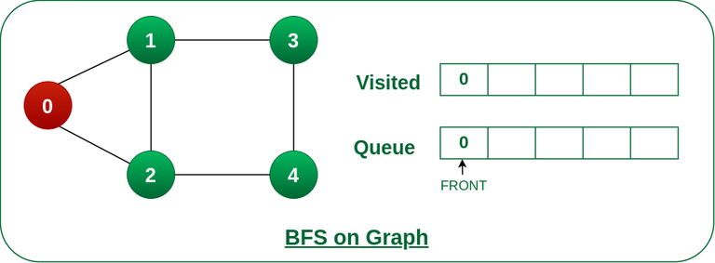
Push node 0 into queue and mark it visited.
Step 3: Remove node 0 from the front of queue and visit the unvisited neighbours and push them into queue.
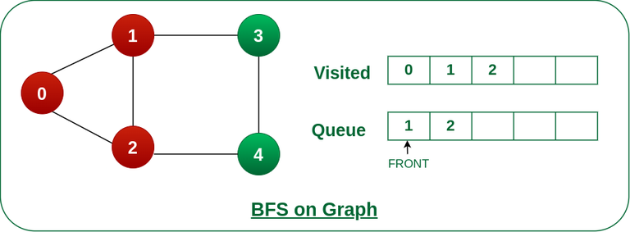
Remove node 0 from the front of queue and visited the unvisited neighbours and push into queue.
Step 4: Remove node 1 from the front of queue and visit the unvisited neighbours and push them into queue.
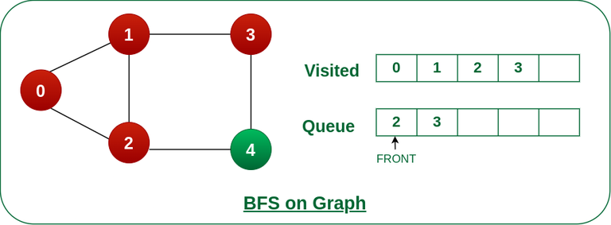
Remove node 1 from the front of queue and visited the unvisited neighbours and push
Step 5: Remove node 2 from the front of queue and visit the unvisited neighbours and push them into queue.
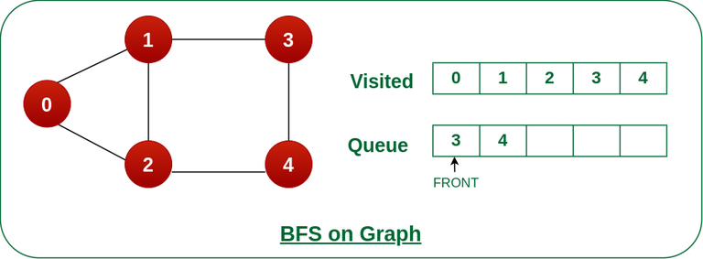
Remove node 2 from the front of queue and visit the unvisited neighbours and push them into queue.
Step 6: Remove node 3 from the front of queue and visit the unvisited neighbours and push them into queue.
As we can see that every neighbours of node 3 is visited, so move to the next node that are in the front of the queue.
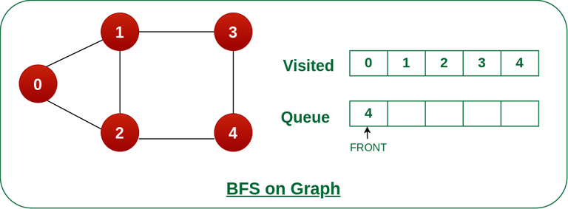
Remove node 3 from the front of queue and visit the unvisited neighbours and push them into queue.
Steps 7: Remove node 4 from the front of queue and visit the unvisited neighbours and push them into queue.
As we can see that every neighbours of node 4 are visited, so move to the next node that is in the front of the queue.
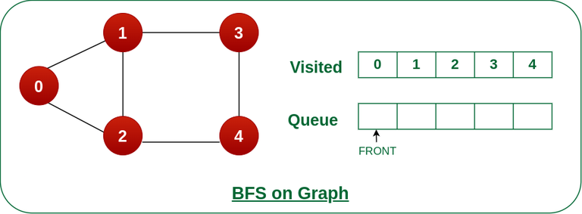

Double Ended Queue Data structure
Double Ended Queue is also a Queue data structure in which the insertion and deletion operations are performed at both the ends (front and rear). That means, we can insert at both front and rear positions and can delete from both front and rear positions.
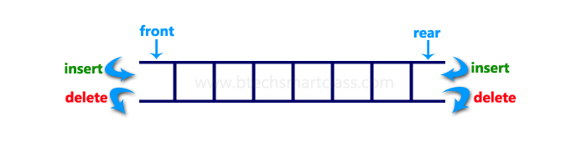
Double Ended Queue can be represented in TWO ways, those are as follows...
- Input Restricted Double Ended Queue
- Output Restricted Double Ended Queue

Input Restricted Double Ended Queue
In input restricted double-ended queue, the insertion operation is performed at only one end and deletion operation is performed at both the ends.
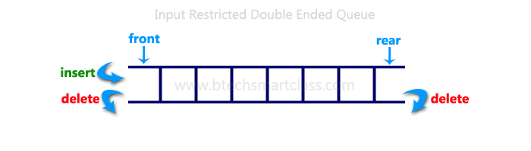

Output Restricted Double Ended Queue
In output restricted double ended queue, the deletion operation is performed at only one end and insertion operation is performed at both the ends.
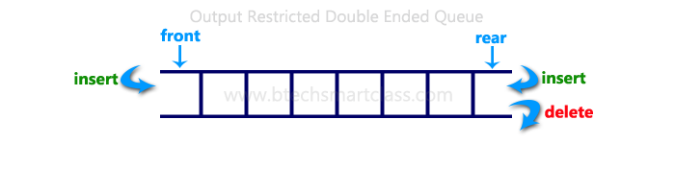

Applications of Deque:
- Deque supports both stack and queue operations.
- It can be used to store web browser history.
- It can be used in job scheduling algorithms.
- In undo operations.

Scheduling :

What are Scheduling Queues?

The processes that are entering into the system are stored in the Job Queue. Suppose if the processes are in the Ready state are generally placed in the Ready Queue.
The processes waiting for a device are placed in Device Queues. There are unique device queues which are available for every I/O device.
First place a new process in the Ready queue and then it waits in the ready queue till it is selected for execution.
Once the process is assigned to the CPU and is executing, any one of the following events occur −
- The process issue an I/O request, and then placed in the I/O queue.
- The process may create a new sub process and wait for termination.
- The process may be removed forcibly from the CPU, which is an interrupt, and it is put back in the ready queue.
