TREES AND HASHING
A tree data structure can also be defined as follows...
Tree data structure is a collection of data (Node) which is organized in hierarchical structure recursively
In tree data structure, every individual element is called as Node. Node in a tree data structure stores the actual data of that particular element and link to next element in hierarchical structure.
In a tree data structure, if we have N number of nodes then we can have a maximum of N-1 number of links.

Example
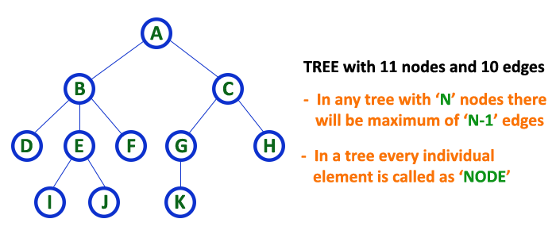

Terminology
In a tree data structure, we use the following terminology...

1. Root
In a tree data structure, the first node is called as Root Node. Every tree must have a root node. We can say that the root node is the origin of the tree data structure. In any tree, there must be only one root node. We never have multiple root nodes in a tree.
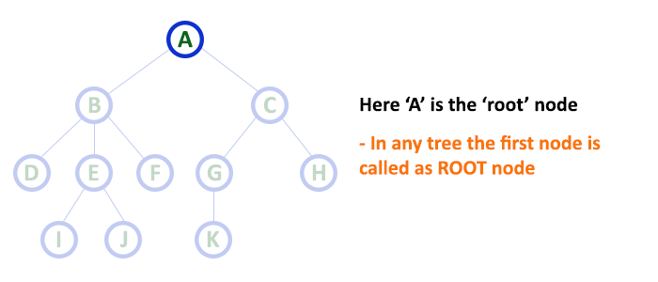

2. Edge
In a tree data structure, the connecting link between any two nodes is called as EDGE. In a tree with 'N' number of nodes there will be a maximum of 'N-1' number of edges.
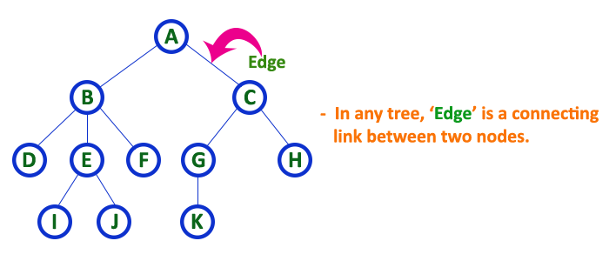

3. Parent
In a tree data structure, the node which is a predecessor of any node is called as PARENT NODE. In simple words, the node which has a branch from it to any other node is called a parent node. Parent node can also be defined as "The node which has child / children".
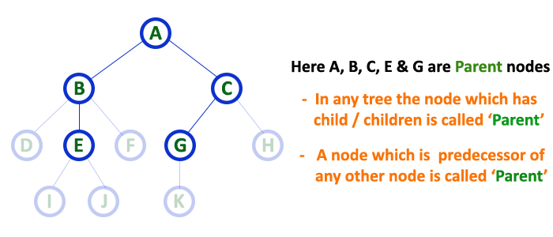

4. Child
In a tree data structure, the node which is descendant of any node is called as CHILD Node. In simple words, the node which has a link from its parent node is called as child node. In a tree, any parent node can have any number of child nodes. In a tree, all the nodes except root are child nodes.
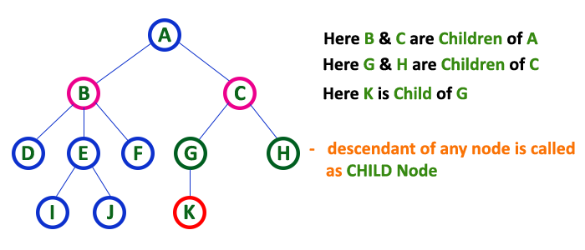

5. Siblings
In a tree data structure, nodes which belong to same Parent are called as SIBLINGS. In simple words, the nodes with the same parent are called Sibling nodes.
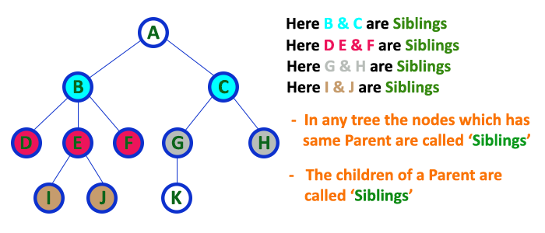

6. Leaf
In a tree data structure, the node which does not have a child is called as LEAF Node. In simple words, a leaf is a node with no child.
In a tree data structure, the leaf nodes are also called as External Nodes. External node is also a node with no child. In a tree, leaf node is also called as 'Terminal' node.
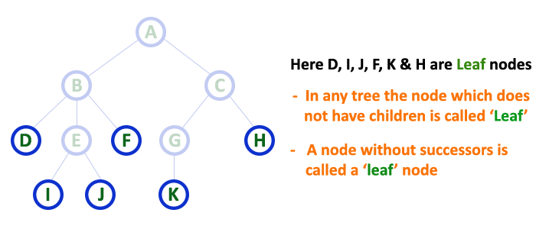

7. Internal Nodes
In a tree data structure, the node which has atleast one child is called as INTERNAL Node. In simple words, an internal node is a node with atleast one child.
In a tree data structure, nodes other than leaf nodes are called as Internal Nodes. The root node is also said to be Internal Node if the tree has more than one node. Internal nodes are also called as 'Non-Terminal' nodes.
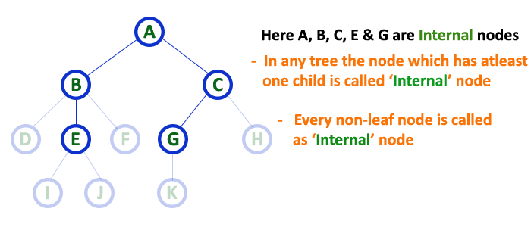

8. Degree
In a tree data structure, the total number of children of a node is called as DEGREE of that Node. In simple words, the Degree of a node is total number of children it has. The highest degree of a node among all the nodes in a tree is called as 'Degree of Tree'
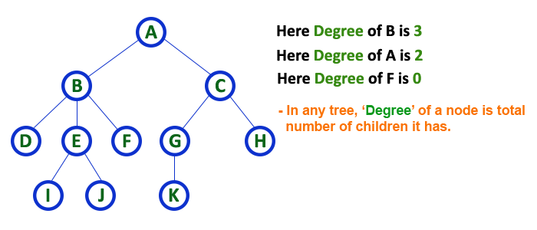

9. Level
In a tree data structure, the root node is said to be at Level 0 and the children of root node are at Level 1 and the children of the nodes which are at Level 1 will be at Level 2 and so on... In simple words, in a tree each step from top to bottom is called as a Level and the Level count starts with '0' and incremented by one at each level (Step).
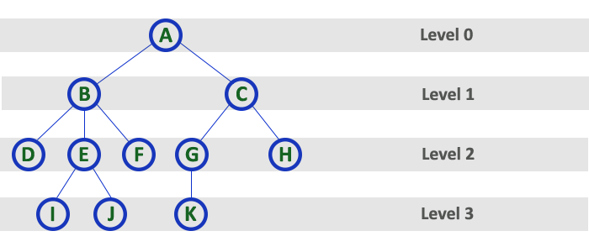

10. Height
In a tree data structure, the total number of edges from leaf node to a particular node in the longest path is called as HEIGHT of that Node. In a tree, height of the root node is said to be height of the tree. In a tree, height of all leaf nodes is '0'.
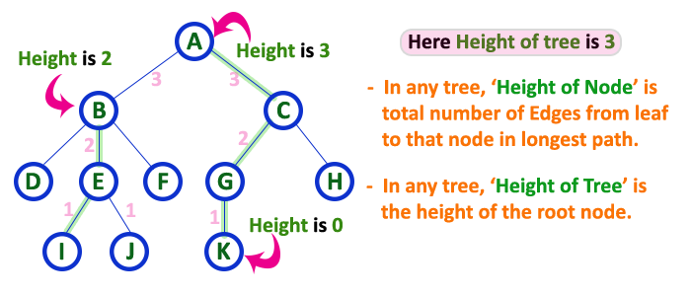

11. Depth
In a tree data structure, the total number of egdes from root node to a particular node is called as DEPTH of that Node. In a tree, the total number of edges from root node to a leaf node in the longest path is said to be Depth of the tree. In simple words, the highest depth of any leaf node in a tree is said to be depth of that tree. In a tree, depth of the root node is '0'.
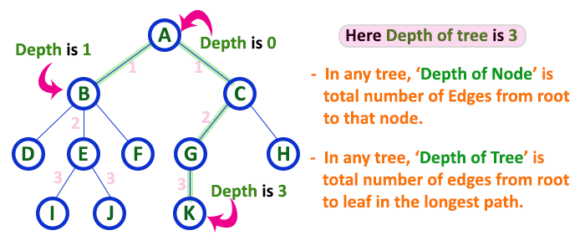

12. Path
In a tree data structure, the sequence of Nodes and Edges from one node to another node is called as PATH between that two Nodes. Length of a Path is total number of nodes in that path. In below example the path A - B - E - J has length 4.
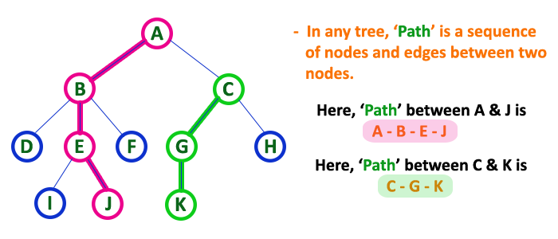

13. Sub Tree
In a tree data structure, each child from a node forms a subtree recursively. Every child node will form a subtree on its parent node.
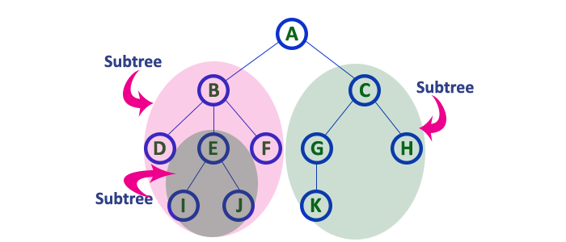

Binary Tree Datastructure
In a normal tree, every node can have any number of children. A binary tree is a special type of tree data structure in which every node can have a maximum of 2 children. One is known as a left child and the other is known as right child.
A tree in which every node can have a maximum of two children is called Binary Tree.
In a binary tree, every node can have either 0 children or 1 child or 2 children but not more than 2 children.

Example
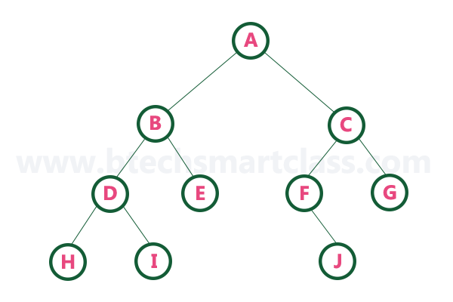
There are different types of binary trees and they are...

1. Strictly Binary Tree
In a binary tree, every node can have a maximum of two children. But in strictly binary tree, every node should have exactly two children or none. That means every internal node must have exactly two children. A strictly Binary Tree can be defined as follows...
A binary tree in which every node has either two or zero number of children is called Strictly Binary Tree

Strictly binary tree is also called as Full Binary Tree or Proper Binary Tree or 2-Tree

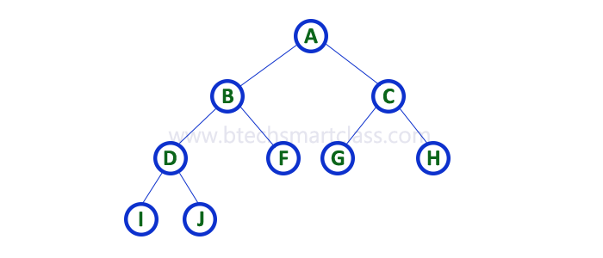
Strictly binary tree data structure is used to represent mathematical expressions.

Example
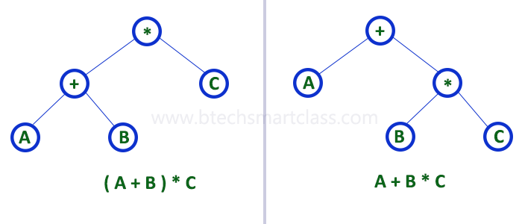

2. Complete Binary Tree
In a binary tree, every node can have a maximum of two children. But in strictly binary tree, every node should have exactly two children or none and in complete binary tree all the nodes must have exactly two children and at every level of complete binary tree there must be 2^{level} number of nodes. For example at level 2 there must be 2² = 4 nodes and at level 3 there must be 2³ = 8 nodes.
A binary tree in which every internal node has exactly two children and all leaf nodes are at same level is called Complete Binary Tree.

Complete binary tree is also called as Perfect Binary Tree

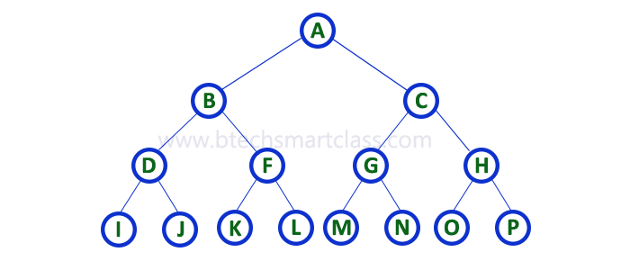

3. Extended Binary Tree
A binary tree can be converted into Full Binary tree by adding dummy nodes to existing nodes wherever required.
The full binary tree obtained by adding dummy nodes to a binary tree is called as Extended Binary Tree.
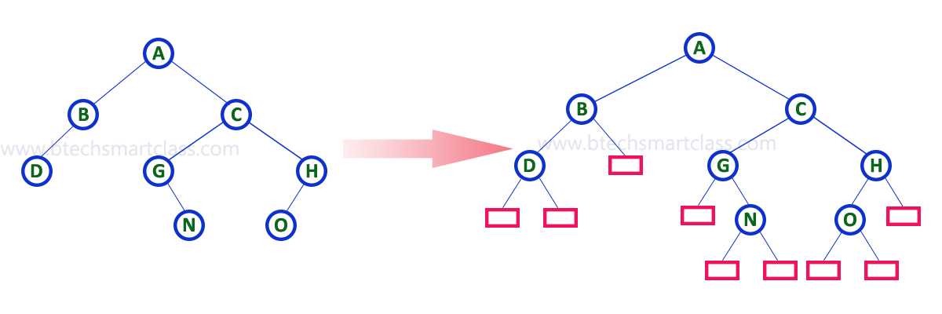
In above figure, a normal binary tree is converted into full binary tree by adding dummy nodes (In pink colour).
A binary tree data structure is represented using two methods. Those methods are as follows...
- Array Representation
- Linked List Representation
Consider the following binary tree...
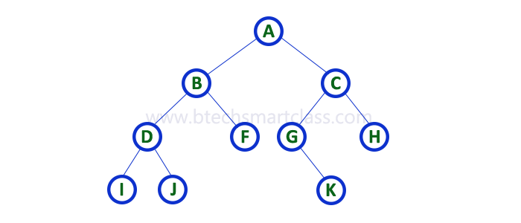

1. Array Representation of Binary Tree
In array representation of a binary tree, we use one-dimensional array (1-D Array) to represent a binary tree.
Consider the above example of a binary tree and it is represented as follows...
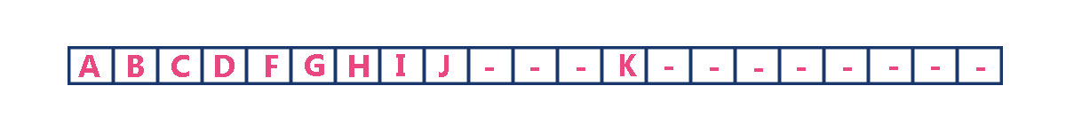
To represent a binary tree of depth 'n' using array representation, we need one dimensional array with a maximum size of 2n + 1.

2. Linked List Representation of Binary Tree
We use a double linked list to represent a binary tree. In a double linked list, every node consists of three fields. First field for storing left child address, second for storing actual data and third for storing right child address.
In this linked list representation, a node has the following structure...

The above example of the binary tree represented using Linked list representation is shown as follows...
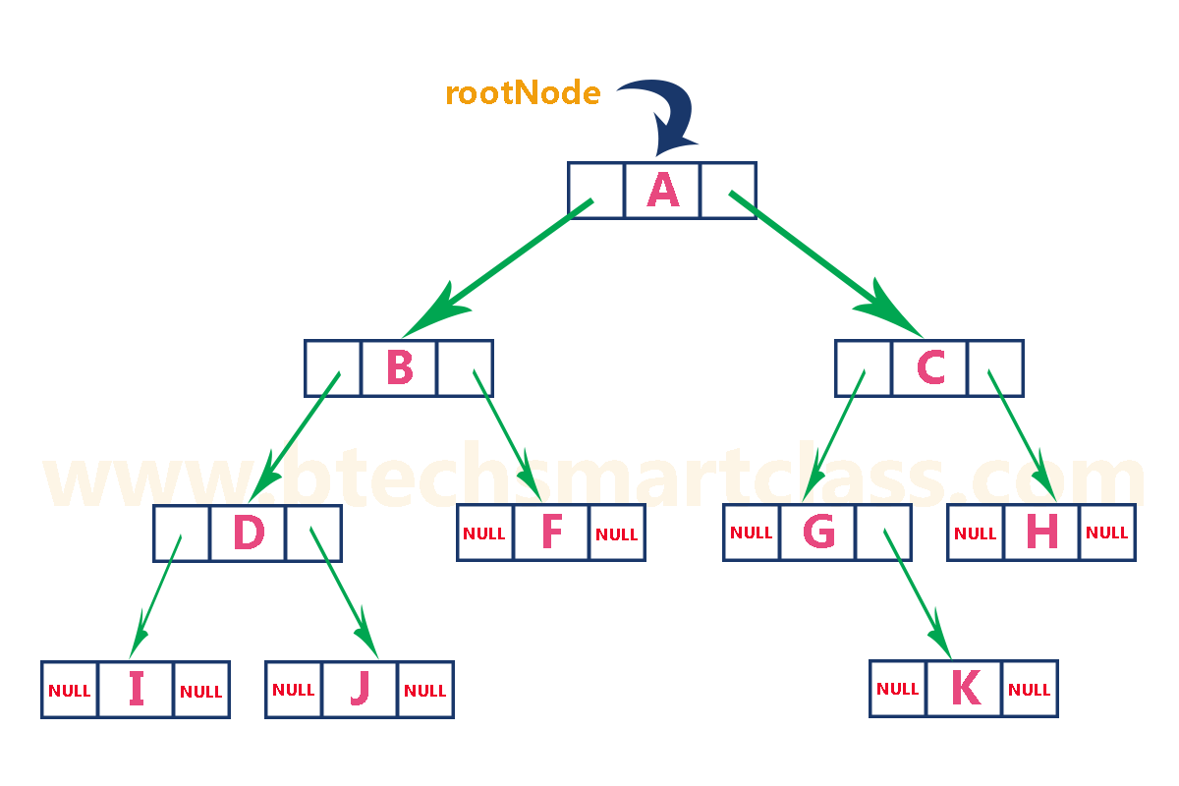

Binary Tree Traversals
When we wanted to display a binary tree, we need to follow some order in which all the nodes of that binary tree must be displayed. In any binary tree, displaying order of nodes depends on the traversal method.
Displaying (or) visiting order of nodes in a binary tree is called as Binary Tree Traversal.
There are three types of binary tree traversals.
- In - Order Traversal
- Pre - Order Traversal
- Post - Order Traversal

What is a Binary Search tree?
A binary search tree follows some order to arrange the elements. In a Binary search tree, the value of left node must be smaller than the parent node, and the value of right node must be greater than the parent node. This rule is applied recursively to the left and right subtrees of the root.
Let's understand the concept of Binary search tree with an example.
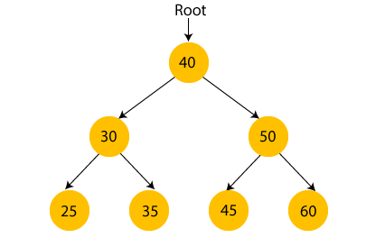
In the above figure, we can observe that the root node is 40, and all the nodes of the left subtree are smaller than the root node, and all the nodes of the right subtree are greater than the root node.
Similarly, we can see the left child of root node is greater than its left child and smaller than its right child. So, it also satisfies the property of binary search tree. Therefore, we can say that the tree in the above image is a binary search tree.
Suppose if we change the value of node 35 to 55 in the above tree, check whether the tree will be binary search tree or not.
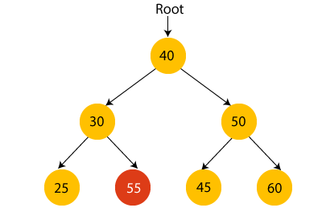
In the above tree, the value of root node is 40, which is greater than its left child 30 but smaller than right child of 30, i.e., 55. So, the above tree does not satisfy the property of Binary search tree. Therefore, the above tree is not a binary search tree.

Advantages of Binary search tree
- Searching an element in the Binary search tree is easy as we always have a hint that which subtree has the desired element.
- As compared to array and linked lists, insertion and deletion operations are faster in BST.

Example of creating a binary search tree
Now, let's see the creation of binary search tree using an example.
Suppose the data elements are - 45, 15, 79, 90, 10, 55, 12, 20, 50
- First, we have to insert 45 into the tree as the root of the tree.
- Then, read the next element; if it is smaller than the root node, insert it as the root of the left subtree, and move to the next element.
- Otherwise, if the element is larger than the root node, then insert it as the root of the right subtree.

Applications of Hashing
- Database indexing: Hashing is used to index and retrieve data efficiently in databases and other data storage systems.
- Password storage: Hashing is used to store passwords securely by applying a hash function to the password and storing the hashed result, rather than the plain text password.
- Data compression: Hashing is used in data compression algorithms, such as the Huffman coding algorithm, to encode data efficiently.
- Search algorithms: Hashing is used to implement search algorithms, such as hash tables and bloom filters, for fast lookups and queries.
- Cryptography: Hashing is used in cryptography to generate digital signatures, message authentication codes (MACs), and key derivation functions.
- Load balancing: Hashing is used in load-balancing algorithms, such as consistent hashing, to distribute requests to servers in a network.
- Blockchain: Hashing is used in blockchain technology, such as the proof-of-work algorithm, to secure the integrity and consensus of the blockchain.
- Image processing: Hashing is used in image processing applications, such as perceptual hashing, to detect and prevent image duplicates and modifications.
- File comparison: Hashing is used in file comparison algorithms, such as the MD5 and SHA-1 hash functions, to compare and verify the integrity of files.
- Fraud detection: Hashing is used in fraud detection and cybersecurity applications, such as intrusion detection and antivirus software, to detect and prevent malicious activities.

Hashing provides constant time search, insert and delete operations on average. This is why hashing is one of the most used data structure, example problems are, distinct elements, counting frequencies of items, finding duplicates, etc.
There are many other applications of hashing, including modern-day cryptography hash functions. Some of these applications are listed below:
- Message Digest
- Password Verification
- Data Structures(Programming Languages)
- Compiler Operation
- Rabin-Karp Algorithm
- Linking File name and path together
- Game Boards
- Graphics

