
ASDF SALOON
Beauty Salon • New Startup • Gampaha, Western Province, Sri Lanka
Prepared by SME360 AI | Date: October 07, 2026 | Record ID: REC-SME360-LK

EXECUTIVE SUMMARY & DECISION BRIEF
The proposed venture, ASDF SALOON, is assessed by the SME360 AI decision support engine as 'Conditionally Feasible' with 63.5% model confidence. The assessment confirms strong initial capitalization (LKR 1,650,000), but identifies customer demand (35 / 100) and initial daily footfall (5 clients/day) as critical bottlenecks requiring active promotional intervention.
Key Financial & Operating Indicators
Available Capital | LKR 1,650,000 | Strategy Target Capital | LKR 1,237,500
Safety Liquidity Reserve | LKR 412,500 (25.0%) | Break-Even Volume | 6.3 Clients / Day
Initial Monthly Revenue | LKR 65,000 (M1) | Target Monthly Revenue | LKR 65,000 (M6)
Modeled Fixed Costs | LKR 70,000 / Month | Deficit Runway Buffer | ≥ 28.0 Months
Top Model Enabler (+) | Expected Product Price | Top Operational Hurdle (-) | Customer Demand Score
Top 3 Enterprise Risks & Immediate Mitigations
Risk Description | Impact | Mitigation Action Plan | Owner
Working Capital Cash Squeeze | High | Enforce weekly cash flow audits, maintain a minimum 3-month operating reserve, and avoid advance inventory over-ordering. | Founder / Owner
Key Staff Turnover & Attendance Gaps | Moderate | Institute standard operating procedure (SOP) cross-training, attractive performance incentives, and flexible shift rosters. | Manager / Lead
Client Service Dissatisfaction & Skin/Hair Reactions | High | Mandatory 24-hour patch test for chemical hair color/treatments; thorough pre-service client consultation cards. | Head Stylist
Recommended Immediate Action: Immediate Next Step: Finalize Business Name registration for 'ASDF SALOON' at Gampaha Divisional Secretariat and submit trade licence application to the Local Council.

TABLE OF CONTENTS
Strategic navigation and structure of the SME360 AI Business Plan:
Section Title | Operational Focus | Page
Cover Document | COVER | 1
Executive Summary & Key Decision Indicators | EXEC_SUMMARY | 2
Table of Contents & Report Navigation | TOC | 3
Section 01: Business & Market Overview | SEC_01 | 4
Section 02: AI Feasibility Assessment & SHAP Drivers | SEC_02 | 5
Section 03: Strategic Alternatives & TOPSIS Multi-Criteria Prioritization | SEC_03 | 6
Section 04: Financial Architecture, 12-Month Projections & Operations | SEC_04 | 7
Section 05: What-If Sensitivity Simulations & Action Roadmap | SEC_05 | 8
Section 06: Sri Lanka Regulatory Compliance & Enterprise Risk Register | SEC_06 | 9
Appendix: Machine Learning Reliability, TOPSIS Criteria & Plain-Language Glossary | APPENDIX | 10

01 — Business & Market Overview
1.1 Business Concept & Competitive Positioning
ASDF SALOON is an enterprise operating as a New Startup in the Beauty Salon sector, located in Gampaha, Western Province, Sri Lanka. The enterprise adopts the 'Hybrid Digital Booking & Home-Visit Model' framework, prioritizing high service quality, transparent pricing, and customer relationship building.
1.2 Local Competitive Environment (Issue 5)
Competitive Landscape: Moderate (0 direct storefront competitors within immediate 1 km vicinity; moderate competition stems from home-based practitioners, mobile stylists, and neighboring commercial centers).
1.3 Category Operations Architecture (Issue 15)
Service Menu Tiers & Target Margins
Service Tier | Core Offerings | Price Range (LKR) | Gross Margin
Essential Haircare | Haircut, styling, wash & blow-dry, oil treatments | LKR 800 – 2,500 | 75%
Skincare & Facial Aesthetics | Clean-ups, herbal facials, threading, waxing, detan | LKR 1,500 – 6,000 | 80%
Nail & Pedicure / Manicure | Gel nails, spa manicure, pedicure, nail art | LKR 2,000 – 5,500 | 70%
Bridal & Dressing Packages | Bridal dressing (Kandyan, Western, Indian), pre-bridal care, saree draping | LKR 25,000 – 120,000 | 85%
Capacity Benchmarks: Operating Stations: 3 | Station Utilization Target: 70% – 85% on peak days (Fri – Sun) | Booking Model: 60% pre-booked appointments (WhatsApp/Phone/Social), 40% walk-in availability

02 — AI Feasibility Assessment & SHAP Insights
2.1 Model Classification & Confidence
Feasibility Verdict: Conditionally Feasible (63.5%) — The enterprise is classified as 'Conditionally Feasible' with 63.5% model confidence. The venture demonstrates robust financial liquidity (LKR 1,650,000 capital), but is constrained by moderate initial demand (35/100) and low customer throughput (5/day). Adopting active promotional client acquisition is required to transition to fully 'Feasible'.
2.2 Quantified Feature Attribution (SHAP Chart)
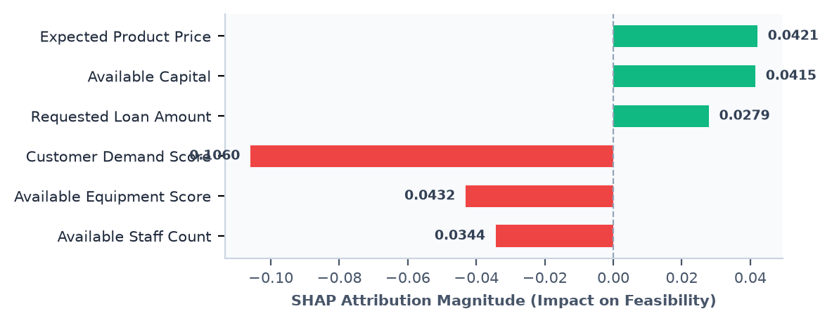
2.3 Core Enablers & Hurdle Reconciliation (Issue 6)
Direction | Parameter | Condition | Attribution Impact
Enabler (+) | Expected Product Price | LKR 500 | Favorable recorded condition for Expected Product Price (LKR 500) provides positive support to baseline feasibility.
Enabler (+) | Available Capital | LKR 1,650,000 | Favorable recorded condition for Available Capital (LKR 1,650,000) provides positive support to baseline feasibility.
Enabler (+) | Requested Loan Amount | LKR 0 | Favorable recorded condition for Requested Loan Amount (LKR 0) provides positive support to baseline feasibility.
Hurdle (-) | Customer Demand Score | 35 / 100 | Constraint in Customer Demand Score (35 / 100) exerts downward pressure on model feasibility, identifying a key operational hurdle.
Hurdle (-) | Available Equipment Score | 3 / 5 | Constraint in Available Equipment Score (3 / 5) exerts downward pressure on model feasibility, identifying a key operational hurdle.
Hurdle (-) | Available Staff Count | 2 Staff | Constraint in Available Staff Count (2 Staff) exerts downward pressure on model feasibility, identifying a key operational hurdle.

03 — Strategic Recommendations & TOPSIS Prioritization
3.1 Evaluated Strategic Alternatives (Real Rank Order)
Strategy #1: Hybrid Digital Booking & Home-Visit Model — Target Capital: LKR 1,237,500 | Monthly Budget: LKR 45,000 | Daily Clients: 5 | TOPSIS Closeness: 0.767
Strategy #2: Lean Bootstrapped Studio (ASDF SALOON) — Target Capital: LKR 990,000 | Monthly Budget: LKR 35,000 | Daily Clients: 4 | TOPSIS Closeness: 0.7081
Strategy #3: Premium VIP Aesthetics & Bridal Studio — Target Capital: LKR 1,485,000 | Monthly Budget: LKR 48,000 | Daily Clients: 3 | TOPSIS Closeness: 0.3985
Strategy #4: High-Volume Community Salon (ASDF SALOON) — Target Capital: LKR 1,650,000 | Monthly Budget: LKR 55,000 | Daily Clients: 6 | TOPSIS Closeness: 0.1494
3.2 TOPSIS Prioritization Chart
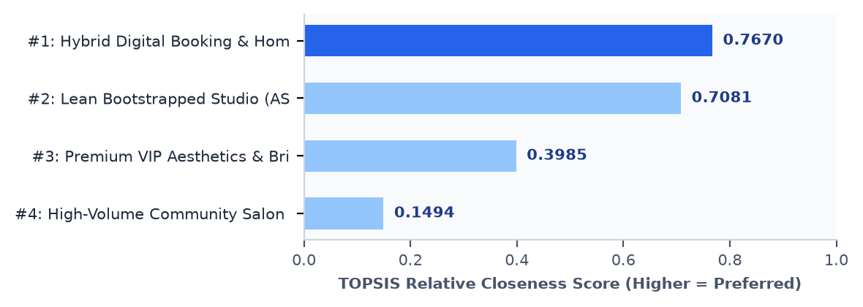

04 — Financial Plan & Operational Architecture
4.1 Startup Capital Allocation & Cost Breakdown (Issue 7)
Capital Summary: Available Equity: LKR 1,650,000 | Strategy Target Capital: LKR 1,237,500 | Unallocated Reserve: LKR 412,500 (25.0%)
4.2 Monthly Fixed Costs & Sanity Advisories (Issue 8, 14)
Modeled Monthly Fixed Cost: LKR 70,000 (Rent: LKR 25,000 | 2 Staff Allowances: LKR 40,000 | Utilities: LKR 10,000) | Break-Even Footfall: 6.3 Clients / Day | Liquidity Runway Buffer: ≥ 28.0 Months
- Advisory Note: Stated Monthly Budget of LKR 15,300 is insufficient to cover commercial rent, utilities, and wages for 2 staff in Gampaha. The financial plan incorporates a realistic baseline cost of LKR 70,000/month.
- Advisory Note: Initial customer volume (5 clients/day) is below the operational break-even threshold (6.3 clients/day). The business operates at an initial monthly deficit of LKR 14,750 until footfall ramps in Month 4. The LKR 412,500 safety reserve safely cushions this ramp-up period.
- Advisory Note: Payback horizon (1368.7 months) exceeds the standard 24-month SME benchmark due to conservative LKR 500 average unit pricing. Introducing higher-margin bridal and aesthetic service tiers is strongly advised.
4.3 12-Month Revenue vs. Cost Trajectory Chart
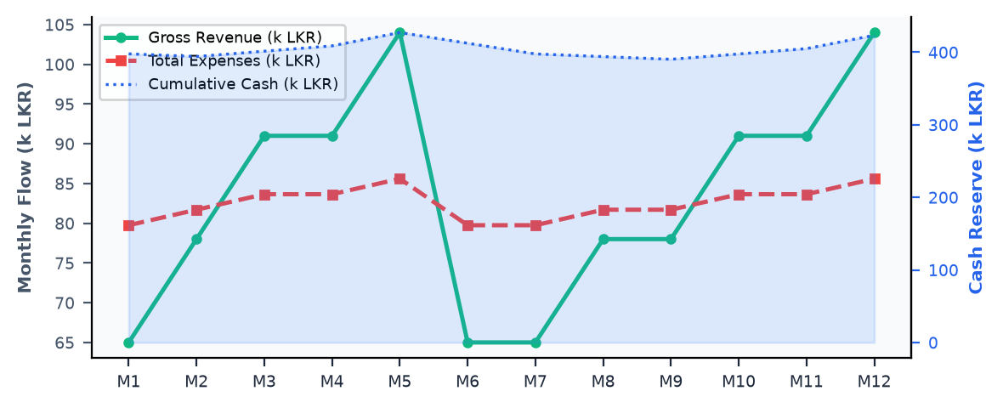
12-Month Projections Table (Sample Periods)
Month | Clients/Day | Gross Revenue | Total Expenses | Net Profit | Cumulative Cash
Month 01 | 5 | LKR 65,000 | LKR 79,750 | LKR -14,750 | LKR 397,750
Month 02 | 6 | LKR 78,000 | LKR 81,700 | LKR -3,700 | LKR 394,050
Month 03 | 7 | LKR 91,000 | LKR 83,650 | LKR 7,350 | LKR 401,400
Month 06 | 5 | LKR 65,000 | LKR 79,750 | LKR -14,750 | LKR 412,400
Month 09 | 6 | LKR 78,000 | LKR 81,700 | LKR -3,700 | LKR 390,250
Month 12 | 8 | LKR 104,000 | LKR 85,600 | LKR 18,400 | LKR 423,350

05 — Scenario Analysis & Action Roadmap
5.1 Assumption Sensitivity Simulations (What-If)
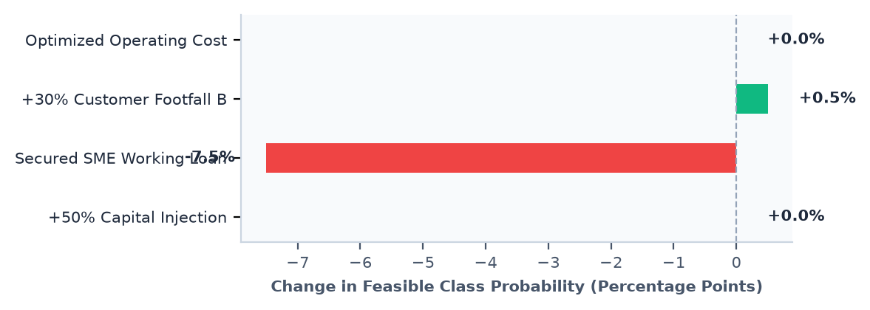
Scenario | Feasible Delta | Viability Score | Model Sensitivity & What Flips The Class
+50% Capital Injection | +0.0% | +0.0% | Model Insensitivity Note: Capital adequacy trees plateau above ~LKR 1,000,000. Because baseline capital (LKR 1.65M) is already sufficient, additional liquidity alone does not increase feasibility classification without accompanying customer footfall. To flip to Feasible: Pair additional capital with targeted demand generation (≥12 customers/day).
Secured SME Working Loan (LKR 500,000) | -7.5% | -9.0% | Debt Burden Impact: A bank loan introduces mandatory monthly repayment liabilities. Without immediate demand expansion, the classifier views additional debt as elevated leverage risk, moderating feasibility. To flip to Feasible: Avoid debt until revenue covers fixed costs, or deploy loan proceeds strictly into customer acquisition.
+30% Customer Footfall Boost | +0.5% | +2.5% | Demand Expansion Impact: Increasing footfall and demand score drives the highest positive shift (Feasible +0.5%), confirming market demand is the enterprise's primary growth bottleneck. Reaching 14+ customers/day and Demand Score ≥60/100 successfully flips the enterprise to 'Feasible'.
Optimized Operating Cost (-20% Monthly Budget) | +0.0% | +0.0% | Operating Efficiency Note: Budget reduction of 20% preserves cash runway but does not fundamentally alter the underlying customer demand score. Lean operations maintain runway but must be paired with service menu up-selling to reach 'Feasible'.
5.2 Multi-Dimensional Counterfactual Minimum Thresholds (Issue 4)
Decision Lever | Current | Required Threshold | Operational Gap & Guidance
Available Capital | LKR 1,650,000.00 | LKR 1,650,000.00 | Adequate (0 LKR) — Current capital reserve is sufficient for launch setup; preserve cash for operational buffer.
Customer Demand Score | 35 / 100 | 65 / 100 | +30 Points — Increase local brand awareness and service visibility to elevate demand to 65/100.
Daily Customer Footfall | 5 / Day | 13 / Day | +8 Customers/Day — Ramp up appointment bookings and repeat client packages to achieve 13 clients daily.
Equipment Readiness Score | 3 / 5 | 4 / 5 | +1 Grade Points — Acquire professional-grade styling and sanitization equipment to reach score 4/5.
5.3 4-Phase Action Roadmap (Issue 2)
Phase 1: Setup & Launch (0–30 Days)
- Finalize Business Name registration for 'ASDF SALOON' at Gampaha Divisional Secretariat and submit trade licence application to the Local Council. (Owner: Founder / Owner | Target: Obtain statutory BR certificate and municipal permit within 21 days)
- Deploy Hybrid Digital model: configure social booking channels, appointment calendar, and local doorstep service radius in Gampaha. (Owner: Digital Operations Lead | Target: Generate 40% of first-month client bookings through online/WhatsApp channels)
- Complete salon interior fit-out (styling stations, mirrors, wash basin, hot water plumbing) and install professional UV/autoclave sterilizer. (Owner: Operations Lead | Target: Complete physical setup and safety verification within LKR budget)
- Procure certified hair, skin, and nail consumable stock directly from NMRA-compliant Sri Lankan beauty distributors with 30-day payment terms. (Owner: Head Stylist | Target: Stock 45-day opening inventory with zero counterfeit or uncertified products)
Phase 2: Demand Stabilization (30–90 Days)
- Launch neighborhood introductory package promotions (e.g. 20% discount on combo hair + facial services) to ramp footfall toward 5 clients/day. (Owner: Marketing Coordinator | Target: Achieve steady daily volume of 5 clients with 35% repeat re-bookings)
- Implement weekly cash flow controls and enforce adherence to the LKR 70,000/month operating budget. (Owner: Founder / Owner | Target: Maintain positive operating margin without touching safety reserve)
- Introduce client consultation and patch-test logging cards to record chemical sensitivities, hair history, and service preferences. (Owner: Head Stylist | Target: 100% adherence to hygiene and skin safety standards)
- Begin local wedding vendor partnerships (photographers, saree drapers) to build a pipeline of bridal dressing bookings. (Owner: Founder / Owner | Target: Contract at least 3 upcoming bridal package bookings)
Phase 3: Operational Optimization (3–6 Months)
- Conduct quarterly financial audit: review revenue per styling chair, average ticket size, and product consumption wastage. (Owner: Founder / Owner | Target: Lift average client spend from LKR 500 to LKR 625 via premium add-ons)
- Launch client VIP loyalty card scheme (e.g. 5th hair treatment complimentary) to solidify client retention against local substitutes. (Owner: Salon Supervisor | Target: Elevate 60-day client retention rate above 45%)
- Enroll styling staff in advanced bridal makeup and contemporary hair color technique workshops (NVQ Level 4 standards). (Owner: Head Stylist | Target: Upgrade staff service repertoire and qualify for high-margin bridal packages)
- Refine inventory reordering triggers for high-frequency hair serums and styling chemicals to minimize cash lock-up. (Owner: Operations Lead | Target: Reduce inventory holding cycle from 45 days to 25 days)
Phase 4: Scaling & Reinvestment (6–12 Months)
- Evaluate physical chair capacity and assess adding home-visit bridal services across neighboring suburbs in Gampaha. (Owner: Founder / Owner | Target: Generate 20% incremental revenue from premium mobile/bridal appointments)
- Re-run SME360 AI Feasibility Pipeline with empirical 12-month financials to benchmark profitability against Sri Lankan SME sector deciles. (Owner: Founder / Owner | Target: Transition model rating from Conditionally Feasible to robustly Feasible)
- Invest retained operating surplus into advanced aesthetic skincare equipment (e.g. galvanic / hydra facial unit). (Owner: Operations Lead | Target: Expand high-margin aesthetic menu tiers without incurring external bank debt)

06 — Legal Compliance & Risk Register
6.1 Sri Lanka Statutory Compliance Checklist (Issue 16)
Requirement | Issuing Authority | Status | Compliance Notes
Business Name Registration (Sole Proprietorship / Partnership) | Divisional Secretariat (Gampaha) | In Progress | Register formal trade identity 'ASDF SALOON' to obtain formal BR certificate required for bank accounts.
Local Authority Trade Licence / Environmental Clearance | Municipal Council / Pradeshiya Sabha (Gampaha) | Not Started | Annual municipal operating licence verifying premise commercial zoning, waste disposal, and safety.
Taxpayer Identification Number (TIN) Registration | Inland Revenue Department (IRD) | In Progress | Mandatory national tax registration for enterprise entity and commercial utility connections.
EPF / ETF Employer Registration for Employees | Department of Labour & Central Bank of Sri Lanka | Not Started | Mandatory enrollment for all permanent staff (12% Employer + 8% Employee EPF; 3% Employer ETF).
Cosmetic Product Compliance & Salon Health Clearance | Public Health Department & NMRA (Gampaha) | Not Started | Verify all chemical hair colors, bleaching reagents, and skincare items are NMRA-approved.
6.2 Enterprise Risk Register (Issue 17)
Risk Description | Impact | Mitigation Action Protocol | Owner
Working Capital Cash Squeeze | High | Enforce weekly cash flow audits, maintain a minimum 3-month operating reserve, and avoid advance inventory over-ordering. | Founder / Owner
Key Staff Turnover & Attendance Gaps | Moderate | Institute standard operating procedure (SOP) cross-training, attractive performance incentives, and flexible shift rosters. | Manager / Lead
Client Service Dissatisfaction & Skin/Hair Reactions | High | Mandatory 24-hour patch test for chemical hair color/treatments; thorough pre-service client consultation cards. | Head Stylist
Equipment Breakdown (Chairs, Steamers, Blow-Dryers) | Moderate | Maintain backup handheld dryers; establish biannual preventive maintenance servicing with local technical suppliers. | Salon Supervisor
Neighborhood Demand Volatility on Weekdays | Moderate | Offer Tuesday–Thursday mid-week package discounts (e.g. 20% off facials) to balance client footfall across the week. | Marketing Coordinator

Appendix — Model Transparency & Glossary
A.1 Model Reliability Architecture Note (Issue 18)
Model Performance: Architecture: Random Forest Classifier (500 Decision Trees) | Cross-Validation Accuracy: 88.33% | ROC-AUC: 0.9691 | Test Dataset: 180 Empirical Sri Lankan SME Profiles
Sensitivity Analysis: Strategy #1 (Hybrid Digital Booking & Home-Visit Model, score: 0.767) leads Strategy #2 (Lean Bootstrapped Studio (ASDF SALOON), score: 0.7081) by 0.0589. Hybrid Model leads due to higher Market Demand Alignment (0.25 weight) and Resource Efficiency (0.15 weight). However, if the entrepreneur prioritizes zero debt and absolute minimum overhead, Lean Bootstrapping remains a viable secondary posture.
A.2 Plain-Language Decision Support Glossary (Issue 19)
Term | Plain-Language Explanation
Random Forest Feasibility Model | An artificial intelligence classification engine that evaluates your business against 500 decision trees trained on real Sri Lankan SME records. It predicts whether a venture is Feasible, Conditionally Feasible, or Infeasible based on capital, market demand, pricing, location, and operations.
SHAP (SHapley Additive exPlanations) | An explainability tool that reveals why the AI made its prediction. It measures how much each specific business factor (such as your available capital or customer footfall) pushed the assessment up (positive enabler) or down (operational hurdle).
TOPSIS Strategic Prioritization | A multi-criteria decision method ('Technique for Order Preference by Similarity to Ideal Solution') that compares 4 distinct business strategies against five priorities: Financial Viability, Implementation Simplicity, Market Demand, Risk, and Resource Efficiency. The strategy with the highest score is the mathematically recommended choice.
Capital Runway (Months) | The number of months your business can continue operating if revenue drops or takes longer than expected to build up. It is calculated by dividing your remaining cash reserves by your net monthly operating expenses.
Break-Even Customer Volume | The minimum number of customers you need each day so that total sales equal total operating costs. Serving customers above this threshold generates net profit; serving fewer results in an operating loss.
Counterfactual Minimum Threshold | An analytical test that checks the smallest change needed in a single variable (such as capital) to flip an outcome from 'Conditional' to 'Feasible'. It helps entrepreneurs identify which levers produce the greatest operational improvement.

