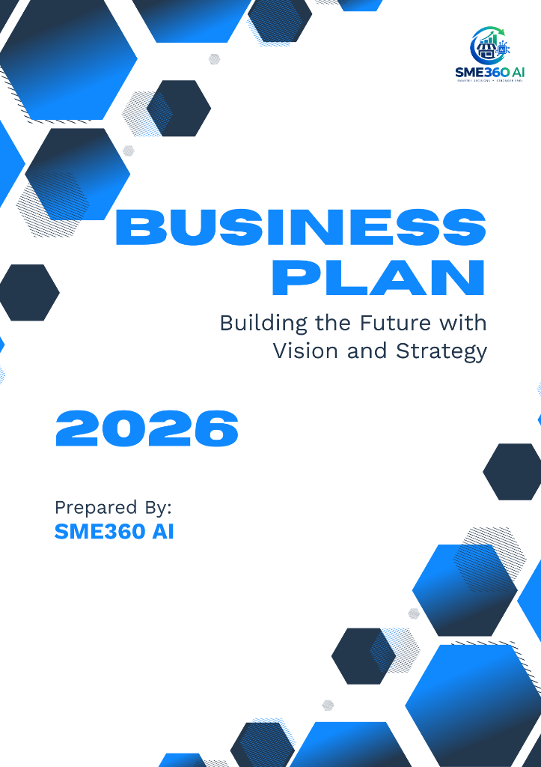


SME360 AI
STRATEGIC BUSINESS PLAN
A Comprehensive Feasibility, Strategic Direction & Implementation Blueprint
ENTERPRISE PROFILE & DOCUMENT METADATA
Prepared For: Serendib Organic Spices
Enterprise Category & Stage: Bakery / Food / Grocery • New Startup
Operating Catchment: Kandy, Central Province, Sri Lanka
Preparation Date: October 08, 2026
Decision Record Reference: N/A

This document synthesizes machine-learned feasibility prediction, explainable SHAP feature attribution, TOPSIS multi-criteria strategy prioritization, and sensitivity scenario stress-testing into an actionable strategic roadmap tailored specifically to this enterprise.

SECTION 01 — BUSINESS & MARKET OVERVIEW
1.1 Business Overview
Serendib Organic Spices is a proposed new startup venture within the Bakery / Food / Grocery sector, planned for launch in Kandy, Central Province, Sri Lanka. The enterprise is structured under a Direct Retail / Service business model, providing commercial offerings tailored to the regional catchment. As a new venture in its initial setup phase, commercial priorities center on establishing initial operations, building customer awareness, and maintaining disciplined operating expenditure.
The business is structured to meet consumer demand in Kandy through focused service execution, relying on founder oversight and targeted local promotions to establish commercial presence.
1.2 Business Concept & Strategic Purpose
Strategic feasibility assessment for the planned launch of Serendib Organic Spices (new startup Bakery / Food / Grocery) located in Kandy, Central Province, Sri Lanka.
- Primary Commercial Offerings: Commercial offerings in Bakery / Food / Grocery
- Target Customer Profile: Local consumers and households in Kandy
- Foundational Objectives: Establish a sustainable Bakery / Food / Grocery enterprise adhering to Hybrid Digital & Local Delivery Model.
1.3 Market Opportunity & Demand Analysis
The proposed enterprise is positioned to serve the Kandy (Commercial Catchment). Based on the entrepreneur's planning assumptions, initial daily patronage is estimated at approximately 35 customers per day, with an expected average unit price of LKR 450.00. Operating across an estimated 26 days per month, the facility anticipates a monthly customer throughput of approximately 910 customer interactions.
The recorded customer demand score for this business profile is 65/100. This indicates that demand development and neighborhood visibility will serve as important priorities during the initial launch phase, requiring active local marketing to capture and sustain the anticipated footfall volume.
1.4 Competition & Location Dynamics
The local competitive environment is recorded with a competition level of Moderate. Specific nearby direct competitor counts were not provided in current business inputs. To secure customer loyalty, the positioning strategy emphasizes: Differentiation via digital channel expansion & low fixed cost and localized customer service responsiveness.
The operating location in Kandy holds a suitability rating of 4/5 within a Commercial setting. Commercial location in Kandy, providing consumer access within the local trading catchment. Commercial operations will focus on direct customer service, operational reliability, and targeted local engagement.
SECTION 02 — AI FEASIBILITY & KEY INSIGHTS
2.1 AI Feasibility Assessment
Based on the integrated evaluation of financial capital, market demand, operational staffing, and resource readiness, SME360 AI assesses Serendib Organic Spices as Conditionally Feasible with a predicted class probability of 57.5%. The multi-class Random Forest feasibility model assigns a predicted probability of 57.5% to Conditionally Feasible, 39.0% to Feasible, and 3.5% to Infeasible. The feasibility model developed in this study was trained and evaluated using the dataset used for this research. This classification indicates that while the business demonstrates commercial potential, specific operational hurdles and working capital safeguards should be addressed during setup.
ASSESSMENT VERDICT: CONDITIONALLY FEASIBLE (Predicted Class Probability: 57.5%)
Class Probabilities: Feasible: 39.0% | Conditionally Feasible: 57.5% | Infeasible: 3.5%

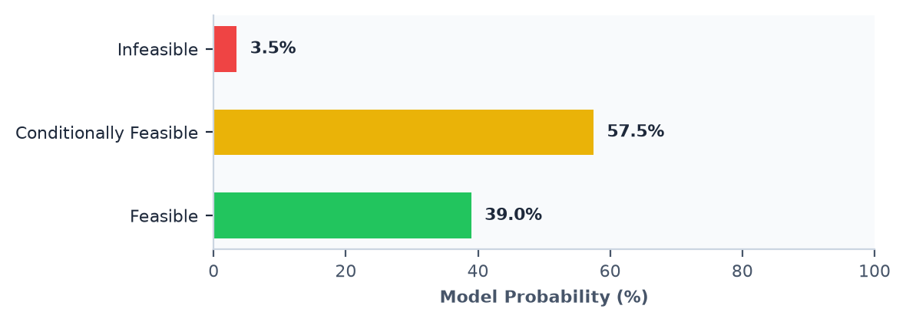
2.2 Why Did the AI Reach This Assessment? (Explainable AI Attribution)
To provide decision-support transparency, SME360 AI uses SHAP (SHapley Additive exPlanations) values to determine how specific business parameters influenced the model's classification. Rather than claiming absolute causality, SHAP identifies features that contributed positive supporting weight toward feasibility versus those that applied downward pressure as operational hurdles.
Primary Positive Supporting Factors:
- Business Stage (New Startup): Recorded condition for Business Stage (New Startup) contributed positively relative to the model baseline.
- Proposed Action (start): Recorded condition for Proposed Action (start) contributed positively relative to the model baseline.
- Expected Product Price (Lkr) (LKR 450): Recorded condition for Expected Product Price (Lkr) (LKR 450) contributed positively relative to the model baseline.
Operational Hurdles Requiring Management Attention:
- Available Staff Count (2 Staff): Recorded condition for Available Staff Count (2 Staff) exerted downward pressure relative to the model baseline, highlighting an operational hurdle.
- Available Equipment Score (1-5) (3 / 5): Recorded condition for Available Equipment Score (1-5) (3 / 5) exerted downward pressure relative to the model baseline, highlighting an operational hurdle.
- Customer Demand Score (1-100) (65 / 100): Recorded condition for Customer Demand Score (1-100) (65 / 100) exerted downward pressure relative to the model baseline, highlighting an operational hurdle.
SECTION 03 — STRATEGIC RECOMMENDATIONS & TOPSIS RANKING
3.1 Strategic Alternatives & Direction
Based on the feasibility diagnosis and identified operational constraints, SME360 AI formulated four tailored strategic pathways for Serendib Organic Spices. Rather than proposing a generic one-size-fits-all plan, each alternative represents a distinct operational philosophy balancing capital intensity, channel deployment, and resource constraints.
Strategy #1: Hybrid Digital & Local Delivery Model
Strategic Focus: Digital Channel Expansion & Low Fixed Cost — Combine focused physical setup with online ordering, social messaging channels, and local delivery coordination to extend customer reach in Kandy.
Expected Impact: Balanced Growth with Controlled Operating Expenditure
Target Capital: LKR 300,000 | Monthly Budget: LKR 18,062 | Target Footfall: 38 Customers/Day | TOPSIS Closeness: 0.7604

Strategy #2: Lean Bootstrapped Launch (Serendib Organic Spices)
Strategic Focus: Capital Preservation & Lean Operations — Optimize initial setup for Serendib Organic Spices by operating lean. Focus on essential equipment and low-cost customer outreach to address the constraint around Available Staff Count.
Expected Impact: Capital Preservation and Leaner Launch
Target Capital: LKR 240,000 | Monthly Budget: LKR 15,938 | Target Footfall: 28 Customers/Day | TOPSIS Closeness: 0.6095

Strategy #3: Premium Quality & Niche Differentiation
Strategic Focus: High Margin & Customer Loyalty — Focus on premium product quality, customized service, and distinctive branding to achieve higher margins without relying heavily on mass customer volume.
Expected Impact: Margin Stability via Differentiated Pricing
Target Capital: LKR 360,000 | Monthly Budget: LKR 19,125 | Target Footfall: 24 Customers/Day | TOPSIS Closeness: 0.4309

Strategy #4: Market Expansion & Customer Acquisition (Serendib Organic Spices)
Strategic Focus: Demand Generation & Volume Reach — Allocate resources toward targeted local customer outreach and visibility for Serendib Organic Spices to address Moderate competition and capture available market demand.
Expected Impact: Higher Volume Throughput with Staged Outlays
Target Capital: LKR 440,000 | Monthly Budget: LKR 26,562 | Target Footfall: 45 Customers/Day | TOPSIS Closeness: 0.3905

3.2 Strategy Prioritization (TOPSIS Multi-Criteria Method)
The strategic alternatives were evaluated using the TOPSIS (Technique for Order of Preference by Similarity to Ideal Solution) decision methodology. The evaluation simultaneously weighed five validated criteria: Financial Viability (25%), Implementation Feasibility (20%), Market Demand Alignment (25%), Resource & Operational Friction (15%), and Resource Efficiency (15%). The table below summarizes the multi-criteria ranking:
Rank | Strategy Alternative | Strategic Focus | Target Capital | TOPSIS Score
#1 | Hybrid Digital & Local Delivery Model | Digital Channel Expansion & Low Fixed Cost | LKR 300,000 | 0.7604
#2 | Lean Bootstrapped Launch (Serendib Organic Spices) | Capital Preservation & Lean Operations | LKR 240,000 | 0.6095
#3 | Premium Quality & Niche Differentiation | High Margin & Customer Loyalty | LKR 360,000 | 0.4309
#4 | Market Expansion & Customer Acquisition (Serendib Organic Spices) | Demand Generation & Volume Reach | LKR 440,000 | 0.3905

Under this multi-criteria analysis, Hybrid Digital & Local Delivery Model attained the highest relative closeness score (0.7604), establishing it as the AI engine's preferred strategic recommendation.
3.3 Entrepreneur Strategic Decision (Human-in-the-Loop Integration)
ACTIVE OPERATING STRATEGY: Hybrid Digital & Local Delivery Model (Matches AI Rank #1)
The entrepreneur reviewed the alternatives and confirmed the adoption of the AI's highest-ranked recommendation, Hybrid Digital & Local Delivery Model (TOPSIS Score: 0.7604). The subsequent financial, operational, and implementation plans are directly calibrated to this strategy.

SECTION 04 — FINANCIAL & OPERATIONAL PLAN
4.1 Financial Overview — Aligned with Hybrid Digital & Local Delivery Model
To operationalize the chosen strategy, the enterprise establishes a target capital allocation of approximately LKR 300,000. Under the baseline operating budget, recurring monthly operational expenditure is projected at LKR 18,062, covering commercial rent, essential payroll, utilities, and routine replenishment inventory. With an expected customer throughput of 35 customers per day, an expected unit price of LKR 450.00, and an operating schedule of 26 days per month, estimated monthly gross sales total approximately LKR 444,600. (Note: This is an estimated monthly gross sales calculation based on stated volume, price, and operating days. It does not account for variable costs or net profit.)
TARGET CAPITAL  LKR 300,000  Baseline Allocation | MONTHLY BUDGET  LKR 18,062  Operating Expenditure | EST. GROSS SALES  LKR 444,600  Volume × Price × Days | BUDGET COVERAGE  16.6 Mo (Strat)  Simplified Budget Ratio

4.2 Funding Structure & Simplified Budget Coverage
The business financing structure comprises LKR 400,000 in recorded available capital and LKR 0 in external loan financing, delivering total initial funding of LKR 400,000. Comparing available capital against the target requirement (LKR 300,000) indicates that the venture is fully funded from baseline capital. Under the baseline operating budget, simplified budget coverage corresponds to approximately 16.6 months for the strategy allocation and 22.1 months for total recorded funds. (Note: Simplified budget coverage represents a capital-to-budget ratio and does not constitute a guaranteed survival period, as it does not model cash flow cycles or unforeseen costs.)
4.3 Operational Plan & Resource Allocation
Staffing & Team Capacity:
The enterprise currently deploys 2 active staff member(s) against an estimated requirement of 2, representing a Balanced staffing allocation. Daily workflow will emphasize clear task specialization and cross-training across front-of-house customer relations and stock management to maintain service continuity during peak hours.
Equipment Readiness & Facilities:
Available equipment readiness is evaluated at 3/5, currently satisfying operational requirements (Supplemental commercial equipment required before full launch). To avoid upfront capital strain, essential commercial fixtures will be prioritized during initial deployment, supplemented by preventive maintenance routines and supplier warranty coverage to avoid unscheduled downtime.
Supplier Logistics & Sourcing Policy:
Regional supplier availability is rated at 4/5 for Regional commercial vendor ecosystem in Kandy. Sourcing strategy will establish commercial terms with reliable suppliers for critical inventory to safeguard against stockouts, while maintaining controlled initial order quantities to optimize working capital.
4.4 Marketing & Customer Acquisition Strategy
Customer acquisition will concentrate on building awareness within the Kandy catchment through Local Community Outreach & Word-of-Mouth. The marketing framework pairs local community engagement with selective promotional tactics designed to encourage trial and repeat patronage:
- Deploy local awareness outreach tailored for Serendib Organic Spices in Kandy.
- Introductory trial promotions during opening weeks.
- Customer loyalty cards to encourage repeat visits.
SECTION 05 — SCENARIO ANALYSIS & ACTION ROADMAP
5.1 What-If Scenario Sensitivity Analysis
To evaluate business resilience before committing capital, SME360 AI simulated four prospective operational shifts. These scenarios represent sensitivity simulations rather than guaranteed future outcomes, highlighting how adjustments in capital, credit, footfall, and operating costs alter the feasibility prediction:
Scenario: +50% Capital Injection
Simulation Objective: Test sensitivity to additional equity or family capital injection.
Model Impact: Predicted Class: Conditionally Feasible | Viability Index Shift: -0.8%
Class Shifts (Percentage Points): Feasible Δ: -1.5 percentage points
Analytical Takeaway: Class probability shifts: Feasible (-1.5 percentage points), Conditional (+1.5 percentage points), Infeasible (+0.0 percentage points).

Scenario: Secured SME Working Loan (LKR 500,000)
Simulation Objective: Assess impact of formal bank credit line.
Model Impact: Predicted Class: Conditionally Feasible | Viability Index Shift: -12.5%
Class Shifts (Percentage Points): Feasible Δ: -12.0 percentage points
Analytical Takeaway: Class probability shifts: Feasible (-12.0 percentage points), Conditional (-1.0 percentage points), Infeasible (+13.0 percentage points).

Scenario: +30% Customer Footfall Boost
Simulation Objective: Simulate successful targeted marketing & footfall growth.
Model Impact: Predicted Class: Conditionally Feasible | Viability Index Shift: -0.5%
Class Shifts (Percentage Points): Feasible Δ: +0.0 percentage points
Analytical Takeaway: Class probability shifts: Feasible (+0.0 percentage points), Conditional (-1.0 percentage points), Infeasible (+1.0 percentage points).

Scenario: Optimized Operating Cost (-20% Monthly Budget)
Simulation Objective: Test lean operational efficiency impact.
Model Impact: Predicted Class: Conditionally Feasible | Viability Index Shift: +0.0%
Class Shifts (Percentage Points): Feasible Δ: +0.0 percentage points
Analytical Takeaway: Class probability shifts: Feasible (+0.0 pp), Conditional (+0.0 pp), Infeasible (+0.0 pp). Note: The simulated parameter adjustment remains within the same decision partition of the trained model (no measurable shift under current decision tree branches).

5.2 Capital Boundary Search (Counterfactual Simulation)
Capital Boundary Search Finding
Capital boundary search under tested scenario assumptions did not identify a single-variable capital threshold to shift the outcome to Feasible within the tested range. Multiple operational dimensions (customer demand, location suitability, staffing) require joint enhancement.
Insight: Under the tested scenario assumptions, parameter boundary search explores capital adjustments associated with class shifts. Adjusting capital alone does not guarantee a higher classification, as viability depends jointly on demand volume, equipment readiness, and cost discipline. This search identifies sensitivity boundaries under tested conditions and does not represent a global optimum.

5.3 Time-Phased Execution Roadmap & Milestones
The implementation roadmap translates strategic recommendations into time-phased execution milestones across four distinct operational horizons:
Phase 1: Operational Setup & Supplier Sourcing (0 – 30 Days)
- Establish initial operational workspace and layout for Serendib Organic Spices.
- Configure digital ordering and local delivery coordination for Serendib Organic Spices in Kandy.
- Confirm commercial supplier agreements and inventory delivery terms.
- Establish daily cash recording and operating expenditure controls.
Phase 2: Customer Acquisition & Burn Control (30 – 90 Days)
- Launch targeted customer outreach to attain 38 daily patrons.
- Monitor monthly operating burn closely against LKR 18,062.50 budget.
- Review supplier fulfillment reliability and inventory replenishment cycles.
- Collect direct customer feedback on pricing and service quality.
Phase 3: Operational Stabilization & Review (3 – 6 Months)
- Conduct quarterly financial review and audit simplified budget coverage.
- Optimize inventory reorder quantities based on top-selling items.
- Review repeat customer patronage rate and local marketing effectiveness in Kandy.
Phase 4: Commercial Scale & Strategy Review (6 – 12 Months)
- Evaluate whether commercial expansion or channel extension is justified by observed demand.
- Re-run SME360 AI Feasibility pipeline using observed operating figures.
- Assess reinvestment of operating surplus into operational productivity improvements.
5.4 Key Management Monitoring Measures
To track operational reality against planning assumptions, management should monitor these operational indicators regularly (Note: These represent management monitoring measures, not model predictions):
Monitoring Measure | Target Metric | Review Frequency | Focus Category
 |  | Daily | Operational
 |  | Monthly | Sales Revenue
 |  | Monthly | Cost Control
 |  | Quarterly | Customer Retention
 |  | Monthly | Operations

5.5 Operational Constraints & Practical Management Considerations
- Working Capital Allocation & Cash Flow: Prioritize vital commercial equipment and maintain disciplined operating cash reserves.
- Staff Capacity & Task Specialization: Standardize daily operating checklists and cross-train existing team members.
- Equipment Readiness & Maintenance: Focus on essential commercial machinery and arrange supplier servicing agreements.
- Local Market Competition: Execute customer differentiation anchored upon digital channel expansion & low fixed cost and responsive service.
FINAL AI DECISION RECOMMENDATION
Following comprehensive evaluation across financial, market, operational, and algorithmic criteria, SME360 AI assesses Serendib Organic Spices as Conditionally Feasible. The entrepreneur has selected Hybrid Digital & Local Delivery Model to guide execution, establishing a realistic operating framework attuned to current capital and market capacity. The primary positive enabler supporting the enterprise is Business Stage, while the primary operational hurdle requiring proactive management is Available Staff Count. The recommended immediate action is to establish initial operational workspace and layout for serendib organic spices.
AI FEASIBILITY ASSESSMENT: CONDITIONALLY FEASIBLE (Predicted Class Probability: 57.5%)
AI Recommended Strategy: Hybrid Digital & Local Delivery Model
Entrepreneur Selected Strategy: Hybrid Digital & Local Delivery Model (Matches AI Rank #1)
Primary Positive Enabler: Business Stage
Primary Operational Hurdle: Available Staff Count
Immediate Recommended Action Step: Establish initial operational workspace and layout for Serendib Organic Spices.

Assumptions & Analytical Disclosures:
- The feasibility model developed in this study was trained and evaluated using the dataset used for this research.
- Financial projections assume operating days and steady unit pricing based on provided business inputs.
- Simplified budget coverage represents a capital-to-budget ratio and does not constitute a guaranteed survival period.
- The entrepreneur should perform on-the-ground market and supplier validation before committing heavy capital investments.

