Test Reporting with Report Portal
Frontend unit tests: Angular, Karma/Jasmine, GitHub Actions on AWS
This document presents the results of the automated unit-test pipeline for the restaurant frontend application. The tests run in GitHub Actions on a self-hosted runner on an AWS EC2 instance, and the results are published to a Report Portal instance hosted on the same server.
The four screenshots below show how results are uploaded, tracked across runs, summarised on a dashboard and inspected test by test.

1. Uploading test results
Karma writes the test results to a JUnit XML file (test-results/junit.xml). The script scripts/rp-upload.mjs reads this file and sends it to Report Portal through its REST API, creating a launch, the test items and error logs.
Figure 1 shows a manual run of the script from the project folder: 259 tests passed, 46 failed and none were skipped.
Figure 1. Running the upload script: 259 passed, 46 failed, 0 skipped.

2. Launch history
Every pipeline run creates a new launch named Frontend unit tests in Report Portal. Figure 2 lists five launches (#1–#5):
- Each launch contains 305 tests: 259 passed and 46 failed, with none skipped.
- All 46 failures are in the To Investigate category. They have not yet been classified as Product Bug, Automation Bug or System Issue.
- Runs #2–#5 took 15–17 seconds each; run #1 took 3 minutes 30 seconds.
- The launch description links each run to its GitHub Actions run number (#12 and #13).
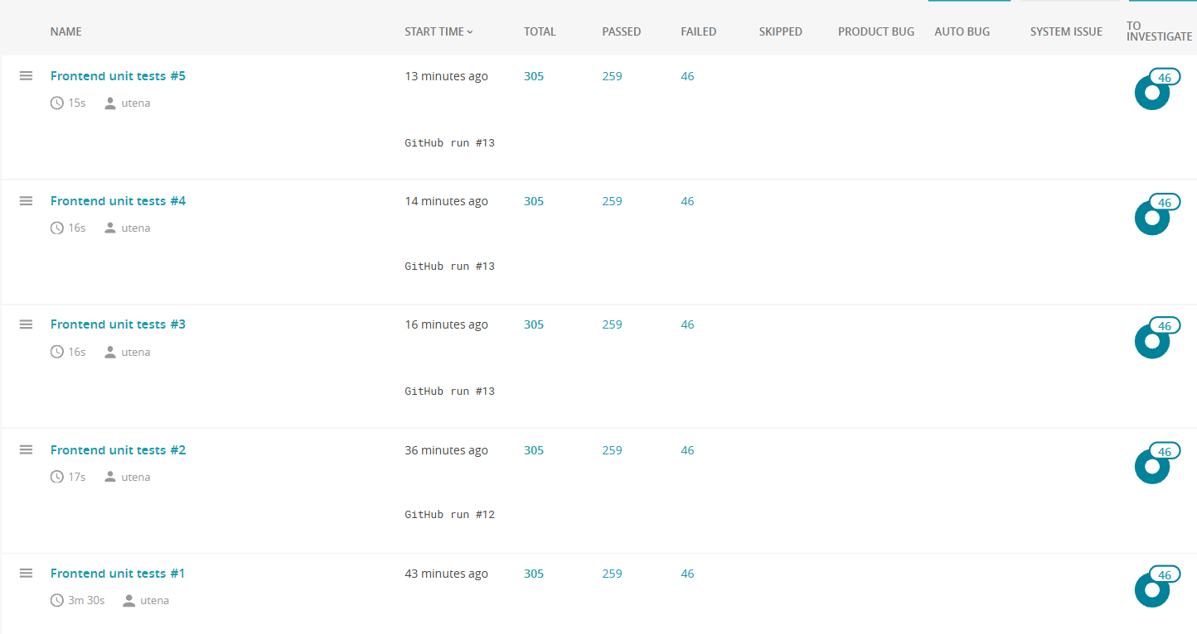
Figure 2. The Launches page: five runs of Frontend unit tests (#1–#5).

3. Dashboard
The Frontend Overview dashboard summarises the five launches with five widgets (Figure 3):
- Most failed test-cases table (TOP-50): the tests that fail most often. Every test listed failed in 4 of 4 analysed executions.
- Launches duration chart: the duration of each launch. Run #1 is clearly the longest, at about 3.3 minutes.
- Failed cases trend chart: a flat line at 46 failed tests per launch.
- Overall statistics: 1,525 test executions across the five launches: 1,295 passed, 230 failed and none skipped. All 230 failures are still marked To Investigate.
- Launch statistics chart: passed and failed tests per launch as stacked bars, which look almost identical for all five runs.
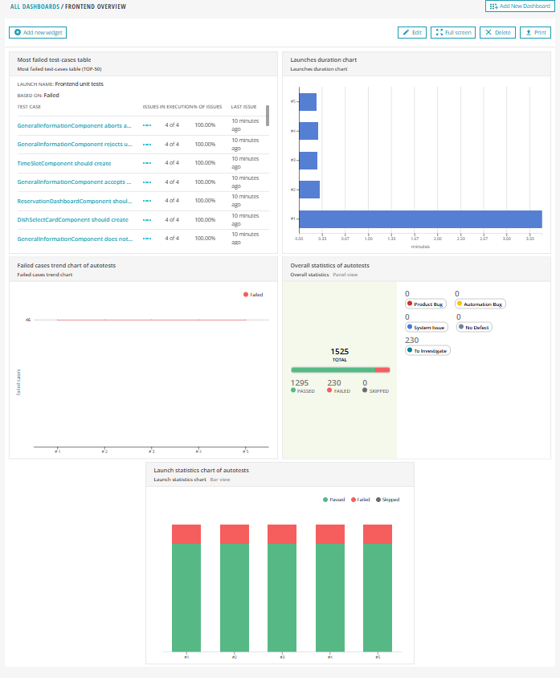
Figure 3. The Frontend Overview dashboard with five widgets.

4. Failed test cases
Opening a launch and filtering by the Failed status lists the individual failing tests. They are grouped under the browser used for the run (Chrome Headless 156.0.0.0, Linux x86_64), and each item has the status Failed and the To Investigate tag. Figure 4 shows some of the failing tests, all from GeneralInformationComponent:
- rejects the first name “Alice!”
- accepts apostrophes and hyphens in names
- handles FileReader errors and preserves the displayed photo
- accepts 50 characters and rejects 51 in firstName
- rejects files larger than 5 MB before reading
- rejects unsupported file type image/svg+xml before reading
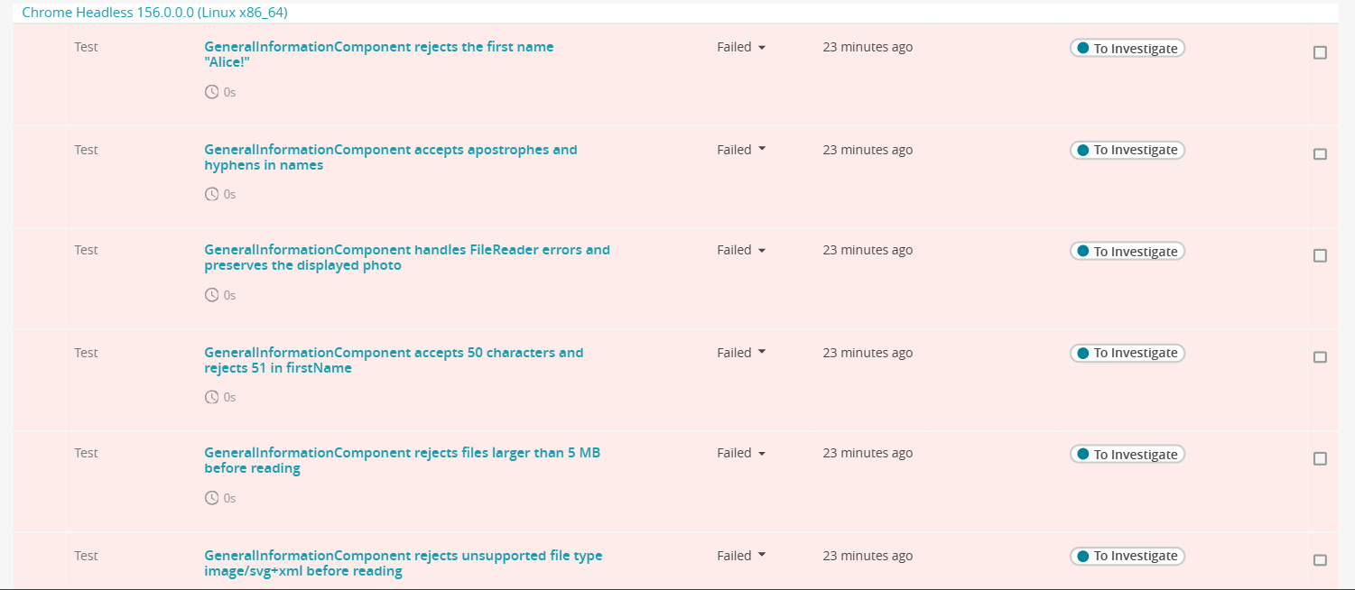
Figure 4. Failed test cases of a launch, grouped by browser (Chrome Headless on Linux).

Summary
- Test results from the pipeline reach Report Portal automatically and appear as a new launch for every run.
- The dashboard shows a stable picture over five runs: 259 passed and 46 failed each time, so the failures are consistent rather than intermittent.
- Next steps: investigate the 46 failing tests, classify their defect types, and re-run the pipeline to see the trend change.

