Internship Project Report

Project Title: Advancing Nutrition Science Through Gemini ai
Submitted in partial fulfilment of the requirements for the
Google Cloud Generative AI conducted by

Smart Bridge

Submitted by
Team Leader : Valli Sri Satya Cheede
Team member : Kumpatla Purna Chandrama Nayudu
Team member : Pala Sai Satish Kumar
Team member : Kunaparaju Vani Vyshnavi

Team ID: LTVIP2026TMIDS86544
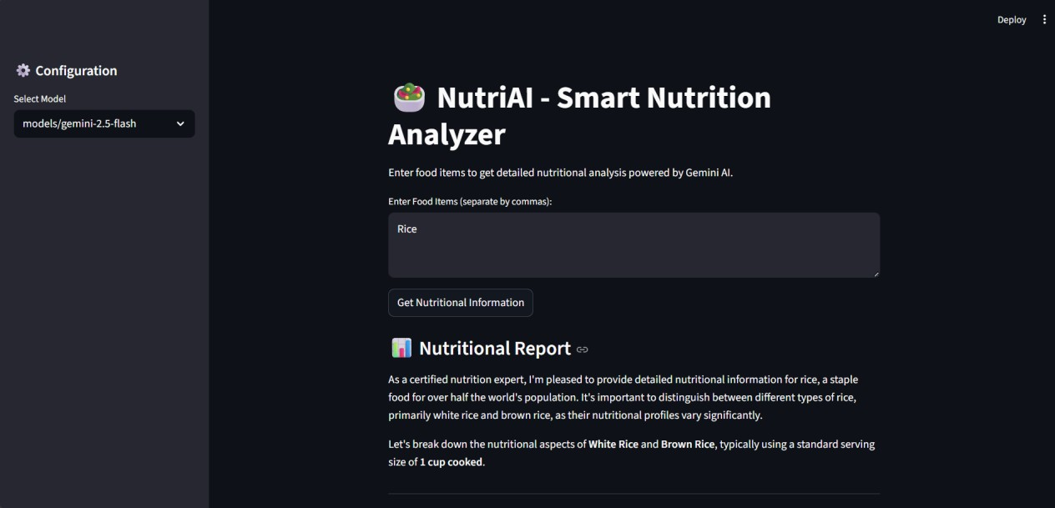

1. INTRODUCTION

1.1 Project Overview
Nutri AI is an advanced AI-powered nutrition analysis system developed to simplify and automate the process of understanding food nutritional values. Many individuals find it difficult to interpret nutritional labels or manually search for calorie and nutrient information online.
Nutri AI provides a smart, efficient, and user-friendly solution by generating instant and structured nutritional reports using Google Gemini.
The application is designed to be accessible, efficient, and scalable, making it suitable for healthconscious individuals, fitness enthusiasts, and students.

1.2 Purpose
- The primary purpose of NutriAI is to enhance and simplify nutritional awareness using artificial intelligence. The key objectives include:
- Reducing time spent on nutrition research – Users do not need to browse multiple websites for calorie and nutrient details.
- Providing detailed nutritional information – The system generates structured reports including macronutrients and micronutrients.
- Automating nutrition analysis using AI – By leveraging generative AI models, NutriAI eliminates manual effort and delivers instant insights.

2. IDEATION PHASE

2.1 Problem Statement
Understanding the nutritional content of food manually is time-consuming and often confusing. Many users struggle to calculate calories, proteins, carbohydrates, fats, vitamins, and minerals accurately.

2.2 Empathy Map Canvas
- User Thinks:
“I want to know whether this food is healthy.”
- User Feels:
Confused by complex nutrition labels
- User Says:
“I don’t understand how many calories I’m eating.”
- User Does:
Searches Google for nutrition details

2.3 Brainstorming
- Ideas considered:
- AI-based nutrition assistant
- Calorie calculator
- Diet recommendation system
- Smart food analyzer
- Final Idea Selected:
AI-powered nutrition analyzer (Nutri AI)

3. REQUIREMENT ANALYSIS

3.1 Customer Journey Map
- User enters food items
- User clicks analyze
- System processes input
- AI generates nutritional report
- User views structured output

3.2 Solution Requirement
- Functional Requirements:
- Accept food item inputs
- Generate AI-based nutritional analysis
- Provide calorie and nutrient details
- Display structured output Non-Functional Requirements:
- Fast response time
- User-friendly interface ➢ Secure API integration
- Reliable performance

3.3 Data Flow Diagram (DFD)
Input → Processing → Output
User Inputs → Gemini AI Processing → Generated Nutritional Report
3.4 Technology Stack

Programming Language – Python
Python is used as the core programming language for developing the system. It is chosen because of its simplicity, readability, and strong support for artificial intelligence, data processing, and API integration.

Web Framework – Streamlit
Streamlit is used to build the user interface of the application. It allows developers to quickly create interactive web applications using simple Python code without requiring knowledge of HTML, CSS, or JavaScript.

AI Model – Google Gemini 1.5 Flash
Google Gemini 1.5 Flash is used as the core artificial intelligence model in the system. It provides fast and accurate responses for tasks such as text understanding, content generation, and analysis, making it suitable for real-time AI applications.

API Integration – Google Generative AI API
The Google Generative AI API is used to connect the application with the Gemini AI model. It enables seamless communication between the system and the AI service

Environment Management – python-dotenv python-dotenv is used to manage environment variables securely. It helps store sensitive data such as API keys and configuration settings in a separate file,

4. PROJECT DESIGN

4.1 Problem Solution Fit
NutriAI effectively solves the problem of manual nutrition research by automating food analysis using AI.

4.2 Proposed Solution
A web application where users input:
- Food items (comma separated)
The system generates:
- Calorie information
- Macronutrient breakdown
- Micronutrient details
- Health benefits
- Dietary considerations

4.3 Solution Architecture
User Interface (Streamlit) → API Integration → Gemini AI Model
→Generated Nutritional Report Output

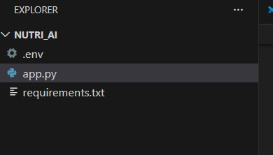

5. PROJECT PLANNING & SCHEDULING

5.1 Project Planning

Ideation – 1 Week
In this phase, the project idea was planned and defined. Requirements were gathered, objectives were set, and the overall system design and workflow were outlined.

Development – 2 Weeks
During this phase, the actual implementation of the system was carried out. The application was developed using Python, Streamlit, and AI integration, and core functionalities were built.

Testing – 1 Week
In the testing phase, the system was checked for errors, bugs, and performance issues. Different test cases were executed to ensure the application works correctly and reliably.

Documentation – 1 Week
This phase involved preparing project documentation, including reports, technical details, user guides, and explanations of the system’s features and workflow.

6. FUNCTIONAL AND PERFORMANCE TESTING
6.1 Performance Testing
- System responds within seconds
- Handles multiple food inputs efficiently
- Generates structured AI-based nutritional reports App.py Code:
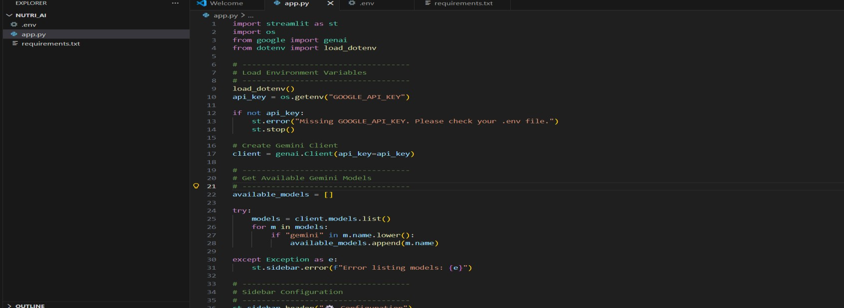
Requirements.txt:
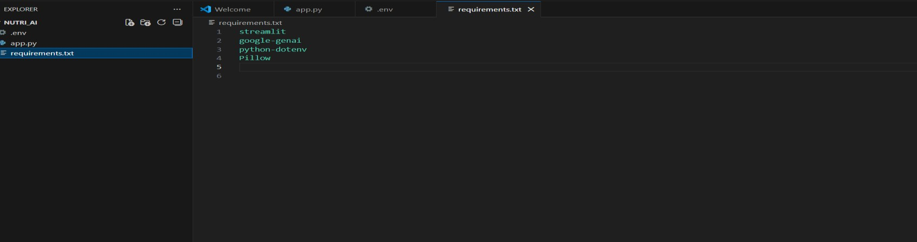
Running the Application:
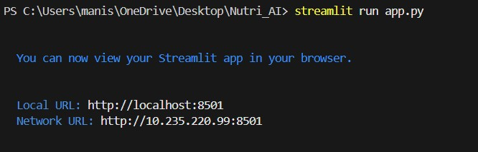
User Interface:
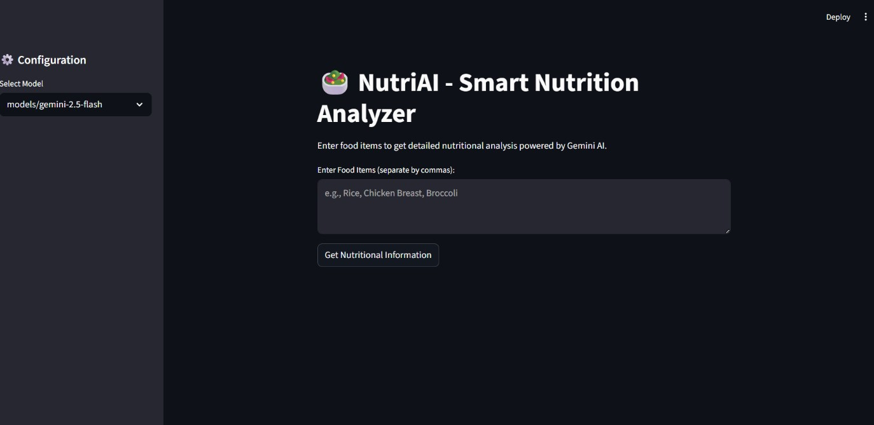

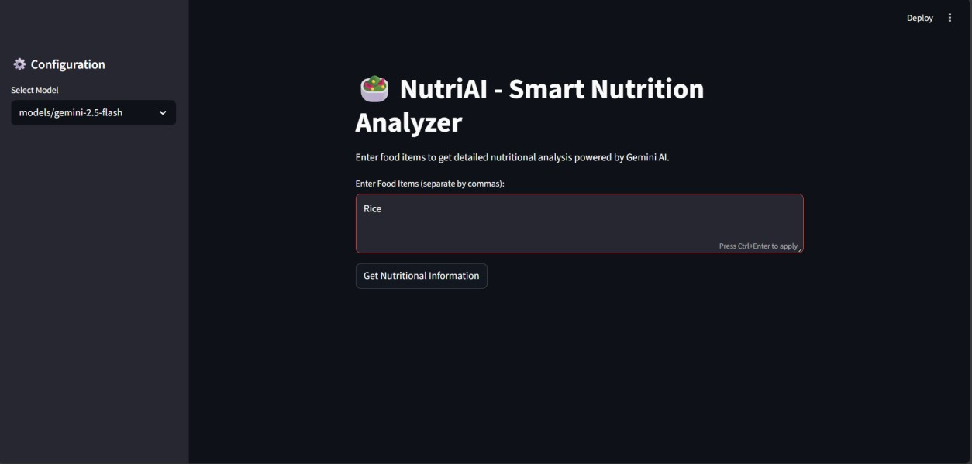

7. RESULTS

7.1 Output Screenshots
Include screenshots of:
User input form:
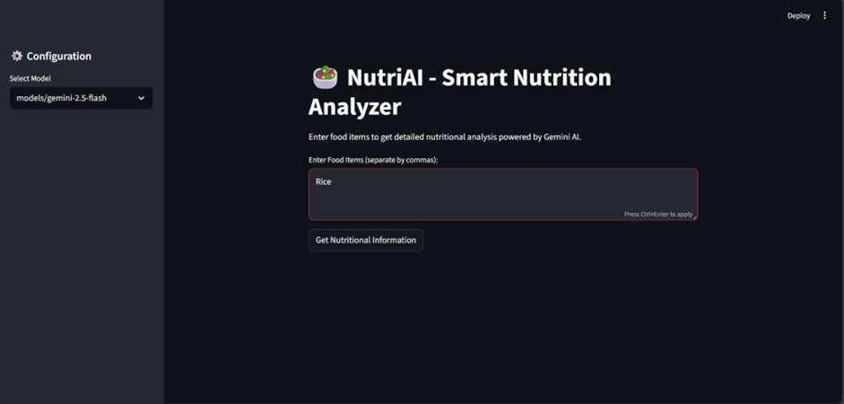

Generated itinerary:
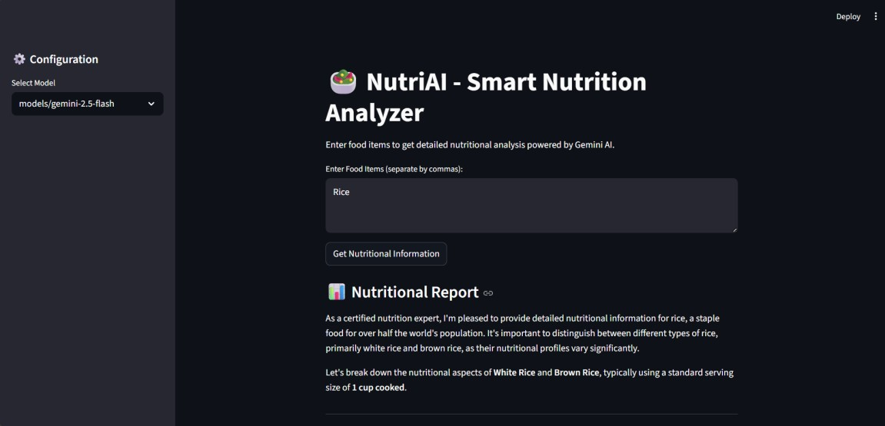

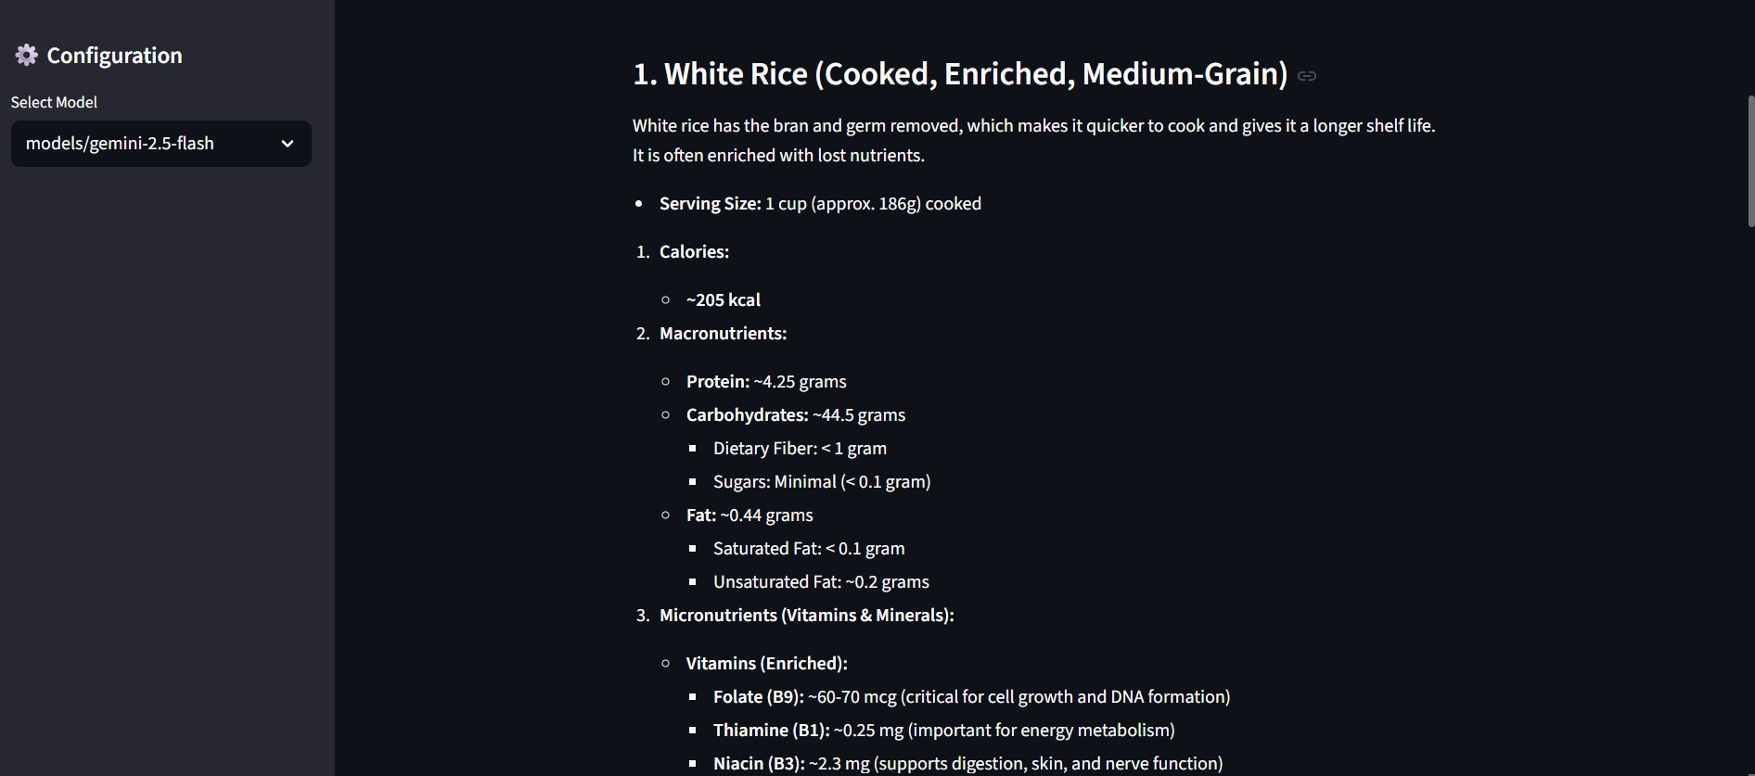

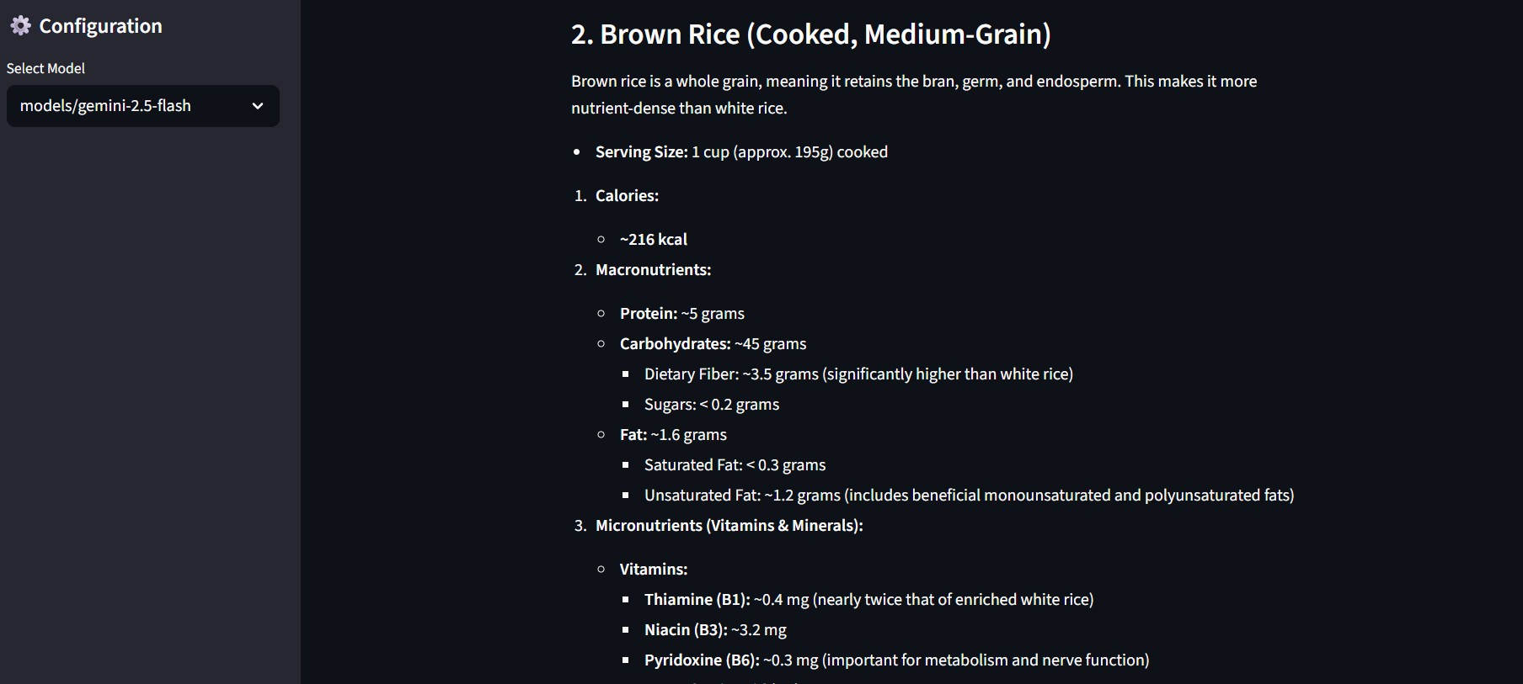

8. ADVANTAGES & DISADVANTAGES

Advantages
- Saves travel planning time – The system quickly generates travel plans, reducing the time users spend searching for information manually.
- Personalized recommendations – It provides customized suggestions based on user preferences such as budget, location, and interests.
- Easy to use – The simple and user-friendly interface allows users to operate the application without technical knowledge.
- AI-powered automation – The use of artificial intelligence automates itinerary creation, making the process faster and more efficient.

Disadvantages
- Requires internet connection – The application depends on an active internet connection to access AI services and APIs.
- Depends on API availability – The system’s performance relies on external AI APIs, so downtime or limits can affect functionality.

9. CONCLUSION

NutriAI successfully demonstrates how artificial intelligence can simplify nutritional analysis.
By integrating Streamlit with Google Gemini AI, the system generates structured nutritional insights instantly.
The project shows the practical application of Generative AI in healthcare and wellness domains, improving accessibility to nutritional information.

10. FUTURE SCOPE
- Meal planning integration
- Calorie tracking dashboard
- Barcode scanning
- PDF report download
- Mobile application version

11. APPENDIX

GitHub Link: https://github.com/kumpatlapurnachandramanayudu

Demo Video Link: https://drive.google.com/file/d/158LVsaCPRWmFN2PjTT_oKrVsueMwOAKh/view?usp=drivesdk

