CMD – COMMON DATA MODEL – OMOP V5.4
Table des matières
Graph v 5.4 2
person 3
observation_period 3
visit_occurrence 3
visit_detail 3
condition_occurrence 3
drug_exposure 3
procedure_occurrence 4
device_exposure 4
measurement 4
observation 4
death 4
note 5
note_nlp 5
specimen 5
fact_relationship 5
location 5
care_site 5
provider 5
payer_plan_period 6
cost 6
drug_era 6
dose_era 6
condition_era 6
episode 7
episode_event 7
metadata 7
cdm_source 7
concept 7
vocabulary 8
domain 8
concept_class 8
concept_relationship 8
relationship 8
concept_synonym 9
concept_ancestor 9
source_to_concept_map 9
drug_strength 9
cohort 9
cohort_definition 10

Graph v 5.4
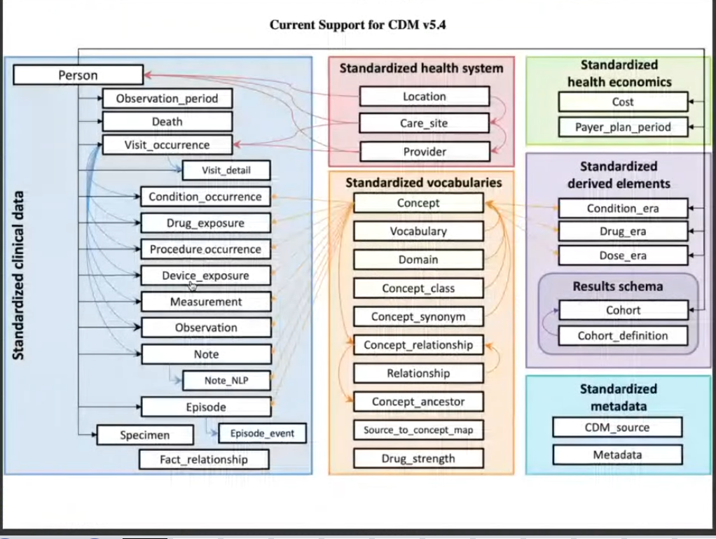

Person, Observation period, condition occurrence (disease or no)
drug exposure
procedure occurrence, Measurement, observation
death (nt in 6.0)
note, note nlp
fact_relationship
payer_plan_period
drug era, dose era, condition_era, drug strength
cohort, cohort definition

person
This table serves as the central identity management for all Persons in the database. It contains records that uniquely identify each person or patient, and some
demographic information.

observation_period
This table contains records which define spans of time during which two conditions are expected to hold: (i) Clinical Events that happened to the Person are recorded in the
Event tables, and (ii) absense of records indicate such Events did not occur during this span of time.

visit_occurrence
This table contains Events where Persons engage with the healthcare system for a duration of time. They are often also called “Encounters”. Visits are defined by a
configuration of circumstances under which they occur, such as (i) whether the patient comes to a healthcare institution, the other way around, or the interaction is
remote, (ii) whether and what kind of trained medical staff is delivering the service during the Visit, and (iii) whether the Visit is transient or for a longer period involving a
stay in bed.

visit_detail
The VISIT_DETAIL table is an optional table used to represents details of each record in the parent VISIT_OCCURRENCE table. A good example of this would be the
movement between units in a hospital during an inpatient stay or claim lines associated with a one insurance claim. For every record in the VISIT_OCCURRENCE table there
may be 0 or more records in the VISIT_DETAIL table with a 1:n relationship where n may be 0. The VISIT_DETAIL table is structurally very similar to VISIT_OCCURRENCE
table and belongs to the visit domain.

condition_occurrence
This table contains records of Events of a Person suggesting the presence of a disease or medical condition stated as a diagnosis, a sign, or a symptom, which is either
observed by a Provider or reported by the patient.

drug_exposure
This table captures records about the exposure to a Drug ingested or otherwise introduced into the body. A Drug is a biochemical substance formulated in such a way that
when administered to a Person it will exert a certain biochemical effect on the metabolism. Drugs include prescription and over-the-counter medicines, vaccines, and large-
molecule biologic therapies. Radiological devices ingested or applied locally do not count as Drugs.

procedure_occurrence
This table contains records of activities or processes ordered by, or carried out by, a healthcare provider on the patient with a diagnostic or therapeutic purpose.

device_exposure
The Device domain captures information about a person’s exposure to a foreign physical object or instrument which is used for diagnostic or therapeutic purposes through
a mechanism beyond chemical action. Devices include implantable objects (e.g. pacemakers, stents, artificial joints), medical equipment and supplies (e.g. bandages,
crutches, syringes), other instruments used in medical procedures (e.g. sutures, defibrillators) and material used in clinical care (e.g. adhesives, body material, dental
material, surgical material).

measurement
The MEASUREMENT table contains records of Measurements, i.e. structured values (numerical or categorical) obtained through systematic and standardized examination
or testing of a Person or Person’s sample. The MEASUREMENT table contains both orders and results of such Measurements as laboratory tests, vital signs, quantitative
findings from pathology reports, etc. Measurements are stored as attribute value pairs, with the attribute as the Measurement Concept and the value representing the
result. The value can be a Concept (stored in VALUE_AS_CONCEPT), or a numerical value (VALUE_AS_NUMBER) with a Unit (UNIT_CONCEPT_ID). The Procedure for
obtaining the sample is housed in the PROCEDURE_OCCURRENCE table, though it is unnecessary to create a PROCEDURE_OCCURRENCE record for each measurement if
one does not exist in the source data. Measurements differ from Observations in that they require a standardized test or some other activity to generate a quantitative or
qualitative result. If there is no result, it is assumed that the lab test was conducted but the result was not captured.

observation
The OBSERVATION table captures clinical facts about a Person obtained in the context of examination, questioning or a procedure. Any data that cannot be represented by
any other domains, such as social and lifestyle facts, medical history, family history, etc. are recorded here.

death

The death domain contains the clinical event for how and when a Person dies. A person can have up to one record if the source system contains evidence about the Death,
such as: Condition in an administrative claim, status of enrollment into a health plan, or explicit record in EHR data.

note
The NOTE table captures unstructured information that was recorded by a provider about a patient in free text (in ASCII, or preferably in UTF8 format) notes on a given
date. The type of note_text is CLOB or varchar(MAX) depending on RDBMS.

note_nlp
The NOTE_NLP table encodes all output of NLP on clinical notes. Each row represents a single extracted term from a note.

specimen
The specimen domain contains the records identifying biological samples from a person.

fact_relationship
The FACT_RELATIONSHIP table contains records about the relationships between facts stored as records in any table of the CDM. Relationships can be defined between
facts from the same domain, or different domains. Examples of Fact Relationships include: Person relationships (https://athena.ohdsi.org/search-
terms/terms?domain=Relationship&standardConcept=Standard&page=2&pageSize=15&query=) (parent-child), care site relationships (hierarchical organizational
structure of facilities within a health system), indication relationship (between drug exposures and associated conditions), usage relationships (of devices during the course of an associated procedure), or facts derived from one another (measurements derived from an associated specimen).

location
The LOCATION table represents a generic way to capture physical location or address information of Persons and Care Sites.

care_site
The CARE_SITE table contains a list of uniquely identified institutional (physical or organizational) units where healthcare delivery is practiced (o�ices, wards, hospitals,
clinics, etc.).

provider
The PROVIDER table contains a list of uniquely identified healthcare providers. These are individuals providing hands-on healthcare to patients, such as physicians, nurses,
midwives, physical therapists etc.

payer_plan_period
The PAYER_PLAN_PERIOD table captures details of the period of time that a Person is continuously enrolled under a specific health Plan benefit structure from a given
Payer. Each Person receiving healthcare is typically covered by a health benefit plan, which pays for (fully or partially), or directly provides, the care. These benefit plans are
provided by payers, such as health insurances or state or government agencies. In each plan the details of the health benefits are defined for the Person or her family, and
the health benefit Plan might change over time typically with increasing utilization (reaching certain cost thresholds such as deductibles), plan availability and purchasing
choices of the Person. The unique combinations of Payer organizations, health benefit Plans and time periods in which they are valid for a Person are recorded in this table.

cost
The COST table captures records containing the cost of any medical event recorded in one of the OMOP clinical event tables such as DRUG_EXPOSURE,
PROCEDURE_OCCURRENCE, VISIT_OCCURRENCE, VISIT_DETAIL, DEVICE_OCCURRENCE, OBSERVATION or MEASUREMENT.
Each record in the cost table account for the amount of money transacted for the clinical event. So, the COST table may be used to represent both receivables (charges) and
payments (paid), each transaction type represented by its COST_CONCEPT_ID. The COST_TYPE_CONCEPT_ID field will use concepts in the Standardized Vocabularies to
designate the source (provenance) of the cost data. A reference to the health plan information in the PAYER_PLAN_PERIOD table is stored in the record for information used
for the adjudication system to determine the persons benefit for the clinical event.

drug_era
A Drug Era is defined as a span of time when the Person is assumed to be exposed to a particular active ingredient. A Drug Era is not the same as a Drug Exposure:
Exposures are individual records corresponding to the source when Drug was delivered to the Person, while successive periods of Drug Exposures are combined under
certain rules to produce continuous Drug Eras.

dose_era
A Dose Era is defined as a span of time when the Person is assumed to be exposed to a constant dose of a specific active ingredient.

condition_era
A Condition Era is defined as a span of time when the Person is assumed to have a given condition. Similar to Drug Eras, Condition Eras are chronological periods of
Condition Occurrence. Combining individual Condition Occurrences into a single Condition Era serves two purposes:
• It allows aggregation of chronic conditions that require frequent ongoing care, instead of treating each Condition Occurrence as an independent event.
• It allows aggregation of multiple, closely timed doctor visits for the same Condition to avoid double-counting the Condition Occurrences. For example, consider a
Person who visits her Primary Care Physician (PCP) and who is referred to a specialist. At a later time, the Person visits the specialist, who confirms the PCP’s original
diagnosis and provides the appropriate treatment to resolve the condition. These two independent doctor visits should be aggregated into one Condition Era.

episode
The EPISODE table aggregates lower-level clinical events (VISIT_OCCURRENCE, DRUG_EXPOSURE, PROCEDURE_OCCURRENCE, DEVICE_EXPOSURE) into a higher-level
abstraction representing clinically and analytically relevant disease phases,outcomes and treatments. The EPISODE_EVENT table connects qualifying clinical events
(VISIT_OCCURRENCE, DRUG_EXPOSURE, PROCEDURE_OCCURRENCE, DEVICE_EXPOSURE) to the appropriate EPISODE entry. For example cancers including their
development over time, their treatment, and final resolution.

episode_event
The EPISODE_EVENT table connects qualifying clinical events (such as CONDITION_OCCURRENCE, DRUG_EXPOSURE, PROCEDURE_OCCURRENCE, MEASUREMENT) to the
appropriate EPISODE entry. For example, linking the precise location of the metastasis (cancer modifier in MEASUREMENT) to the disease episode.

metadata
The METADATA table contains metadata information about a dataset that has been transformed to the OMOP Common Data Model.

cdm_source
The CDM_SOURCE table contains detail about the source database and the process used to transform the data into the OMOP Common Data Model..

concept
The Standardized Vocabularies contains records, or Concepts, that uniquely identify each fundamental unit of meaning used to express clinical information in all domain
tables of the CDM. Concepts are derived from vocabularies, which represent clinical information across a domain (e.g. conditions, drugs, procedures) through the use of
codes and associated descriptions. Some Concepts are designated Standard Concepts, meaning these Concepts can be used as normative expressions of a clinical entity
within the OMOP Common Data Model and within standardized analytics. Each Standard Concept belongs to one domain, which defines the location where the Concept
would be expected to occur within data tables of the CDM.
Concepts can represent broad categories (like ‘Cardiovascular disease’), detailed clinical elements (‘Myocardial infarction of the anterolateral wall’) or modifying
characteristics and attributes that define Concepts at various levels of detail (severity of a disease, associated morphology, etc.).
Records in the Standardized Vocabularies tables are derived from national or international vocabularies such as SNOMED-CT, RxNorm, and LOINC, or custom Concepts
defined to cover various aspects of observational data analysis.

vocabulary
The VOCABULARY table includes a list of the Vocabularies collected from various sources or created de novo by the OMOP community. This reference table is populated
with a single record for each Vocabulary source and includes a descriptive name and other associated attributes for the Vocabulary.

domain
The DOMAIN table includes a list of OMOP-defined Domains the Concepts of the Standardized Vocabularies can belong to. A Domain defines the set of allowable Concepts
for the standardized fields in the CDM tables. For example, the “Condition” Domain contains Concepts that describe a condition of a patient, and these Concepts can only
be stored in the condition_concept_id field of the CONDITION_OCCURRENCE and CONDITION_ERA tables. This reference table is populated with a single record for each
Domain and includes a descriptive name for the Domain.

concept_class
The CONCEPT_CLASS table is a reference table, which includes a list of the classifications used to differentiate Concepts within a given Vocabulary. This reference table is
populated with a single record for each Concept Class.

concept_relationship
The CONCEPT_RELATIONSHIP table contains records that define direct relationships between any two Concepts and the nature or type of the relationship. Each type of a
relationship is defined in the RELATIONSHIP table.

relationship
The RELATIONSHIP table provides a reference list of all types of relationships that can be used to associate any two concepts in the CONCEPT_RELATIONSHP table.

concept_synonym
The CONCEPT_SYNONYM table is used to store alternate names and descriptions for Concepts.

concept_ancestor
Like a tree ? A faire ?
The CONCEPT_ANCESTOR table is designed to simplify observational analysis by providing the complete hierarchical relationships between Concepts. Only direct parent-
child relationships between Concepts are stored in the CONCEPT_RELATIONSHIP table. To determine higher level ancestry connections, all individual direct relationships
would have to be navigated at analysis time. The CONCEPT_ANCESTOR table includes records for all parent-child relationships, as well as grandparent-grandchild
relationships and those of any other level of lineage. Using the CONCEPT_ANCESTOR table allows for querying for all descendants of a hierarchical concept. For example,
drug ingredients and drug products are all descendants of a drug class ancestor.
This table is entirely derived from the CONCEPT, CONCEPT_RELATIONSHIP and RELATIONSHIP tables.

source_to_concept_map
The source to concept map table is a legacy data structure within the OMOP Common Data Model, recommended for use in ETL processes to maintain local source codes
which are not available as Concepts in the Standardized Vocabularies, and to establish mappings for each source code into a Standard Concept as target_concept_ids that
can be used to populate the Common Data Model tables. The SOURCE_TO_CONCEPT_MAP table is no longer populated with content within the Standardized Vocabularies
published to the OMOP community.

drug_strength
The DRUG_STRENGTH table contains structured content about the amount or concentration and associated units of a specific ingredient contained within a particular drug
product. This table is supplemental information to support standardized analysis of drug utilization.

cohort
Comme un groupe de patients qui se définissent de la même façon… Un cluster (en data par épidémio)
The COHORT table contains records of subjects that satisfy a given set of criteria for a duration of time. The definition of the cohort is contained within the
COHORT_DEFINITION table. It is listed as part of the RESULTS schema because it is a table that users of the database as well as tools such as ATLAS need to be able to write
to. The CDM and Vocabulary tables are all read-only so it is suggested that the COHORT and COHORT_DEFINTION tables are kept in a separate schema to alleviate
confusion.

cohort_definition
= metadata de cohort ?
The COHORT_DEFINITION table contains records defining a Cohort derived from the data through the associated description and syntax and upon instantiation (execution
of the algorithm) placed into the COHORT table. Cohorts are a set of subjects that satisfy a given combination of inclusion criteria for a duration of time. The
COHORT_DEFINITION table provides a standardized structure for maintaining the rules governing the inclusion of a subject into a cohort, and can store operational
programming code to instantiate the cohort within the OMOP Common Data Model.

